
GEOGRAPHY MARKING SCHEME
FORM FOUR PAPER 1
TRIAL 2, 2019
- a) Solar system (2mks)
- Refers to the sun, eight planetsand the heavenly bodies.
b) Tree theories explaining the origin of the solar system (3mks)
- Nebular cloud theory
- Passing star theory
- Collision
- Explosion
- i) Faulting (2mks)
- Fracturing of the earth crust/crustal rock due to tensional force.
ii) Three types of faults (3mks)
- Normal
- Reverse
- Tear/shear/slip
- Thrust
- An anticlinal
- i)Glacier (2mks)
- A large sheet ice
ii) V –Terminal/Moraine
T –
S -
- Conditions necessary for the formation of a beach (5mks)
- Slope gentleness
- Shallowness of the shore
- Breaking, waves should have a strong swatch than backwash
- Waves should carry a large load of materials to be deposited.
- a) Part X – Stalactite
Part Y – Stalagmite
Part Z – Pillar
b) Two conditions necessary for development of Karst scenery (2mks)
- Moderate to abundant rainfall
- Low water table
- Hard and well jointed rocks
- Thick layer of calcium carbonate rocks
- An area of limestock /chalk
- a) i) 3613 (2mks)
ii) North to South (2mks)
b)i) 190/3
Vol
ii) 9.2km $±$ 0.1
iii) Complete good square = 0
Incomplete = $\frac{19}{2}=9.5 square$(1mk)
1 grid square = 1km^{2 (1mk)}
9.5sq =
$$\frac{9.5sq ×{1km}^{2}}{1sq}$$
= 9.5km²
iv) Three economic activities carried in the area (6mks)
- Trade- Evidenced by presence of shops at grid 4219, 2324
- Transportation – present of all weather roads and railways –A23 and railway from Mwatate to Voi
- Communication – Presence of post office at 2919
c) Factors that may have influenced Agricultural activities in the area
- Flat extensive land – Availability of flat land on the Southern part of the map favouring sisal growing.
- Availability of water – Favouring cattle rearing evidence by cattle dip at grid of 2324.
- Availability of Agricultural extensional services – Evidenced by presence of Agricultural office 412a and ministry of Agriculture farm at 4128.
- Availability of efficient transport network – Evidence by many roads connection and railway lines.

- a) Vulcanicity (2mks)
- All various ways by which solid liquid and gaseous materials are forced into earth’s crust and its surface.(A ward any other relevant answer starting with the process.

b)Distinguish extrusive and intrusive vulcanicity (4mks)
- Extrusive vulcanicity is the process where the materials actually break through the surface of the earth in a volcanic eruption while Intrusive vulcanicity is the process where the material does not have enough strength to break through the surface of the earth.
c)Three resultant features due to intrusive vulcanicity (3mks)
- Sill
- Dykes
- Laccoliths
- Batholiths
- Lopoliths
- Phacoliths
d) Continental drift theory (8mks)
- The world was one called Pangea.
- Pangea was surrounded by a large water body called Panthallassa
- Pangea broke into two namely the Godwanaland and Laurasia.
- Godwanaland and Laurasia were separated by a long water body called Tethys.
- Godwanaland drifted to the south and ruptured giving continents such as South America., Autardtiza, Australia among others.
- Laurasia drifted to the North and ruptured giving continents such as Eurasia, North America among others.
e) i) Two artificial causes of earth movements (2msk)
- Explosion especially in quarrying sites
- Movement by heavy machines such a railways
- Reserviours especially in water dammed areas.
ii) Three significance of volcanicity to human activities
- Volcanic eruptions can cause great loss of life and property.
- Volcanic Mountaincreates rain shadow effect resulting to aridity.
- Some volcanic lava flows develop into poor soils which are not suitable for Agriculture
- Rugged nature and volcanic land scape make settlement and Agriculture difficult.
- Some volcanic landscapes creates barriers which obstruct transport and communication.
- a) Climate (2mks)
- Average weather conditions of a given place overalong period of time usually 30-35 years.
b)Factors influencing climate under the following sub-headings:
- Latitude (5mks)
- Latitude refers to the distance from the equator.
- Generally temperature decreases with increase in latitude.
- This is caused by the fact that the insolation received on the earth at the equator is greater and decreasespole wardslatitudes and also influence the seasonal variation of rainfall due to the changing positions of the inter-tropical convergence zone (ITCZ)
- Altitude (4mks)
- This affects temperature, rainfall and pressure
- Lowlands are generally warmer than highlands
- Atmospheric pressure is higher at low altitude and low at high altitudes.
- Highlands receive relief rainfallwhile lowlands receive frontal rainfall
- Ocean current (4mks)
- Warm ocean currents warm up onshore winds building its capacity to hold moisture leading to heavy rainfall on Coastal land while cold ocean currents rain in the sea, only dry winds reach the coast lading to the occurrence of desert like condition.
c) i) Distinguish aridity and desertification (2mks)
- Aridity – State on insufficient moisture leading to scarcity or lack of vegetation and deficiency in soil fertility.
- Desertification – Encroachment of desert like conditions into formerly productive lands.
(Should be properly defined to clearly give out the difference).

ii) Four causes of aridity and desertification together with their possible solutions (8mks)
- Low and unreliable rainfall of below 250mmPh possible solution – Irrigating dry lands.
- Overgrazing censed by over stocking acceleration soil erosion.
- Possible solution – controlling the number of animals kept through putting laws in place. Legislative policies.
- Destruction of vegetation through cultivation possible solution – Afforestation and reafforestration.
- Industrialization leading to global warming – possible solution – controlling Industrialization and enacting laws governing pollutions.
- a) Ways of water movement in oceans (2mks)
- Vertical movement
- Horizontal
b) Four types of tides (4mks)
- Perigean
- Apogean
- Spring
- Neap
c)Factors that influence wave transportation (4mks)
- Gradient of the shore where gentile slopes allows occurrence of long shore drift and the vice versa.
- Strength of waves where strong waves carry large quantities of material over along distance and the vice versa.
- Nature of the load/weight of the load.
- Presence of ocean currents.
Award any other well stated point
d)i) Wave depositional features (1x4=4mks)
- Beaches
- Spits
- Tombolo
- Bars
- Salt marshes
- Dune belts
- Cuspate forelands
ii)Factors influencing the type of coast (2x2=4mks)
- Tidal current
- Relative change in the level of the land and the sea.
- Nature of rock – Hard rocks resist soft rocks – easily eroded.
- Human activities – eg canals, construction, and artificial harbor leading to the alteration of the natural appearance of coast.
Award any other relevant point
iii) Benefits they might have enjoyed due to conducting a reconnaissance oftheir place of study (3mks)
- Assisted in preparing a working schedule
- Helped in proper time management
- Enables familiarization with the area of study.
Award any other relevant point
iv)Ways the learners might have used in collecting the data (2mks)
- through observation
- through note taking
- through photographing /photo taking

Award any other relevant point
v)Type of coral reef they might have studied during the period of their study (2mks)
- Fringing reef
- Barrier reef
- A tool reef
- a) Major deserts found in;
- Africa (3mks)
- Sahara
- Kalahari
- Namib
- Processes in which wind erodes the earth’s surface (2mks)
- Abrasion
- Deflation
- Ways in which transports its load (6mks)
- Saltation – Where coarse grained sand particles are transported through a series of shorts jumps / bouncing along the earth surface
- Suspension – Very fine materials are picked by which raised high and blown for long distance.
- Surface creep – Heavy materials are rolled /pushed for short distances along the earth surface
b)How the following desert features are formed. (5mks)
- Yardangs
- Prevailing winds blows across the land where there are alternating vertical bands of resistant and non-resistant rocks.
- Rock layers lie parallel to direction of the prevailing wind
- Soft rocks are eroded by wind through abrasion to form depression /furrows while hard bands of rocks form ridges.
- The ridges forms features called yardangs
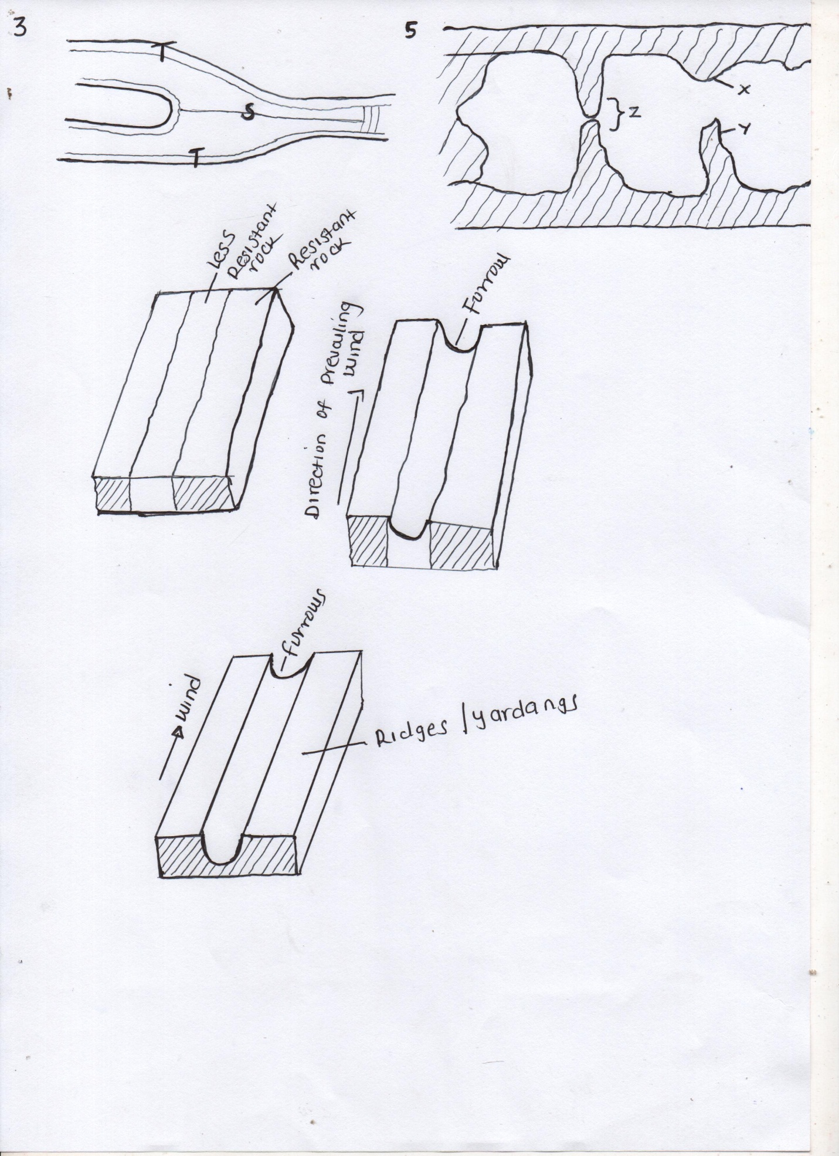

- Mushroom block (6mks)
- Formed where there is a homogenous rock outcrop along the direction of prevailing winds.
- The base of rock is eroded more by wind abrasion.
- The top part is polished and smoothened through abrasion to form a massive rock with abroad rounded top called a mushroom block.
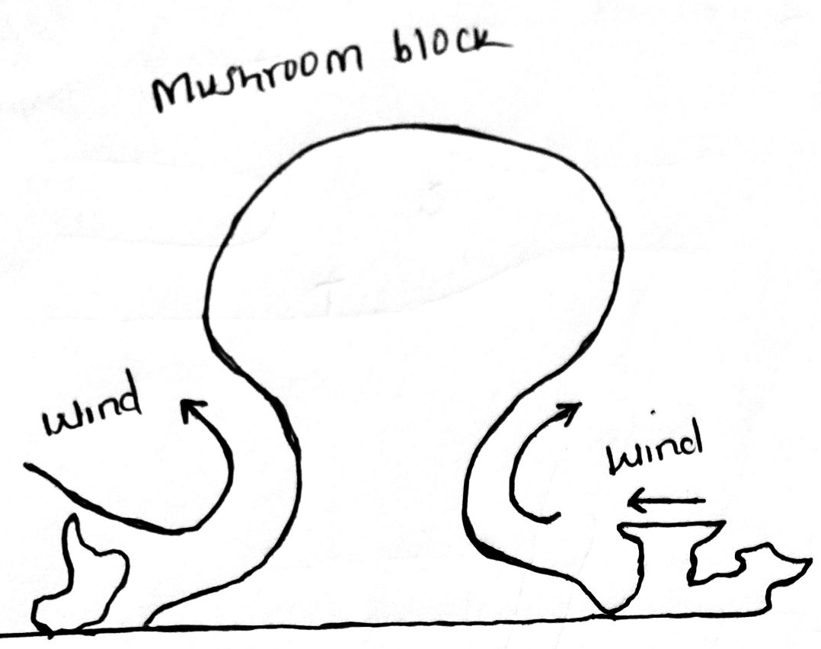

c) i) Barchan (1mk)
ii) Part marked J – Horns (1mk)
Part marked L – Steep slope (1mk)

