

FORM FOUR TRIAL 2, 2019
Kenya Certificate of Secondary Education

312/1 GEOGRAPHY
PAPER ONE
TIME: 2¾HRS
INSTRUCTIONS
- This paper consist of two section A and B
- Answer ALL the questions in section A
- Answer question 6 and any other two questions from section B
- Candidates should answer the questions in English

SECTION A (25MKS)
Answer all the questions in this section
- a) Define the term solar system (2mks)
b) Give any three theories explaining the origin of the solar system (3mks)
- i) What is faulting (2mks)
ii) Mention any three types of faults (3mks)
- i) Define a glacier (2mks)
ii) The diagram below shows types of moraines in a valley glacier (3mks)
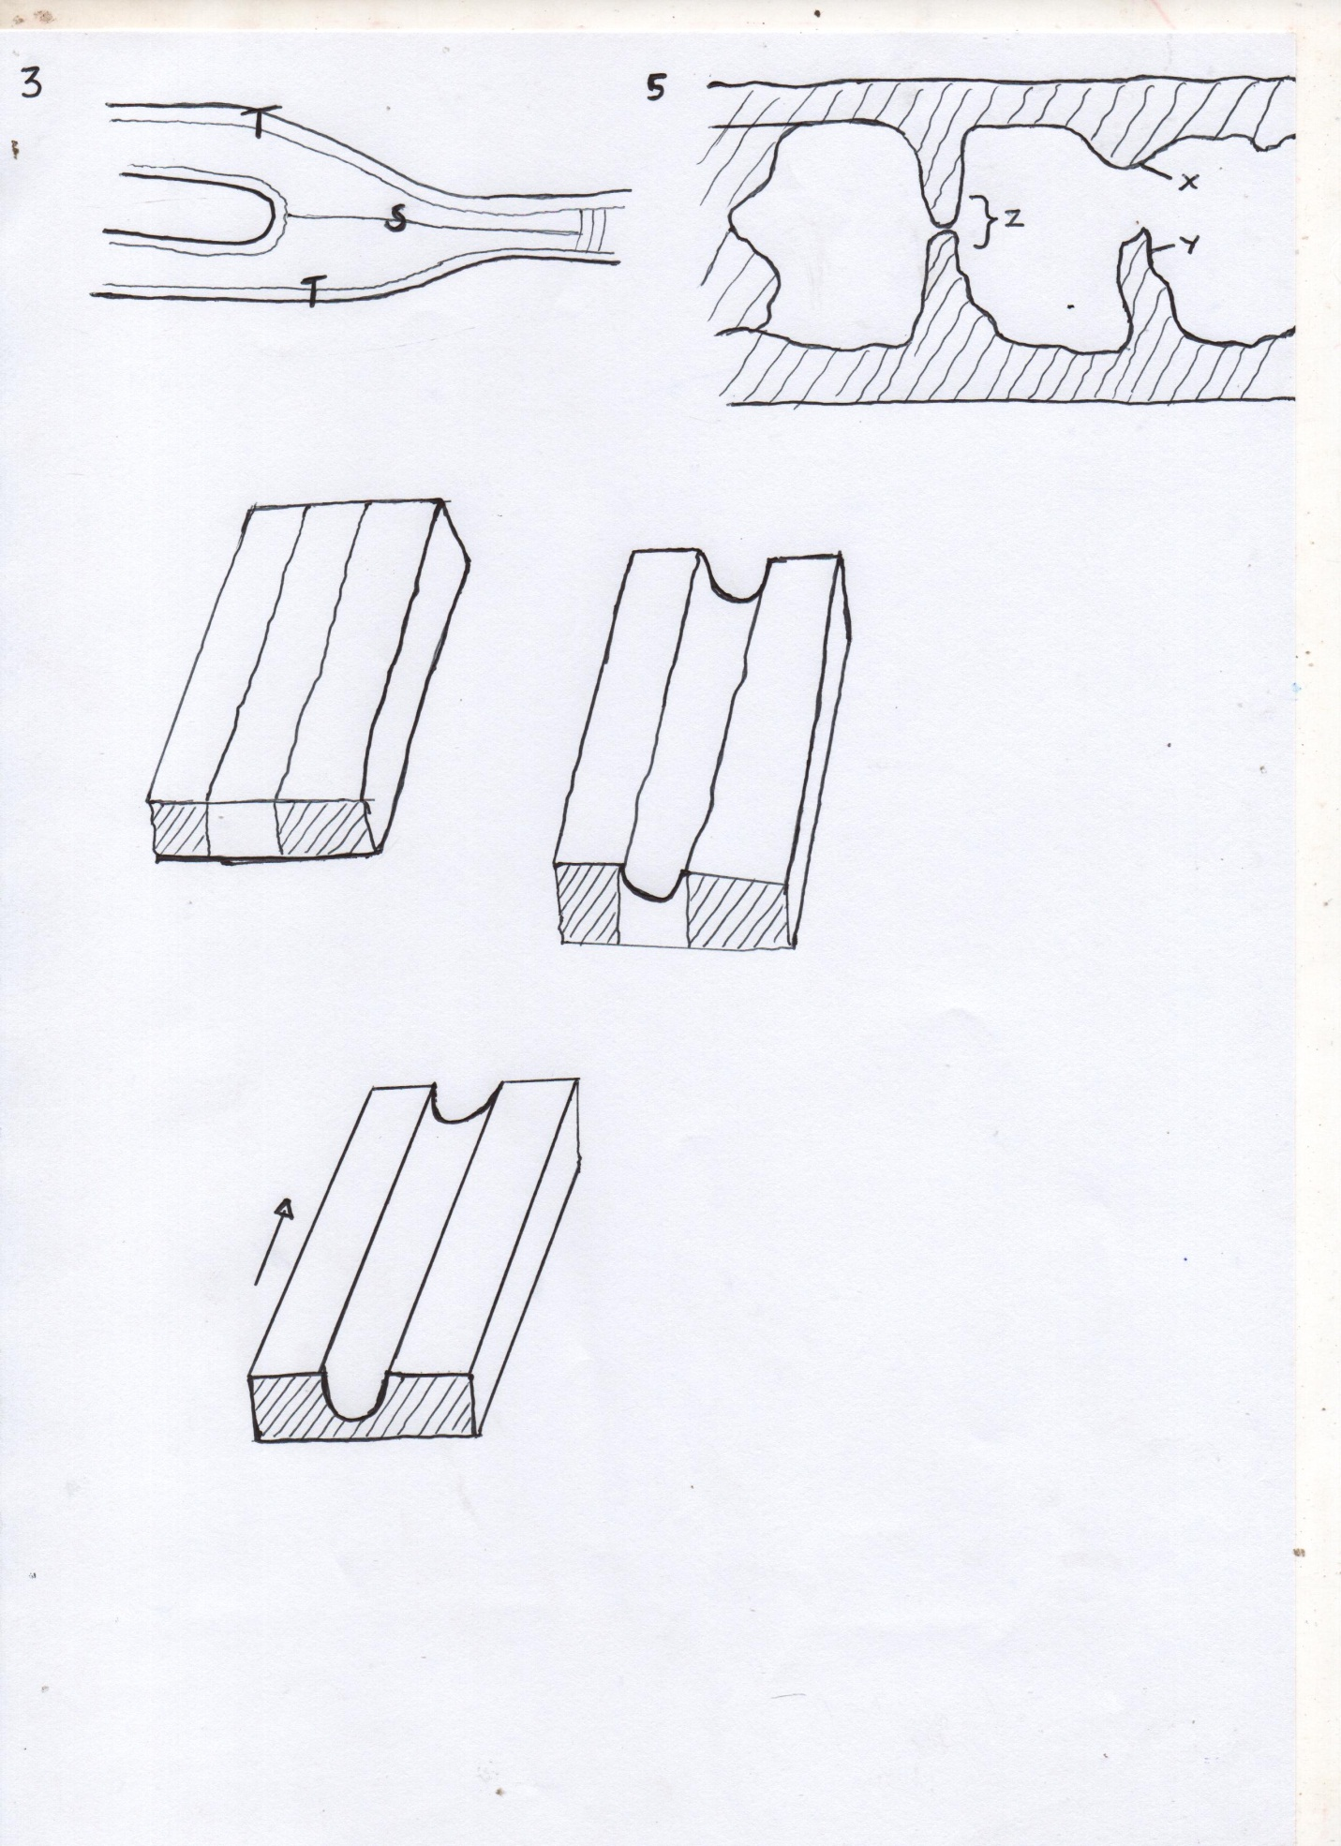

V

Name parts V, T & S
- State five conditions necessary for the formation of a beach (5mks)
- a) Study the diagram and answer the following questions. (3mks)

Name parts X, Y &Z
b) State any two conditions necessary for development of Karst scenery (2mks)

SECTION B
Answer question 6 and any other two questions from this section
- Study the map of Taita Hills 1:50,000 (Sheet 198/4) provided and answer the following questions.
- i) Give the four figure grid reference of L.R 3880/s (2mks)
ii) What is the general direction of R. Ruhiaa tributary of R. vol (Goshi) (2mks)
- i) Give the adjoining sheet of Taita Hills on the North Coast part of the map. (2mks)
ii) Measure the length of the Bound surface Road A23 from Mwatake to LC
(Level Crossing) (2mks)
iii) Calculate the area of the forest covering Shellemba and Majengo Zones (3mks)
iv) Citing evidence from the map, identify three economic activities carried in the area
(6mks)
- Citing evidence from the map, explain any fourfactors that may have influenced Agricultural activities in the Area (8mks)
- a) Define the term Vulcanicity? (2mks)
b) Distinguish Extrusive and intrusive vulcanicity (4mks)
c) Give any three resultant features due to intrusive vulcanicity (3mks)
d) Describe the continental drift theory (3mks)
e) i) State two artificial causes of earth movements (2mks)
ii) Explain any three significance of vulcanicity to human activities. (8mks)
- a) What is climate? (2mks)
b) Explain the factors influencing climate under the following sub-headings:
- Latitude (5mks)
- Altitude (4mks)
- Ocean currents (4mks)
c) i) Distinguish Aridity and desertification. (2mks)
ii) State any four causes of aridity and desertification together with their possible solutions
(8mks)
- a) Name two ways of water movement in Oceans (2mks)
b) List any four types of tides (4mks)
c) State four factors that influence wave transportation (4mks)
d) Yururugirl’s school, form 4 Geography class carried out a field study at a wave deposition site at the coast of Mombasa.
- List any four wave depositional features they might have observed. (4mks)
- Explain any two factors influencing the type of coast they might have studied. (4mks)
- Give any three benefits they might have enjoyed due to conducting reconnaissance to their place of study (3mks)
- List two ways the learners might have used in collecting the data (2mks)
- Mention any two types of coral reef they might have studied during the period of their study (2mks)

- a) Name three major deserts found in:
- Africa (3mks)
- Give two processes in which wind erodes the earth’s surface (2mks)
- Explain three ways in which wind transport its load (6mks)
b) Using well labeled diagrams, explain how the following desert features are formed.
- Yardangs (5mks)
- Mushroom block (6mks)
c) The diagram below represents features resulting from wind deposition in a desert
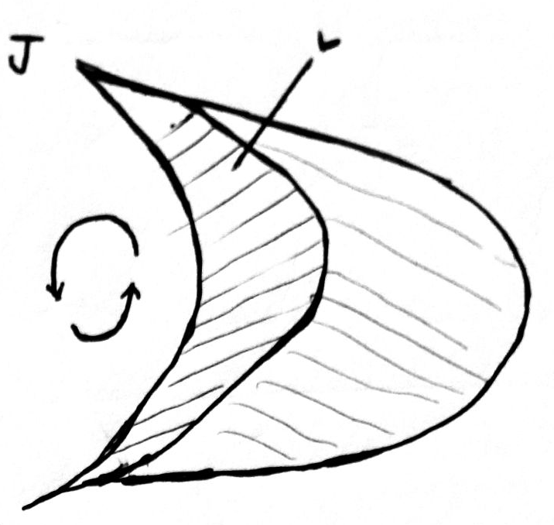

Use it to answer questions that follow
- Name the above feature (1mk)
- Name the parts marked; (2mks)
J & L

