NAME _______________________________ Admn. No. __________________
Student’s signature ___________
Date _____/ __/
School ______________________
312/1
GEOGRAPHY
PAPER 1
2 ¾ HOURS

2020 FORM 4 TERM 1 ENTRY EXAMS

GEOGRAPHY
PAPER 1
2 ¾ HOURS

INSTRUCTIONS TO CANDIDATES
This paper has two sections Aand B
Answer all questions in section A
In section B answer question 6 and any two questions
All answers must be written in English in the booklet provided

SECTION A
ANSWER ALL THE QUESTIONS IN THIS SECTION
1.a)What is the difference between a meteor and a meteorite (2mks)

b)State three effects of earth’s revolution (3mks)

2.a)List two elements of weather(2mks)

b)Name three processes through which the atmosphere is heated (3mks)

3a)What is weathering (2mks)

b)Give three processes of chemical weathering (3mks)

4a)Name three types of coral reefs (3mks)

b)What are the benefits of coral reefs in the areas they have developed (2mks)

5a) State two factors which influence occurrence of surface run-off (2mks)

b)The diagram below shows a waterfall. Name the features marked X,Y, and Z (3mks)

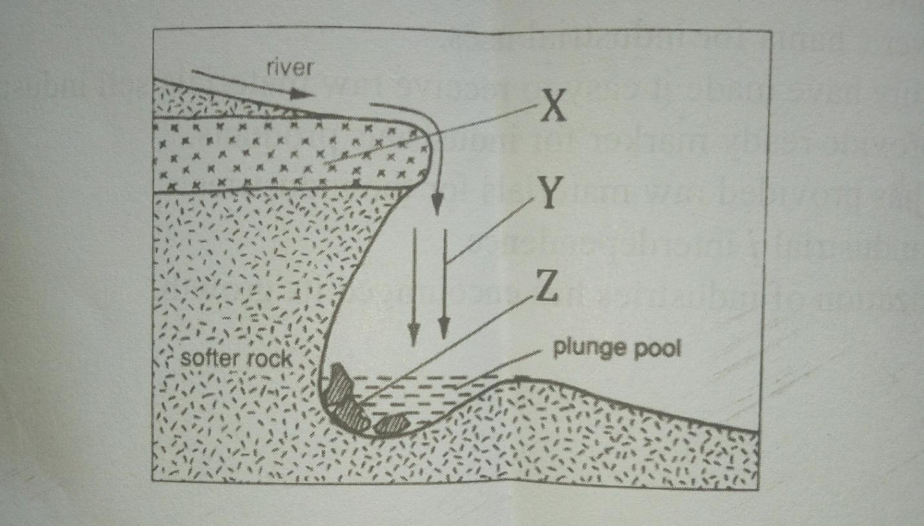

SECTION B
ANSWER QUESTION 6 AND ANY OTHER TWO QUESTIONS FROM THIS SECTION

6.Study the map of Taita hills(scale 1:50.000) provides and answer questions while follows.

Ai)Give the latitudinal position of the South Eastern corner of the map extract (2mks)

ii)State the four figure grid reference of the school at Mrabenyi (1mk)

iii)Identify the adjoining sheet number to the S.E of Taita hills (1mk)

Bi)Measure the length of dry weather road D535 from the junction at grid 4028 to the east of the map (2mks)

ii)Calculate the area enclosed by the railway line to the south Eastern part of the map (2mks)

Ci)Reduce the square enclosing Easting 37 to 42 and Northing 26 to 31 by 2, on the reduce square indicate the following.

-Ronge forest

-Road D535

-Outcrop rock (5mks)

ii)Give the new scale of the reduced square (2mks)

Di)Describe the drainage of the area covered by the map (4mks)

ii)Identify two methods of representing relief used in the map extract (2mks)

iii)Citing evidence from the map give two economic activities carried out (4mks)

7ai)What is artesian well? (2mks)

ii)List four conditions necessary for the formation of an artesian well.(4mks)

b)With the aid of a well labeled diagram, describe the three zones of underground water(6mks)

ii)Identify three sources of underground waters (3mks)

c)Explain three ways in which a Karst landscape would influence human activities (6mks)

d)Your class intends to carry out a field study on limestone area near your school
i)Name two surfaces features you are likely to identify (2mks)

ii)State two problems you are likely to identify (2mks)

8a)i)Define the term glaciation 2mks

ii)Name three types of glaciers 3mks

b)Describe how the following features found in upland glaciated landscape are formed
i)U-shaped valley(5mks)

Pyramidal peak (5mks)

c)Explain three significance of upland glaciated features to human activities(6mks)

d)Suppose you were to carry out a field study of a glaciated lowland
i)State two advantages of using oral interview to collect information during the field study(2mks)

ii)Name two features found in glaciated lowlands that you are likely to study (2mks)

9ai)Differentiate between a soil profile and soil catena(2mks)

ii)Draw a well labeled diagram of a mature soil profile(4mks)

bi)Other than topography name three factors that influence formation of soil(4mks)

ii)Explain how topography influences formation of soil (3mks)

iii)List three characteristics of desert soils (3mks)

ci)Give three types of soil erosion (3mks)

ii)Explain three effects of soil erosion on human activities (6mks)

10a)The diagram below represents zones of natural vegetation on a mountain within tropical regions, use it to answer questions (a) and (b)

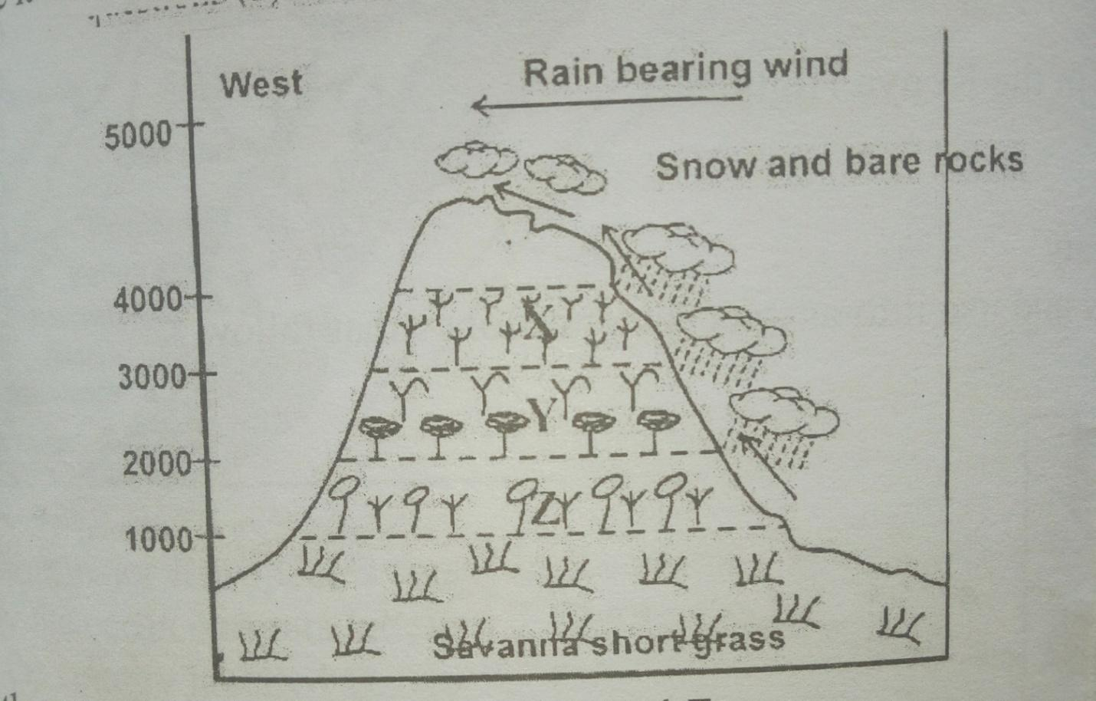

i)Name the vegetation zones marked X,Y and Z (3MKS)

ii)Give two reasons why the mountain top has no vegetation (2mks)

b) Describe the characteristics of savanna grasslands (4mks)

c) Explain four factors that have led to the decline of natural grassland in Kenya (8mks)

d) You carried out a field study of different tree species
i)Identify three activities you would carry out during the field study(3mks)

ii)How would you identify the different tree species?(3mks)

iii)State two methods you would use to determine the height of the trees (2mks)

