FORM 2 GEOGRAPHY
MARKING SCHEME
TERM 3 2021

- a) Is the external conditions surrounding an organism/plants/animals
b) Physical
- Human
- Practical
- a) i) Relief/Orographic rainfall
ii) G is warm and moist while H is cold and dry
b) The intensity of sun’s radiation
- The transparency of the atmosphere
- The earth’s average distance from the sun
- The position of the earth on its orbit
- The inclination/angle of the surface on which the sun’s rays fall
- a) Weather is the daily atmospheric conditions of a place over a short period of time
while climate is the average weather conditions of a place over a long period of time.
b) Altitude
- Temperature decreases with increasing to height hence high altitude areas have lower temperatures than low altitude areas which are warmer
- High altitude areas have a low atmospheric pressure than low altitude areas which have higher atmospheric pressure
- A rise in altitude causes a fall in temperature and a cooling effect which causes
Condensation and rainfall on the windward side
- Altitude causes Anabatic and Katabatic winds/temperature inversion in mountainous areas
Distance from the school
- Areas closer to the sea are wetter than those for the sea due to maritime influence
- During summer land surfaces are warmer than sea surfaces so that inland areas are warmer than those nearer to the sea in winter land are warmer
- Winds blowing over the sea pick moisture which later fall as rainfall in the coastal areas. They blow as dry winds further inland causing aridity
- a)
Epicenter | Seismic focus
Is a point on the earth’s surface vertically above the seismic focus | Is the point where the seismic waves originate
b)
- Mid-ocean ridges
- Ocean deeps and volcanic islands
- Regions of crustal compressions
- Within the Rift Valleys
- In areas of volcanic activities

- Beds and seams
- Lodes and veins
- Alluvial deposits
- Weathering products
- A COMPARATIVE LINE GRAPH SHOWING FOREST COVERAGE IN “000 HACTARES BETWEEN 2013 AND 2016
Vertical scale 1 cm rep 20,000 ha
Horizontal scale 2 cm 2 1 year

i) Kenya transport logs through tracks and lorries/road while Canada transport logs
through melt ice/rivers
In Kenya softwood forests occupy the highland regions while in Canada softwood
Forests occupy both lowland and highland regions.
In Kenya only mature trees are harvested while in Canada clear cutting is done

- a)
- Normal
- Reverse
- Tear/shear/slip/strike
- Thrust fault
- Anticlinal
b) Layers are subjected to tensional forces
Two normal faults develop parallel to each other
The middle block subsides/sinks/downloads
The sunken middle part forms a depression called Rift Valley
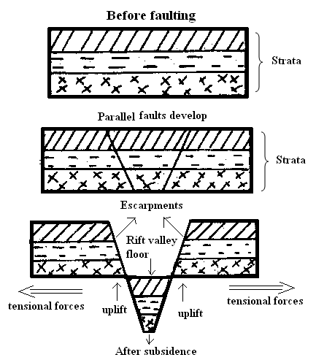

ii) Some rivers may end up flowing along faults lines, thus forming a fault guided
drainage pattern
- Uplifting of land which follows faulting may block a river. This may cause it to reverse/change its direction of flow
- When faulting occurs across a river valley, it may cause the river to disappear into the ground through a fault line
- Faulting may lead to the formation of escarpments with springs forming at the forming at the base due to exposure of the water table
- When faulting occurs across a river valley, vertical displacement of land may occur. The river forms a waterfall where it descends the newly formed escarp
- If rift valley occurs in an enclosed area, a basin may be formed when rivers flow into the basin a lake may be formed. This basin may become an area of inland drainage.

c) Faulting leads to formation of features that form beautiful scenery which attracts
tourists
- Faulting leads to formation of lakes that are important fishing grounds/tourist sites/provide water for irrigation/ for domestic use
- Faulting causes displacement of rocks which exposes minerals that are mined
- Faulting may lead to the formation of mountains/horst which experiences rainfall on the windward side that give rise to rivers which provide water for industrial/domestic/agricultural use
- Block mountains leads to formation of relief rainfall on the windward side which favours agriculture
- Faulting may cause subsidence of land which may lead to loss of life/property
- Faulting creates deep faults which are passage of steam jets which may be utilized for geothermal power, production
- When faulting occurs a ridge it may provide a dip which could form a mountain pass where transport/communication lines can be constructed/may hinder development of transport
- a) Is a type of plant life that develops naturally and is the most suited to that particular environment.
b)
- Trees are tall
- Trees have straight and smooth trunks
- Trees have formed canopies
- Vegetation has little or no undergrowth
- The trees are mainly hardwood
- Trees have buttressed roots for support
c)
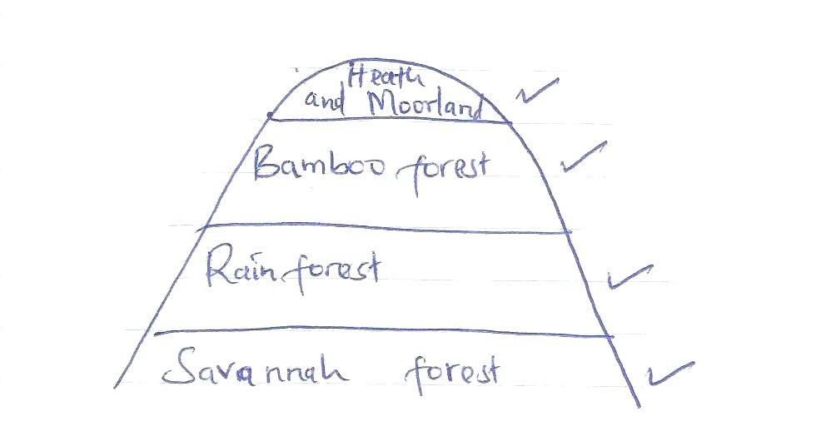
d) To identify the type of vegetation around
To investigate factors favouring the growth of vegetation (any two)
ii) Holding group discussion in class
Group presentation (any two)
a) ) Spot heights
Trigonometrical points
Contours
Form lines
Pictorials
Hachures
b) i) 1 cm rep 0.5 km
ii) 1 cm rep 2.5 km

b

9c)
6.9 7.0 7.1
i) 977202
ii) Full squares 13+8
2
13+4
17 km²
iii) 135⁰
iv) 2⁰ 33’
- i) x – laccolith
y – batholith
- Rocks beneath the crust are in a semi-solid state due to high temperature and high pressure
When pressure decreases the rocks become semi liquid and are known as magma.
Earth movement cause vertical or horizontal cracks in the rocks
The molten magma force itself through the cracks when magma cools and solidifies in a horizontal crack or bedding plan it forms a feature called sill.
b)Volcanic moutains are sources of rivers which provide water for irrigation, domestic
and industrial
- Influence formation of relief rainfall
- Volcanic soils are suitable for agriculture
- Volcanic mountains encourage the growth of forests on windward side which provide timber for construction
- Volcanic mountains form beautiful sceneries which attract tourists
- Host springs/geysers are used to generate geothermal
- Crater lakes are good for fishing
- Volcanic rocks provide materials for construction

c) i) Bad weather eg it may rain
- Accidents may occur
- A researcher may fall sick
ii) To identify the main type of rocks
To find out the uses of rocks (any two )

