NAME: …………………………………………………………..CLASS:…………………..

INDEX NO……………………………………………………………………………

312/1
GEOGRAPHY
PAPER 1
TIME: 2 ¾ HOURS

END OF TERM 1 EXAMINATION 2020
FORM 4

INSTRUCTIONS:

- The paper comprises of 2 sections A and B.
- Attempt all question in section A.
- In section B, answer question 6 and choose any other two questions.
- Use separate answer sheets for section A and each question in section B.

This paper consists of 4 printed pages. Candidates should check the question paper to ensure that all pages are printed as indicated and no questions are missing.

SECTION A
Answer all questions in this section
1. a) Identify Two forces responsible for the spherical shape of the earth. (2 marks)
b) Give Three reasons why the interior of the earth is still hot. (3 marks)
2. a) Outline Two characteristics of the troposphere. (3 marks)
b) Apart from cloud cover, identify Two other factors which influence the amount of solar radiation received on the earth's surface. (2 marks)
3. a) What is river rejuvenation. (2 marks)
b) The diagram below represents a river capture,

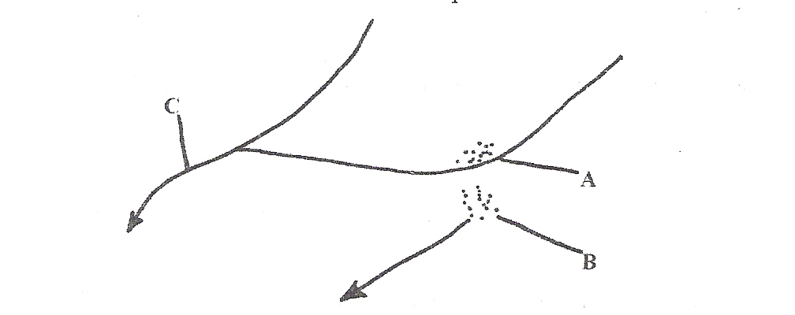

Name the features marked A, B, C. (3 marks)
4. a) Name a place in Kenya where tarns are found. (1 mark)
b) Describe how a tarn is formed. (4 marks)
5. (a) Give two main zones of the atmosphere. (2 marks)
(b) What is?
(i) Zero lapse rate. (2 marks)
(ii) Negative lapse rate. (2 marks)

SECTION B:
Answer question 6 any other two questions from this section.
6. Study the map of Migwani 1:50,000 (sheet 151/1) provided and answer the following questions.
(a) (i) What is the altitude of the lowest contour shown on the map? (1 mark)
Give the six-figure grid reference of Mboni dam. (2 marks)
(iii) What is the length in Kilometres of the All Weather Road Bound Surface C94 from
the junction with the Dry Weather Road D502 to Northing 84? (2 marks)

b) Draw a rectangle measuring 10 cm by 8 cm to represent the area enclosed by Eastings 90 and 00 and Northings 62 and 70. (1 mark)
On the rectangle, mark and name the following features:
- Musengo school
(ii) Road E742
(iii) Kitui Hills (3 marks)
(c) (i) Citing evidence from the map, identify four social services offered in Mutitu (Ndooa) township. (4 marks)
(ii) Describe the relief of the area covered by the map. (6 marks)
(d) Describe the characteristics of the long profile of river Ikoo. (6 marks)
7. a) State three characteristics of the inter-tropical convergence zone (ITCZ). (3 marks)
b) With the aid of a well labeled diagram describe how relief rainfall is formed. (6 marks)
c) State five characteristics of the hot desert climate. (5 marks)
d) You are required to carry out a field study to determine the relationship between climate and
vegetation in your district.
i) Give three reasons why you would need the map of the district. (3 marks)
ii) Name two sampling techniques you are likely to use during the field study. (2 marks)
iii) Give two reasons why sampling would be appropriate for this field study. (2 marks)
iv) State four methods you would use to record data during the field study. (4 marks)
8. a) (i) What is a lake? (2 marks)
(ii) State three factors that determine the permanency of a lake. (3 marks)
b) Describe how Lake Kanyaboli was formed. (6 marks)
c) Explain four causes of salinity of lake Magadi. (8 marks)
d) Explain three negative effects of lakes on human activities. (6 marks)
9. (a) State four causes of mechanical weathering. (4 marks)
(b) (i) Describe the carbonation process of chemical weathering. (3 marks)
(ii) Name two rocks that can be weathered through the carbonation process. (2 marks)
(iii) Name two features that can be formed on the earth's surface as the carbonation process of
weathering takes place. 2 marks)
(c) (i) What is an exfoliation dome? (1 mark)
(ii) Describe how an exfoliation dome is formed. (3 marks)
(d) Explain three ways in which weathering positively influence man's activities and two negative
effects of weathering. (10 marks)

10. (a) What is the difference between faulting and folding? (2 marks)
(b)Name
(i) Two types of faults. (2 marks)
(ii) Three types of folds. (3 marks)
On the outline map of Africa provided name the fold mountains marked X,Y, Z (3 marks)
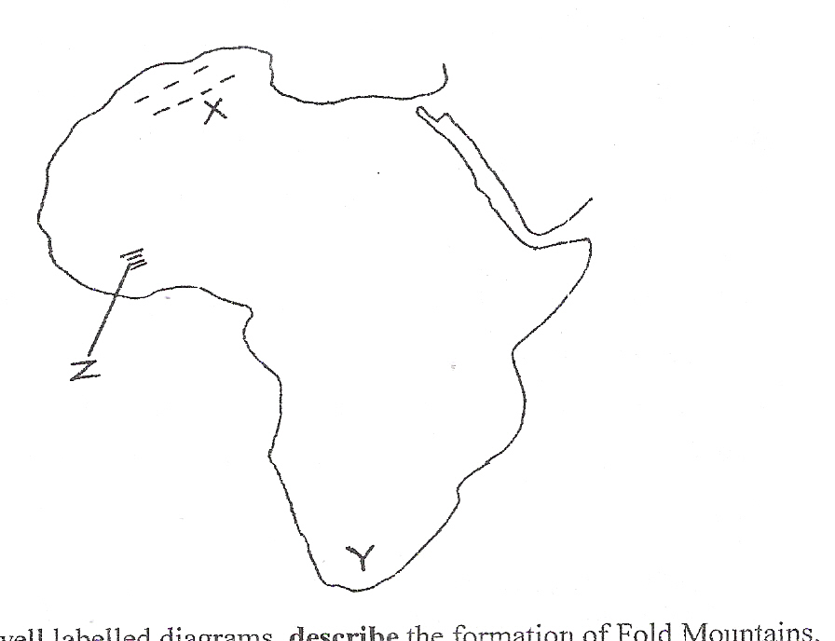

(c) With the aid of well labeled diagrams, describe the formation of Fold Mountains. (10 marks)
(d) (i) What is the name given to the period of mountain building? (1 mark)
(ii) Identify four main mountain buildings periods ever known in history. (4 marks)

