**LANJET CLUSTER EXAMINATION**

**GEOGRAPHY Paper 1 (312/1).**

**DECEMBER, 2020**

**MARKING SCHEME**

**SECTION A**

1. (a) Give the **two** main types of eclipses. (2 marks)

* ***Solar eclipse***
* ***Lunar eclipse***

(b) State **two** characteristics of the oceanic crust. (2 marks)

* ***The dominant minerals are silica and magnesium.***
* ***Average density of rocks is 3.0 gm/cm3***
* ***The sima rocks are solid in state.***
* ***Sima rocks are elastic.***

2. (a) Outline **two** ways in which clouds are classified. (2 marks)

* ***According to their height.***
* ***According to their appearance***.
* ***According to their formation.***

(b) State **three** ways in which wind affects the weather of a place. (3 marks)

* ***Wind transfers heat to a place which affects temperature.***
* ***Wind transfers moisture to a place which affects rainfall.***
* ***Wind facilitates movement of clouds over a region.***

3. (a) Define the term folding. (2 marks)

***Folding is the process of crustal distortion which causes crustal rocks to bend upwards or downwards***. OR

***Folding is the process through which young sedimentary rocks bend upwards or downwards due to compressional forces***.

(b) The diagram below represents parts of a fold. Use it to answer question. Name the parts marked E, F and G. (3 marks)

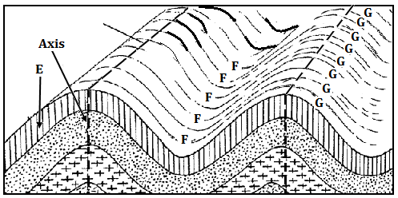

4. (a) Give **two** examples of mechanically formed sedimentary rocks. (2 marks)

***E – Limb.***

***F – Trough***

***G - Anticline***

(b) List **three** types of rock metamorphism. (3 marks)

* ***Thermal metamorphism/contact metamorphism***
* ***Dynamic metamorphism/kinetic metamorphism***
* ***Regional metamorphism***

5. (a) What is mechanical weathering. (2 marks)

***Mechanical weathering is the physical break up of rocks without any alteration in their chemical composition.***

(b) Give **three** causes of chemical weathering. (3 marks)

* ***High temperatures in an area.***
* ***Presence of gases in the air***
* ***Presence of moisture.***

**SECTION B**

6. Study the map of Yimbo provided and use it to answer the following questions.

(a) (i) Convert the map scale to a statement scale. (2 marks)

***Map scale: 1:50,000***

***Convert 50,000 cm to kilometres 50,000 ÷ 100,000 = 0.5 km***

***One centimetre represents half a kilometer. OR***

***1cm represents 0.5 kilometres***

(ii) Give **two** evidences of water transport in the area covered by the map. (2 marks)

* ***Presence of a port (grid square 1491)***
* ***Presence of a ferry at grid square 1593)***

(iii) In which hemisphere is the area covered by the map located? (1 mark)

***Southern hemisphere***

(b) (i) What is the area in square kilometres of the region representing Busia district on the map? (2 marks)

***Full squares 5 × 1km2 = 5.0km2***

***Incomplete (9 ÷ 2) × 1km2 = 4.5km2***

***TOTAL 9.5 km2 Accept ± 0.5 km2***

(ii) Name **two** types of swamps in the area covered by the map. (2 marks)

* ***Seasonal swamp***
* ***Papyrus swamp***

(c) (i) Identify **four** types of natural vegetation in the area covered by the map. (4 marks)

* ***Thicket***
* ***Scrub***
* ***Scattered trees***
* ***Woodland***
* ***Papyrus /swamp vegetation***

(ii) Citing evidence from the map, state **two** economic activities carried out in the area covered by the map. (4 marks)

* ***Transport services due to presence of a ferry and roads such as C 506 and C 501/2.***
* ***Trade due to presence of market centres***
* ***Fishing due to presence of ports such as Port South by and a pond at grid square 3891.***
* ***Processing due to presence of a posho mill at grid square 3280***

(d) (i) Using a vertical scale of 1cm to represent 20 metres, draw an accurate cross section along northing 83 from easting 26 to easting 32. On the cross section, mark and name:

* A hill
* A river
* Road C 506 (6 marks)

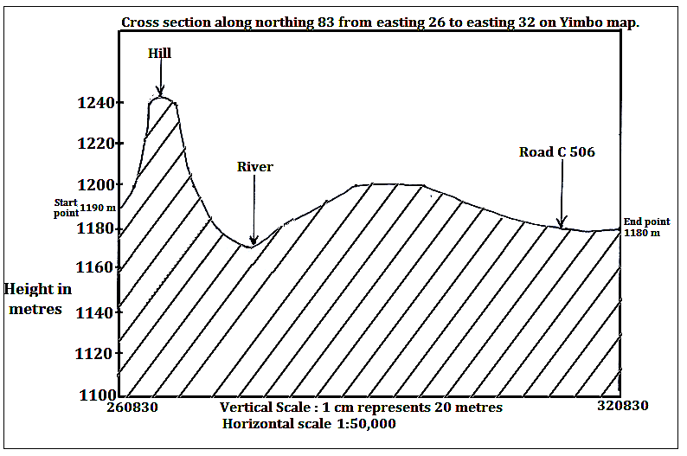

(ii) Calculate the vertical exaggeration of the cross section. (2 marks)

***VE = Vertical scale = 1cm represents 20 M***

***Horizontal scale 1:50,000***

***= 1:2,000***

***1:50,000***

***= 1 X 50,000***

***2,000 1***

***= 25 or 25 times***

7. (a) What is faulting? (2 marks)

***Faulting is the process through which crustal rocks fracture due to tectonic forces.***

(b) Give **two** differences between normal and reversed faults. (4 marks)

***Normal faults occur due to tension forces while reversed faults occur due to compressional forces.***

***Along a normal fault, one block of land is displaced/slides downwards in relation to another while on a reversed fault, one block of land is displaced/thrust upwards in relation to another.***

***The fault plane is exposed along a normal fault forming an escarpment while on a reversed fault, the escarpment is formed due to erosion/denudation.***

(c) (i) Apart from escarpments, list **four** other features formed due to faulting. (4 marks)

* ***Fault steps***
* ***Rift valleys***
* ***Fault blocks(block mountains and horsts)***
* ***Tilt blocks***

(ii) With the aid of well labelled diagrams, describe how a horst is formed. (7 marks)

* ***Layers of rocks are subjected to tension forces.***
* ***A strain occurs on the rocks leading to the formation of parallel normal faults.***
* ***Continued tension pulls apart the blocks of land on either side of the faults.***
* ***This causes the side blocks to gradually subside to a lower level thus exposing the fault plane.***
* ***The centre block is left standing at a higher level and is called a horst surrounded by steep escarpments.***

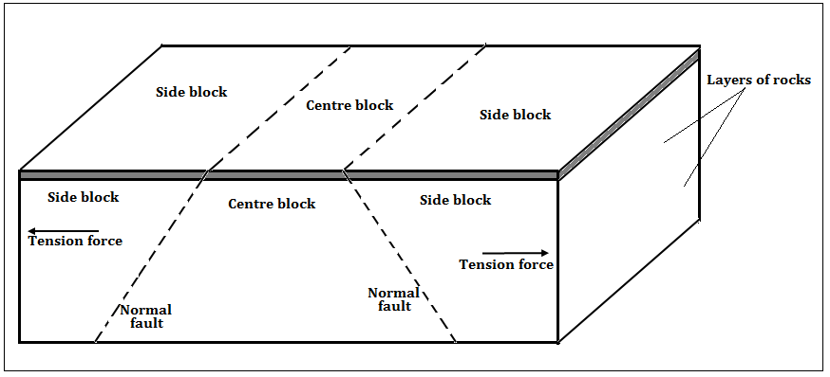

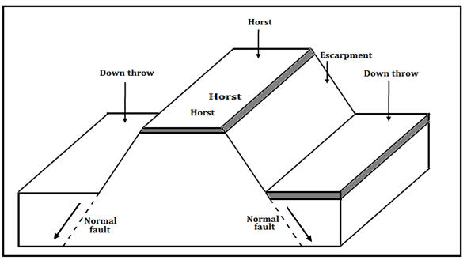

(d) Explain **four** ways in which features resulting from faulting influences human activities. (8 marks)

* ***Block Mountains and horsts formed through faulting are water catchment areas thus sources of rivers which provide water for agriculture domestic/ industrial use.***
* ***Uneven sinking during the formation of a Rift Valley forms depressions that are filled with water to form of lakes that are important fishing grounds.***
* ***Subsidence of land during formation of Rift valleys has led to exposure of minerals that are mined to generate income.***
* ***Windward slopes of fault blocks influence formation of relief rainfall which favour agricultural activities/ forestry/ settlement.***
* ***Faulting has resulted to formation of deep faults which are passage of stream jets that are harnessed to generate electricity.***
* ***Faulting results in the formation of Rift Valleys, escarpments and fault blocks that form attractive sites for tourism activity thus generating income.***
* ***Fault features such as fault blocks and escarpments create difficulties in the construction of roads, railways and pipelines thus increasing the cost of construction.***

8. (a) Differentiate between natural and secondary vegetation. (2 marks)

***Natural vegetation refers to plant cover that grows in the wild/on its own without any interference by people or animals whereas secondary vegetation refers to plant cover that grows on its own after original vegetation has been cleared by people.***

(b) (i) List f**our** main types of natural vegetation in Kenya. (4 marks)

* ***Forest vegetation***
* ***Savannah vegetation***
* ***Scrub/desert vegetation***
* ***Heath and moorland vegetation***
* ***Swamp vegetation***

(ii) Explain **four** factors that influence the distribution and type of natural vegetation in Kenya. (8 marks)

* ***Variations in rainfall. Areas receiving high rainfall tend to have forests, moderate rainfall grasslands while low rainfall scrub vegetation.***
* ***Variations in temperature. Warm moist areas support many plant species ,hot dry areas limits the number of plant species while some cold mountain slopes support heath and moorland vegetation***
* ***Variations in soil. Areas with deep and well drained soils supports tree/forest growth, thin soils support grass and shrubs while saline soils support few plants.***
* ***Variations in drainage. Well drained soils support a wide variety of plants while waterlogged regions supports swamp vegetation.***
* ***Variations in aspect. Windward slopes are wetter thus support luxuriant growth of plants/forests while leeward slopes are drier thus support fewer plant species.***
* ***Human activities such as clearance of land for mining, settlement and agriculture reduces the percentage of natural vegetation.***

(c) Describe the characteristics of tropical monsoon forests. (5 marks)

* ***Tall trees species up to 30 metres.***
* ***Tree species grow further apart thus have more branches.***
* ***Denser undergrowth as sunlight penetrates to the forest floor.***
* ***Tree species are mainly hardwoods.***
* ***Particular tree species dominate in an area.***
* ***Most of the tree species are deciduous/shed their leaves.***
* ***Fewer tree species compared to tropical rainforests.***

(d) You intend to carry out a field study on natural vegetation in your sub county.

(i) State **three** reasons why you would prepare a route map. (3 marks)

* ***To show the direction to be followed during the study.***
* ***To help in estimating the distance to be covered during the study.***
* ***To help in preparation of a work schedule.***
* ***To assist in estimating the time required for the study.***
* ***To help in deciding the technique of data collection.***

(ii) Outline **three** characteristics of vegetation that you would study. (3 marks)

* ***Density of the vegetation.***
* ***Height of plants.***
* ***Types of plant species/vegetation.***
* ***Distribution of plant species***.
* ***Shape of tree crowns.***
* ***Density of leaf cover.***

9. The diagram below shows a vertical section through the zones of underground water.

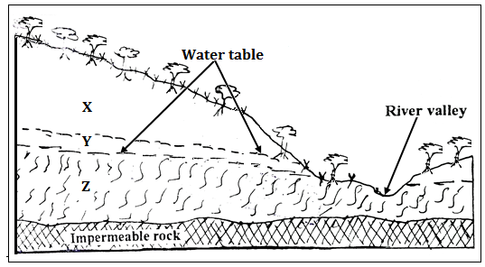

(a) (i) Name the parts zones marked X, Y and Z (3 marks)

***X – Zone of non-saturation***

***Y – Zone of intermittent/seasonal saturation.***

***Z – Zone of permanent saturation.***

(ii) State **three** major sources of ground water (3 marks)

* ***Rain water which infiltrates the ground to lower parts.***
* ***Melt water from ice or snow which also infiltrates through rocks.***
* ***Water from rivers, lakes, swamps and ponds which seeps into the ground.***

(b) Explain how the following factors influences the presence of underground water.

(i) Amount of rainfall (2 marks)

***Infiltration is higher in areas that receive high annual rainfall than in regions that receive low rainfall***.

***Light rains falling over a prolonged period of time infiltrates more than a short lived heavy downpour***.

(ii) Nature of rocks in an area (2 marks)

***The more permeable surface rocks are, the higher the infiltration rate. Impermeable rocks on or near the surface blocks infiltration resulting in high surface runoff.***

(iii) Slope gradient (2 marks)

***Infiltration is greater on flat areas since water remains in one place over a long period of time while areas with steep slopes have greater surface runoff.***

(c) Explain **four** conditions that lead to the formation of an artesian well. (8 marks)

* ***The aquifer must lie in between two impermeable rocks so that it can retain water.***
* ***The aquifer must bend downwards from the intake area and form a broad shallow basin/syncline.***
* ***The sides of the aquifer must be exposed in a high rainfall area or lake which is the source of water.***
* ***The mouth of the artesian well must be at a lower level than the intake area to allow water to be forced to the surface under its own pressure.***
* ***The aquifer must be made of the same material to allow water to pass through it.***

(d) Your class is planning to carry out a field study in a Karst landscape.

(i) Give **two** reasons why it is important to seek permission from the school administration. (2 marks)

* ***It is an official requirement to seek permission.***
* ***To enable administration arrange for transport***
* ***To enable administration provide essential tools.***
* ***To enable administration take care of any disruption in the school programme***
* ***For the school administration to provide lunch.***
* ***For the school to provide entry fee/money where required.***

(ii) State three challenges that you are likely to encounter during the field study. (3 marks)

* ***Attacks by wild animals / insects***
* ***Harsh weather conditions like high temperature***
* ***Rugged terrain making movement difficult***
* ***Fatigue due to walking for long distances***
* ***Getting lost in the steep landscape***
* ***Inadequate time for data collection***
* ***Injuries from sharp rocks***

10. The diagram below shows a glacial erosional feature in lowlands.

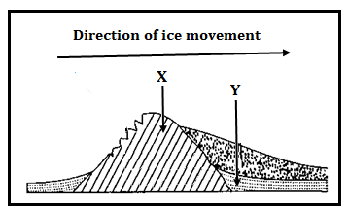

(a) (i) Name the parts marked P and Q. (2 marks)

* ***P – Crag***
* ***Q - Tail***

(ii) Outline four factors that influence glacial deposition in lowlands. (4 marks)

* ***Occurrence of gentle slopes.***
* ***The amount of ground moraine.***
* ***High friction on moving ice.***
* ***Changes in weather conditions.***

(b) Explain how the following processes of glacial erosion occur.

(i) Plucking. (4 marks)

***Pressure from the overlying mass of ice causes freeze thaw action. Melting water fills the cracks/joints in the bed rock. As water freezes it exerts pressure on the cracks enlarging them. The enlarged cracks lead to disintegration of the rock.***

***The rock debris are scoured or pulled off the mother rock by the moving ice.***

***The disintegrated rocks eventually get embedded within the mass of ice.***

***As the ice moves, it pulls out or gorges out the embedded rock from the mother rock. This process is called plucking.***

(ii) Abrasion. (2 marks)

***Rock debris carried within moving ice scrap and scratch rock surfaces over which glacier moves. The scrapping and polishing dislodges some rocks which are added to the ice***.

(c) Describe how a fiord is formed. (7 marks)

* ***Initially, there existed a river valley in a mountainous region near the sea.***
* ***The river valley had well developed interlocking spurs.***
* ***The entire river valley was covered with ice during the period of glaciation.***
* ***The river valley was eroded through plucking and abrasion.***
* ***The former interlocking spurs were trimmed through plucking and abrasion forming truncated spurs.***
* ***Plucking process straightened and widened the river valley while abrasion greatly deepened it.***
* ***The eroded materials were deposited towards the sea side.***
* ***When ice melted, a wide, flat bottomed valley with steep sides called a glacial trough was formed.***
* ***When the sea level did rise, the entire glacial trough was submerged upto far inland forming an inlet called a fiord/fjord.***

(d) Explain three ways through which glaciation influences agriculture. (6 marks)

* ***Some boulder clay plains, outwash plains and old glacial lake beds have very rich deposits that favour crop farming.***
* ***Glaciated valleys have good pastures that favour transhumance in some countries.***
* ***Some boulder clay deposits create a swampy land which hinders agriculture.***
* ***Glacial deposits lead to the formation of numerous glacial lakes thus reducing the arable land in some countries.***