LANJET CLUSTER EXAMINATION
GEOGRAPHY Paper 1 (312/1).
DECEMBER, 2020
MARKING SCHEME

SECTION A
1. (a) Give the two main types of eclipses. (2 marks)
- Solar eclipse
- Lunar eclipse
(b) State two characteristics of the oceanic crust. (2 marks)
- The dominant minerals are silica and magnesium.
- Average density of rocks is 3.0 gm/cm³
- The sima rocks are solid in state.
- Sima rocks are elastic.
2. (a) Outline two ways in which clouds are classified. (2 marks)
- According to their height.
- According to their appearance.
- According to their formation.
(b) State three ways in which wind affects the weather of a place. (3 marks)
- Wind transfers heat to a place which affects temperature.
- Wind transfers moisture to a place which affects rainfall.
- Wind facilitates movement of clouds over a region.
3. (a) Define the term folding. (2 marks)
Folding is the process of crustal distortion which causes crustal rocks to bend upwards or downwards. OR
Folding is the process through which young sedimentary rocks bend upwards or downwards due to compressional forces.
(b) The diagram below represents parts of a fold. Use it to answer question. Name the parts marked E, F and G. (3 marks)
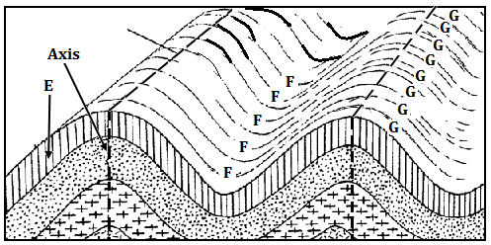
4. (a) Give two examples of mechanically formed sedimentary rocks. (2 marks)
E – Limb.
F – Trough
G - Anticline
(b) List three types of rock metamorphism. (3 marks)
- Thermal metamorphism/contact metamorphism
- Dynamic metamorphism/kinetic metamorphism
- Regional metamorphism
5. (a) What is mechanical weathering. (2 marks)
Mechanical weathering is the physical break up of rocks without any alteration in their chemical composition.
(b) Give three causes of chemical weathering. (3 marks)
- High temperatures in an area.
- Presence of gases in the air
- Presence of moisture.
SECTION B
6. Study the map of Yimbo provided and use it to answer the following questions.
(a) (i) Convert the map scale to a statement scale. (2 marks)
Map scale: 1:50,000
Convert 50,000 cm to kilometres 50,000 ÷ 100,000 = 0.5 km
One centimetre represents half a kilometer. OR
1cm represents 0.5 kilometres
(ii) Give two evidences of water transport in the area covered by the map. (2 marks)
- Presence of a port (grid square 1491)
- Presence of a ferry at grid square 1593)
(iii) In which hemisphere is the area covered by the map located? (1 mark)
Southern hemisphere

(b) (i) What is the area in square kilometres of the region representing Busia district on the map? (2 marks)
Full squares 5 × 1km² = 5.0km²
Incomplete (9 ÷ 2) × 1km² = 4.5km²
TOTAL 9.5 km² Accept ± 0.5 km²
(ii) Name two types of swamps in the area covered by the map. (2 marks)
- Seasonal swamp
- Papyrus swamp
(c) (i) Identify four types of natural vegetation in the area covered by the map. (4 marks)
- Thicket
- Scrub
- Scattered trees
- Woodland
- Papyrus /swamp vegetation
(ii) Citing evidence from the map, state two economic activities carried out in the area covered by the map. (4 marks)
- Transport services due to presence of a ferry and roads such as C 506 and C 501/2.
- Trade due to presence of market centres
- Fishing due to presence of ports such as Port South by and a pond at grid square 3891.
- Processing due to presence of a posho mill at grid square 3280
(d) (i) Using a vertical scale of 1cm to represent 20 metres, draw an accurate cross section along northing 83 from easting 26 to easting 32. On the cross section, mark and name:
- A hill
- A river
- Road C 506 (6 marks)
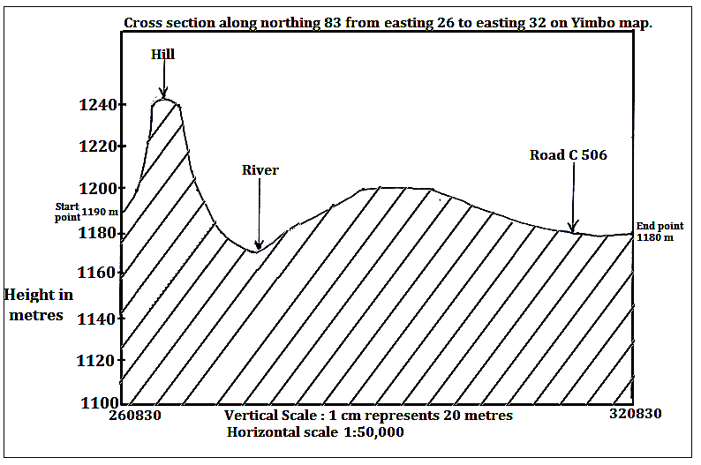
(ii) Calculate the vertical exaggeration of the cross section. (2 marks)
VE = Vertical scale = 1cm represents 20 M
Horizontal scale 1:50,000
= 1:2,000
1:50,000
= 1 X 50,000
2,000 1
= 25 or 25 times

7. (a) What is faulting? (2 marks)
Faulting is the process through which crustal rocks fracture due to tectonic forces.
(b) Give two differences between normal and reversed faults. (4 marks)
Normal faults occur due to tension forces while reversed faults occur due to compressional forces.
Along a normal fault, one block of land is displaced/slides downwards in relation to another while on a reversed fault, one block of land is displaced/thrust upwards in relation to another.
The fault plane is exposed along a normal fault forming an escarpment while on a reversed fault, the escarpment is formed due to erosion/denudation.
(c) (i) Apart from escarpments, list four other features formed due to faulting. (4 marks)
- Fault steps
- Rift valleys
- Fault blocks(block mountains and horsts)
- Tilt blocks
(ii) With the aid of well labelled diagrams, describe how a horst is formed. (7 marks)
- Layers of rocks are subjected to tension forces.
- A strain occurs on the rocks leading to the formation of parallel normal faults.
- Continued tension pulls apart the blocks of land on either side of the faults.
- This causes the side blocks to gradually subside to a lower level thus exposing the fault plane.
- The centre block is left standing at a higher level and is called a horst surrounded by steep escarpments.

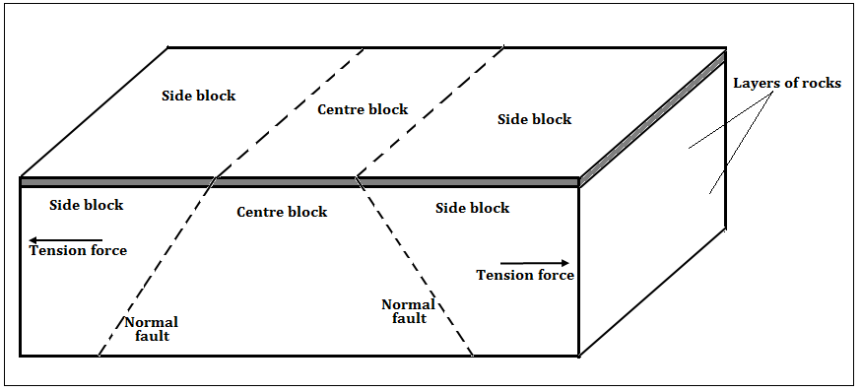
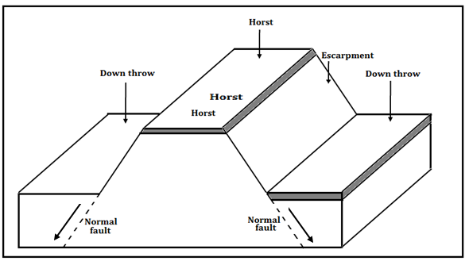

(d) Explain four ways in which features resulting from faulting influences human activities. (8 marks)
- Block Mountains and horsts formed through faulting are water catchment areas thus sources of rivers which provide water for agriculture domestic/ industrial use.
- Uneven sinking during the formation of a Rift Valley forms depressions that are filled with water to form of lakes that are important fishing grounds.
- Subsidence of land during formation of Rift valleys has led to exposure of minerals that are mined to generate income.
- Windward slopes of fault blocks influence formation of relief rainfall which favour agricultural activities/ forestry/ settlement.
- Faulting has resulted to formation of deep faults which are passage of stream jets that are harnessed to generate electricity.
- Faulting results in the formation of Rift Valleys, escarpments and fault blocks that form attractive sites for tourism activity thus generating income.
- Fault features such as fault blocks and escarpments create difficulties in the construction of roads, railways and pipelines thus increasing the cost of construction.

8. (a) Differentiate between natural and secondary vegetation. (2 marks)
Natural vegetation refers to plant cover that grows in the wild/on its own without any interference by people or animals whereas secondary vegetation refers to plant cover that grows on its own after original vegetation has been cleared by people.
(b) (i) List four main types of natural vegetation in Kenya. (4 marks)
- Forest vegetation
- Savannah vegetation
- Scrub/desert vegetation
- Heath and moorland vegetation
- Swamp vegetation
(ii) Explain four factors that influence the distribution and type of natural vegetation in Kenya. (8 marks)
- Variations in rainfall. Areas receiving high rainfall tend to have forests, moderate rainfall grasslands while low rainfall scrub vegetation.
- Variations in temperature. Warm moist areas support many plant species ,hot dry areas limits the number of plant species while some cold mountain slopes support heath and moorland vegetation
- Variations in soil. Areas with deep and well drained soils supports tree/forest growth, thin soils support grass and shrubs while saline soils support few plants.
- Variations in drainage. Well drained soils support a wide variety of plants while waterlogged regions supports swamp vegetation.
- Variations in aspect. Windward slopes are wetter thus support luxuriant growth of plants/forests while leeward slopes are drier thus support fewer plant species.
- Human activities such as clearance of land for mining, settlement and agriculture reduces the percentage of natural vegetation.
(c) Describe the characteristics of tropical monsoon forests. (5 marks)
- Tall trees species up to 30 metres.
- Tree species grow further apart thus have more branches.
- Denser undergrowth as sunlight penetrates to the forest floor.
- Tree species are mainly hardwoods.
- Particular tree species dominate in an area.
- Most of the tree species are deciduous/shed their leaves.
- Fewer tree species compared to tropical rainforests.
(d) You intend to carry out a field study on natural vegetation in your sub county.
(i) State three reasons why you would prepare a route map. (3 marks)
- To show the direction to be followed during the study.
- To help in estimating the distance to be covered during the study.
- To help in preparation of a work schedule.
- To assist in estimating the time required for the study.
- To help in deciding the technique of data collection.
(ii) Outline three characteristics of vegetation that you would study. (3 marks)
- Density of the vegetation.
- Height of plants.
- Types of plant species/vegetation.
- Distribution of plant species.
- Shape of tree crowns.
- Density of leaf cover.

9. The diagram below shows a vertical section through the zones of underground water.
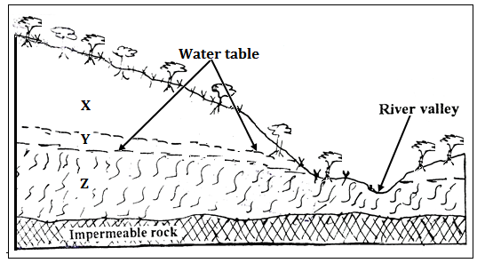

(a) (i) Name the parts zones marked X, Y and Z (3 marks)
X – Zone of non-saturation
Y – Zone of intermittent/seasonal saturation.
Z – Zone of permanent saturation.
(ii) State three major sources of ground water (3 marks)
- Rain water which infiltrates the ground to lower parts.
- Melt water from ice or snow which also infiltrates through rocks.
- Water from rivers, lakes, swamps and ponds which seeps into the ground.
(b) Explain how the following factors influences the presence of underground water.
(i) Amount of rainfall (2 marks)

Infiltration is higher in areas that receive high annual rainfall than in regions that receive low rainfall.
Light rains falling over a prolonged period of time infiltrates more than a short lived heavy downpour.

(ii) Nature of rocks in an area (2 marks)

The more permeable surface rocks are, the higher the infiltration rate. Impermeable rocks on or near the surface blocks infiltration resulting in high surface runoff.

(iii) Slope gradient (2 marks)

Infiltration is greater on flat areas since water remains in one place over a long period of time while areas with steep slopes have greater surface runoff.

(c) Explain four conditions that lead to the formation of an artesian well. (8 marks)
- The aquifer must lie in between two impermeable rocks so that it can retain water.
- The aquifer must bend downwards from the intake area and form a broad shallow basin/syncline.
- The sides of the aquifer must be exposed in a high rainfall area or lake which is the source of water.
- The mouth of the artesian well must be at a lower level than the intake area to allow water to be forced to the surface under its own pressure.
- The aquifer must be made of the same material to allow water to pass through it.
(d) Your class is planning to carry out a field study in a Karst landscape.
(i) Give two reasons why it is important to seek permission from the school administration. (2 marks)
- It is an official requirement to seek permission.
- To enable administration arrange for transport
- To enable administration provide essential tools.
- To enable administration take care of any disruption in the school programme
- For the school administration to provide lunch.
- For the school to provide entry fee/money where required.
(ii) State three challenges that you are likely to encounter during the field study. (3 marks)
- Attacks by wild animals / insects
- Harsh weather conditions like high temperature
- Rugged terrain making movement difficult
- Fatigue due to walking for long distances
- Getting lost in the steep landscape
- Inadequate time for data collection
- Injuries from sharp rocks

10. The diagram below shows a glacial erosional feature in lowlands.
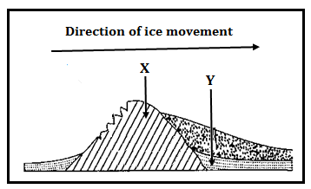
(a) (i) Name the parts marked P and Q. (2 marks)
- P – Crag
- Q - Tail
(ii) Outline four factors that influence glacial deposition in lowlands. (4 marks)

- Occurrence of gentle slopes.
- The amount of ground moraine.
- High friction on moving ice.
- Changes in weather conditions.
(b) Explain how the following processes of glacial erosion occur.
(i) Plucking. (4 marks)
Pressure from the overlying mass of ice causes freeze thaw action. Melting water fills the cracks/joints in the bed rock. As water freezes it exerts pressure on the cracks enlarging them. The enlarged cracks lead to disintegration of the rock.
The rock debris are scoured or pulled off the mother rock by the moving ice.
The disintegrated rocks eventually get embedded within the mass of ice.
As the ice moves, it pulls out or gorges out the embedded rock from the mother rock. This process is called plucking.

(ii) Abrasion. (2 marks)

Rock debris carried within moving ice scrap and scratch rock surfaces over which glacier moves. The scrapping and polishing dislodges some rocks which are added to the ice.

(c) Describe how a fiord is formed. (7 marks)
- Initially, there existed a river valley in a mountainous region near the sea.
- The river valley had well developed interlocking spurs.
- The entire river valley was covered with ice during the period of glaciation.
- The river valley was eroded through plucking and abrasion.
- The former interlocking spurs were trimmed through plucking and abrasion forming truncated spurs.
- Plucking process straightened and widened the river valley while abrasion greatly deepened it.
- The eroded materials were deposited towards the sea side.
- When ice melted, a wide, flat bottomed valley with steep sides called a glacial trough was formed.
- When the sea level did rise, the entire glacial trough was submerged upto far inland forming an inlet called a fiord/fjord.

(d) Explain three ways through which glaciation influences agriculture. (6 marks)
- Some boulder clay plains, outwash plains and old glacial lake beds have very rich deposits that favour crop farming.
- Glaciated valleys have good pastures that favour transhumance in some countries.
- Some boulder clay deposits create a swampy land which hinders agriculture.
- Glacial deposits lead to the formation of numerous glacial lakes thus reducing the arable land in some countries.

