TRIAL ONE EVALUATION TEST 2019
MARCH 2019
GEOGRAPHY
312/2
2 ¾ HRS

INSTRUCTIONS
This paper has two sections; A and B.
Answer ALL the questions in section A.
In section B answer questions 6 and any other TWO questions.
All answers must be written in the answer booklet provided.

SECTION A
Answer ALL the questions in this section.
- a) State two factors that favour the growth of softwood forests in Kenya. (2mks)
b) Explain how forests help to conserve water catchment area. (2mks)
- Give three reasons why it is important to study Geography. (3mks)
- a) State two human factors that favour fishing. (2mks)
b) Name three major fresh water fishing grounds in East Africa. (3mks)
- a) Give three advantages of mechanization of agriculture. (3mks)
b) State three consequences of high dependence on agriculture in the developing countries. (3mks)
- a) i. Why is it necessary to conserve water? (2mks)
ii. How does terracing help in water conservation? (2mks)
b) State four effects of wind as an environmental hazard in Kenya. (4mks)

SECTION B
- Study the photograph provided and use it to answer the questions below;
Secondary Geography form four Student’s Book Fourth Edition, page 43 Fig. 3.12
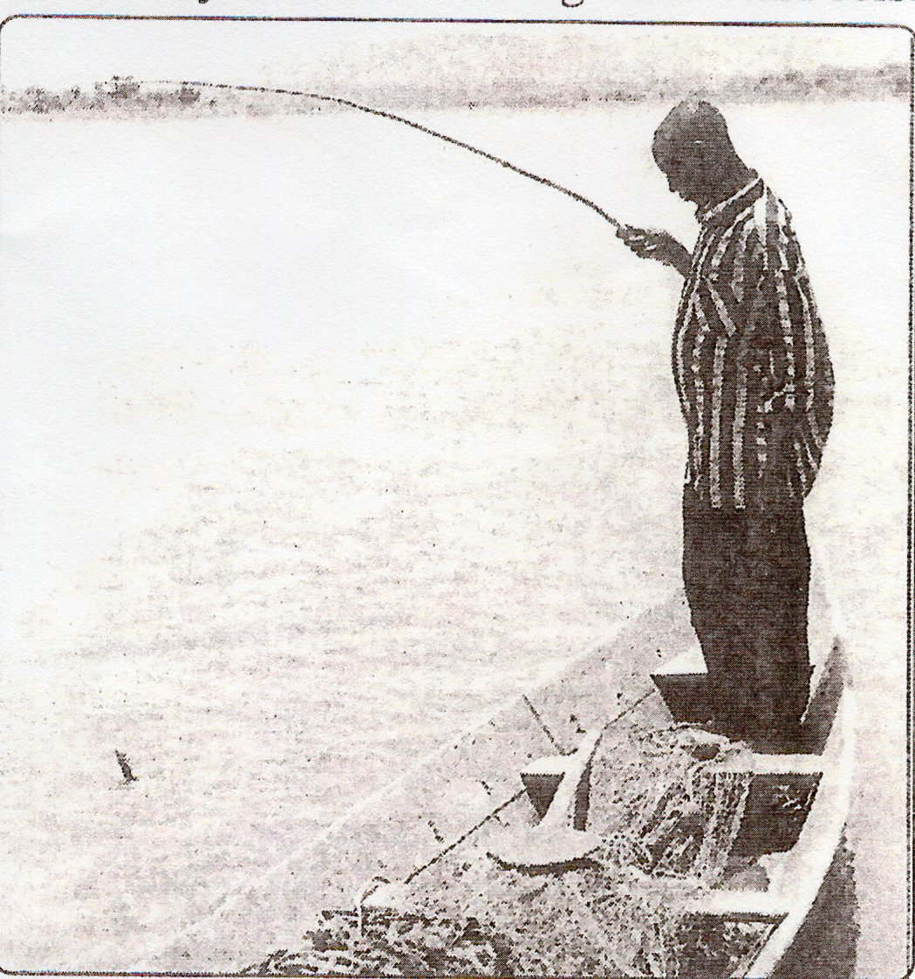

- Name:
- The fishing method shown in the photograph. (1mk)
- Two examples of fish that may be caught using this method. (2mks)
- Describe how the fishing method shown in the photograph provided is used to fish. (5mks)
- i. Give three methods used to preserve fish. (3mks)
ii. Explain how the following factors favour fishing.
- Indented coastline. (2mks)
- Ocean currents. (2mks)
- i. Outline four ways in which marine fisheries in Kenya can be conserved. (4mks)
ii. Explain three problems experienced by fishermen while fishing in Lake Victoria. (6mks)
- a) State three physical conditions that favour coffee growing in the central highlands of Kenya. (3mks)
b) Describe the stages involved in coffee production from picking to marketing. (8mks)
c) Explain four problems facing coffee farming in Brazil. (8mks)
d) Your Geography class carried out a field study on a coffee farm.
i. State four methods the class may have used to collect data. (4mks)
ii. During the field study, the class collected data on quantities of coffee produced in the farm in the last five years. State two methods the class may have used to present the data. (2mks)
- a) i. What is irrigation? (2mks)
ii. State two types of irrigation. (2mks)
iii. Outline three physical factors that influenced the location of Perkerra Irrigation Scheme. (3mks)
b) Explain the following physical problems facing irrigation farming in Kenya;
i. Excess amount of water. ( 2mks)
ii. Soil erosion. (2mks)
iii. Weeds. (2mks)
c) i. Apart from afforestation and reafforestation name three other methods used to rehabilitate land. (3mks)
ii. Mention three factors that facilitated land reclamation in the Netherlands. (3mks)
d) Give the differences in the methods of land reclamation in Kenya and the Netherlands under the following sub – headings;
i. Methods of reclamation. (2mks)
ii. Reasons for reclamation. (2mks)
iii. Area of reclamation. (2mks)
- a) i. List two characteristics of gold. (2mks)
ii. Why is gold the world’s most valuable mineral? (1mk)
b) i. Name the world’s leading country produce of gold. (1mk)
ii. Identify the main gold mining area in South Africa. (1mk)
iii. Describe how gold occurs in South Africa. (3mks)
c) Which is the most appropriate method of mining gold in South Africa, the reason for the method. (2mks)
d) i. Describe how gold is processed in South Africa. (5mks)
ii. Explain five significance of gold mining in South Africa. (10mks)
- a) What is eco-tourism? (2mks)
b) i. Give four tourist attraction found at the coast of Kenya. (4mks)
ii. State five problems associated with tourism in Kenya. (5mks)
c) State four ways in which game reserves are of benefits to the communities living near them. (4mks)
d) Explain the difference between tourism in Kenya and Switzerland. (10mks)

