NAME……………………….……………………………………CLASS……….ADM:..................

FORM 4 GEOGRAPHY PAPER 2 (312/2) TERM 2 2022 OPENER EXAM FORM 4
EXAM DURATION: 2 HOURS 45 MINUTES

INSTRUCTIONS

- This paper has two sections: A & B.

- Answer all questions in section A.

- Answer question 6 and any other two questions from section B,

- Candidates should answer the questions in English.

- All answers to be written in foolscaps provided.

This paper consists of 4 printed pages. Candidates should check the question paper to ascertain that all pages are printed as indicated and that no pages are missing.

SECTION A

Answer all questions from this section.

- (a) Apart from economic Geography, give three other sub branches of human Geography. (3 marks)

 | (b) | Explain the relationship between Geography and economics. | (2 marks)
2. | (a) | Name two methods used in alluvial mining | (2marks)
 | (b) | State three effects of limestone mining at Bamburi in Mombasa County. | (3marks)

- Study the graph below and use it to answer the question (a) and (b).
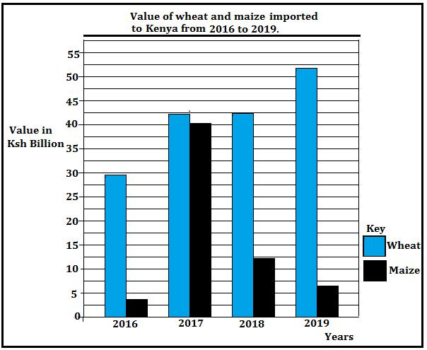

 | (a) | Identify the type of graph drawn above. | (1 mark)
 | (b) | State three conclusions that can be derived from the graph? | (3 marks)
4. | (a) | What is plantation agriculture. | (2 marks)
 | (b) | State three disadvantages of plantation agriculture. | (3 marks)
5. | (a) | State three conditions necessary for the formation of petroleum. | (3 marks)
 | (b) | Give three disadvantages of petroleum as a source of energy. | (3 marks)

SECTION B

Answer all questions from this section.

- Study the photograph below and use it to answer questions (a) and (b)
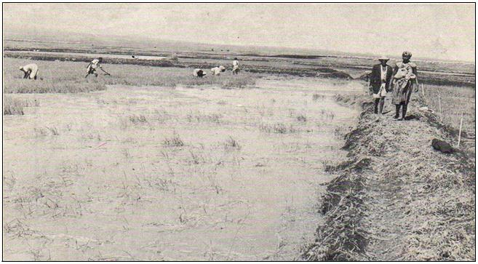

(a) (i)

Name the type of photograph shown above.

(1 mark)

(ii) Give two reasons for your answer in (a)(i) above.

(2 marks)

- (i) What is the approximate time of the day was the photograph taken? (1mark)

- Name three specific places in Kenya where the photograph is likely to have

been taken. (3marks)

- (i) Citing evidence from the photograph, explain three conditions necessary for the economic activity shown that can be observed from the photograph. (6 marks)

(ii) Using evidence from the photograph, explain two health problems that the people practicing this economic activity would experience. (4 marks)

(d) Explain four benefits of the Zuider Zee project in the Netherlands

(8 marks)

7. | (a) | (i) | Define the term forestry. | (1 mark)
 |  | (ii) | Give three differences between natural forests and planted forests. | (3 marks)
 | (b) | Explain four causes of forest depletion in Kenya today. |  | (8 marks)

- The map of Kenya below shows some forest reserves in Kenya. Use it to answer question (i)
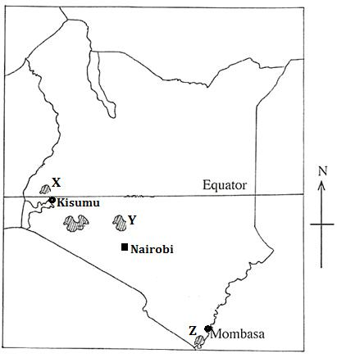

(i) Identify the forests marked X, Y and Z. (3 marks)

- State four measures that are being undertaken by the Kenya Government to

conserve forests. (4 marks)

- Explain three factors favouring the exploitation of softwoods in Canada.

(6 marks)

8. | (a) | (i) | Name two categories of arable farming. | (2 marks)
 |  | (ii) | Give three economic factors that influence agriculture. | (3 marks)

- State five physical conditions favoring sugarcane farming in western Kenya.

(c) Describe the stages involved in sugarcane processing in western Kenya. (d) Explain four economic problems facing sugarcane farmers in Kenya

(5 marks)

(7 marks)

(8 marks)

9. | (a) | (i) | Define the term fishing. | (2 marks)
 |  | (ii) | Give three examples of pelagic fish. | (3 marks)
 | (b) | Describe how trawling method of fishing is carried out. |  | (6 marks)

- Explain three reasons why freshwater fishing is more widespread than

(d)

marine fishing in East Africa.

Explain four measures taken to conserve fisheries in Kenya.

(6 marks)

(8 marks)

10. | (a) | (i) | What is eco-tourism? | (2 marks)
 |  | (ii) | State four factors that limit domestic tourism in Kenya. | (4 marks)
 | (b) | (i) | Give three tourist attractions found at Nairobi. | (3 marks)

  - Explain four measures that Kenya should take in order to attract more
Tourists. (8 marks)

- Explain the differences between the tourism in Kenya and Switzerland under the following sub-headings:

(i) | Security | (2 marks)
(ii) | Culture. | (2 marks)
(iii) | Waterfalls. | (2 marks)
(iv) | Beaches. | (2 marks)

