GEOGRAPHY MARKING SCHEME PAPER 1
SECTION A
1. a) Weather is the state of atmosphere of a given place over a short period of time while climate is average weather conditions of a place recorded over a long period of time (30-35) years. 2x1=2mks
b) Factors
- Human error/students unable to read the instruments
- Interference with the instruments by people/students
- Poor siting of weather station
- Extreme weather conditions cause inaccurate readings.
- Natural calamities may cause damage to some instruments 3x1=3mks

2 a) Folding
Bending or distribution of crustal rocks which make them to bend upwards and downwards due to compression forces. 2mks
b) Factors
- Rock types/flexibility or elasticity of the rock.
- Strength or intensity of compression force.
-High temperatures that make rocks to be flexible.
- age of sedimentary rocks. 3mks

3 a) Diagram
W- rain forest
X- Bamboo
Y- Heath and moorland 3mks

b) Reasons
- Temperature too low to support plant growth.
-Bare rock or no soil to support plant growth
- Water is in frozen state. 2mks

4 (a) Soil
- Accumulation of rock particles minerals organic matter and air on earth surface.
or
- The top most layer of loose rock materials or earth’s surface on which plants grow.
b) -Nature of the bed rock.
- Mineral composition- chemical composition
- Climatic factors
- Vegetation cover or presence of humus. 3mks

5 a) Wind erosion
- Yardang
- Rock pedestal
- Zeugen
- Ventifacts
- Mushrooms block 2mks
b) Factors
- Strength of wind strong desert winds erode and carry away a lot of dry materials.
- Absence of obstacles/vegetation/bare surfaces exposed to erosion.
- Temperature variation high and low which cause weathering facilitating wind erosion
- Nature of the rock materials dry loose/unconsolidated materials are easily carried by wind. 3mks

SECTION B
Answer question 6 and any other TWO questions from this section.

6. Study the map of YIMBO 1:50,000(sheet 115/1) provided answer the following questions.
(a) (i) Convert the Representative Fraction scale given on the map to a
statement scale. (2 mks)

RF Scale is 1:50,000
Change ground distance into kilometers
50,000/100,000= 0.5 km
Therefore, 1 cm represents 0.5 kilometers

(ii) Identify three Districts the area covered by the Yimbo map. (3 mks)
- Siaya District
- Busia District
- Busoga District
(b) (i) Give the exact height of Usengi hill. (1 mk)
- 1269 meters

(ii) Using evidence from the map, give two social services that are offered in the area covered by the map. (2 mks)
- Education due to the presence of schools e.g Nyagoma Mission school
- Health services due to the presence of dispensaries e.g. Usigu dispensary

(c) (i) Using a vertical scale of 1 cm represents 20m, draw a cross section from grid reference 320790 to grid reference 390790. (4 mks)

(ii) On the cross section, mark and name the following:-
- A lake (1 mk)
- Main track (motorable) (1 mk)
- A river (1 mk)

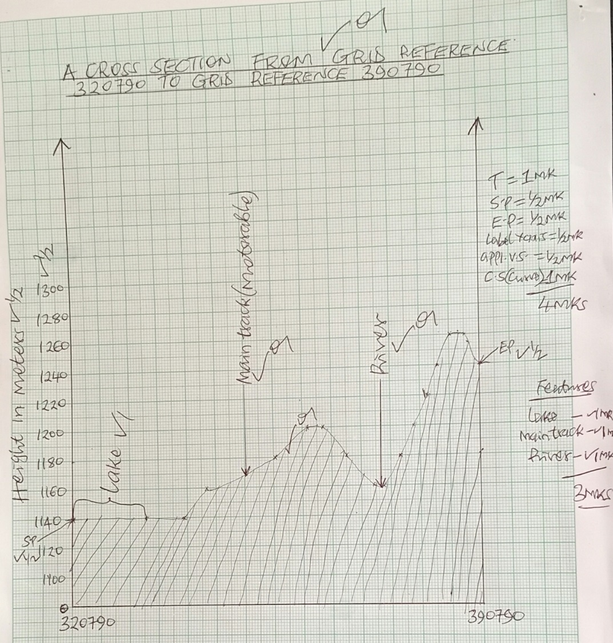

(d) (i) Describe the relief of the area covered by the map (4 mks)
- The main relief features are hills, and river valleys.
- There are many hills such as Usengi hill,Abiero hill, Serawongo hill etc.
- Usengi hill has steep slopes.
- There is a depression occupied by lake Sare
- There are river valleys such as occupied by river Yala, river Ulomaetc
- The area is generally gently sloping
- The land rises from he west towards the east
Any 4x1=4 mks
(ii) Explain three factors that have influenced the distribution settlement in the area covered by the map. (6 mks)
- Vegetation-there are no settlement within the thickets due to safety concerns and presence of pests such as mosquitoes.
- Drainage-there are no settlements within the poorly drained areas such as swamps due to difficulties in constructing houses and/ fear of floods.
- Relief-there are no settlements on steep areas such as Usengihill due to difficult in erecting houses
- Social amenities-there are many settlements close to schools for ease of access to Education.
- Economic activities-There are many settlements around market centers and towns for ease of access to goods and services. Any 3x2=6 mks
7 a) Temperate grassland
H- Pampas of Argentina
J- Steppes of Russia
K- Powns of Australia 3 mks

B i) Characteristics of the natural vegetation.
  - The vegetation is tropical rainforest/equatorial forest.
  - The forest consists of mixed variety of the tree species.
  - The trees shed their leaves at different times of the year/they are evergreen.
  - The trees have broad leaves/drip tipped leaves and they take long to mature.
  - The forest has little or no undergrowth and has numerous liana/climbing plants.
  - Some of the trees have butteress roots.
  - The forest has crowns that form canopies with three distinct layers.
C i) Adaptation of vegetation
  - Some plants have thick/fleshy/succulent leaves to enable them store water.
  - Some plants have long roots to tap the ground water.
  - Some plants have no leaves/waxy/needle like leaves to reduce transpiration.
  - Some plants have thick/hard barks to reduce transpiration.
  - Some plants have shiny surfaces to reflect light. mks
ii) Reasons for no vegetation
  - The ground is frozen most of the year.
  - The area has very short growing season/short summer/warm seasons.
  - The area has thin soils
  - Some plants are poorly drained. 2 mks
di) Activities carried out
  - Measures distances/calculate distance/heights
  - Collect samples of plants /count plants
  - Take photographs of plants
  - Record/take notes. 3 mks
ii) Identification of vegetation
  - By their appearance/their colour of flowers/size of their leaves the nature of their bark
  - Texture of their leaves
  - System of their leaves.
8. a i) Glacier is a mass of ice moving outward from an area of accumulation 2 mks
ii) Movement
  - Plastic flowage
  - Basal slip
  - Extrusion flow 3 mks
b) – Abrasion is caused by the rock debris embedded in the glacier which acts as a tool for scratching and polishing the rock surfaces over which the glacier moves as materials are dragged over the underlying rocks during ice movement. 3 mks
– Plucking occurs when the ice at the base and on the sides of the glacier freezes onto the rocks. The rocks are pulled and carried away by the moving ice. This is facilitated by freeze and their process. 3 mks
c) Pyramidal peak
- Ice accumulates in several cracks on mountain sides. Ice exerts pressure on the cracks. Plucking action of ice enlarges the crack allowing more ice to collect in them. Freeze –thaw action leads to expansion of cracks making them large basins. Moving ice pludes off loose rock material from the basin thus enlarging them further. Three or more of these ridges/arêtes converge at the mountain top farming a jagged peak known as a pyramidal peak /horn.
d) Positive effects
- Glacial till provides fertile soils which are suitable for arable farming .
- Ice sheets in their scouring effect reduce the surface which may expose the minerals making them easy to extract.
- Out wash plains comprise of sand and gravel which are used as building materials.
- Glacial lakes found in lowland areas can be exploited for various economic uses such as fishing & transportation.
- Glaciation forms feature such as drumlins/eskers which are tourist attraction
- Glaciated lowlands are generally flat and ideal for establishment of settlement or development of transportation network. (8 mks)

(9) a) i) Difference between weathering and mass wasting.
Weathering is the disintegration and decomposition of rocks at or near the earth’s surface insitu due to mechanical and chemical processes while mass wasting is the downward movement of weathered rocks materials along a slope under the influence of gravity. (2 mks)

ii) Factors that influence the rate of weathering. (4mks)
- climate
- nature of rocks
- gradient of the slope
- living organisms
- human activities
- time
Any 4x1 = 4mks
iii) Processes of mechanical weathering.
- Exfoliation
- Granular disintegration
- Block separation
- Crystal growth
- Slaking
- Frost action
- Pressure release/ unloading
Any 4x1 = 4mks
b) Biological weathering by:.
- Animals
- Burrowing animals dig into cracks in rocks breaking the rocks mechanically.
- Bacteria and earthworms produce enzymes that aid chemical weathering in rocks.
- Large herds of animals weather rocks with their hooves.
- Animals urine aid chemical weathering.
Any 2x1 = 2mks
- Man
- Mining, quarrying, construction and cultivation loosens and breaks rocks.
- Industrial pollution of air, water and land aids chemical weathering.
- Burning vegetation and bush fires weakens rocks exposing them to further weathering.
- Clearing vegetation exposes rocks to weathering.
- Irrigation in arid areas causes leaching of minerals which aids chemical weathering.
Any 2x1 = 2mks
c) i) Mass movement?
It is the downward movement of weathered rock materials lubricated by water along a slope.
2 mks

ii) Types of rapid mass movement.
  - Earth flow
  - Mud flow
  - Landslides, slumping, debris fall, Nebris slide, rockfall, rock slide, avalanche.
  - Rainwash/ downwash
Any 3x1 = 3mks

d) Explain three positive effects of weathering on human activities.
- Weathering breaks rocks to form deep soils which are important for agriculture.
- Weathering breaks down some rocks to form valuable minerals which are exploited and sold for income and serve as industrial raw materials.
- Rocks undergo weathering to form beautiful sceneries that attract tourism which brings foreign exchange.
- Weathering weakens rocks which make mining and quarrying easy.
- Some weathering processes such as hydrolysis form important clay minerals which are used as industrials raw materials e.g kaolin clay.
Any 3x2 = 6mks
10 a) i) Desert surfaces
    - Sandy /erg
    - Rocky/reg
    - Stoney hamada 3 mks
ii) Wind transportation
- Surface creep. The heavy materials/small stones, pebbles are dragged along the ground by wind currents
- Saltation large fragments/sand particles are lifted from the ground by eddy action. They are moved in a series of hops/along with wind currents.
- Suspension- This is when every fine particles and light materials are picked up by the wind and carried within the wind. Some of these materials can be lifted to a great height in the atmosphere and travel for a very long distance before being deposited. 3 mks
b) X-Horns
Y- Eddy currents
Z- gentle windward slope.

c) Rock pedestal

Rock pedestals are made of heterogeneous rocks with horizontal layers of alternating hard and soft rocks which lie in the path of moving wind. The rock is acted on by wind abrasion and weathering. The soft layers are worn out more rapidly than the resistant ones, resulting in an irregular mass of rock with protruding layers that alternate with hollows. (5 mks)

d) Significance
- Desert features form good sites for tourist attraction, thereby earning foreign exchange.
- Wind deflation hollows or oasis are sources of water for domestic and agricultural use.
- Wind deposited sands or loess form fertile plains for farming.
- Salty flats are economically used for salt production.
- Shifting and dunes hinder transport activities.
- Desert sceneries are ideal for film making.
- The vast sand seas are ideal for military training and nuclear testing. (8 mks)

