GEOGRAPHY Paper 2
Marking Scheme
2021

1. a) Two ways in which minerals occur

- veins / lodes
- beds / seams
- alluvial deposits
- placer deposits
- weathering and leaching products (2 mks)
b) Problems facing soda ash exploitation in Magadi

- located in remote areas with poor transport and communication links
- there is inadequate fresh water supply for use in the factory and domestic purposes
- the area has no permanent inhabitants to provide the factory with reliable labour
- competition from large soda ash mining countries in USA, China and Israel
- low prices in salt has demoralized operators (3 mks)

2. a) Define Agroforestry
It is a land use system where there is growing of trees and crops on the same piece of land at the same time

b) Reasons why Agroforestry is encouraged in Kenya
- to ensure continuous supply of wood fuel, timber herbal medicine and raw materials for paper making
- reduce importation of forest products
- create employment opportunities
- protect the soil from erosion
- improve the scenic beauty
- to maintain the hydrological cycle (3 mks)

3. a) Apart from land pollution, name two other types of environmental hazards (2 mks)
- Wind stroms
- Pest and disease
- Lightening
- Floods
- Fire out breaks
- Earthquakes
b) State three ways through which land pollution can be controlled (3 mks)
- Burning waste
- Digging pit for throwing rubbish / waste disposed.
- Educating the public on the effect of land pollution
- Recycling waste materials
- Minimizing use of harmful chemicals
- Legislation against dumping
- Setting up garbage collection/ provision of bins
4. a) Apart from a telephone, state two other forms of communication (2 mks)
- Internet/computer
- Telex/telefax
- Pagers
- Cell phone/mobile phone
- Fibre cable network (2 mks)
(b) Mention three problems facing railway transport in Africa (3 mks)
- There is insufficient capital to expand the railway network in some Africa countries
- It is difficult to connect the railway line of one country with another because of different gauges.
- Different ideologies and political instability in some African countries hinder efforts to construct railway lines to link them.
- Many parts of Africa are in productive, it would be uneconomical to construct railway lines.
- There is poor management of the sector leading to many railway lines and train left unserviced making the mode of transport unreliable.
- African countries produce similar goods hence there is limited trade between them, this does not warrant construction of railway line. (3 mks)

5. a) Apart from the common market for eastern and southern Africa (COMESA) identify two
other trading blocks in Africa
- Southern African development community (SADC)
- Economic community of west Africa states (ECOWAS) (2 mks)
b) Give three benefits of (COMESA) to the members states
- Has created a large market for each country
- Has promoted regional peace
- Has led to expansion of industries and agriculture to cater for the wide market
- Has reduced tariffs
- Has expanded market for goods hence promoting industrial development as demand increases (3 mks)

SECTION B:

6 (a) (i) Identify the type of photograph above Ground general view (1 mk)
(ii) Draw a rectangle measuring 15cm by 10cm to represent the area
covered by the photograph (1 mk)
(iii) On the rectangle, sketch and label four main features shown on the photograph (4 mks)

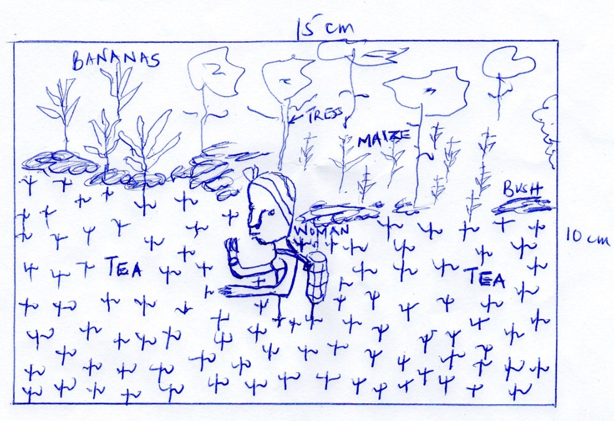

(b) (i) Which type of farming is shown on the photograph (1 mk)
Mixed crop farming
(ii) Give three physical conditions favouring tea farming in Kenya
- Requires rainfall of about 1500cm per annum/well distributed
- Cool to warm temperatures of between 15⁰c – 30⁰c
- Fertile, deep, well drained acidic and well aerated soils/volcanic soils
- It grows well between 1500 – 2200 metres above sea level
- It should be sheathered from strong wind and sunshine (3 mks)
(iii) Describe the stages of the processing (5mks)
- In the factory, tea leaves are weighed and spread out on long wire trays
- Leaves are dried by blasting warm air from underneath to remove any moisture.
- Leaves are rolled mechanically between steel rollers to break up fibres.
- Chopped leaves are placed in containers for fermentation to reduce tannic acid by half and changing the colour to gre brown
- Leaves are roasted and dried over fire until they are black in colour
- Leaves are sieved to eliminate stems and other unwanted particles
- The finished product is graded and packed for export.
(c) (i) State two areas in Kenya where maize is grown on large scale (2 mks)
- Uasin Gishu
- Trans-Nzoia
- Nakuru
- Bungoma
(ii) Explain four problems facing maize farmers in Kenya (8 mks)
- Farm inputs are expensive, reducing farmers profit margins
- The prices in the market keep on fluctuating making it hard for the farmers to plan, or recover their inputs.
- Adverse weather conditions/unfavourable weather/prolonged drought destroy the crop leading to low yields/low income for the farmer.
- Pests and diseases e.g. stalk bores, army worms, aphids, weevils, etc destroy the crop leading to loss for the farmers
- Inadequate storage facilities, hence post harvest losses/low income for the farmers.
- Stiff competition in the market/flooded market with cheap imports from foreign countries.
- Poor transport and communication networks in the growing areas affecting marketing
- Shortage of capital to buy inputs, discouraging farmers
- Maize grow encourages monoculture. Soils are easily exhausted and requires regular application of fertilizer/manure making this farming venture expensive.

7. a) Differentiate between land reclamation and rehabilitation.
- Land reclamation is the process of converting less productive land into a more productive state for agricultural or settlement purposes while land rehabilitation is the process of restoring degraded land back to useful state. (2 mks)
b) Give three methods used to reclaim land in Kenya.
- Draining
- Irrigation
- Planting of draught resistance vegetation
- Control of tse tse fly. (3 mks)
c) i) State two methods that are used to control Tse Tse flies in Kenya.
- Bush clearing of tse tse fly infested areas
- Use of traps
- Construction of buffer zones
- Spraying using insecticides. (2 mks)
ii) Explain three benefits of perkerra irrigation scheme.
- Made use of unproductive semi- arid land into productive land.
- Created employment opportunities for local population.
- Raised the standards of living of many farmers.
- Supplied agricultural produce to the local market. (6 mks)
d) i) What is a polder?
A polder is a low-lying area reclaimed from a sea. (2 mks)
ii) Name two crops grown in polders.
- Barley
- Oats
- Sugar beets
- Rye (2 mks)
iii) Outline the stages through which land is reclaimed from the sea in the Netherlands.
- Parts of the low lying land covered by sea water is enclosed using strong walls / dykes.
- Ring canals are constructed to lead water to pumping station.
- The water is pumped out using wind mills.
- Ditches are then dug to drain excess water from the enclosed area/ land.
- Reeds planted to suck up water and reduce salinity.
- Chemicals are added to the soil to reduce salinity / fresh water is flashed into the enclosed land to reduce salinity.
- Oats, rye and sugar beets are planted to improve the pH of the soil and reduce the water.
- The land is dry and ready for use.
- The land is sub-divided and leased to farmers. (8 mks)

8. a) i) Differentiate between fishing and fisheries.
Fishing refers to all activities involved in the exploitation of fish and other aquatic resources for commercial purposes while fisheries are water bodies where aquatic organisms/ fish are found or reared for exploitation. (2 mks)
ii) State two categories of fish.
- Pelagic fish
- Demersal fish
- Anadromours fish (2 mks)

b) (i) Apart from trawling, name two other methods of deep sea fishing.
- Long line / lining
- Drifting
- Purse seine net / seining (2 mks)

ii) With the aid of a diagram, describe trawling method of fishing.
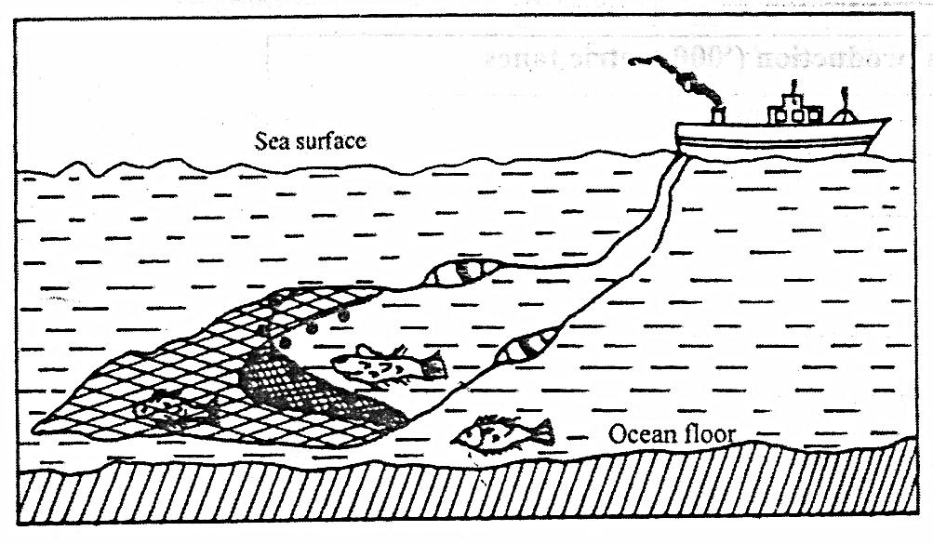
- A bag shaped net is attached to a trawler ship.
- The net is thrown into the water by the trawler ship
- The upper part of the net is kept afloat by corks or floats.
- The lower part of the net has weights to make it sink to the sea bed.
- The net mouth is kept open by outer boards/ head beams.
- The trawler drags or pulls the net along the sea bed.
- After sufficient fish have been caught, the net is hauled into the trawler to empty the fish. (6 mks)

c) Problems experienced by Kenyan fishermen in L. Victoria.
- Occurrence of strong winds or thunderstorms which lead to high waves that cause accidental / drowning and destruction of fishing vessels and nets.
- Poor fishing equipments or motor boat engines which are inefficient leading to low catch and delayed landing of fish.
- Poor shortage or preservation facilities which result in deterioration of fish.
- Floating of vegetation like water hyacinth entangle and tear fishing nets which results in loss to fishermen or hinders movement of boats.
- Swampy or marshy parts of the lake shores which make the landing of the fishing boats difficult.
- Insecurity or theft of fishing equipment discourages fishermen.
- Conflict with neighbouring countries makes Kenyan fishermen get arrested which hinders fishing e.g Migingo Island conflict with Uganda.
Any 4 x 2 = 8 mks

d) The world map below shows major fishing grounds. Use it to answer the following question.

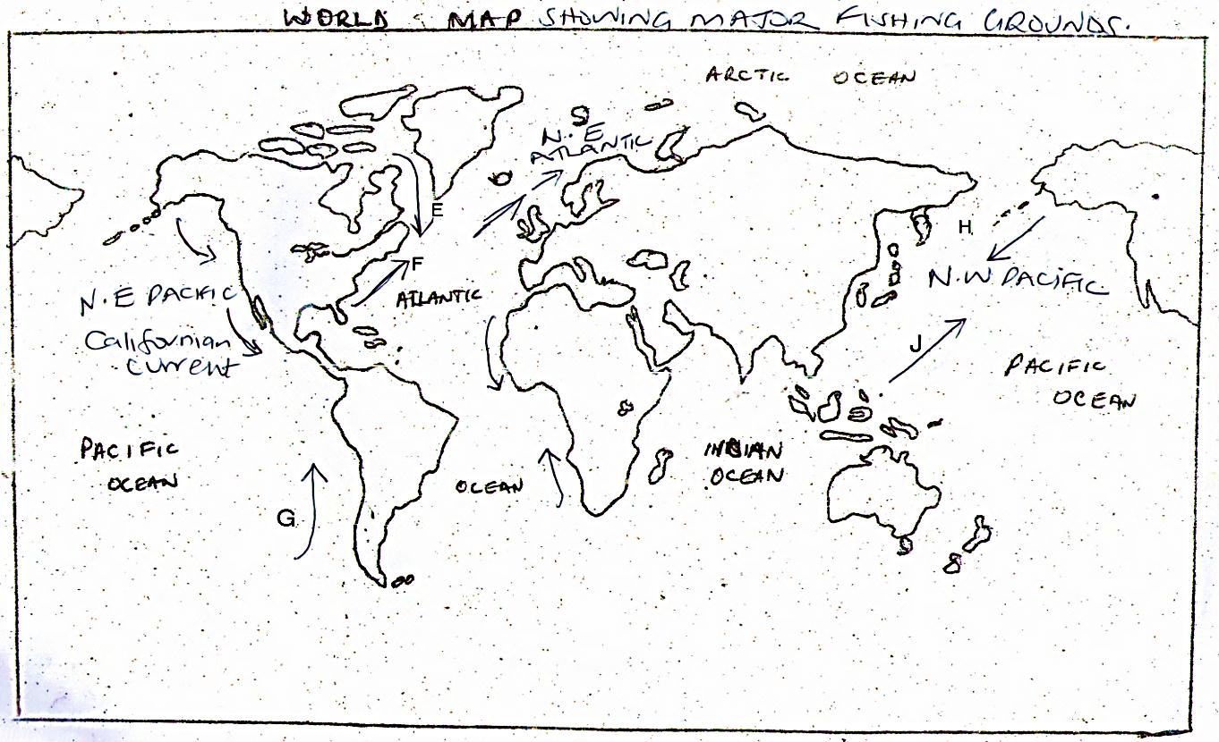

i) Name the ocean currents marked:
E – Cold Labrador Current
F – Warm Gulf stream current
G – Cold Peruvian current
H – Cold Oyashio current
J – Warm Kuroshio Current Any 1 x 5 = 5 mks

ii) Explain three factors that favour fishing in Japan.
- The mountainous or rugged nature of the country hinders agricultural activities hence fishing is an alternative economic activity.
- Japan has a large population which provides ready market for fish.
- The Japanese have a long history of sea farming thus they are highly experienced in fishing which promotes the fishing culture.
- The shallow continental shelf allows sunlight to penetrate to the bed for growth of plankton.
- The many off shore islands provide sheltered inlets ideal for the establishment of fishing ports and villages.
Any 4 x 2 = 8 mks

9. a) i) Define wildlife.
- Wildlife refers to undomesticated animals and plants(fauna and flora) found in their natural habitats.
Any 2 x 1 = 2mks
- Distinguish between a game sanctuary and a game ranch.
- A game sanctuary is an area set aside for protection of specific animals or birds/endangered species from extinction while a games ranch is a protected large tracts of land for rearing specific kinds of animals for meat game products.
NB: Both definitions must be correct for the student to score.
(4 mks)
b) i) Name national parks marked A, B and C.
- A – Kisite Marine park
- B – Amboseli.
- C – Ruwenzori. (3 mks)

ii) Four factors showing the future of tourism industry in Kenya.
- Aggressive promotion by ministry of Tourism through KTB through exhibitions abroad to promote Kenya as a tourist destination and also marketing is being done within, targeting domestic tourists.
- Lowering of tariffs in hotels, games parks and airports taxes so as to encourage more tourists visits Kenya.
- Strength of the Kenyan shillings depreciation will attract more tourists since most will find it cheaper to visit Kenya.
- Opening up of new areas with untapped attraction potential e.g. around lakes like Baringo, Bogoria, Turkana ect.
- Developing of sustainable tourism e.g. Eco-tourism i.e. tourism that involve conservation of the environment.
- Formation of Kenya National tourism master plan to underscore the need to diversity tourist sources, attractions and opening up of new avenues.
Any 4 x 2 = 8 mks
iii) Explain how the following factors influence wildlife.
- Vegetation.
- Different plants and animals are found in different vegetation zones.
- Natural forests are habitat for elephants gorillas, baboons, monkeys, variety of birds and insects.
- Savannah grasslands with acacia trees host a lot of herbivores e.g gazelles, wild beasts.
- Woodland savannah is a home for many animals like gazelles, bees and the carnivores as well as they shelter in the bushes.
- Semi deserts and desert vegetation support hardy animals which can withstand dry conditions e.g. hartebeest, grant gazelle.
Any 2 x 2 = 4mks
- Altitude.
- Determines the climate and vegetations type.
- Very high mountains e.g. Mt. Kenya and Kilimanjaro are too cold, hence absence of animals.
- Different plant formation are therefore found at different altitudes hence also determine type of animals present there.
- Savannah is found near the base then the forest, bamboo forest and health and moon land.
Any 2 x 2 = 4mks

10. a) i) What is energy conservation?
- This involve the use of available energy resources in the most efficient manner in order to ensure no wastage. (2 mks)
- Identify three non-renewable sources of energy.
- Petroleum.
- Coal.
- Natural gas.
- Uranium.
Any 3 x 1 = 3 mks
- Three advantages of Hydroelectric power as a source of energy.
- Clean and environmentally friendly.
- Is inexhaustible.
- Can be transmitted over long distance using cables.
- Can be put into many use.
- Relatively easy to use i.e. operate from a switch.
- Can be adjusted to any fraction depending on the need.
- Viable source of energy because it has significant production levels.
- Can be used almost throughout the world.
- Construction of dam lead to creation of lakes used for irrigation/recreation/supply of water/fishing etc.
Any 3 x 1 = 3 mks
- i) What are the causes of energy crisis?
- Over-reliance on petroleum and its products.
- High oil prices due to sharp se in oil demand.
- Economic and political sanctions.
- Uncertainties in oil supplies to consumers.
- Rapid depletion of oil reserves.
- Conflict in the Middle East especially between Israel and Palestine.
- Mismanagement of energy.
- Oil production limits set by OPEC.
- Artificial shortages by countries like Russia and USA relying on oil from other countries while conserving their own.
Any 4 x 1 = 4 mks

- Explain four measures being taken by the government to conserve energy.
- Developing other alternative sources of energy to reduce overdependence on petroleum especially for industrial and domestic use.
- Creating awareness on the need to conserve energy and use of energy saving devices.
- Increase exploration and exploitation/prospecting by encouraging foreign investors to invest which has several exploitation in Northern Kenya and coast.
- Improve the state of the roads to reduce traffic jams and high consumption.
- Developing and improving public transport reducing the need to use personal vehicles.
- Encouraging the use of other means of transport e.g. motorcycles, bicycles or walk over short distances.
Any 4 x 2 = 8 mks
c) Students from your school carried out a field at Olkaria Geothermal Power Generation station.
- What preparations did they take before going out for the field study.
- Seeking permission from relevant authorities.
- Formulate objectives and hypothesis.
- Conduct a reconnaissance.
- Divide into groups/hold ground discussion.
- Assemble necessary equipment.
- Prepare a questionnaire.
- Prepare a work schedule.
- Read more on the topic.
- Determine methods of collecting and recording data.
Any 3 x 1 = 3mks

- Identify the secondary sources of data they would use to prepare for the study.
- Text books.
- Past research papers.
- Photographs.
- Journals/magazines.
Any 2 x 1 = 2 mks

