NAME…………………………………………………..……. INDEX NO……………………

SCHOOL…………………………………..………………….SIGNATURE…………………..

DATE………………………

GEOGRAPHY
PP 2.
2021
TIME $2\frac{3}{4}$ Hours.

Instructions to candidates.
(a) Write your name and index number in the spaces provided above.
(b) Sign and write the date of the examination in the spaces provided above.
(c) This paper consist of two sections; A and B.
(d) Answer all the questions in section A and question 6 and any other two questions in
section B.
(e) Answer all the questions in English.

SECTION | QUESTIONS | MAXIMUM SCORE | CANDIDATE’S SCORE
A | 1-5 | 25
B | 6 | 25  25  25
 | TOTAL SCORE

SECTION A. Answer all the questions.

1. a) Give any two ways in which minerals occur. (2 mks)

b) State three problems facing soda ash exploitation in Magadi. (3 mks)

2. a) Define the term agroforestry. (2 mks)

b) State three reasons why agroforestry is being encouraged in Kenya. (3 mks)

3. a) Apart from land pollution name two other types of environmental hazards. (2mks)
b) State three ways through which land pollution can be controlled. (3 mks) (3mks

4. (a) Apart from a telephone, state two other forms of communication (2mks)
(b) Mention three problems facing railway transport in Africa (3mks)

5. a) Apart from the common market for Eastern and southern Africa (COMESA)
identify two other trading blocks in Africa. (2 mks)
b) Give three benefits of COMESA to member states. (3 mks)

SECTION B. Answer question 6 compulsory and only other two questions from the remaining questions.

6. Study the photograph below and answer questions that follow

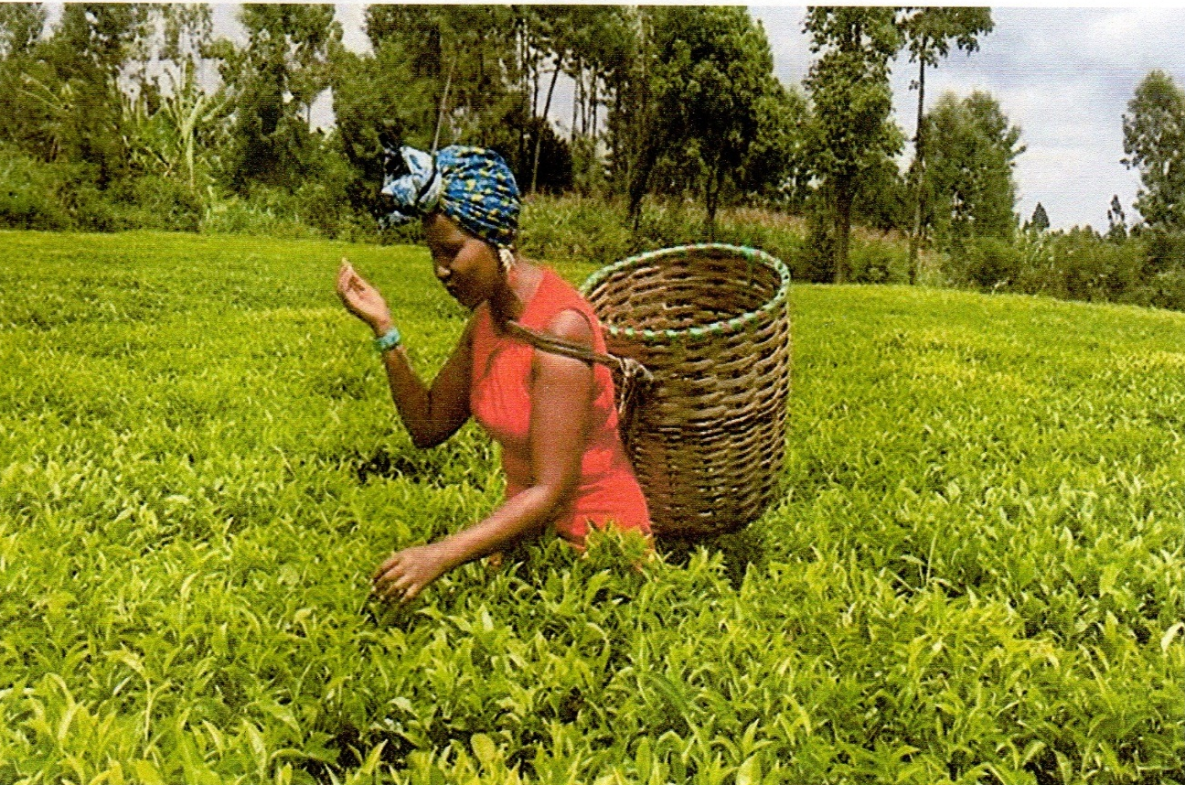

- (i) Identify the type of photograph shown above (1 mk)
(ii) Draw a rectangle measuring 15cm by 10cm to represent the area covered by the Photograph (1 mk)
(iii) On the rectangle, sketch and label four main features (4 mks)
- (i) Which type of farming is shown on the photograph (1 mk)
(ii) Give three physical conditions favouring tea farming in Kenya (3 mks)
(iii) Describe the stages of tea processing (5 mks)
- (i) State two areas in Kenya where maize is grown on large – scale (2 mks)
(ii) Explain four problems facing maize farmers in Kenya (8 mks)

7. a) Differentiate between Land Reclamation and Rehabilitation. (2 mks)
b) Give three methods used to reclaim land in Kenya. (3mks)
c) i) State two methods that are used to control tse tse fly in Kenya. (2 mks)
ii) Explain three benefits of perkerra irrigation scheme. (6 mks)
d) i) What is a polder? (2 mks)
ii) Name two crops grown in the polders. (2 mks)
iii) Outline the stages through which land is reclaimed from the sea in the
Netherlands. (8 mks)

8. a) i) Differentiate between fishing and fisheries. (2 mks)
ii) State two categories of fish. (2 mks)
b) Apart from Trawling, name two other methods of fishing. (2 mks)
c) Explain four problems experienced by Kenyan fishermen in Lake Victoria. (8 mks)
d) The world map below shows major fishing grounds.

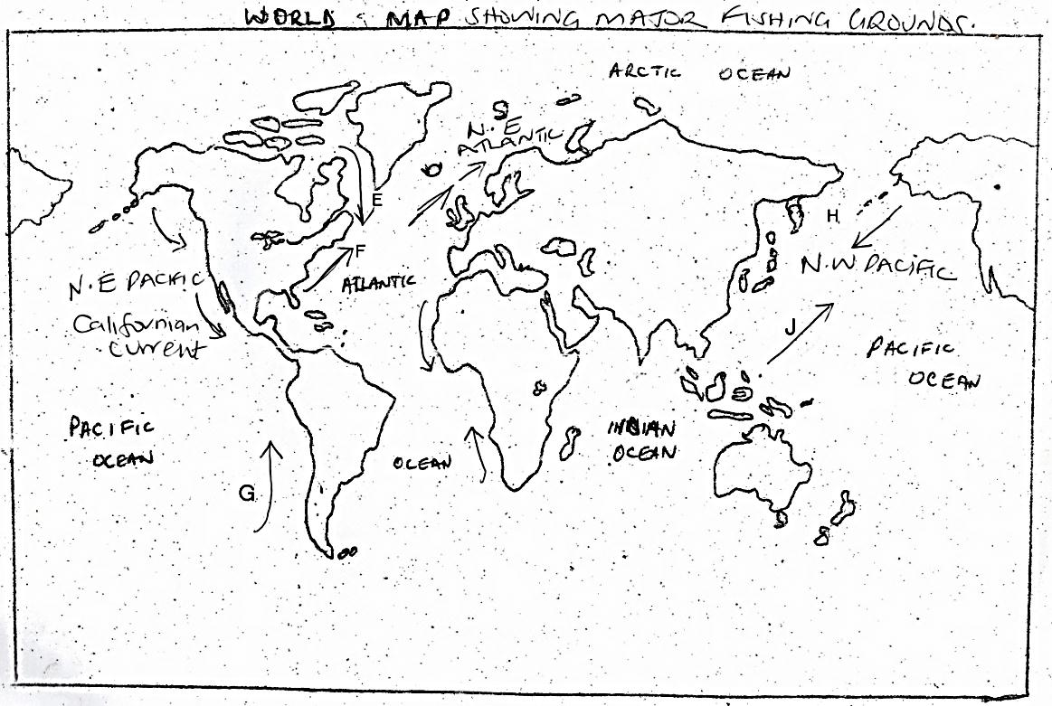

Use it to answer the following questions.
- Name the ocean currents marked: (5 mks)
E –
F –
G –
H –
J –

- Explain three factors that favour fishing in Japan. (6 mks)

9. a) i) Define wildlife. (2 mks)
ii) Distinguish between a game sanctuary and a game ranch. (4 mks)
b) Study the following map of East Africa and answer the questions below.
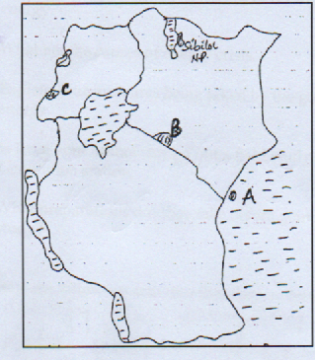
i) Name national parks marked A, B and C. (3 mks)
ii) Explain four factors showing the future of tourism industry in Kenya. (8 mks)
iii) Explain how the following factors influence wildlife.
- Vegetation. (4 mks)
- Altitude. (4 mks)
10. a) i) What is energy conservation? (2 mks)
- Identify three non-renewable sources of energy. (3 mks)
- State three advantages of Hydroelectric power as a source of energy. (3 mks)
b) i) What are the causes of energy crisis? (4 mks)
ii) Explain four measures being taken by the government to conserve energy. (8 mks)
c) Students from your school carried out a field at Olkaria Geothermal Power Generation station.
- What preparations did they take before going out for the field study. (3 mks)
- Identify the secondary sources of data they would use to prepare for the study. (2 mks

