MERU CENTRAL SUB COUNTY
GEOGRAPHY Paper 1
Marking Scheme
DEC -2020

- (a) Name two forces responsible for the shape of the earth (2mks)
- Gravitational force
- Centrifugal force
- Centripetal force
(b) Mention three effects of the rotation of the earth (3mks)
- Causes occurrence of day and night due to apparent movement of the sun
- Leads to falling and rising of ocean tides/high and low tides
- Causes a difference of one hour between longitudes 15⁰ apart/causes time difference over the earth surface/causes time difference at different longitudes.
- Causes deflection of winds and ocean currents
- Causes differences in atmospheric pressure on the surface of the earth.
- Causes variation in the speed of air masses.
- (a) State two types of igneous rocks (2mks)
- Intrusive /plutomic
- Extrusive/volcanic
- Hypabysal/intermediate
(b) Give three characteristics of sedimentary rocks (3mks)
- Occur in layers/stratified
- Are non-crystalline
- Contain fossils/plant and animals remains
- Are elastic/easily folded to form fold mountains
- Have bending planes/plane of stratification
- (a) Differentiate between weathering and mass wasting (2mks)
- Weathering is the breakdown/disintegration/decomposition of rocks at or near surface of the earth in situ by physical/chemical processes while mass wasting is displacement/movement of weathered materials down a slope under the influence of gravity.
(b) State three causes of landslides (3mks)
- The gradient of the slope
- Nature of the materials on the slope
- The amount of precipitation
- Occurrence of earth movements such as earthquakes
- Rise in temperature in glaciated highlands
- Clearing of vegetation cover on the steep slopes
- Human activities on steep slopes such as mining and construction.

4. a)Reason for studying plate tectonic theory
- to know the origin of the continents
- enables one to understand the origin / creation of structural landform
- helps us understand how the earth maintains balance
- it explain the causes of earthquake and vulcanicity3 x 1 = 3mks
b) Two types of tectonic boundaries
- compressional / destructive / convergent
- extension boundary / divergent boundary
- transform boundary / lateral boundaryany 2 x 1 = 2mks
5.(a) Name two features that are formed on emerged highland coast.
- Raised cliffs
- Raised wave-cut platforms
- Raised beaches
- Raised caves
- Archs
- Stamps
(b) State three conditions necessary for the formation of spit (3mks)
- The waves must carry a large amount of load
- The long shore drift must be weak
- There must be a shallow shore
- Waves must have strong swash and weak backward.

SECTION B

6.(a) (i) What type of map is Yimbo? (1mk)
- Topographical map
(ii) Convert the scale of the map to statement scale (1mk)
- 1cm to represent fifty thousand centimetres
- 1 cm to represent five hundred metres
- 1 cm to represent zero point five kilometres
(iii)Measure the length of all weather, loose surface road C506 from the junction in the grid square 3082 up to where it ends in the grid square 3986. (Give your answer in kilometers) (2mks)
- 10.1 + 0.1 km
(iv) Calculate the bearing of the trigonometric station 115 T 27 from the air photo principal point in the grid square 2586. (2mks)
- 97⁰
(b) Draw a rectangle measuring 14cm by 10cm to represent the area enclosed by Eastings 28 and 35 and Nothings 78 and 83 (6mks)
On the rectangle, mark and name the following features.
- All weather roads, loose surface
- Lake Victoria
- Ndate River
- Thicket
- Papyrus swamp

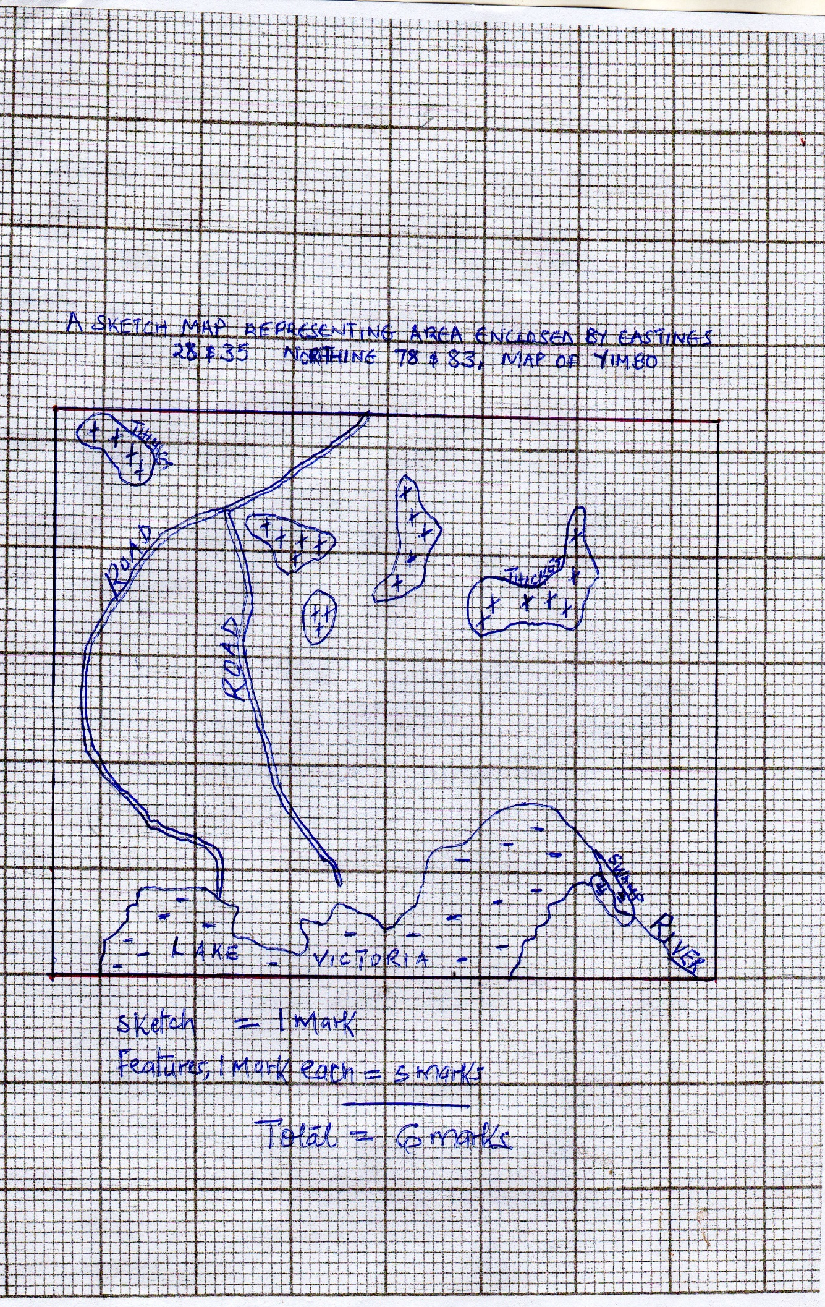

(c) (i) Identify two methods used to show relief of the area covered by the map (2mks)
- Contours
- Trigonometric stations
(ii) Describe the drainage of the area covered by the map (2mks)
- The areas has many/permanent rivers
- There are many seasonal rivers/indefinite rivers
- The main drainage feature is lake Victoria
- There are papyrus swamps, seasonal swamps
- There are man-made reservours /dams
- Some rivers form dendritic drainage pattern e.g. along river Yala
- There are disappearing/vanishing rivers
- There is a pond (grid square 3891)
- There is a water hole (grid square 2882)
- The main river is river Yala
(d) Citing evidence, state two economic activities of the area shown on the map (2x2=4mks)
- Trade – presence of markets, shops
- Fishing – L. Victoria
- Transport – L.Victoria/Ports, Network of Roads
- Industry/Processing – Posho Mill
- Crop Farming – Posho Mill
7.(a) (i) Define continental drift (1mk)
- Slow but gradual movement of the plates making continents
(ii) Give two significance of plate tectonic boundaries (2mks)
- They are sources of earthquakes which led to destruction of life and property
- They create beautiful features attracting tourists
- Causes volcanicity resulting to formation of valuable minerals e.g. diamonds
- Causes formation of landforms e.g. fold mts (Himalayas and ocean trenches important to man
(b) (i) Apart from, tension forces, explain two other processes that may cause faulting 2 x 2 (4mks)
- Faulting may be caused by forces acting horizontally towards each other which cause compression of crustal rocks, due to compression forces.
- Faulting may occur where horizontal forces act parallel to each other in opposite direction resulting in shearing/tearing
- Faulting may also occur due to vertical movements which may exert a strain in the rocks making them to fracture.
(ii) With the aid of well labelled diagrams, describe formation of Rift Valley through tension forces (6mks)
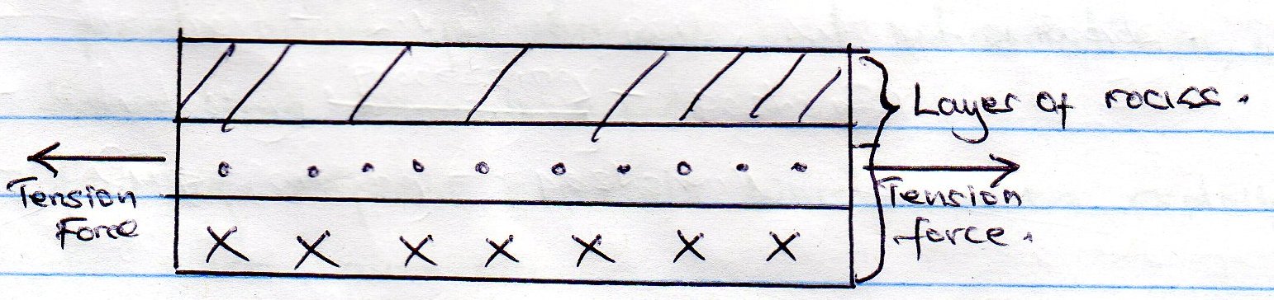

Layers of rocks are subjected to tensional forces, they move away from each other.

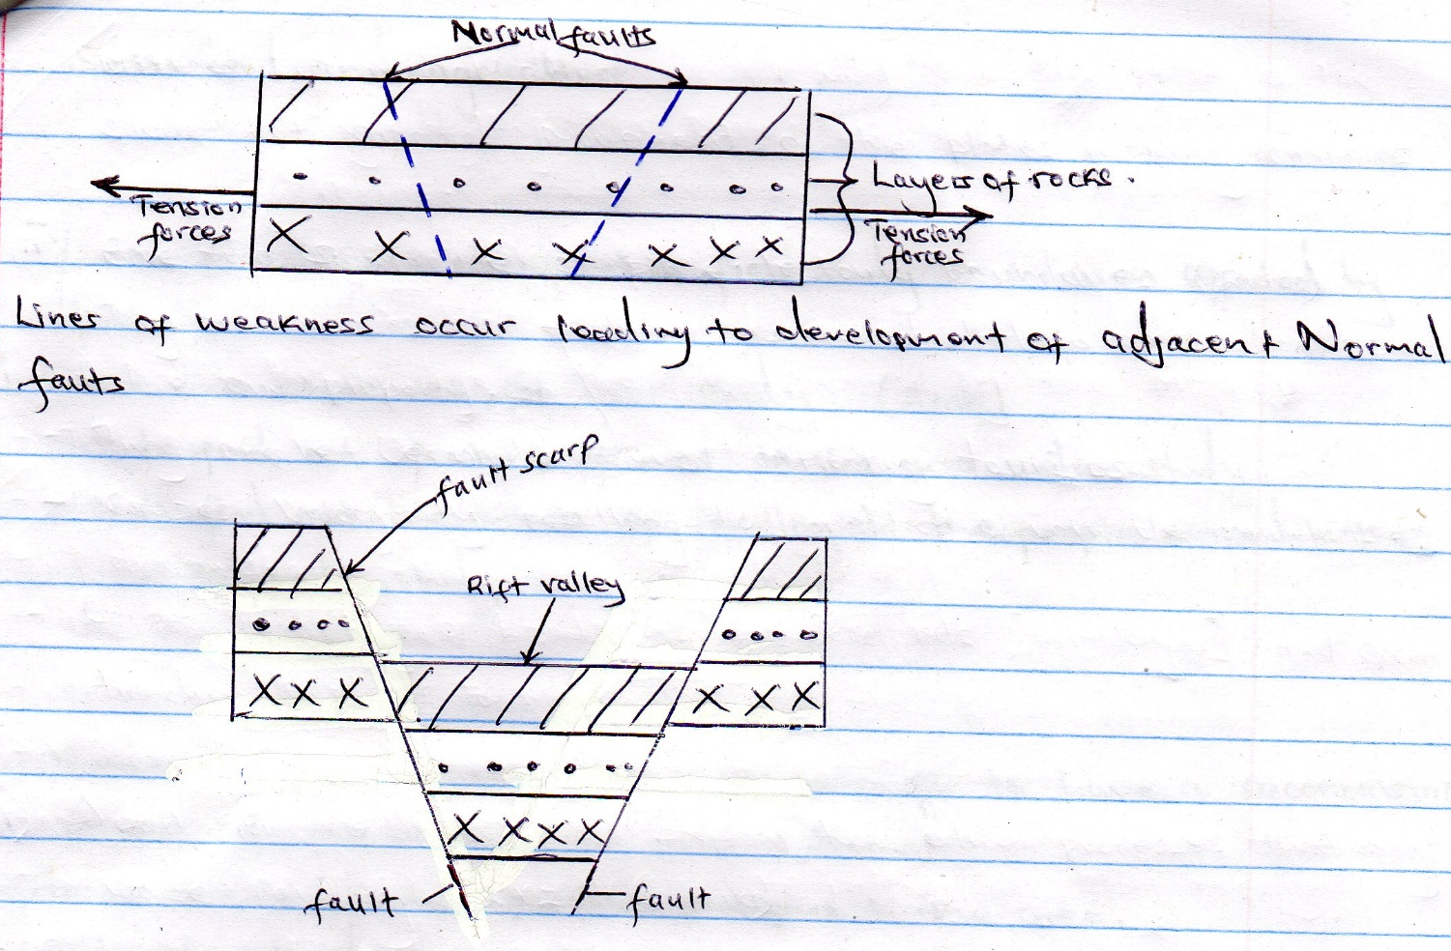

The central block sinks/subsides to form a long narrow depression called the Rift valley
- Diagram – 3mks
- Text – 3 mks
(b) (iii) Mention four positive effects of faulting (4mks)
- Faulting leads to formation of beautiful features that are tourism attraction who bring foreign exchange
- Depressions in the Rift Valley contain water that form lakes which provide water for domestic and industrial use, used for fishing etc
- Faulting expenses minerals which can be exploited, marketed to earn revenue.
- Step faulting makes rivers to have waterfalls for H.E.P generation
- Faulting leads to formation of block mountains like Ruwenzori Mts which receive high rainfall on the windward side attracting settlement and agriculture
(c) You are planning to carry out of field study on an area affected by faulting.
(i) State two objectives for your study (2mks)
- To find out features formed in the area under study
- To find out the effects of faulting to the people settled in the area under study
(ii) State three reasons why it is importance to have a reconnaissance survey/pre visit of the area (3mks)
- To be able to indentify possible problems in the area
- To be able to draw a route map
- To be able to prepare a working schedule/plan of activities
- To be able to draw up study objectives and hypothesis
- To indentify suitable methods of data collection
- To indentify equipment for the study
- To prepare financial requirement
- To seek permission from relevant authority in the area.
(iii) Give three follow-up activities you are likely to engage in (3mks)
- Data analysis/visualizing data
- Studying/group discussion
- Studying/testing of samples
- Classifying/categorizing of data
- Writing a report
- Write an appreciation letter to the authorities in the area of study

8. a
i) Definition glaciation
- glaciation refers to the action of moving ice / process by which glaciers change the landscape on large scale
ii) Types of glaciers
- continental glacier
- valley glacier
- piedmont glacier
- cirque glacier
- nicher glacier 3mks
b) i)Formation of V-shaped valle
- a pre-existing V-shaped valley is filled with ice / glacier
- the glacier erodes the V-shaped valley by abrasion and plucking process vertically and laterally
- the valley is deepened and widened by vertical erosion and lateral erosion
- the end spurs are truncated / trimmed / cut
- the ice melts away leaving a U-shaped valley 5mks
ii) Formation of a pyramidal peak
- initially ice collects in several hollows on the moutain side
- the ice exerts pressure on the hollows / cracks
- the plucking action of the ice enlarges the hollows so that more ice collects in them
- freeze thaw action of the ice leads to the expansion of cracks / hollows making them large basin which are called cirques
- nivation into the back walls of the hollows making them recede into the mountain side / the cirques recede toward each other
- steep sided, knife edged ridges called aretes are formed and they separate the cirques
- eventually three or more of these ridges / aretes converge at the top of the mountain forming a jagged peak called a pyramid peak / horn (surrounded by corries cirques) 5mks
c) Significance of upland glaciated features to human activities
- the warm valleys are suitable for farming / cultivation / glaciated uplands provide suitable grazing lands as they form fine benches on which summer pasture grow e.g. in Switzerland
- glacial uplands form magnificent features that encourage recreation / sporting activities e.g. mountaineering, ice skating, skiing /encourage tourism e.g. features like pyramidal peak, aretes etc.
- glaciated discourage human settlement hence the growth of the forest and therefore lumbering is practiced
- waterfalls formed by rivers in glaciated highlands provide suitable site for hydro-electric power production
- corries lakes / terms offer suitable areas for sports fishing
- the U-shaped valley / glacial through form natural route way e.g. roads / railway
- fiord coastlines harbours as well as good fishing grounds 6mks
d) i)Advantages of using oral interview to collect information during the field study
- it gives first hand information
- the interviewer can seek clarification on any ambiguities questions
- the interviewer create a good rapport with the interviewee
- the interviewer can elicit more information by initiating further discussion
- the method is useful in collecting information from people who cannot write and read 2 x 1 = 2mks
ii) Features found in a glaciated lowland
- depressions / glacial lakes
- roche montonee
- crag and tail
- Drumlins
- boulder train
- kaimes
- terminal moraine
- till plain / glacial till / boulder
- outwash plain 2 x 1 = 2mks
9
(a) Differentiate between watershed and catchment area (2mks)
- Watershed is a ridge line/boundary separating drainage/river system/basins while
Catchment area is an area/land from which a river/reservoirs drains its water/source of a river/rivers
- Explain three ways by which a river transports its load (3 x 2 =6mks)
- Suspension – light materials are carried with in the water turbulence
- Siltation – particles are carried in a series of hops and jumps
- Traction – Large boulders are dragged along the river bed by pushing power of water assisted by gravity.
- Solution – some rock minerals are dissolved and carried in solution form.
(b) Study the diagram given below and answer questions that follow.
- Name the features marked X, W and Z (3mks)
X – Elbow of Capture
W – Wind Gap
Z – Misfit
- Explain the process of river capture (3 mks)
- There must be two rivers flowing parallel to each other and sharing a watershed, one is more powerful
- A tributary of the powerful river extends its long profile through head ward erosion
- The actively eroding river, gradually erodes away the ridge that separates the two rivers
- The powerful river reaches the soruce of the weak rover diverting its water into its channel.
(c) Give three characteristics of a river in its youthful stage (3mks)
- It has narrow V-shape valley
- Presence of waterfalls, rapids, cataracts
- Erosion is predominant
- River gradient is steep
- Vertical erosion dominant
- River volume is low
- Presence of gorges, interlocking spurs, pot holes, pludge pools

(d) Explain four economic importance of river to man (4 x 2=8mks)
- Rivers provide water for irrigation, domestic & industrial use
- Rivers provide route –ways/navigable rivers are used for transportation
- River banks and on beds, sand is corrected for building and construction
- River and its features have beautiful scenaries attracting tourists
- Rivers provide fishing grounds, providing protein food
- Rivers with waterfalls and rapids provide sites for generation of hydro-electric power for domestic and industrial use.
- Some rivers provide port facilities especially in the rias and estuaries, e.g. port on Matandi on Congo river
- Some alluvial sediment along the river may contain valuable minerals like gold and diamonds.
- During flooding river deposit alluvium on the flood plain and deltas, hence fertile soils for agriculture
- In youthful stage, rivers cut deep valleys in the mountains creating mountain passes, used for road and railway construction
- Some rivers form natural boundaries between divisions, provinces, countys and counties.

10.i) Define Aridity
Aridity refers to the state of land being deficient in moisture leading to scarcity vegetation (2mks)

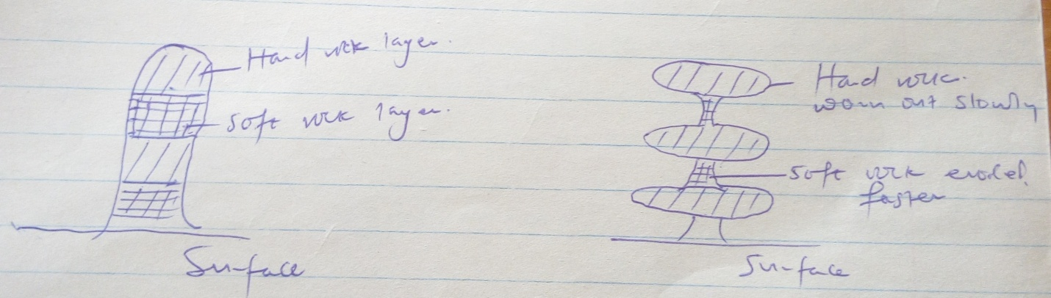

- Wind abrasion attack a rock outcrop with alternating layers of hand and soft rock
- The softer rocks are eroded faster than hand rocks
- Wind erosion is more effective nearer the ground surface where abrasive materials are heavier this leads to the formation of rock outcrop of different shape called rock predestine
b)ii) Deflation
- Abrasion
ii) – Sand dunes
- Barchans
- Drass
- Loess
iii) Decaying plants produce organic acid which reacts with some rock causing them to decaying hence weather
- Plants like algae and lichen retain water in the rocks resulting to chemical weathering
- i) Insufficient rainfall which discourages luxuriant growth of vegetation
- High temperature / low temperature lead to aridity due to little precipitation
- relief barrier
- continentality
- influence of wind system
3x2=6mks
iii) Introduction of energy saving jikos to reduce pressure on forests
- carrying out afforestation programmes
- irrigating dry lands
- irrigating alternative sources of fuel to reduce wood consumption
- stabilizing sand dunes by planting barriers at the fringes of deserts
4x1=4mks

THIS IS THE LAST PRINTED PAGE

