NAME……………………………………………………………. INDEX NO…………………

SCHOOL…………………………………………………………. SIGNATURE………………

DATE………………………
MERU CENTRAL SUB COUNTY
312/1
GEOGRAPHY
PP 1.
DECEMBER 2020.
TIME $2\frac{3}{4}$ Hours.

Instructions to candidates.
(a)White your name and index number in the spaces provided above.
(b) Sign and write the date of the examination in the spaces provided above.
(c) This paper consists of two sections; A and B.
(d) Answer all the questions in section A and question 6 and any other two questions in section B.
(e) Answer all the questions in English.

SECTION | QUESTIONS | MAXIMUM SCORE | CANDIDATE’S SCORE
A | 1-5 | 25
B | 6 | 25  25  25
 | TOTAL SCORE

SECTION A. Answer all questions in this section.

- (a) Name two forces responsible for the shape of the earth (2mks)
(b) Mention three effects of the rotation of the earth (3mks)
- (a) Sate two types of igneous rocks (2mks)
(b)Give three characteristics of sedimentary rocks (3mks)
- (a) Differentiate between weathering and mass wasting (2mks)
(b) State three causes of landslides (3mks

- a) Give three reasons why it is necessary to study the plate tectonic theory. (3 marks)

b) Name two types of plate tectonic boundaries. (2 marks)

- .(a) Name two features that are formed on emerged highland coast (2mks)
(b) State three conditions necessary for the formation of a spit (3mks)

SECTION B :Answer question 6 compulsory and only other two from the remaining questions.

- (a) (i) What type of map is Yimbo Map extract (1mk)
(ii) Convert the scale of the map to statement scale (1mk)
(iii) Measure the length of all weather road, loose surface road C 506 from the junction in the grid square 3082 up to where it ends in the grid square 3986. (Give your answer in kilometers) (2mks)
(iv) Calculate the bearing of the Trigonometric station 115 T 27 from the air photo principal point in the grid square 2586 (2mks)
(b) Draw a rectangle measuring 14cm by 10cm to represent the area enclosed by Eastings 28 and 35 and northing 78 and 83. (6mks)
On the rectangle, mark and name the following features
- All weather roads, loose surface
- Lake Victoria
- Ndate River
- Thicket
- Papyrus swamp
(c) (i) Identify two methods used to show relief of the area covered by the map (2mks)
(ii) Describe the drainage of the area covered by the map (7mks)
(d) Citing evidence from the map, state two economic activities of the area shown on the map (4mks)

7.(a) (i) Define continental drift
(ii) Give two significance of plate tectonic boundaries (2mks)
b (i) Apart from tension forces, explain two other process that may cause faulting (4mks)
(ii) With the aid of well-labelled diagrams, describe the formation of Rift valley through tension forces (6mks)
iii) Mention four positive effect of faulting (4mks)
c)You are planning to carry out a field study on the area affected by faulting
- State two objectives for your study
- State three reasons why it is important to have a reconnaissance survey/pre-visit of the area (3mks)
- Give three follow-up activities you are likely to engage in (3mks)

8. a i) Define the term glaciation. (2 marks)
ii) Name three types of glaciers. (3 marks)
b) Describe how the following features found in upland glaciated landscape are formed.
i) U-shaped valley (5 marks)
ii) Pyramidal peak (5 marks)
c) Explain three significances of upland glaciated features to human activities. (6 marks)
d) Suppose you were to carry out a field study of glaciated lowland.
i) State two advantages of using oral interview to collect information during the field study. (2 marks)
ii) Name two features found in glaciated lowland that you are likely to study. (2 marks)

9.(a) (i) Differentiate between watershed and catchment area (2mks)
(ii) Explain three ways by which a river transports its load (6mks)
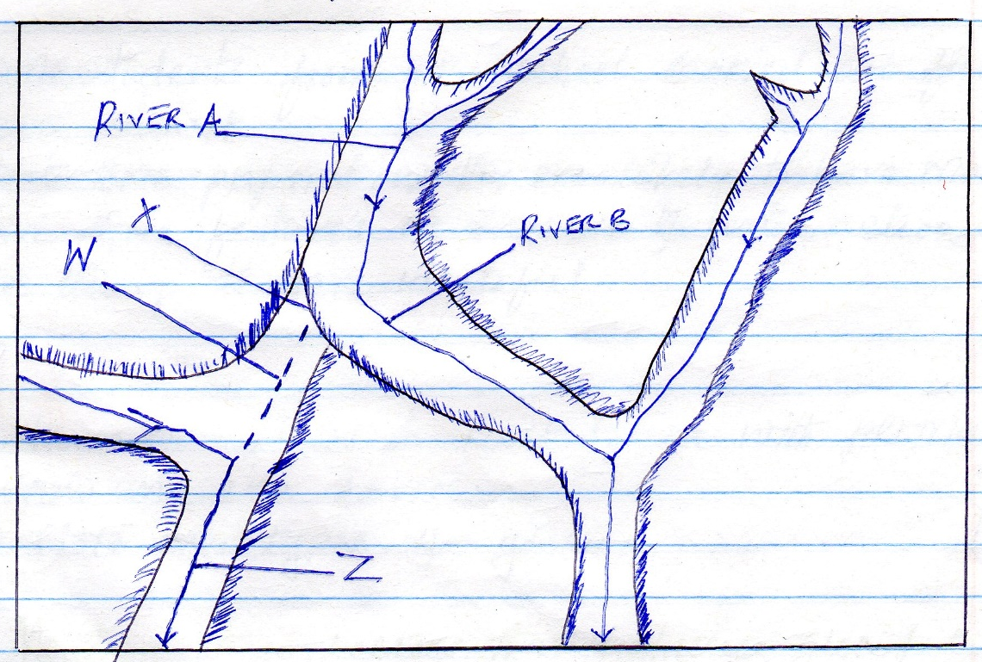
(b) Study the diagram given below and answer questions that follow

- Name the features marked X, W and Z (3mks)
- Explain the process of river capture (3mks)
c) Give three characteristics of a river in its youthful stage (3mks)
d) Explain four economic importance of a river to human activities (8mks)

10 a, .Define aridity
- With an aid of a well labeled diagram describe how a rock pedestal is formed (5mks)
b ,
- Give two process through which wind erodes the earth surface (2mks)
- Give two wind depositional features found in the desert (2mks)
- explain two ways through which plants causes weathering in arid and semi-arid areas 4mks
c. i. Explain the causes of aridity and desertification (6mks)
ii. State four measures that can control aridity and desertification ( 4mks)

