Section I (50 marks) – answer all questions in this section
1 | Without using a calculator, evaluate;  $\frac{-8+\left(-5\right) × \left(-8\right)-(-6)}{-3+(-8)÷2 × 4}$ | (3 Marks)
2 | Without using mathematical tables or a calculator, evaluate;  $\frac{\sqrt[3]{675×135}}{\sqrt{2025}}$ | (2 Marks)
3 | If $\frac{\sqrt{14}}{\sqrt{7}-\sqrt{2}}$ $-$ $\frac{\sqrt{14}}{\sqrt{7}+\sqrt{2}}$ = 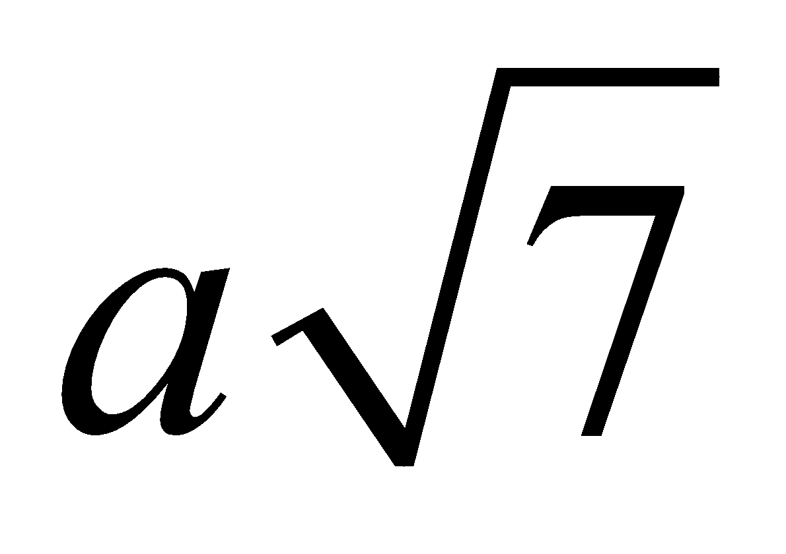 + 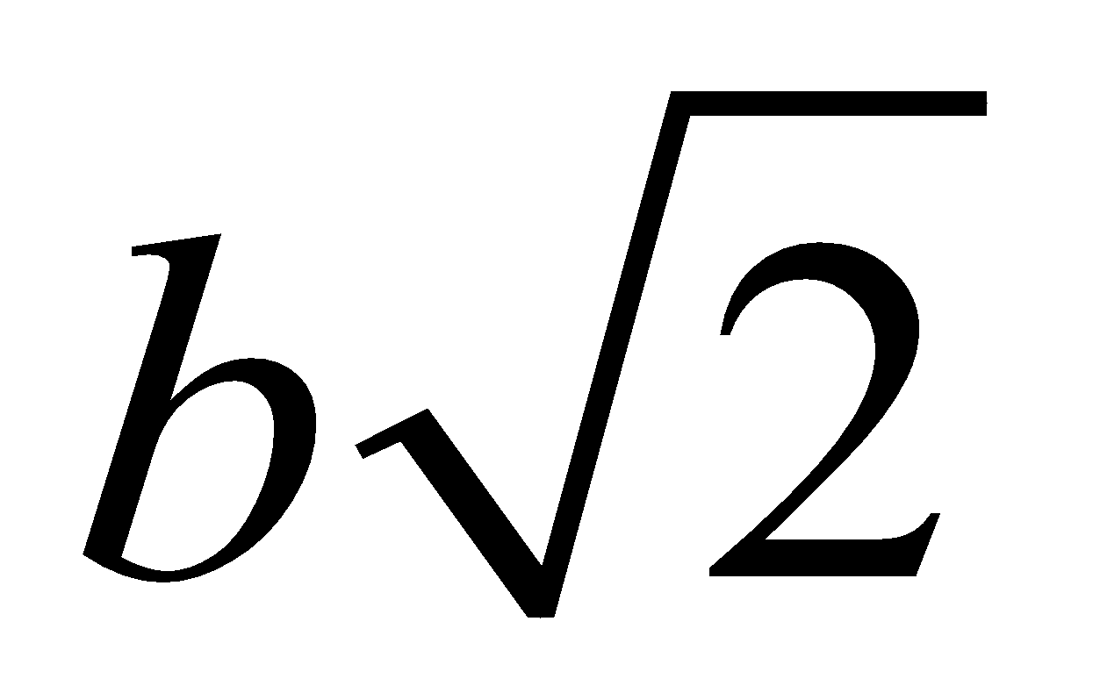,  Find the values of $a and b$ where $a and b$ are rational numbers | (4 Marks)

4 | Kenyan bank buys and sells foreign currencies using the rate shown below  Buying (Ksh) Selling (Ksh)  Euro 86.25 86.97  100 Japanese Yen 66.26 67.26  A Japanese travelling from France arrives in Kenya with 5000 Euros, which he converts to Kenyan shillings at the bank. While in Kenya he spent a total of Ksh. 289,850 and then converted the remaining Kenyan shillings to Japanese Yen at the bank. Calculate the amount of Japanese Yen that he received. | (3 Marks)
5 | The cost price of 31’’ inch flat LG TV screen is Ksh. 36,500. Mary bought a screen on hire purchase price by paying a deposit of Ksh. 12,000 and 15 monthly installments of Ksh. 2050 each. Calculate the monthly rate of interest she was charged. Give your answer to 2 decimal places. | (4 Marks)
6 | Given that tan x$°$= $\frac{12}{5}$ . Find sin (90-x)$°$ without mathematical table or a calculator. | (3 Marks)

7. | Given that OA= 2i + 3j and OB=3i- 2j. Find the magnitude of AB to one decimal place. |  |  |  | 3mks
8. |  | In the figure below, ABCDE is a regular pentagon and ABF is an equilateral triangle
 |  | 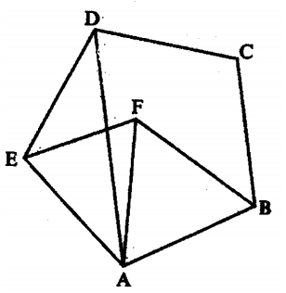 | Find the size of;
 |  |  | a. | $∠$ADE | 1mk
 |  |  | b. | $∠$AEF | 1mk
 |  |  | c. | $∠$DAF | 1mk
9. | Solve the inequality $3-2x<x≤\frac{2x+5}{3}$ and show the solution on the number line |  |  |  | 4mks

10. | A line with gradient of -3 passes through the points (3, k) and (k, 8). Find the value of k and hence express the equation of the line in the form $ax+by=c$, where a, b and c are constants. | 3mks
11. | Without using mathematical tables or a calculator, evaluate;  $6 \log_{2}\sqrt[3]{64}+10\log_{3}\sqrt[5]{243}$ | 3mks
12. | Make $n$ the subject of the formula  $E= \sqrt{\frac{x(n-x)}{n-1}}$ | 3mks

13. | Two variables $p and q$ are such that $p$ is directly proportional to $x and q$ is inversely proportional to $x$. When $x = 2$ their sum is $8$ and when$x = 3$ their sum is$7$. Find the constants of proportionality |  | 4mks
14. | Two points P and Q have coordinates (-2, 3) and (1, 3) respectively. A translation maps point P to P’(10, 10).
14. | a. | Find the coordinates of Q’, the image of Q under the translation | 1mk
14. | b. | The position vectors of P and Q in (a.) above are $p and q$ respectively. Given that $mp-nq=\left(-12 9 \right)$,  Find the values of $m and n$ | 3mks

15. |  | The diagram below represents a right pyramid on a square base of side 3cm. the slanting edge of the pyramid is 4cm  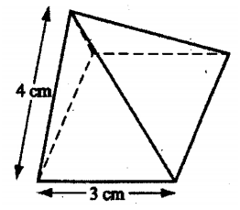
15. | a. | Draw to scale a net of the pyramid | 2mks
15. | b. | On the net drawn, measure the height of the triangular face from the top of the pyramid. | 1mk
16. | Using a ruler and a pair of compass only, construct 90⁰ on line AB provided below; |  | 1mk
A
B
Section II (50 marks) – answer only five questions in this section
17. |  |  | In the figure below, $TA$ is a tangent to the circle $ABCD$ with centre$O$. $∠TAD$=48º and $∠BOD$=116⁰.$∠ATD={26}^{o}$  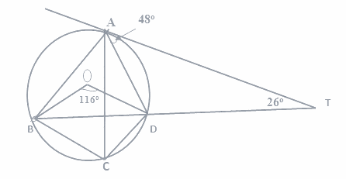  Giving reasons Calculate:  - $∠$ACD (2mks)  - $∠$ABO (2mks)  - $∠$ADO (2mks)  - $∠$ACB (2mks)  - $∠$_{AOB} _{(2mks)}
18. | The table below shows income tax rates of a certain year.  Monthly income (Ksh) Tax rate (%)  Up to 9680 10  9681- 18800 15  18801- 27920 20  27921- 33040 25  Over 37040 30  In that year Mr.Mwangi,s monthly earnings were as follows:  Basic salary Kshs.19600, House allowance Kshs.6, 000, medical, allowance Kshs.2840 and travelling allowance Kshs.5,000. Mr.Mwangi was entitled to a monthly personal relief of Ksh.1056 and an insurance relief of 15% of premiums paid.
18. | a. |  |  | Calculate:  - Mwangi’s taxable income per month | 2mks
18. |  |  |  | - Monthly tax paid by Mwangi if he paid monthly insurance premiums of Ksh.3200. | 4mks
18. | b. |  |  | Bob deposited Kshs.150, 000 in a bank which paid compound interest quarterly. If at the end of second year the total amount in the bank was Ksh.213,315,calculate the rate of interest p.a | 4mks

19 | A solid S is made up of a cylindrical part and conical part. The height of the solid is 4.5m. The common radius of the cylindrical part and the conical part is 0.9 m. the height of the conical is 1.5m
19 | 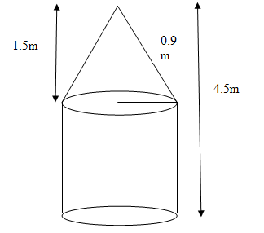 | a. | Calculate the volume, correct to 1 decimal place, of solid S | 4mks
b. | Calculate the total surface area of solid S |  |  | 4mks
c. | A square base pillar of side 1.6m has the same volume as solid S. determine the height of the pillar, correct to 1 decimal place. |  |  | 2mks

20. | The table below shows marks obtained by 100 candidates at East side high school in biology examination
  Marks | 15-24 | 25-34 | 35-44 | 45-54 | 55-64 | 65-74 | 75-84 | 85-94
  Frequency | 6 | 14 | 24 | 14 | x | 10 | 6 | 4
 | a. | Determine the value of x. | 2mks
 | b. | Design a frequency distribution table to represent the above data | 2mks
 | b. | State the modal class | 1mk
 | c. | Calculate the median mark | 3mks
 | d. | Calculate the mean mark. | 2mks

21. | The figure below shows a velocity-time graph of journey of a car. The car starts from rest and accelerates at 2 ³/₄ m/s² for t seconds until it is 22m/s.  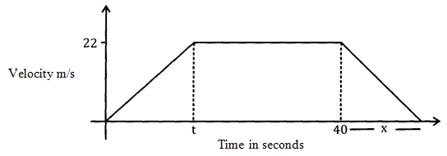  Brakes are applied bringing it uniformly to rest. The total journey is 847m long. Find:
21. | a. | The value of t, the acceleration time. | 2mks
21. | b. | The distance travelled during the first t seconds. | 2mks
21. | c. | The value of x, the deceleration time. | 4mks
21. | d. | The rate of deceleration. | 2mks

22. | The diagram below (not drawn to scale) represents the cross-section of a solid prism of height 8.0cm  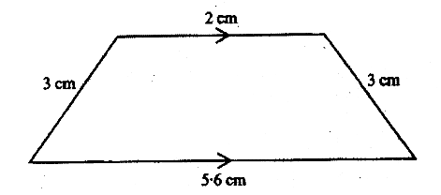
22. | a. | Calculate the volume of the prism |  | 3mks
22. | b. | Given the density of the prism is 5.75 g/cm³, calculate its mass in grams |  | 2mks
22. | c. | A second prism is similar to the first one but is made of a different material. The volume of the second prism is 246.24cm³
22. | c. | i. | Calculate the area of the cross-section of the second prism. | 3mks
22. | c. | ii. | Given that the ratio of the mass of the first prism to that of the second is 2:5, find the density of the second prism | 2mks

23. |  | A bus left Mombasa and travelled towards Nairobi at an average speed of 60 km/h. After 2 ½ hours, a car left Mombasa and travelled along the same road at an average speed of 100 km/h. If the distance between Mombasa and Nairobi is 500 km, determine;
23. | a. | i. | The distance of the bus from Nairobi when the car took off. | 2mks
23. | a. | ii. | The distance the car travelled to catch up with the bus. | 4mks
23. | b. | Immediately the car caught up with the bus, the car stopped for 25 minutes. Find the new average speed at which the car travelled in order to reach Nairobi at the same time as the bus. |  | 4mks

24. | a. | The diagram below shows a sketch of the line $y=3x$ and the curve $y=4-x^{2}$ intersecting at points P and Q  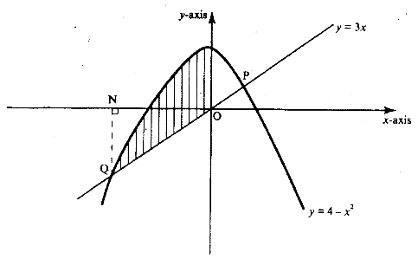
24. | a. | Find the coordinates P and Q | 4mks
 | b. | By correcting each number to one significant figure, approximate the value of $788×0.006$. Hence calculate the percentage error arising from the approximation. | 3mks
 | c. | The table below shows some corresponding values of $x and y$ for the curve represented by  $y=\frac{1}{4}x^{3}-2$  On the grid provided below, draw the graph of $y=\frac{1}{4}x^{3}-2 for-3≤x≤3.$ Use the graph to estimate the value of $x when y=2$.
  $X$ | -3 | -2 | -1 | 0 | 1 | 2 | 3
  $Y$ | -8.8 | -4 | -2.3 | -2 | -1.8 | 0 | 4.8
