ST. AUGUSTINE MUKUMU BOYS’ PRIMARY
ENVIRONMENTAL ACTIVITIES
GRADE 1END TERM EXAM TERM 1 2019

- ______________ is seen in the sky during the day (stars, sun, moon)

- We go to school during ________________ (day, night)

- This is a _____ ( (moon, stars, sun)

- We carry an umbrella when it is ___________(sunny, windy, rainy)
Match the pictures with the name

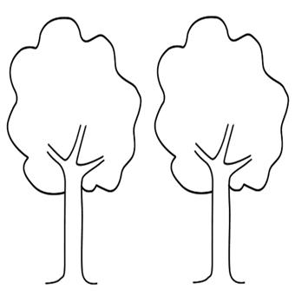
- Windy

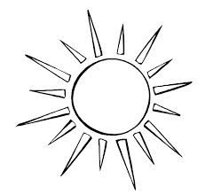
- Calm

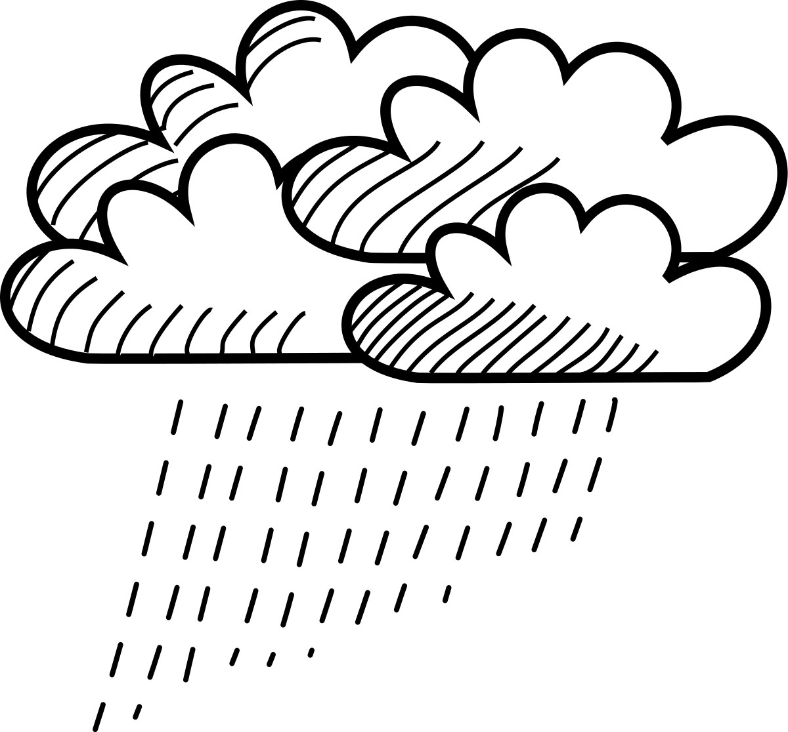
- Sunny

- Rainy

- A ____________ is a source of water. (tap, rain)
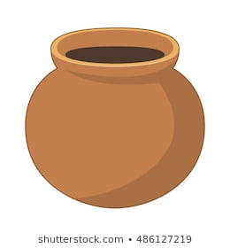

- We use __________ soil to model the pot. (clay, sand)

- A hen gives us ________________ (milk, eggs).
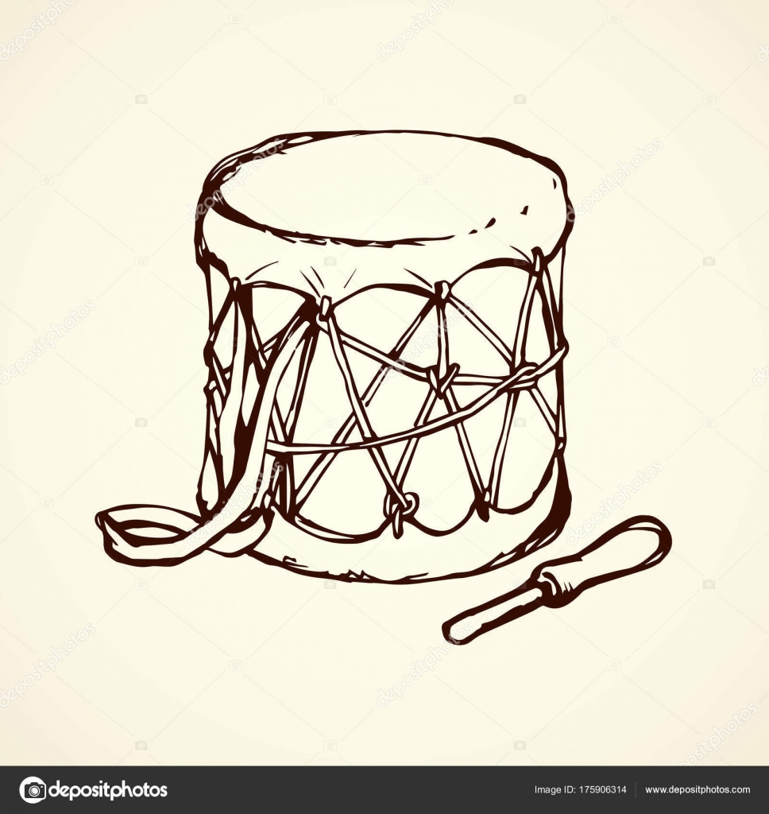

- This drum produces sound by ______________ (beating, plucking)
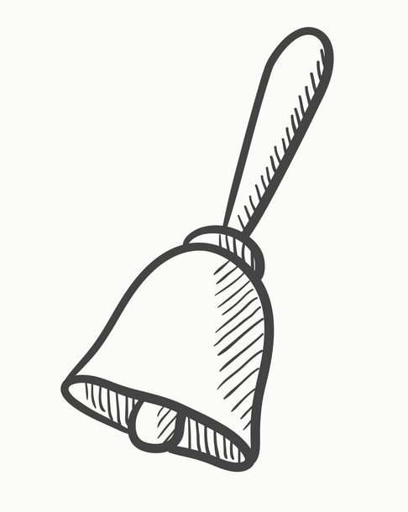
- This is a __________ ( (bell, key)

14.A ____________gives us meat and milk (cow, sheep)
15. We should use a ______ to wash clothes (bucket, basket)
16. Nights are always ________________ (white, dark).

17. Draw one domestic animal

18. Draw a rainy day

Match the pictures
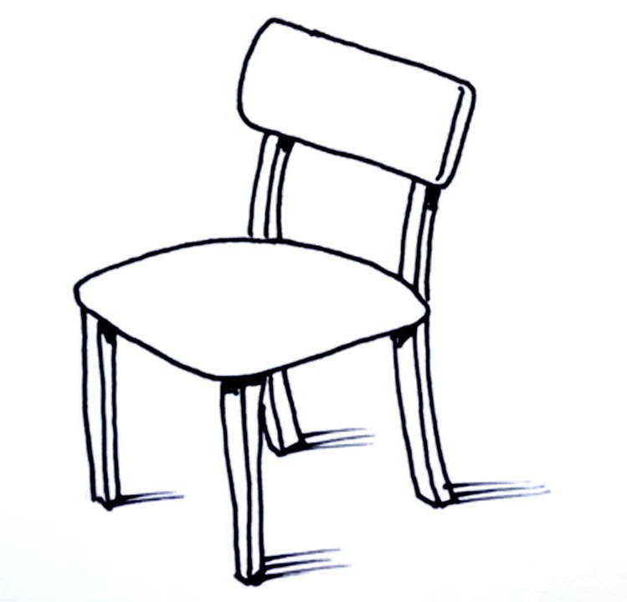
19. glass

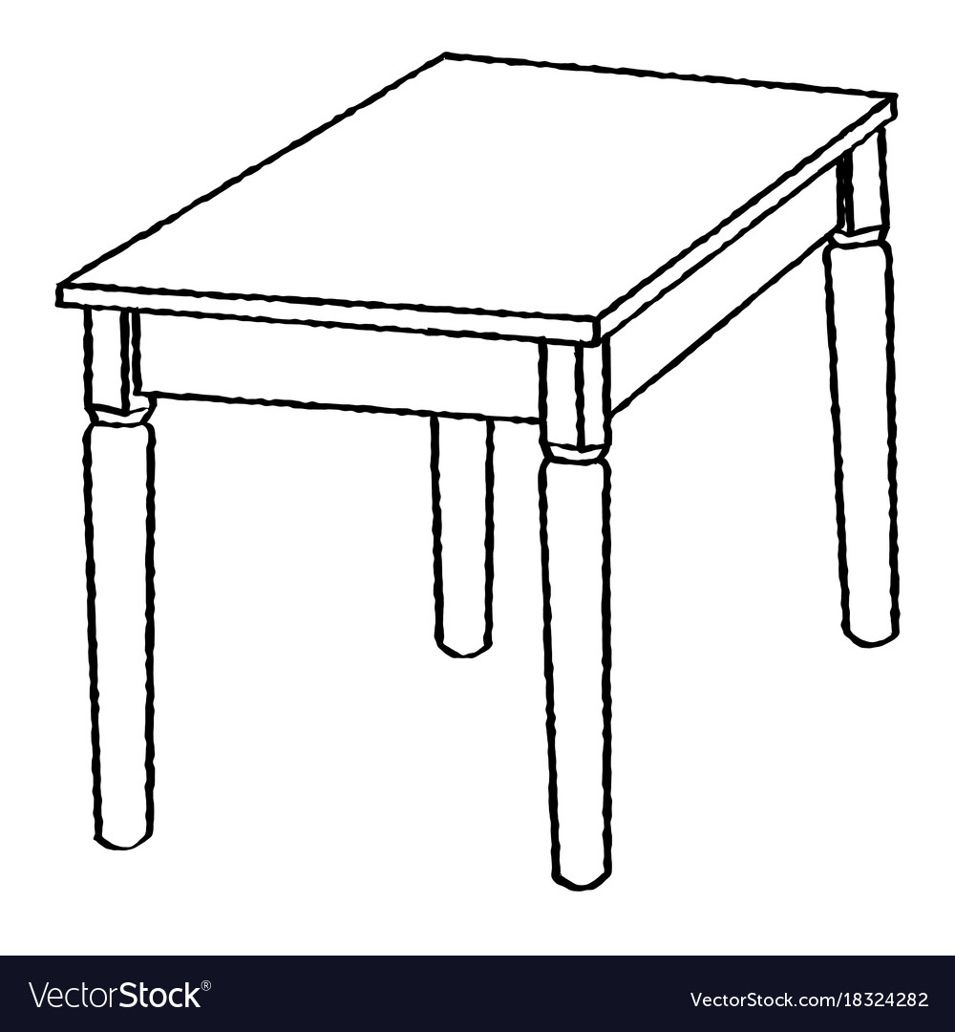
20. cooking stick


21. table

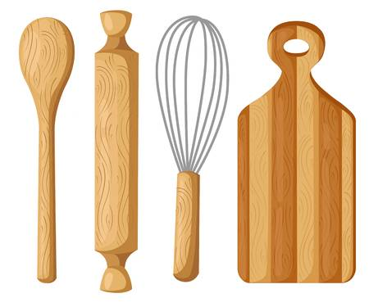
22. chair

23. All children should go to __________________ (work, school)

24. It is your responsibility to ______________ in the family. (play, help)

25. When they fall sick, children should go to ______________(hospital, school).

