Name……………………………………………….Adm No………..Class……
Index No……………………….. Signature…………………………

121/2
MATHEMATICS ALT A
Paper 2
2 ½ Hours
JULY/ AUGUST 2019
GATUNDU SOUTH SUB-COUNTY EVALUATION EXAMINATION

INSTRUCTIONS TO CANDIDATES
- Write your name and Admission number in the spaces provided at the top of this page.
  - This paper consists of two sections: Section I and Section II.
  - Answer ALL questions from section I and ANY FIVE from section II
  - All answers and workings must be written on the question paper in the spaces provided
below each question.
  - Show all the steps in your calculation, giving your answer at each stage in the spaces
below each question.
  - Non – Programmable silent electronic calculators and KNEC mathematical tables may be
used, except where stated otherwise.

FOR EXAMINERS USE ONLY

SECTION I
1 | 2 | 3 | 4 | 5 | 6 | 7 | 8 | 9 | 10 | 11 | 12 | 13 | 14 | 15 | 16 | TOTAL

SECTION II
17 | 18 | 19 | 20 | 21 | 22 | 23 | 24 | TOTAL

Grand total
SECTION I (50 marks)
Answer all the questions in this section in the spaces provided
- Without using mathematical tables, evaluate the expression below.
3 log₁₀ 5 – ½ log₁₀ 64 + 6 log₁₀2. (3mks)

- Nanjala invested Sh.560,000 in Pesa Bank for 5 years and earned a compound interest of Sh.189,406. Omedo invested some money in a different bank at the same rate p.a for
3 ½ years and earned a compound interest of sh.142,522. If Nanjala’s interest was compounded semi-annually, find the principal amount that Omedo invested, to the nearest Sh.10. (3mks)

. 3. Find the value of x for which

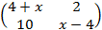is a singular matrix. (3mks)

- Make n the subject of the equation. (3mks)

P = m²
q 3
1 – n²

- The effort (E) applied on a lever to lift a load (L) is partly constant and partly varies as L. When L=3, E=4 and when L=15, E=10. Find the equation connecting E and L. (3mks)

- Simplify leaving your answer in form of a +b. State the value of a, b and c.
(3mks)
−
− +

- Find the centre and radius of a circle whose equation is (3mks)
3x² +3y² −24 x +6y + 3 =0

- Expand (1 – ½ x)⁵ and use the first four terms of your expansion to evaluate (0.95)⁵. Give your answer to 4 s.f. (4mks)

- Determine the quartile deviation for the following set of number
4,9,5,4,7,6,2,1,6,7,8 (3mks)

- A machine A can do a piece of work in 5 hrs while machine B can do the same amount of work in 8 hours, machine A was set to do the piece of work but after 3 hours. It broke down and machine B did the rest of work. Calculate the time machine B took to do the rest of work. (3mks)

- The sides of a triangle were measured and recorded as 8cm, 10cm and 15cm. Calculate the percentage error in the calculation of its perimeter correct to 2 decimal places. (3mks)

- Point T divides line MN externally in the ratio 5:2. Taking the position vectors of M and N to be M= 8 and N= 5

-12 -6
15 0 respectively, find the position vector of T. (3mks)

- Kimtai has 2400m of wire with which he wants to fence three sides of a rectangular piece of land in his farm then grow fruits in it. The fourth side is already fenced. Determine the dimensions that will give the maximum possible area. (4mks)

14. A trader mixed grades A, B and C of coffee in the ratio 2:3:5 respectively. Grade A cost sh. 650 per kg, grade B cost sh. 500 per kg and grade c cost sh. 420 per kg.
(a) Find the cost of 1kg of the mixture (2 marks)

(b) If the trader sold the mixture at a profit of 20%, calculate the selling price of 3kg of the mixture (2 marks)

- In the figure below, AD is a tangent to the circle at D. AB=11cm and BC=8cm. Find the length of AD in 4s.f. (2mks)

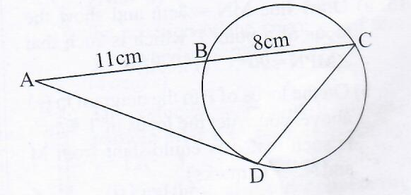

- (a) Draw line MN= 7cm and show the locus of a point P which is such that ‹MPN = 90°. (1mk)
(b) On the locus of P in the diagram in (a) above, construct the locus of T which is such that is equidistant from M and N. (2mks)

SECTION II: (50 Marks)
Answer any five questions from this section in the spaces provided

17. The cost of Jane’s car at the beginning of the year 2000 was sh.750,000. It depreciated in value by 7% per year for the first three years, by 8% for the next two years and by 11% per year for the subsequent years.
- Find the value of the car at:
- The start of the year 2003. (2mks)

- The end of the year 2007. (3mks)

- At the beginning of 2008, Jane sold the car through Mary, a dealer, at 22% more than its actual depreciated value to Lucy. Taking Mary’s sale price as the car’s value after depreciation, find the average monthly rate of depreciation for the 8 years. (5mks)

- The diagram below shows a circle and a triangle that touches its circumference.

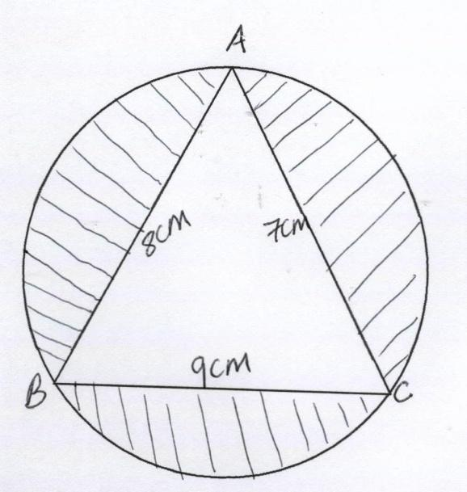

- Find the radius of the circle. (6mks)

- Find the area of the shaded region. (4mks)

- The table below shows the income tax rates for a certain year.

Taxable pay per month (Ksh) | Tax rates
1 – 9,680  9,681 – 18,800  18,801 – 27,920  27,921 – 37,040  37,040 and above | 10%  15%  20%  25%  30%

That year Kazembe paid net tax of Ksh.5,512 per month. His total monthly taxable allowances amounted to Ksh.15,220 and he was entitled to a monthly personal relief of Ksh.1,162.
Every month the following deductions were made:
  - NHIF – Ksh. 320
  - Union dues – Ksh.200
  - Co-operative shares – Ksh.7,500

(a) Calculate Kazembe’s monthly basic salary in Ksh. (7mks)

(b) Calculate his monthly net salary. (3mks)

- The figure below is a square based pyramid ABCDV with AD=DC=6cm and
height VO=10cm

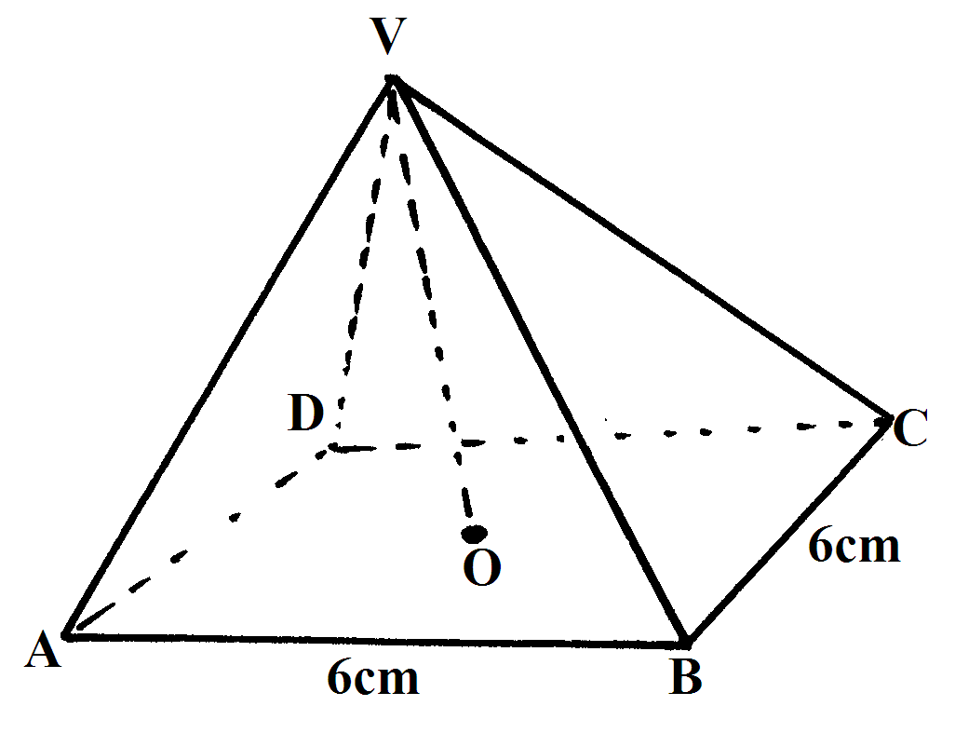

(a) State the projection VA on the base ABCD. (1mk)

(b) Find (i) The length of VA (3mks)

(ii) The angle between VA and ABCD (2mks)

(iii) The angle between VDC and ABCD (2mks)

(iv) Volume of the pyramid. (2mks)

- (a) Complete the table below, giving the values correct to 2 d.p.

X⁰ | 0 | 30 | 60 | 90 | 120 | 150 | 180 | 210 | 240 | 270 | 300 | 330 | 360
Sin2x | 0 |  | 0.87 |  | -0.87 |  | 0 | 0.87 |  |  |  |  | 0
3Cos x ₋2 | 0 | 0.60 |  | -2 | -3.5 |  |  | -4.60 |  |  | -0.5 |  | 1

(b) On the grid provided draw the graphs of y = Sin2x and y = 3 Cos x – 2 for
0⁰≤ x ≤ 360⁰ on the same axes.
Use a scale of 1 cm to represent 30⁰ on the x-axis and 2 cm to represent 1
unit on the y-axes. (5mks)

(c) Use the graph in (b) above to solve the equation 3cos x – Sin2x = 2 (2mks)

(d) State the amplitude of y = 3cos x – 2 (1mk)

- Three variables P, Q and R are such that P varies directly as Q and inversely
as the square of R, when P = 18 Q=24 and R = 4

(a) Find the relationship connecting P, Q and R hence find the value of P when
Q = 30 and R = 10. (5mks)

(b) If P is increased by 20% and R decreased by 10%. Find the percentage
change in Q. (5mks)

- A geometric progression (G.P) is such that the product of its first three terms is 8,000.
- Taking the first term as ‘a’ and the common ratio as ‘r’, express ‘r’ in terms of ‘a’. (3mks)

- The sum of the first three terms in (a) above is 78. Determine the first term and the common ratio of two possible sequences. Hence write the first 6 terms of the two sequences. (5mks)

- Find the product of the 8th terms of the two sequences. (2mks)

- (a) The gradient function of a curve is given by dy = 3x²-2
dx
Determine the equation of the curve given that y=1 when x= -2. (4mks)

(b) The velocity, V m/s of a moving particle after t seconds is given by v=12t² -5.
(i) Find the total distance covered by the particle in the third second. (3mks)

- If the distance covered by the particle at t=1 second was 2m, what distance had been covered at t=5? (3mks)

