Name:………………………………………...………………Index No………………………
Date:…………………………….………
Candidate’s Signature:……………….…………
PHYSICS PRACTICAL
PAPER 232/3
JULY/AUG 2019
TIME:2 ½ HOURS

Kenya Certificate of Secondary Education (K.C.S.E.)

232/3 Physics Paper 3
2 ½ hours

INSTRUCTIONS TO CANDIDATES

- Write your name and index number in the spaces provided above.
- Sign and write the date of examination in the spaces provided above.
- Answer ALL the questions in the spaces provided in the question paper.
- You are supposed to spend the first 15 minutes of the 2½ hours allowed for this paper reading the whole paper carefully before commencing your work.
- Marks are given for a clear record of the observations actually made, their suitability, accuracy and the use made of them.
- Candidates are advised to record their observations as soon as they are made.
- Non-programmable silent electronic calculators may be used.
- This paper consists of 8 printed pages.
- Candidates should check the question paper to ascertain that all the pages are printed as indicated and that no questions are missing.
- Candidates should answer the questions in English.

For Examiner’s Use Only
Question 1
 | b | c | d(i) | d(ii) | e | f | g | h | TOTAL
Maximum Score | 1 | 1 | 5 | 5 | 1 | 2 | 2 | 3 | 20
Candidate’s Score

Question 2
 | v | viii | Ix | x | xi | TOTAL
Maximum Score | 1 | 8 | 5 | 3 | 3 | 20
Candidate’s Score

QUESTION 1 PART A
- You are provided with the following
- A micrometer screw gauge (to be shared)
- Nichrome wire mounted on a mm scale labeled AB
- A voltmeter (0-3v or 0-5v)
- Ammeter (0-1A)
- A switch
- A jockey/long wire with crocodile clip attached
- TWO new dry cells and cell holder
- 8 connecting wires with crocodile clips attached to one end
Proceed as follows
- Set up the circuit as shown below ensure that when the switch is open, both meters read zero, keep the switch open when readings are not being taken.
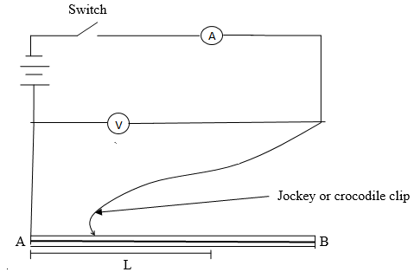

- Measure and record the diameter d of the nichrome wire AB using the micrometer screw gauge.

$d=________________________m$ (1mk)

- Disconnect the jockey from wire AB and close the switch. Record the value E of the voltmeter reading.

$E=________________________v$ (1mk)

- Now, connect the jockey on AB at a distance L=10cm. Close the switch and record the voltmeter and ammeter readings, V and I respectively in table 1 below.
- Table 1
L(cm) | 10 | 20 | 30 | 40 | 50 | 90
V(v)
I(A)
IV(watts)
    - Complete the table (5mks)

    - Plot a graph of IV (y axis) against L (5mks)



- Using your graph, find the value L_{o} from your graph (the horizontal axis)

$L_{0}=________________________cm$ (1mk)
g) Now, place the jockey on AB such that the length L is equal to the value of L= 63cm. close the switch and record both the voltmeter reading, V and the ammeter reading, I

$V=________________________$ (1mk)

$I=________________________$ (1mk)

- Work out the values r where $r=\frac{E-V}{I}$ (2mk)

- Work out the value of e where $e=\frac{{πrd}^{2}}{2.52}$ (3mk)

Question 2
You are provided with the following apparatus
- two metre rules
- two stands and two clamps
- two bosses
- three pieces of thread
- a spring
- one mass of 100g
- a stopwatch
i) Set the apparatus as shown in figure1 below.
ii) Suspend one end of the metre rule with a thread at 5cm mark from the end.
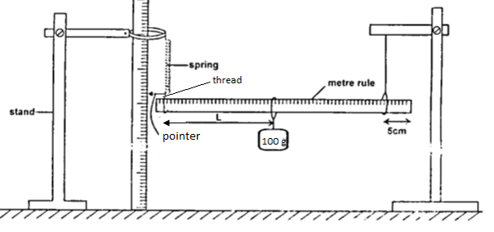
Figure 1
iii) Suspend the other end with a spring also 5cm from the end so that the metre rule is horizontal.
iv) Hold the other rule vertically on the bench so that it is near the end with a pointer as shown in the diagram above.
v) Read the pointer position, Lo .................. cm (1 mk)
vi) Hang on the horizontal metre rule, the 100g mass at a length, L = l0cm from the spring. Record the pointer position X, in the table below.
vii) Displace the mass slightly downwards and release it to oscillate vertically. Take time for 20 oscillations and record in the table below,
viii) Repeat the procedures above for other positions of L, and record the values in the table below

Length L (cm) | 10 | 20 | 30 | 40 | 50
Pointer position X
Extension (m)
Time of 20 oscill,t (s)
Periodic time,T (s)
T² (s²)
(8mks)

ix) Plot a graph of extension, e (y – axis) against T² (5 mks)


x) Calculate the gradient of the graph. (3 marks)

ix) Given that $e= \frac{RT^{2}}{4π^{2}}$determine the value of R (3 marks)

