441/2
HOMESCIENCE
PAPER 2
PRACTICAL
(CLOTHING AND TEXTILE)
TIME: 2 ½ HOURS

GOLDEN ELITE EXAMINATIONS

Kenya Certificate of Secondary Education (K.C.S.E.)
HOMESCIENCE
PAPER 2
TIME: 2 ½ HOURS

A pattern of a child’s dress is provided. You are advised to study the sketches, instructions and the layout carefully before you begin the test.

MATERIALS PROVIDED

- Pattern pieces
- Plain light weight fabric 60cm by 90cm wide
- Sewing thread to match the fabric
- A 6” zip to match the fabric.
- An embroidery thread.
- One large envelope.

THE TEST
Using the materials provided, cut out and make the LEFT HALF of a child’s dress to show the following processes:-
- Joining of the shoulder seam using a double stitched seam.
- Joining of the side seam using an open seam.
- Fixing the Zip fastener using the concealed method.
- Preparation of an interfaced collar.
- Joining the Back and Front neck facings.
- Attaching the collar using the facings.
- Secure the lower hem using herringbone stitches. (Only the Dress front)
At the end of the examination, firmly sew onto your work, on a single fabric, a label bearing your Name and index number.
Remove needles, pins and unnecessary threads from your work, then fold your work neatly and place it in the envelope provided.

Do not put scraps of fabric in the envelope.

BACK VIEW FRONT VIEW
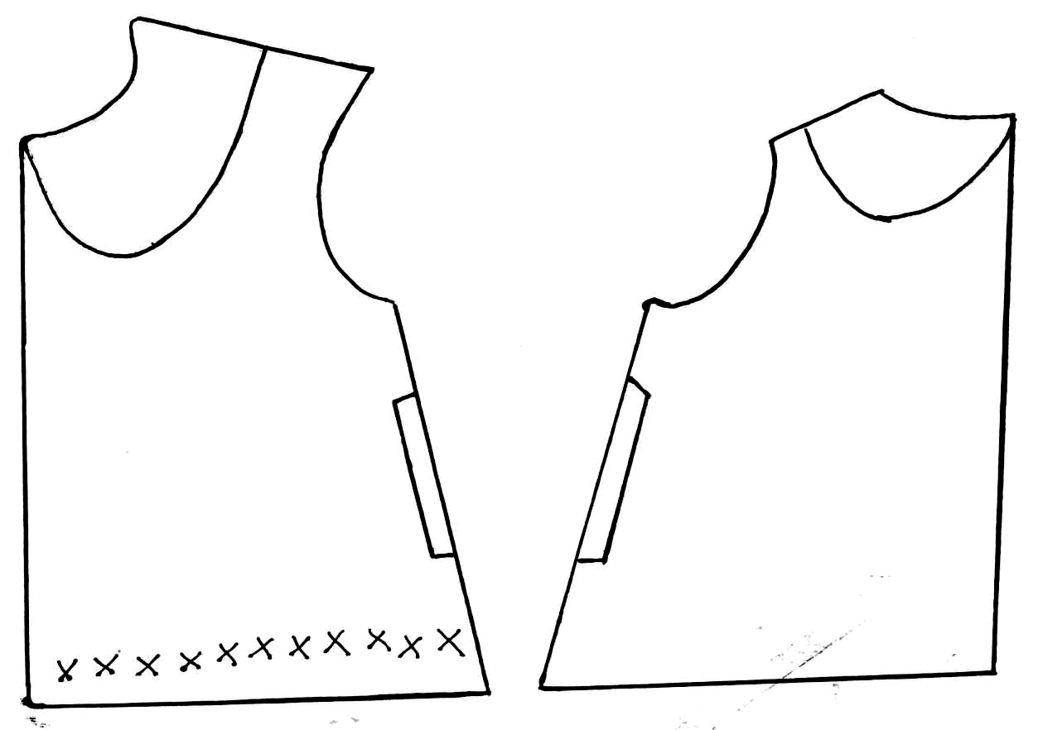
THE LAYOUT (NOT DRAWN TO SCALE)
