

BIOLOGY
PAPER 2
THEORY
2 HOURS

2021 TRIAL 3 OCT/N0VEMBER INTERNAL EXAMINATION

Kenya Certificate of Secondary Education (K.C.S.E.)

Name………………………………………………………. Adm No……………….
Stream……………………………………………………. Date ………………………….
Sign ..............................................................................

BIOLOGY
PAPER 2
2 HOURS

INSTRUCTIONS TO CANDIDATES
(a) Write your name and index number in the spaces provided above.
(b) Sign and write the date of examination in the spaces provided above.
(c) This paper consists of two sections A and B
(d) Answer all the questions in section A in the spaces provided
(e) In section B answer question 6 (compulsory) and either question 7 or 8 in the spaces provided after question 8.

For examiner’s use only
Question | Maximum score | Candidate’s score
1 | 8
2 | 8
3 | 8
4 | 8
5 | 8
6 | 20
6 | 20
Total score | 80

SECTION A 40 MARKS
Answer all the questions in this section in the space provided
- The diagram below shows a section through the mammalian skin

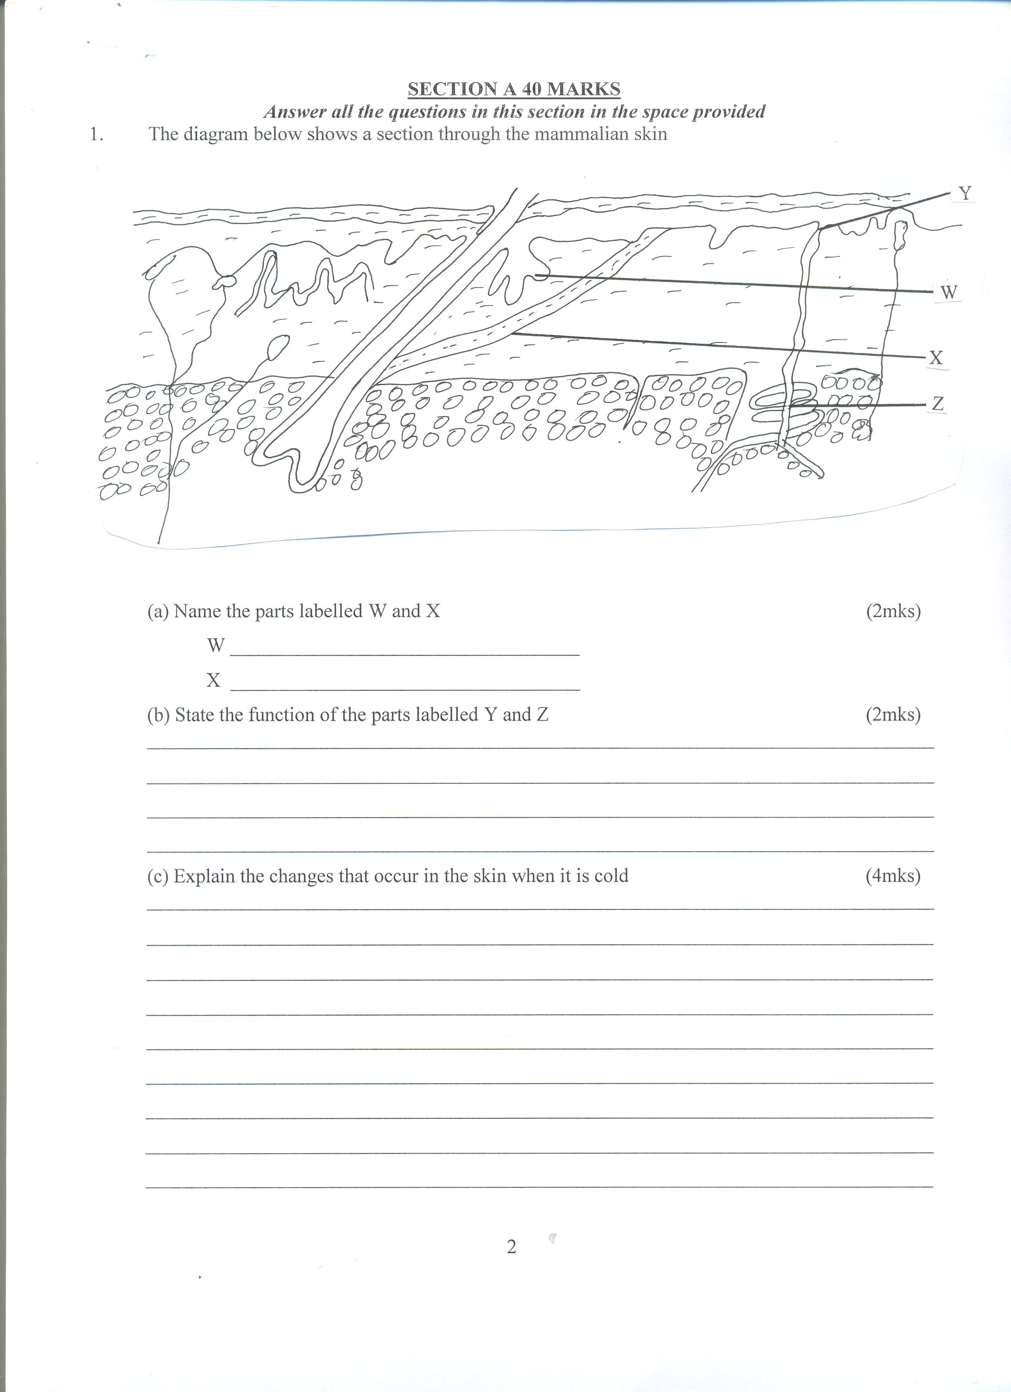

(a) Name the parts labelled W and X (2mks)
W………………………………………………….
X …………………………………………………
(b) State the function of the parts labelled Y and Z (2mks)
………………………………………………………………………………………………………………………………………………………………………………………………………………………………………………………………………………………………………………………………………………………………………………………………………………………………………………………………
(c) Explain the changes that occur in the skin when it is cold (4mks)
………………………………………………………………………………………………………………………………………………………………………………………………………………………………………………………………………………………………………………………………………………………………………………………………………………………………………………………………
………………………………………………………………………………………………………………………………………………………………………………………………………………………………………………………………………………………………………………………………………………………………………………………………………………………………………………………………

- (a) Eye colour in fruits flies is sex-linked. Red eye colour R is dominant to white eye colour r
A heterozygous red –eyed female fly was crossed with a white eyed male
(i) Show the parental genotypes (1mk)
………………………………………………………………………………………………………………………………………………………………………………………………………………………………
(ii) By means of a genetic cross, determine the genotypic ratio of the offsprings (4mks)

(iii) Explain why the actual phenotype ratio obtained from this cross could differ from the
Expected (1mk)
………………………………………………………………………………………………………………………………………………………………………………………………………………………………………………………………………………………………………………………………………………
(b) Name two disorders due to non-disjuction (2mks)
………………………………………………………………………………………………………………………………………………………………………………………………………………………………………………………………………………………………………………………………………………
- The diagram below represents a feeding relationship in an ecosystem.

Snakes

Frogs Hawks

Zooplanktons small fish
Snails

Phytoplanktons

(a) Name the type of ecosystem represented by the above food web (1mk)
………………………………………………………………………………………………………………………………………………………………………………………………………………………………
(b) Name the organism in the food web that
(i) Is a producer (1mk)
………………………………………………………………………………………………………………………………………………………………………………………………………………………………
(ii) Occupies the highest tropic level. (1mk)
………………………………………………………………………………………………………………………………………………………………………………………………………………………………
(c) (i) Write a food chain that ends with the hawk as a quarternary consumer. (1mk)
………………………………………………………………………………………………………………………………………………………………………………………………………………………………
(ii) State two short terms effects on the above ecosystem if all the small fish were killed (2mks)
………………………………………………………………………………………………………………………………………………………………………………………………………………………………………………………………………………………………………………………………………………
(d) (i) How does oil spills lead to death of fish? (1mk)
………………………………………………………………………………………………………………………………………………………………………………………………………………………………………………………………………………………………………………………………………………………………………………………………………………………………………………………………
(ii) Name one other cause of water pollution apart from oil spills. (1mk)
………………………………………………………………………………………………………………………………………………………………………………………………………………………………
- The experiment below was set – up to investigate some physiological processes. The glucose
solution was first boiled then cooled. The set up was left for 24 hours

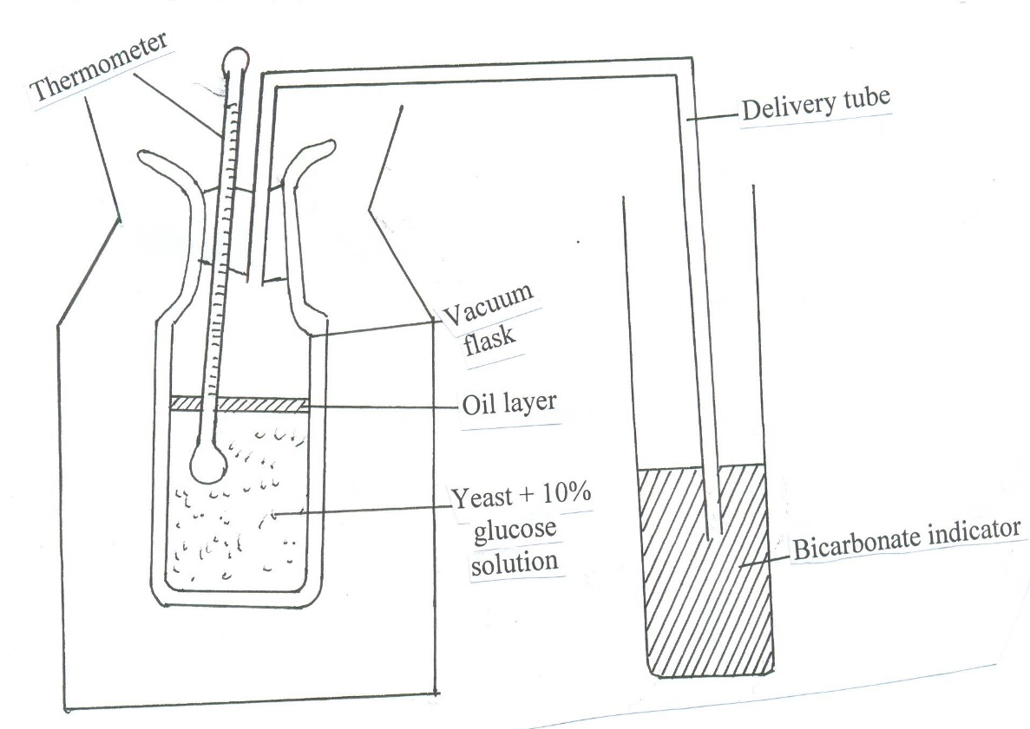

(a) Suggest two aims of the experiment. (2mks)
………………………………………………………………………………………………………………………………………………………………………………………………………………………………………………………………………………………………………………………………………………………………………………………………………………………………………………………………
(b) (i) State the expected observations after 24 hours (2mks)
………………………………………………………………………………………………………………………………………………………………………………………………………………………………………………………………………………………………………………………………………………………………………………………………………………………………………………………………
(ii) Explain your observations in a (i) above (2mks)
………………………………………………………………………………………………………………………………………………………………………………………………………………………………………………………………………………………………………………………………………………………………………………………………………………………………………………………………
(iii) Why was glucose solution boiled then cooled? (1mk)
………………………………………………………………………………………………………………………………………………………………………………………………………………………………………………………………………………………………………………………………………………
(c) Suggest a control for the above experiment. (1mk)
………………………………………………………………………………………………………………………………………………………………………………………………………………………………
- A group of students set up an experiment to investigate a certain physiological process. The set up was as shown in the diagram below.

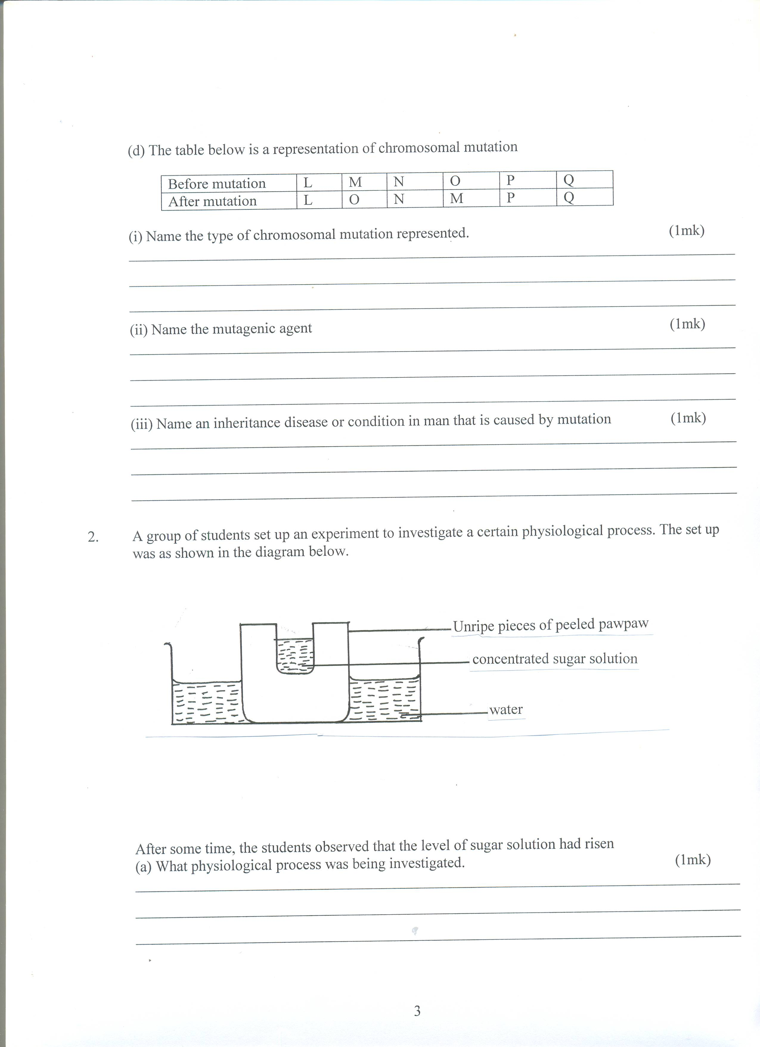

After some time, the students observed that the level of sugar solution had risen
(a) What physiological process was being investigated. (1mk)
………………………………………………………………………………………………………………………………………………………………………………………………………………………………
(b) Account for the rise in the level of sugar solution in this experiment. (4mks)
………………………………………………………………………………………………………………………………………………………………………………………………………………………………………………………………………………………………………………………………………………
………………………………………………………………………………………………………………………………………………………………………………………………………………………………………………………………………………………………………………………………………………
(c) (i) State the results that the students would obtain if they repeated the experiment using
a piece of boiled pawpaw. (1mk)
………………………………………………………………………………………………………………………………………………………………………………………………………………………………………………………………………………………………………………………………………………
(ii) Give a reason for your answer (2mks)
………………………………………………………………………………………………………………………………………………………………………………………………………………………………………………………………………………………………………………………………………………

SECTION B (40 MARKS)
Answer questions 6 (compulsory) and either questions 7 or 8 in the spaces provided questions
- During germination and growth of a cereal, the dry weight of endosperm, the embryo and the total dry weight were determined at two day intervals. The results are shown in the table below:

Time after planting (days) | Dry weight of endosperm (mg) | Dry weight of embryo (mg) | Total dry weight (mg)
0 | 43 | 2 | 45
2 | 40 | 2 | 42
4 | 33 | 7 | 40
6 | 20 | 17 | 37
8 | 10 | 25 | 35
10 | 6 | 33 | 39
- Using the same axes, draw graphs of dry weight of endosperm, embryo and the total dry weight against time. (7mks)

- What was the total dry weight on day 5 (1mark)
..........................................................................................................................................................................................................................................................................................................................................................................................................................................................................................................................................
- Account for
- Decrease in dry weight of endosperm from 0 to 10 (2mks)
............................................................................................................................................................................................................................................................................................................................................................
- Increase in dry weight of embryo from day 0 to day 10 (2mks)
........................................................................................................................................................................................................................................................................................................................................................................................................................................................................................................................................................................................................................................................................................................................
- Decrease in total dry weight from day 0 to day 8 (1mk)
.......................................................................................................................................................................................................................................................................................................................................................................................................................................................................................................................................... iv. Increase in total dry weight after day 8 (1mk)
................................................................................................................................................................................................................................................................................................................................................................................................................................................................................................................................................................................................................................................................................................
- State two factors within the seed and two outside the seed that cause dormancy
- Within the seed. (2mks)
..........................................................................................................................................................................................................................................................................................................................................................................................................................................................................................................................................

- Outside the seed (2marks)
..........................................................................................................................................................................................................................................................................................................................................................................................................................................................................................................................................
- Give two characteristics of meristematic cells (2mks)
..........................................................................................................................................................................................................................................................................................................................................................................................................................................................................................................................................

7. (a) Describe the process of fertilization in flowering plants (15mks)
(b) State the changes that take place in a flower after fertilization (5mks)

8. (a) Describe the mechanism of inhalation in man. (10mks)
(b) Using photosynthesis theory explain the mechanics of opening of stomata. (10mks)
………………………………………………………………………………………………………………………………………………………………………………………………………………………………………………………………………………………………………………………………………………
………………………………………………………………………………………………………………………………………………………………………………………………………………………………………………………………………………………………………………………………………………
………………………………………………………………………………………………………………………………………………………………………………………………………………………………………………………………………………………………………………………………………………
………………………………………………………………………………………………………………………………………………………………………………………………………………………………………………………………………………………………………………………………………………
………………………………………………………………………………………………………………………………………………………………………………………………………………………………………………………………………………………………………………………………………………
………………………………………………………………………………………………………………………………………………………………………………………………………………………………………………………………………………………………………………………………………………
………………………………………………………………………………………………………………………………………………………………………………………………………………………………………………………………………………………………………………………………………………
………………………………………………………………………………………………………………………………………………………………………………………………………………………………………………………………………………………………………………………………………………
………………………………………………………………………………………………………………………………………………………………………………………………………………………………………………………………………………………………………………………………………………
………………………………………………………………………………………………………………………………………………………………………………………………………………………………………………………………………………………………………………………………………………
………………………………………………………………………………………………………………………………………………………………………………………………………………………………………………………………………………………………………………………………………………
………………………………………………………………………………………………………………………………………………………………………………………………………………………………………………………………………………………………………………………………………………
………………………………………………………………………………………………………………………………………………………………………………………………………………………………………………………………………………………………………………………………………………
………………………………………………………………………………………………………………………………………………………………………………………………………………………………………………………………………………………………………………………………………………
………………………………………………………………………………………………………………………………………………………………………………………………………………………………………………………………………………………………………………………………………………
………………………………………………………………………………………………………………………………………………………………………………………………………………………………………………………………………………………………………………………………………………
………………………………………………………………………………………………………………………………………………………………………………………………………………………………………………………………………………………………………………………………………………
………………………………………………………………………………………………………………………………………………………………………………………………………………………………………………………………………………………………………………………………………………
………………………………………………………………………………………………………………………………………………………………………………………………………………………………………………………………………………………………………………………………………………

