

233/1
CHEMISTRY
PAPER 1
TIME: 2 HOURS

2021 TRIAL 3 OCT/N0VEMBER INTERNAL EXAMINATION

Kenya Certificate of Secondary Education (K.C.S.E.)

Name………………………………………………………. Adm No……………….
Stream……………………………………………………. Date ………………………….
Sign ..............................................................................

233/1
CHEMISTRY
PAPER 1
TIME: 2 HOURS

Kenya certificate of secondary education (K.C.S.E)

INSTRUCTIONS TO CANDIDATES:
- Write your name and index number in the spaces provided above.
- Sign and write the date of examination in the spaces provided above.
(iii) Answer ALL the questions in the spaces provided.
(iv) Mathematical tables and silent electronic calculators may be used.
(v) All working must be clearly shown where necessary.
(vi) Candidates should check the question paper to ascertain that all the pages
are printed as indicated and that no questions are missing

For Examiner’s Use Only
Questions | Maximum Score | Candidate’s Score
1 –30 | 80

- The samples of equal volumes of water were put in 100cm³ conical flasks and heated for 5 minutes on a Bunsen flame. It was observed that sample 1 registered a low temperature than sample II
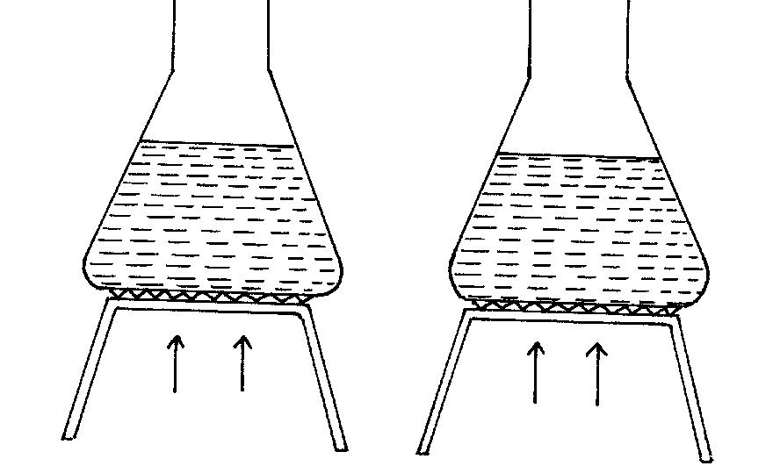
Flame 1
Flame II

(a) Name flame I (1mk)

…………………………………………………………………………………………………..
(b) State one disadvantage of using flame I for heating (1mk)

…………………………………………………………………………………………………..
- Study the diagram below and answer the questions that follow.
The diagram shows the method used to separate component of mixture P

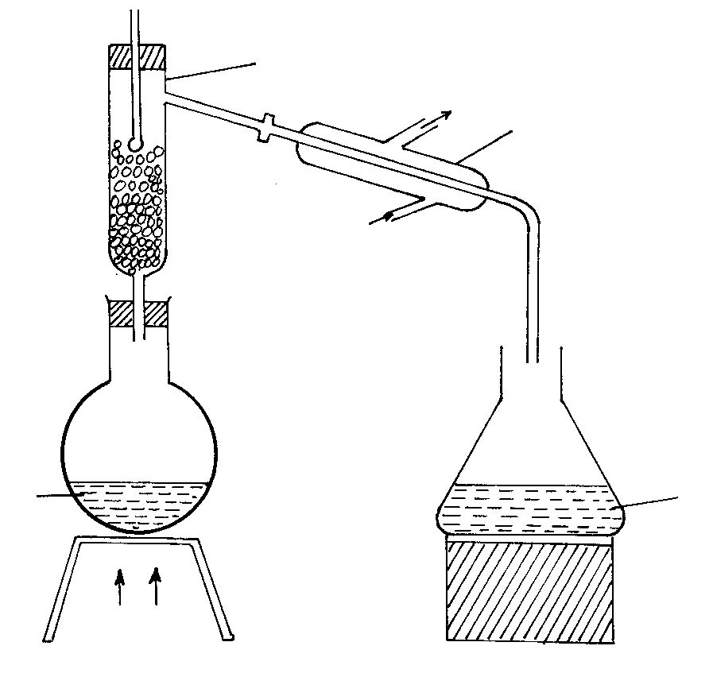
Liquid mixture
P
.
Heat
Distillate
Cold water
Lie big condenser
Hot water
X
(a) Name X (1mk)

………………………………………………………………………………………………………….
(b) What is the name given to the method used in separation of mixture P (½mk)

………………………………………………………………………………………………………….

(c) What would happen if the inlet and outlet of water were interchanged ( ½mk)

…………………………………………………………………………………………………………………………………………………………………………………………………………………….
(d) Which physical property is used to separate mixture P (1mk)

…………………………………………………………………………………………………………..
- The table below shows the solubility of three solids P, Q, and R.

Solid Cold Water Hot Water
P soluble soluble
Q insoluble insoluble
R Insoluble soluble
How would you obtain pure samples of R,P and Q (2mks)

………………………………………………………………………………………………………………………………………………………………………………………………………………………………………………………………………………………………………………………………………………………………………………………………………………………………………………………………………………………………………………………………………………………………………………
- State why a water molecule H₂O can combine with H⁺ ion to form H₃O⁺ ion (1mk)
………………………………………………………………………………………………………………………………………………………………………………………………………………………………………………………………………………………………………………………………………………
- The P^{H} values of some solutions are given below
P^{H} | 14.0 | 1.0 | 8.0 | 6.5 | 7.0
Solution | M | L | N | P | Z
(a) Identify the solution with the lowest concentration of hydrogen ion. Give reason for your answer (1mk)

……………………………………………………………………………………………………………………………………………………………………………………………………………………
(b) Which solution would be used as an anti-acid for treating stomach upset. Give for your answer (1mk)
……………………………………………………………………………………………………………………………………………………………………………………………………………………

- The data below gives the electronic configuration of some selected atoms and ions
Atom/ion | A²⁺ | B | C²⁻ | D²⁺ | E | F⁻ | G⁺ | H
Electronic configuration | 2 | 2.4 | 2.8 | 2.8.8 | 2.8 | 2.8.8 | 0 | 2.8.2
(a) Select an atom that is a noble gas (1mk)

…………………………………………………………………………………………………………..
(b) What is the atomic number of C and A (1mk)

……………………………………………………………………………………………………………………………………………………………………………………………………………………
(c) Select an element that belong to group 2 and period four (1mk)

………………………………………………………………………………………………………….
(d) Write the formula of the compound formed when D and F react (1mk)

…………………………………………………………………………………………………………..
- Helium is used instead of hydrogen in balloons for metrological research. Explain (1mk)

………………………………………………………………………………………………………………………………………………………………………………………………………………………………
- Zinc metal and hydrochloric acid reacts according to the following equation
Zn_{(s)} + 2HCl _{(aq)} ZnCl_{2 (aq)} + H_{2 (g)}
1.96g of Zinc metal were reacted with 100cm³ of 0.2M hydrochloric acid
a) Determine the reagent that was in excess (2mks)
Zn=65.2; Molar gas volume at s.t.p 22.4 liters
………………………………………………………………………………………………………………………………………………………………………………………………………………………………………………………………………………………………………………………………………………………………………………………………………………………………………….
(b) Calculate the total volume of hydrogen gas that was liberated at s.t.p (1mk)
………………………………………………………………………………………………………………………………………………………………………………………………………………………………………………………………………………………………………………………………
- Give the IUPAC names of the following compounds (1mk)
(i) .CH₃CH₂CH₂CH CH₃

CH₃ …………………………………………………………………………….

(ii) CH₃CH=CHCl …………………………………………………………………………… (1mk)

- 0.9g of potassium chloride and potassium carbonate mixture completely reacted with 25cm³ of 0.2M hydrochloric acid
(i) Write an equation of the reaction which takes place (1mk)

…………………………………………………………………………………………………………
(ii) Determine the number of moles of the acid used (1mk)
……………………………………………………………………………………………………………………………………………………………………………………………………………………
(iii) Calculate the mass of potassium chloride in the mixture (K=39.0; C=12.0; O=16.0) (2mks)
…………………………………………………………………………………………………………………………………………………………………………………………………………………………………………………………………………………………………………………………………………………………………………………………………………………………………………

- Study the flow chart below and answer the questions that follow

Dilute Hydrochloric acid
Metal M
Colourlesss gas
Solution E
White ppt soluble in excess
Process 2
NaOH added
drop wise
Process I
Ammonia solution added drop wise
White ppt soluble
in excess

(i) Identify metal M: ………………………………………………………. (1mk)

(ii) Colourless gas: …………………………………………………………. (1mk)

(iii) Write an equation that leads to the formation of white precipitate in process (1mk)

…………………………………………………………………………………………………
- a) Define the term dynamic equilibrium (1mk)
END
………………………………………………………………………………………………………………………………………………………………………………………………………………………………………………………………………………………………………………………………..

b) A reaction at equilibrium can be represented as
2CrO²⁻_{4[aq]} +2H⁺[aq] Cr₂O7 ²[⁻_{aq]} + H₂O_{{l}}
Yellow orange
State and explain the observation made when NaOH is added to the equilibrium mixture (2mks)
…………………………………………………………………………………………………………………………………………………………………………………………………………………………………………………………………………………………………………………………………………………………………………………………………………………………………………
13. Few drops of hydrochloric acid were added into a test tube containing lead {II} Nitrate solution
a) State one observation made (1mk)

…………………………………………………………………………………………………………
b) Write an ionic equation of the reaction that occurred in the test tube (1mk)

…………………………………………………………………………………………………………
- A compound of carbon, hydrogen and oxygen contains 57.15% carbon, 4.76% hydrogen and the rest oxy gen. If its relative molecular mass is 126, find its molecular formula. (C = 12, H = 1, O = 16) (3mks)

………………………………………………………………………………………………………………………………………………………………………………………………………………………………………………………………………………………………………………………………………………………………………………………………………………………………………………………………………………………………………………………………………………………………………………………………………………………………………………………………………………………………
- Study the information in the table below and answer the questions that follow.

Salt | Solubility g/100g of water
Salt | At 40°C | At 60°C
CuSO₄ | 28 | 38
Pb(NO₃)₂ | 79 | 98

A mixture containing 35g of CuSO₄ and 78g of Pb(NO₃)₂ in 100g of water at 60°C was cooled to 40°C.

i) Which salt crystallized out? Give a reason. (2 marks)
……………………………………………………………………………………………………………………………………………………………………………………………………………………
ii) Calculate the mass of the salt that crystallized out. (1 mark)
……………………………………………………………………………………………………………………………………………………………………………………………………………………
- a) Distinguish between strong and concentrated acid ( 1mk)

…………………………………………………………………………………………………………………………………………………………………………………………………………………………………………………………………………………………………………………………………………………………………………………………………………………………………………
b). A solution of ammonia in methylbenzene has no effects on red litmus paper while a
solution of ammonia in water turns red litmus paper blue. Explain (2mks)
…………………………………………………………………………………………………………………………………………………………………………………………………………………………………………………………………………………………………………………………………………………………………………………………………………………………………………
- Name the process which takes place when
- Iodine changes directly from solid to gas (1mk)

…………………………………………………………………………………………………..
- Fe²⁺_{( aq)} changes to Fe³⁺_{(aq)} (1mk)

………………………………………………………………………………………………….
- White sugar changes to black when mixed with concentrated sulphuric (VI) acid (1mk)

………………………………………………………………………………………………….
- In the last stage of the solvay process, a mixture of sodium hydrogen carbonate and ammonium chloride is formed

- State the method of separation used (1mk)
…………………………………………………………………………………………………………..
- Write an equation showing how lime is slaked (1mk)
…………………………………………………………………………………………………………..
- Name the by- product recycled in the above process (1mk)
…………………………………………………………………………………………………………..
- The diagram below is a section of a model of the structure of element K
Key
charged nucleus

electron
+
+
+
+
+
+
+
+
+
+
+
+
+
+
+
+
+
+
+
- State the type of bonding that exist in K (1mk)
………………………………………………………………………………………………………….
- In which group of the periodic table does element K belong. Give a reason (2mks)
……………………………………………………………………………………………………………………………………………………………………………………………………………………
- Study the diagram below and answer the questions that follow
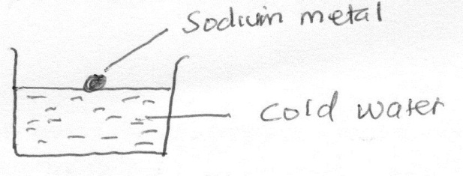
- State two observations made in the above experiment when sodium react with water (2 mks)

……………………………………………………………………………………………………………………………………………………………………………………………………………………
- Write a chemical equation for the reaction that takes place (1mk)

………………………………………………………………………………………………………….

- (a) Explain why permanent hardness in water cannot be removed by boiling (2mks)
………………………………………………………………………………………………………………………………………………………………………………………………………………………………………………………………………………………………………………………………
(b) Name two methods that can be used to remove permanent hardness from water (1mk)
……………………………………………………………………………………………………………………………………………………………………………………………………………………

22. Write an equation to show the effect of heat on the nitrate of: - (2mks)
i) Potassium
…………………………………………………………………………………………………..
(ii) Silver
…………………………………………………………………………………………………..
- Study the diagram below and use it to answer the questions that follow.

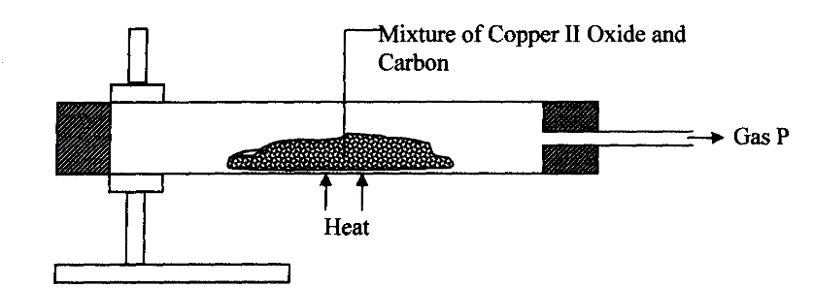

- State the observation made in the combustion tube. (1mk)
……………………………………………………………………………………………………………………………………………………………………………………………………………………
- Write an equation for the reaction that took place in the combustion tube. (1mk)
………………………………………………………………………………………………………. (c) Name gas P (1mk)

…………………………………………………………………………………………………………
24. Sulphur exists in two crystalline forms.
a) Name one crystalline form of Sulphur. (1mk)
…………………………………………………………..………………………………………………
b) State two uses of Sulphur. (2mks)
………………………………………………………………………………………………………..………………………………………………………..……………………………………………………

- Bond energies for some bonds are tabulated below: -
BOND | BOND ENERGY KJ/mol
H – H | 436
C = C | 610
C- H | 410
C – C | 345

Use the bond energies to estimate the enthalpy for the reaction. (3mks)
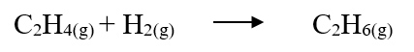
…………………………………………………………………………………………………………………………………………………………………………………………………………………………………………………………………………………………………………………………………………………………………………………………………………………………………………………………………………………………………………………………………………………………………………………………………………………………………………………………………………………………………………………………………………………………………………
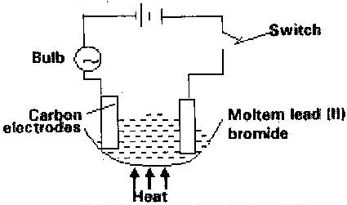
- Study the set up below and answer the questions that flows

State all the observations that would be made when the circuit is completed (3mks)
……..…………………………………………………………………….……………………..…………..……………………………………………………………………………………………………………………………………………………………………………………………………………………………………………………………………………………………………………………………………………..

- Describe how solid samples of salts can be obtained from a mixture of lead (II) chloride, sodium chloride and ammonium chloride. (3mks)

………………………………………………………………………………………………………………………………………………………………………………………………………………………………………………………………………………………………………………………………………………………………………………………………………………………………………………………………………………………………………………………………………………………………………………………………………………………………………………………………………………………………
- The diagram below represents a set-up used to prepare oxygen gas.
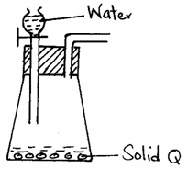

(a) Name substance Q. (1mk)

…………………………………………………………………………………………………..

(b) Complete the set-up to show how oxygen gas is collected. (1mk)

(c) Write the equation for the reaction that occur. (1mk)

…………………………………………………………………………………………………………
- Two reagents that can be used to prepare chlorine gas are potassium manganate
(VII) and hydrochloric acid.
(a) Write an equation for the reaction. (1mk)

…………………………………………………………………………………………………………..
b) Give the formula of another reagent that can be used instead of potassium manganate (VII). (1mk)

…………………………………………………………………………………………………………..

- Using an equation illustrate how chlorine bleach coloured substances. (2mks)
………………………………………………………………………………………………………………………………………………………………………………………………………………………………………………………………………………………………………………………………

