
443/1 AGRICULTURE

PAPER 1
(THEORY)
DURATION:: 2HRS

2021 TRIAL 3 OCT/N0VEMBER INTERNAL EXAMINATION

Kenya Certificate of Secondary Education (K.C.S.E.)

Name………………………………………………………. Adm No……………….
Stream……………………………………………………. Date ………………………….
Sign ..............................................................................

443/1 AGRICULTURE
PAPER 1
(THEORY)
DURATION:: 2HRS

Instructions to candidates
a) Write your name and index in the spaces provided above
b) Sign and write the date of examination in the spaces provided above
c) This paper consists of three sections A, B and C.
d) Answer all the questions in sections A and B.
e) Answer any two questions in section C
f) All answers should be written in the spaces provided in the question paper.

For Examiner’s Use Only
Section | Question | Maximum Score | Candidates Score
A | 1 – 20 | 30
B | 21 - 26 | 40
C | 27-29 | 20
Total Score |  | 90

- State two methods which can be used to detect mineral deficiency in crops. (lmk)
……………………………………………………………………………………………………….
……………………………………………………………………………………………………….
- State two conditions under which shifting cultivation is favourable. (lmk)
……………………………………………………………………………………………………….
……………………………………………………………………………………………………….
- State two conditions under which seeds are seeded at a high seed rate. (2mks)
……………………………………………………………………………………………………….
………………………………………………………………………………………………………. ……………………………………………………………………………………………………….
……………………………………………………………………………………………………….
- State three ways in which trees improve soil fertility. (1 ¹/₂ mks)
……………………………………………………………………………………………………….
……………………………………………………………………………………………………….
……………………………………………………………………………………………………….
- Give three causes of hardpans in cultivation. (1 ¹/₂ mks)
……………………………………………………………………………………………………….
………………………………………………………………………………………………………. ……………………………………………………………………………………………………….
- Under what two conditions does opportunity cost not exist? (lmk)
……………………………………………………………………………………………………….
……………………………………………………………………………………………………….
- Give two roles of additives in silage making. (lmk)
……………………………………………………………………………………………………….
……………………………………………………………………………………………………….
- Outline four advantages of mixed farming. (2mks)
……………………………………………………………………………………………………….
………………………………………………………………………………………………………. ……………………………………………………………………………………………………….
……………………………………………………………………………………………………….

- Give three reasons why bulbils make good planting materials than suckers. (2mks)
……………………………………………………………………………………………………….
………………………………………………………………………………………………………. ……………………………………………………………………………………………………….
- Give three reasons why agriculture is defined as a science. (1 ¹/₂ mks)
……………………………………………………………………………………………………….
……………………………………………………………………………………………………….
……………………………………………………………………………………………………….
- Give four characteristics of large scale farming system. (2mks)
……………………………………………………………………………………………………….
………………………………………………………………………………………………………. ……………………………………………………………………………………………………….
……………………………………………………………………………………………………….
- State four farming practices which help to improve soil structure. (2mks)
……………………………………………………………………………………………………….
………………………………………………………………………………………………………. ……………………………………………………………………………………………………….
……………………………………………………………………………………………………….
- Give four effects of top dressing on a pasture. (2mks)
……………………………………………………………………………………………………….
………………………………………………………………………………………………………. ……………………………………………………………………………………………………….
……………………………………………………………………………………………………….
- What are the two reasons for innoculating legume seeds before planting . (1mk)
……………………………………………………………………………………………………….
……………………………………………………………………………………………………….
- State two advantages of carrying out pruning in banana production. (1mk)
……………………………………………………………………………………………………….
……………………………………………………………………………………………………….

- In maize hybrid 614 what do the following figures stand for? (1mk)
(i) 6……………………………………………………………………………………
- 4…………………………………………………………………………………….
- Give two ways in which pastures are classified. (1mk)
……………………………………………………………………………………………………….
……………………………………………………………………………………………………….
- Name four practices carried out to improve and maintain permanent pasture. (2mks)
……………………………………………………………………………………………………….
……………………………………………………………………………………………………….
……………………………………………………………………………………………………….
……………………………………………………………………………………………………….
- Give four advantages of tissue culture. (2mks)
……………………………………………………………………………………………………….
……………………………………………………………………………………………………….
……………………………………………………………………………………………………….
……………………………………………………………………………………………………….
- Give three stages of controlling devils horsewhip by mechanical means. (1½ marks)
……………………………………………………………………………………………………….
……………………………………………………………………………………………………….
……………………………………………………………………………………………………….

SECTION B
- The diagram below shows a set up of apparatus for finding the percentage of humus contents in a soil by ignition.
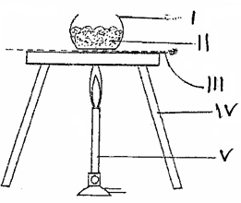

(a) Label the apparatus. (2 marks)

I ……………………………………………………………………………………………

II …………………………………………………………………………………………...

III …………………………………………………………………………………………..

IV …………………………………………………………………………………………...

(b) Outline the steps followed in carrying out the illustrated experiment. (3 marks)

………………………………………………………………………………………………………
………………………………………………………………………………………………………
………………………………………………………………………………………………………
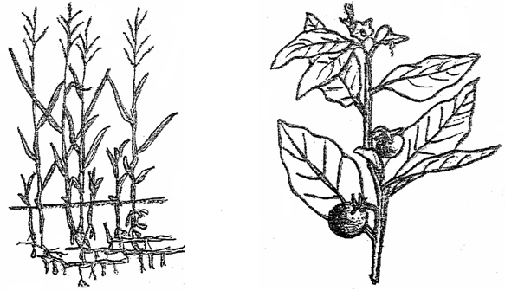
………………………………………………………………………………………………………
G
H

(i) Identify the weeds above. (2 marks)

G ……………………………………………………………………………

H ……………………………………………………………………………

- State the economic importance of the weed shown in diagram G. (2 marks)

………………………………………………………………………………………………………
………………………………………………………………………………………………………
………………………………………………………………………………………………………
………………………………………………………………………………………………………
(iii) Why is it difficult to control weed in diagram G? (1 mark)

………………………………………………………………………………………………………
………………………………………………………………………………………………………
- Study the pest below and answer the questions below.

- Identify the pest (1 mark)
…………………………………………………………………………………………..
- State two methods of controlling the pest. (2 marks)
………………………………………………………………………………………………………
………………………………………………………………………………………………………
- Name the crops attacked by the pest. (2 marks)
………………………………………………………………………………………………………
………………………………………………………………………………………………………

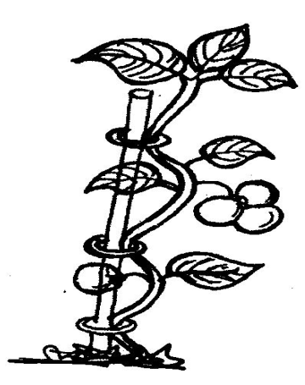
- The diagram below illustrates a field management practices in tomatoes

- Identify the practice (1 mark)
…………………………………………………………………………………………….
- State three reasons for carrying out the practice. (3 marks)
………………………………………………………………………………………………………
………………………………………………………………………………………………………
………………………………………………………………………………………………………
- Give another practice that could be carried out to give the same results. (1 mark)
………………………………………………………………………………………………………
- Study the diagram below then answer the questions that follow:
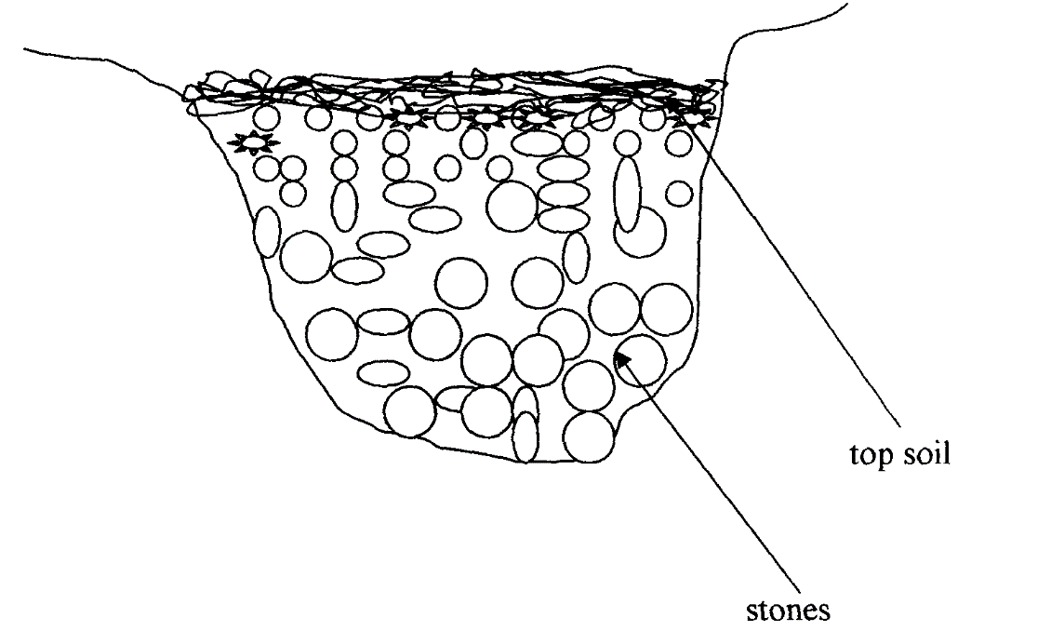
- Identify the method of drainage above. (1mk)
………………………………………………………………………………………………………
………………………………………………………………………………………………………

- State other three methods used to drain swampy areas. (3mks)
…………………………………………………………………………………………………….
…………………………………………………………………………………………………….
…………………………………………………………………………………………………….
- Give four importance of drainage. (4mks)
…………………………………………………………………………………………………….
…………………………………………………………………………………………………….
…………………………………………………………………………………………………….
…………………………………………………………………………………………………….
…………………………………………………………………………………………………….
……………………………………………………………………………………………………. …………………………………………………………………………………………………….
…………………………………………………………………………………………………….
- Study the processes of chemical water treatment below and answer the questions that follow:
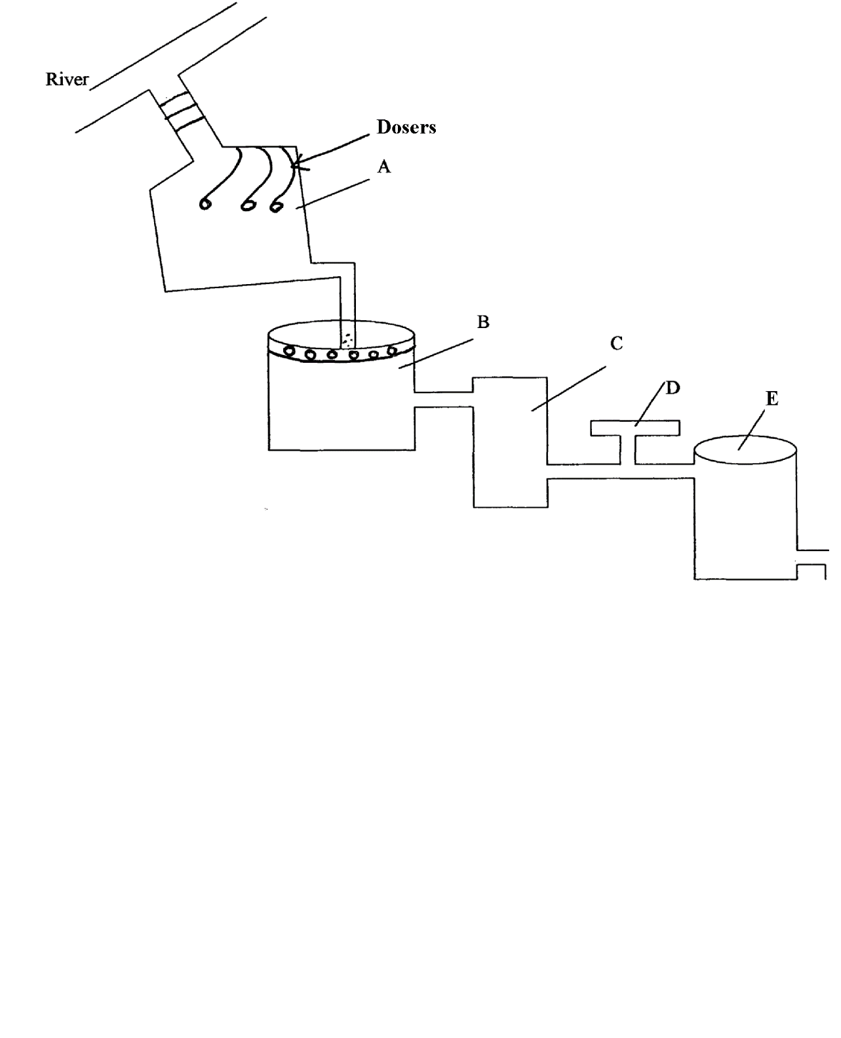
(a) Identify the parts labeled: (2mks)
A ……………………………………………………………………………………….
B ……………………………………………………………………………………….
C ……………………………………………………………………………………….
D ………………………………………………………………………………………
(b) State two chemical substances added at part labeled B and give their functions. (2mks)
…………………………………………………………………………………………………….
…………………………………………………………………………………………………….
(c) State two factors which influence the quantity of the chemical used in part labeled D.
(2mks)
…………………………………………………………………………………………………….
…………………………………………………………………………………………………….
…………………………………………………………………………………………………….
(d) State three uses of water in crop production. (3 mks)
…………………………………………………………………………………………………….
…………………………………………………………………………………………………….
…………………………………………………………………………………………………….
(e) State three types of production functions in agriculture. (3mks)
…………………………………………………………………………………………………….
…………………………………………………………………………………………………….
…………………………………………………………………………………………………….
SECTION C (20MKS)
- (a) Describe the cultural methods of weed control in crop production. (l0mks)
……………………………………………………………………………………………………….
………………………………………………………………………………………………………. ……………………………………………………………………………………………………….
………………………………………………………………………………………………………. ……………………………………………………………………………………………………….
………………………………………………………………………………………………………. ……………………………………………………………………………………………………….
………………………………………………………………………………………………………. ……………………………………………………………………………………………………….
………………………………………………………………………………………………………. ……………………………………………………………………………………………………….

(b) Describe the harmful effects of pests on crops (10mks)
……………………………………………………………………………………………………….
………………………………………………………………………………………………………. ……………………………………………………………………………………………………….
………………………………………………………………………………………………………. ……………………………………………………………………………………………………….
………………………………………………………………………………………………………. ……………………………………………………………………………………………………….
………………………………………………………………………………………………………. ……………………………………………………………………………………………………….
………………………………………………………………………………………………………. ……………………………………………………………………………………………………….
……………………………………………………………………………………………………….
………………………………………………………………………………………………………. ……………………………………………………………………………………………………….
………………………………………………………………………………………………………. ……………………………………………………………………………………………………….
……………………………………………………………………………………………………….
- (a) Discuss the human factors which influence agriculture. (10 marks)
……………………………………………………………………………………………………….
………………………………………………………………………………………………………. ……………………………………………………………………………………………………….
………………………………………………………………………………………………………. ……………………………………………………………………………………………………….
………………………………………………………………………………………………………. ……………………………………………………………………………………………………….
………………………………………………………………………………………………………. ……………………………………………………………………………………………………….
………………………………………………………………………………………………………. ……………………………………………………………………………………………………….
……………………………………………………………………………………………………….
………………………………………………………………………………………………………. ……………………………………………………………………………………………………….
………………………………………………………………………………………………………. ……………………………………………………………………………………………………….
………………………………………………………………………………………………………. ……………………………………………………………………………………………………….
……………………………………………………………………………………………………….
(b) Explain five factors to consider when choosing the planting time. (10 marks)
……………………………………………………………………………………………………….
………………………………………………………………………………………………………. ……………………………………………………………………………………………………….
………………………………………………………………………………………………………. ……………………………………………………………………………………………………….
………………………………………………………………………………………………………. ……………………………………………………………………………………………………….
………………………………………………………………………………………………………. ……………………………………………………………………………………………………….
……………………………………………………………………………………………………….
- Describe the production of carrots under the following sub headings
a) Seedbed preparation (3 marks)
……………………………………………………………………………………………………….
………………………………………………………………………………………………………. ……………………………………………………………………………………………………….
……………………………………………………………………………………………………….
……………………………………………………………………………………………………….
………………………………………………………………………………………………………. ……………………………………………………………………………………………………….
……………………………………………………………………………………………………….

b) Harvesting (4 marks)
……………………………………………………………………………………………………….
………………………………………………………………………………………………………. ……………………………………………………………………………………………………….
……………………………………………………………………………………………………….
……………………………………………………………………………………………………….
………………………………………………………………………………………………………. ……………………………………………………………………………………………………….
……………………………………………………………………………………………………….

c) Explain five cultural methods of weed control in beans production. (10 marks)
……………………………………………………………………………………………………….
………………………………………………………………………………………………………. ……………………………………………………………………………………………………….
……………………………………………………………………………………………………….
……………………………………………………………………………………………………….
………………………………………………………………………………………………………. ……………………………………………………………………………………………………….
……………………………………………………………………………………………………….
……………………………………………………………………………………………………….
………………………………………………………………………………………………………. ……………………………………………………………………………………………………….
……………………………………………………………………………………………………….
……………………………………………………………………………………………………….
………………………………………………………………………………………………………. ……………………………………………………………………………………………………….
……………………………………………………………………………………………………….

d) Outline three roles of sulphur in crop production. (3 marks)
……………………………………………………………………………………………………….
………………………………………………………………………………………………………. ……………………………………………………………………………………………………….
………………………………………………………………………………………………………. ……………………………………………………………………………………………………….
……………………………………………………………………………………………………….

