Name………………………………………………… Adm No……………Class………
121/2
Mathematics
Paper 2
2 ½ Hours June 2022

KASSU JET EXAMINATIONS
Kenya Certificate of Secondary Education (K.C.S.E)

INSTRUCTIONS TO CANDIDATES
- Write your name and Admission number in the spaces provided at the top of this page.
- This paper consists of two sections: Section I and Section II.
- Answer ALL questions in section 1 and ONLY FIVE questions from section II
- All answers and workings must be written on the question paper in the spaces provided below each question.
- Show all the steps in your calculation, giving your answer at each stage in the spaces below each question.
- Non – Programmable silent electronic calculators and KNEC mathematical tables may be used, except where stated otherwise.

FOR EXAMINERS USE ONLY

SECTION I
1 | 2 | 3 | 4 | 5 | 6 | 7 | 8 | 9 | 10 | 11 | 12 | 13 | 14 | 15 | 16 | TOTAL

SECTION II GRAND TOTAL

17 | 18 | 19 | 20 | 21 | 22 | 23 | 24 | TOTAL

SECTION I. Answer all the questions ( 50 marks)

- A student spends $\frac{3}{8}$ of his time playing basketball, $\frac{1}{4}$ of the remaining in playing table tennis and $\frac{3}{4}$ of the remaining time playing volleyball. The rest is spent on reading novels. What fraction of the time is spent on reading novels? (3 marks)

- Simplify; $\frac{\sqrt{5 }- 1}{\sqrt{5}+ 1}$. (3 marks)

- Solve the equation $2\log{3 + \log\left( x-2 \right)} = 2\log{x }$ (3 marks)

- The base and perpendicular height of a triangle measured to the nearest millimetre are $15.0 cm$ and $9.5 cm$ respectively. Find
- The absolute error in calculating the area of the triangle (1 mark)

- The percentage error in the area, giving the answer to 1 decimal place.
(3 marks)

- Find the value of θ, given that; $\frac{1}{2}sin = 0.35$ for$0^{0} ≤ θ ≤ {360}^{0}$
(3 marks)

- Make Q the subject of formula $P=\sqrt{\frac{Q^{2}}{Q^{2}-1}}$ (3 marks)

- The coordinates of the end points of a diameter of a circle are $A\left(2,4\right)$and$B(2,6).$ Find the equation of the circle in the form $ax^{2} + by^{2} +cx + dy + e = 0$ (4 marks)

- Kimani wants to buy a TV on hire purchase. It has a cash price of Ksh.$30,000$. He makes a down payment of Ksh.$9,000$ and $12$ monthly instalments of ksh$. 2,200$ each. Calculate the rate of compound interest charged per month.(Give your answer to 1 dp). (3 marks)

- Expand (3 + 3x)⁶ in ascending powers of x. Hence use the expansion up to the 3rd term, to find the value of (3.03)⁶ correct to 2 decimal places. (3 marks)

- The following are ages of students in a class 7,9,8,9,11,12,10 9,8,6,7,10,11,12,6,9,7, and 11.
a). Complete the frequency distribution table below (1 mark)
Ages | 6 | 7 | 8 | 9 | 10 | 11 | 12
No of students

b). Calculate the standard deviation of their ages in five years’ time. (2 marks)

- Find the possible values of x given that $\left(\begin{aligned}x+8 8 \\ 6 x\end{aligned}\right)$ is a singular matrix.
(3 marks)

- Evaluate using the logarithm table; (4 marks)
${\left(\frac{\log{9.814}}{4.283 × {\left(0.009478\right)}^{2}}\right)}^{- \frac{1}{2}}$

- The figure below is that of a circumcircle of the triangle $ABC$. The radius of the circle is $5cm$. Given that $ABC = 70^{0}$ and $ACB=40^{0}$. Calculate the area of $ABC$ . (3 marks)
A
C
B
70º
40º

- A quantity P varies partly as the cube of Q and partly varies inversely as the square of Q. when Q = 2, P = 108 and when Q = 3, P = 259. Find the value of P when Q = 6. (3 marks)

- The table below shows the number of insects and corresponding number of days in breeding.
Number of insects | 200 | 300 | 400 | 500 | 600 | 700 | 800 | 900
days | 4.4 | 6.4 | 7.4 | 8.0 | 8.5 | 9.0 | 9.5 | 10
a). On the grid provided, draw the graph of number of insects against the number of days. (1 mark)
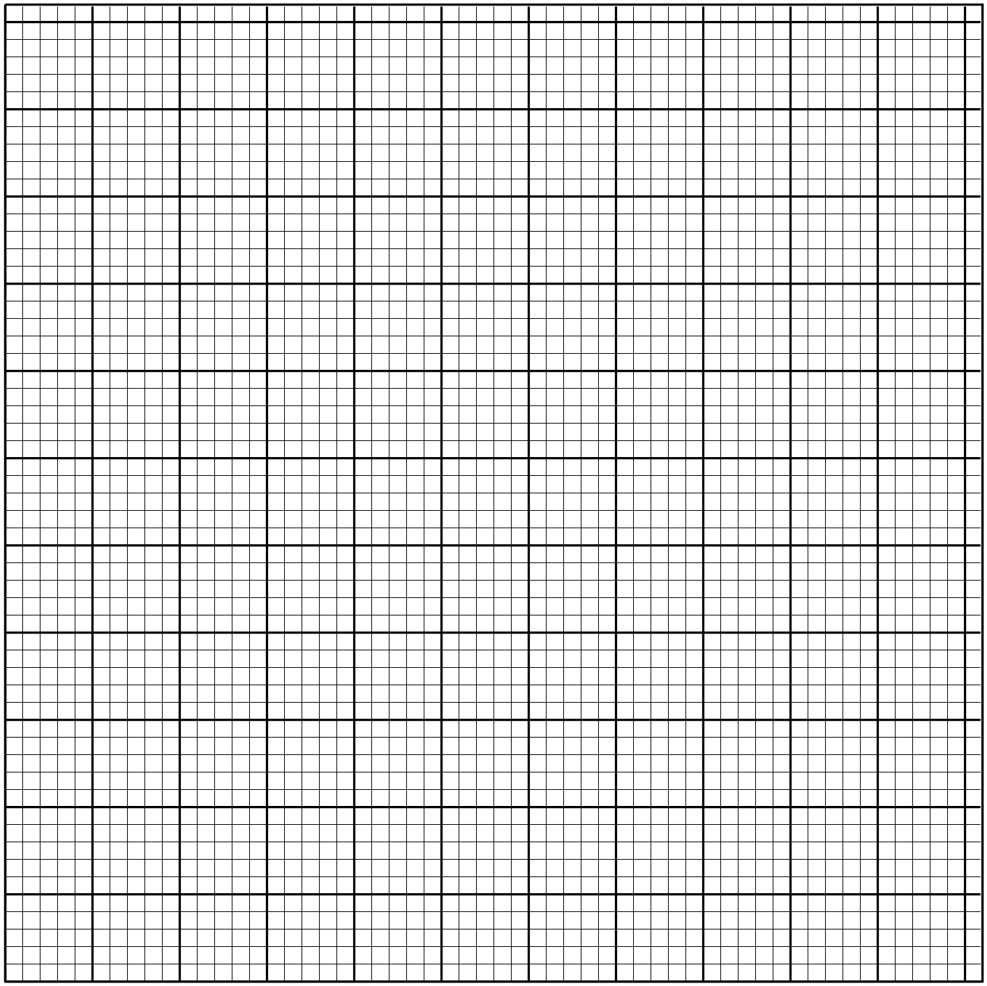

b). Determine the rate of breeding between 5th and 7th day. (2 marks)

- Calculate the area of the minor segment of a circle of radius $5√2cm$, cut off by a chord of length $10cm.$ (3 marks)

SECTION II: Answer any 5 questions from this section. ( 50 marks)

- Income rates for income earned were charged as shown in the table alongside:
A civil servant earns a monthly salary of $Ksh.27,000$. He was also given a house allowance of $Ksh. 12,000$ , transport allowance $Ksh.1,800$ and medical allowance $Ksh.2,000$. He is entitled to a family relief of Kshs. 1040 per month.
Income in Ksh. pm | Rate in Ksh. Per Shs. 20
$$1- 8400$$ | $$2$$
$$8401- 18,000$$ | $$3$$
$$18,001- 30,000$$ | $$4$$
$$30,000 - 36,000$$ | $$5$$
$$36,000-48,000$$ | $$6$$
$$48,001 and above$$ | $$7$$

Determine:
a) (i) His taxable income per month in Ksh. (2 marks)
(ii) His net tax. (6 marks)

b) In addition, the following deductions were made
NHIF Ksh. 430
Loan repayment Ksh. 6500
Bank shares Ksh. 1000.
Calculate his net pay per month. (2 marks)
- a). In the figure below, $OY:YA= 1:3$, $AX:XB=1:2$, $OA= a$ and $OB =b$ . $n$ is the point of intersection of $BY$ and $OX$.
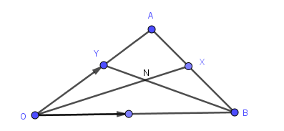

Determine;
i. OX (2 marks)

ii. BY (1 mark)

b) Given that $BN = mBY$ and $ON = nOX$, express ON in two ways in terms of $a, b, m$ and $n$ (3 marks)

c) Find the values of $m$ and $n$ (4 marks)

- (a) In a geometrical progression the sum of the second and third term is $12$ and the sum of the third and fourth terms is $-36$. Find the first term and the common ratio. (4 marks)

(b) In an arithmetic progression the $12^{th}$ term is $25$ and the $7^{th}$ term is three times the second term, find;
i) The first term and the common difference (4 marks)

ii) The sum of the first 10 terms of the arithmetic progression.(2 marks)

- The table below shows the frequency distribution of marks scored by students in a test.
Marks | 1-10 | 11-20 | 21-30 | 31-40 | 41-50
Frequency | 2 | 4 | 8 | 4 | 2

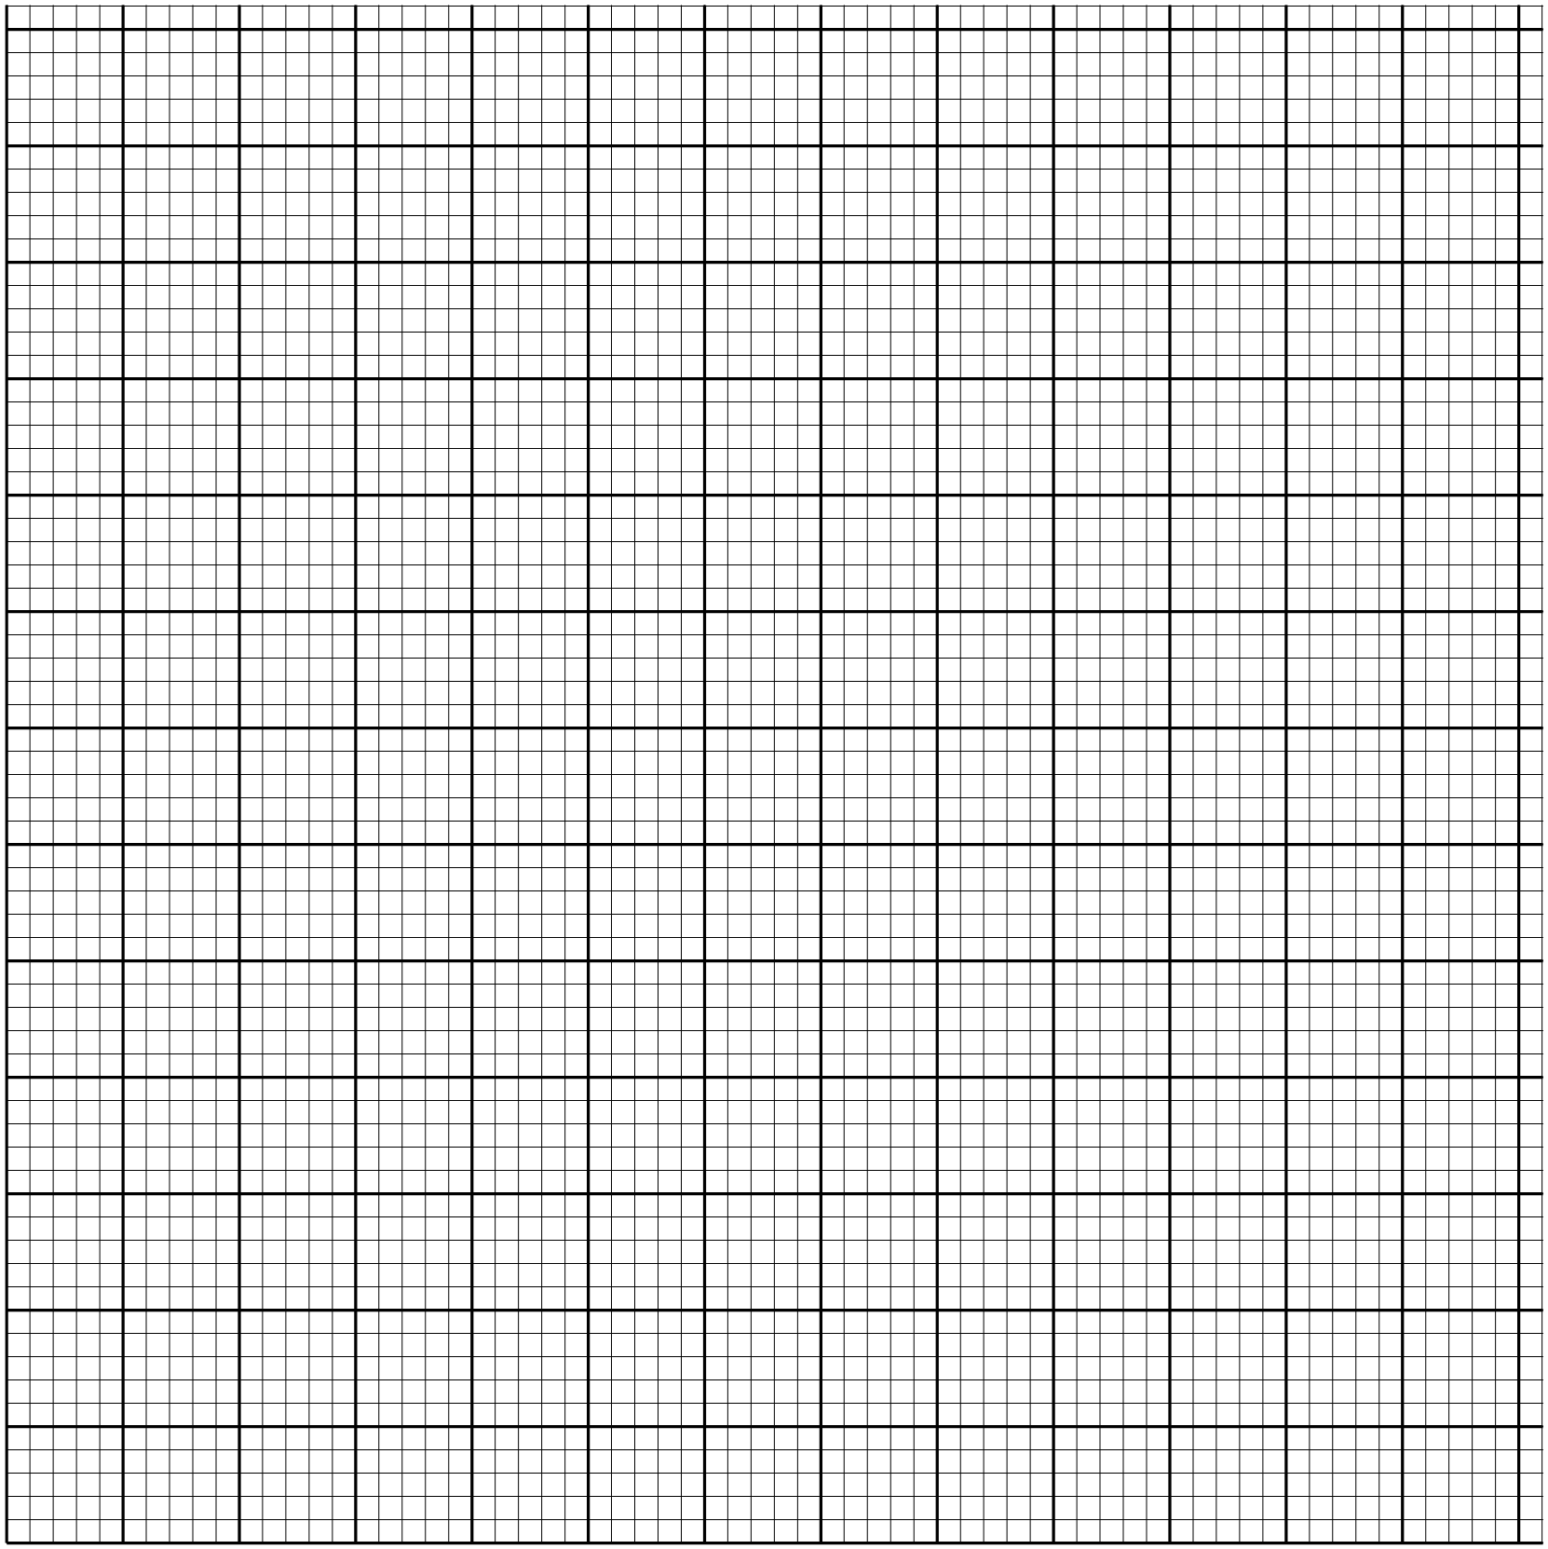a). On the grid provided, draw a cumulative frequency curve for the data.
(3 marks)

b). Use your graph to determine;
( i). The pass mark if only 6 students passed the exam. (2 marks)

( ii). The upper quartile mark (1 mark)

c). Find the percentage change if the upper quartile in b(ii) above was found by calculation. (3 marks)

- A gold urn contains $3$ red balls and$4$ white balls and a silver urn contains 5 red balls and$2$ white balls. A die is rolled and if a $6$ shows, balls will be selected at random from the gold urn. Otherwise balls are selected from the silver urn.
  - Find the probability of selecting a red ball. (3 marks)

  - If two balls are selected at random without replacement,
- Draw a tree diagram to represent this information. (3 marks)

- Find the probability that two balls are white. (2 marks)

- Find the probability that there is at most one white ball from the silver urn.
(3 marks)

- a) Using a ruler and a compass only construct triangle ABC where $AB=7cm$, Angle $CBA=82.5$⁰ and $BC=5cm$ (4 marks)

b) i) Locate a point $T$ inside the triangle which is equidistant from points A and B and also equidistant from lines $AB$ and $AC$ (3 marks)

ii) Measure $TB$ (1 mark)

c) By shading the unwanted region show the area inside the triangle where P lies if it is nearer to point $B$ than to point $A$ and also nearer to the line $AB$ than line $AC$. (2 marks)

- (a) Complete the table for $y = Sin x + 2 Cos x.$ (2 marks)
$$x^{0}$$ | $$0$$ | $$30$$ | 60 | 90 | 120 | 150 | 180 | 210 | 240 | 270 | 300
$$Sin x$$ | 0.00 |  |  | 1.00 |  | 0.50 |  | -0.50 |  |  | -0.87
$$2 cos x$$ | 2.00 |  |  | 0.00 |  | -1.73 |  | -1.73 |  |  | 1.00
$$y$$ | 2.00 |  |  | 1.00 |  | -1.23 |  | -2.23 |  |  | 0.13

(b) Draw the graph of $y = Sin x + 2 cos x.$ (3 marks)
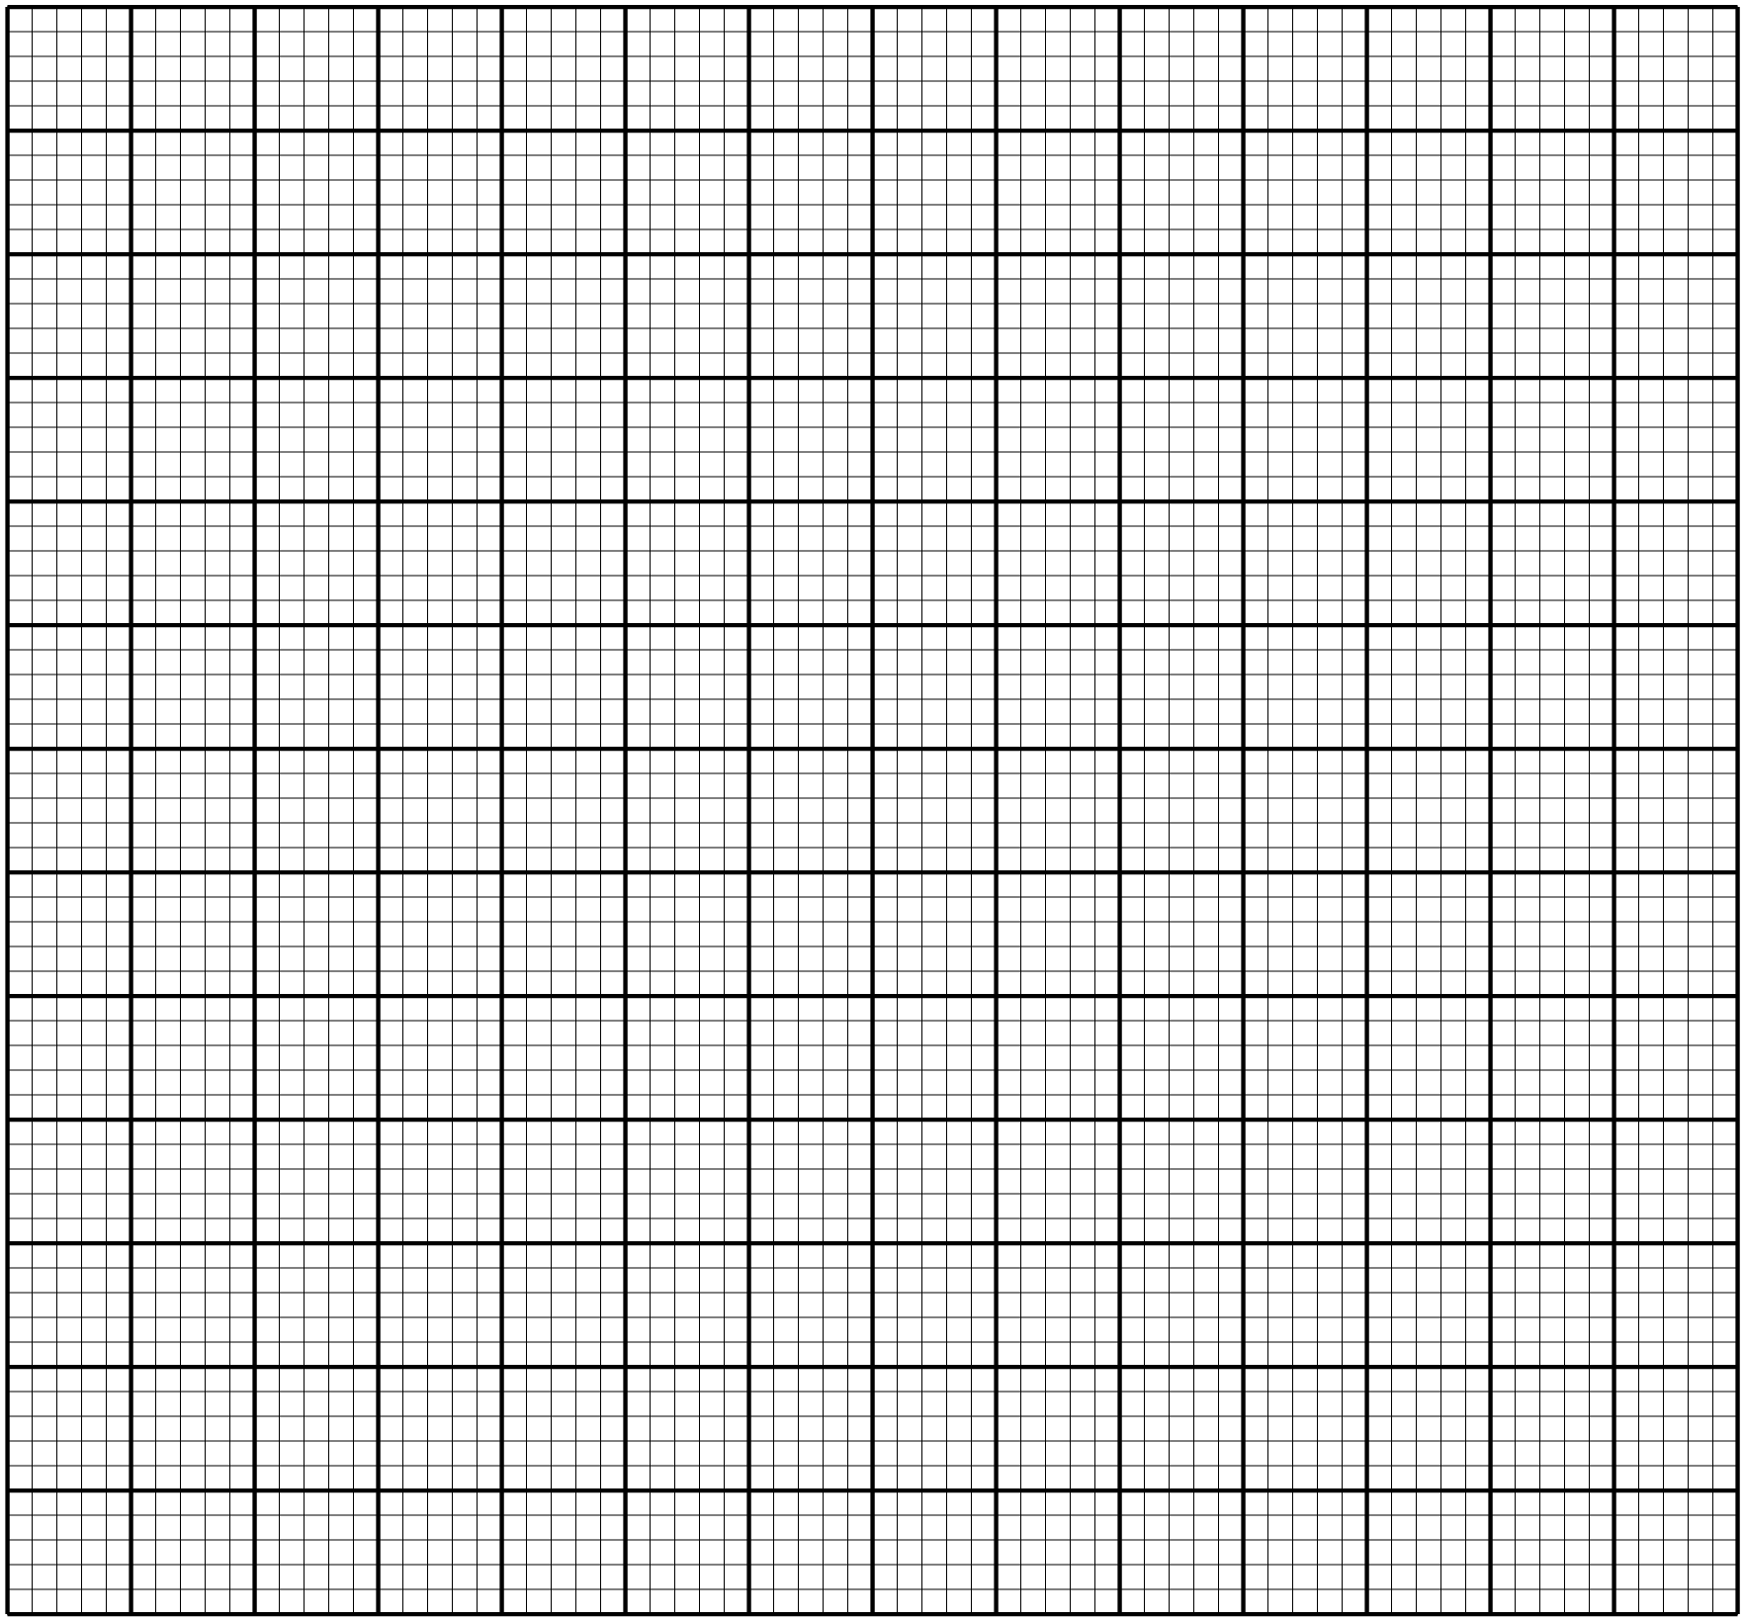

c). Solve $sinx + 2 cos x = 0$ using the graph. (2 marks)

d). Find the range of values of x for which $y < -0.5$ (3 marks)

- A triangle ABC with vertices at A (1,-1) ,B (3,-1) and C (1, 3) is mapped onto triangle A¹B¹C¹ by a transformation whose matrix is .Triangle A¹B¹C¹ is then mapped onto A¹¹B¹¹C¹¹ with vertices at A¹¹ (2, 2), B¹¹ (6, 2) and C¹¹ (2,-6) by a second transformation.
(i) Find the coordinates of A¹B¹C¹ (3 marks)

(ii) Find the matrix which maps A¹B¹C¹ onto A¹¹B¹¹C¹¹. (3 marks)

(iii) Determine the ratio of the area of triangle A¹B¹C¹ to triangle A¹¹B¹¹C¹¹. (1 mark)

(iv) Find the transformation matrix which maps A¹¹B¹¹C¹¹ onto ABC (3 marks)

