**LIVESTOCK PRODUCTION IV**

**(LIVESTOCK MANAGMENT PRACTICES)**

This topic entails the following:

* Description of livestock rearing practices
* Carrying out livestock rearing practices
* Livestock routine management practices i.e. feeding, de-beaking e.t.c.

The following relevant questions and their answers in this topic will greatly motivate and help the user to comprehend and understand the required concepts and practices:

1. Give **four** reasons of carrying out crutching sheep management

2. Name **two** ways a farmer can perform closed methods of castration on his male livestock

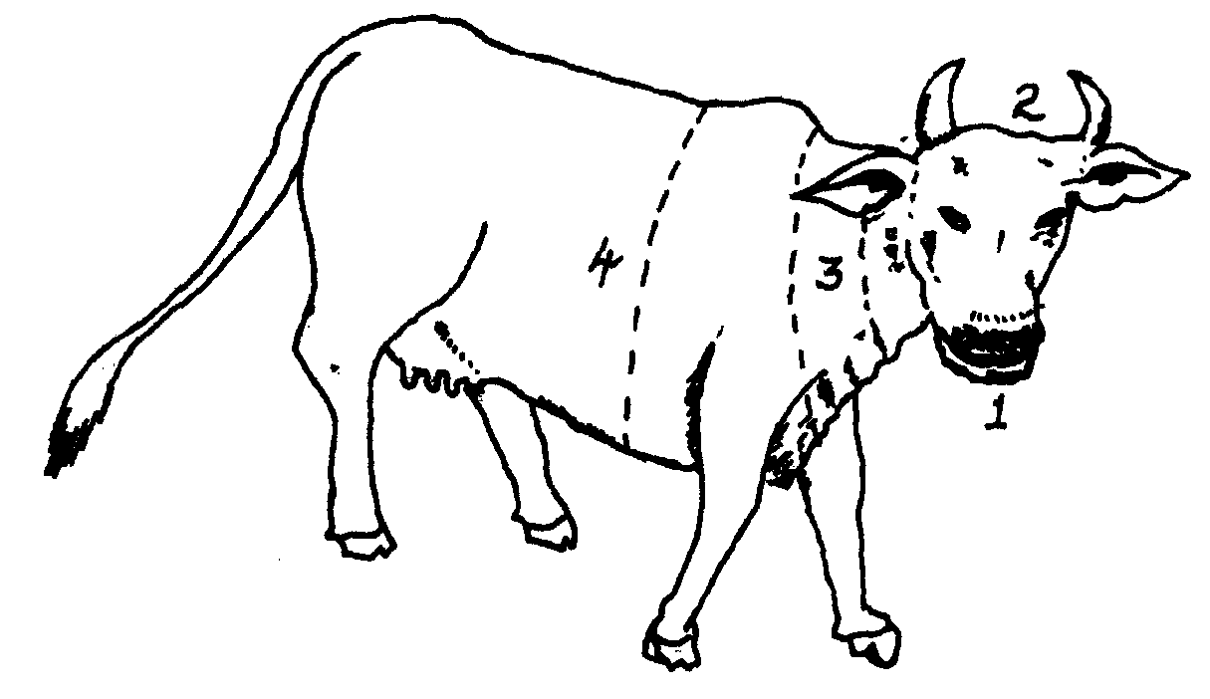3. Below is a diagram of a farm animal. Study the diagram carefully and then answer the questions

that follow

a) On the drawing, mark the letters indicated in brackets the part of the animal where:

i) Branding should take place (B)

ii) Vaccination should be carried out (V)

iii) Body temperature of the animal should be taken (BT)

iv) Mastitis infection may occur (M)

b) Name **three** areas of the animal body where ticks are likely to be found

c) Name the parts of the animal numbered 1-4

4. a) What is castration as used in livestock production?

b) State **four** reasons why castration is done in livestock

5. (a) Describe the management of a gilt from weaning to furrowing

(b) Discuss the preparation a poultry farmer should make before the arrival of day old chicks

6. Outline **two** reasons for raddling in sheep management

7. State any **fou**r reasons for castrating male piglets

8. What are the methods of stocking bees? Give **two**.

9. State **two** ways that show how good feeding help to control livestock diseases

6. Name any **two** recommended methods of docking lambs

7. State three disadvantages of inbreeding

8. State **four** routine management practices that should be carried out on a lactating ewe

9. (a) Describe the procedure which should be followed to castrate a three weeks old piglet using

surgical method

(b) (i) State **five** factors that should be considered when sitting a bee hive in a farm

(ii) Describe the management practices that would ensure maximum harvest of fish from a

fish pond

10. Give **three** types of bees found in a bee colony

11. List **three** methods of castrating farm

12. Outline the routine management practices of piglets from the 1st day to the 8th week

13. List **three** types of calf pens

14. State **two** factors that could lead to failure to conceive in sows after service

15. List **three** advantages of hoof trimming in sheep production

16. State **four** factors considered when citing an apiary in the farm

17. Name **three** methods of stocking a beehive with honey bees

18. List **three** common methods of extracting honey from the combs

19. a)The illustration below shows a method of identifying pigs, study the diagram and answer the questions that follow:-

i) On the diagram **A** provided below, draw the mark to indicate a pig number 147,

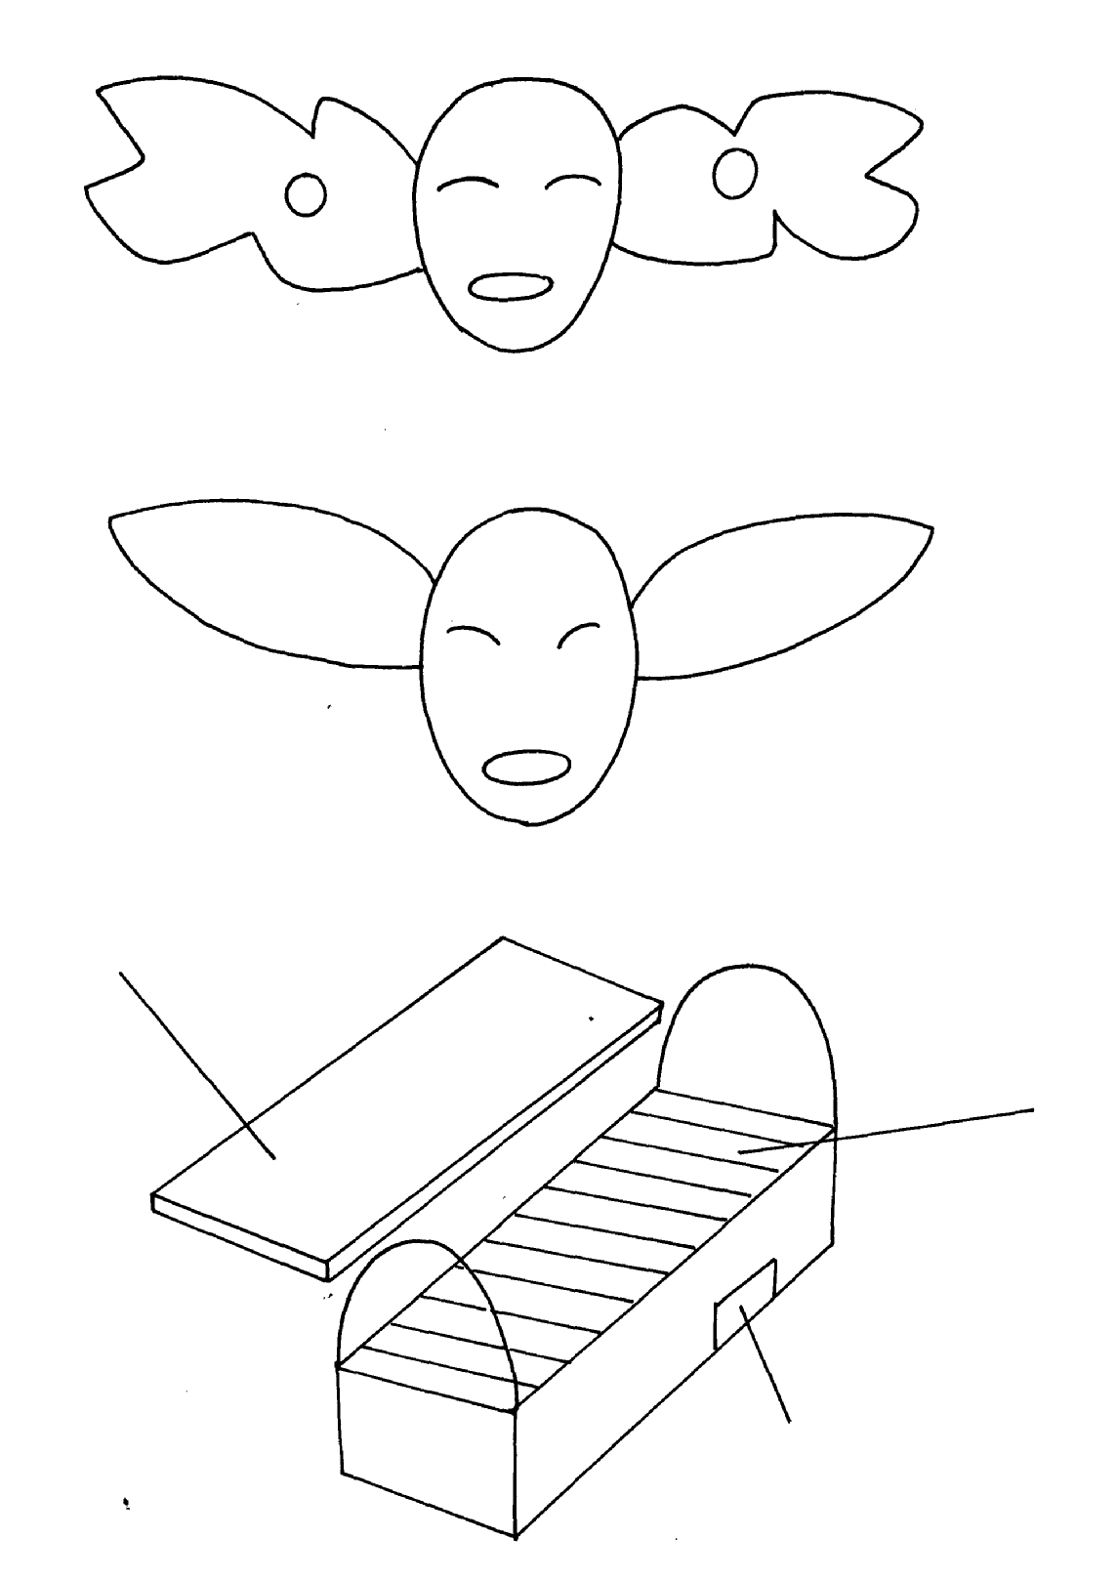using the procedure of ear-notching in diagram

A

ii) What is the recommended stage of growth in pigs at which the ear-notching should be

carried out?

iii) State any **three** reasons why weight is an important routine management practice in pig

production

b) Below are illustrations showing the various parts of the Kenya top bar hive. Use the illustration

to answer the question that follow



D

C

B

i) label the parts **B ,C** and **D**

ii) How can a farmer attract bees to colonize a new hive?

iii) Outline the procedure of opening the hive to harvest honey

20. a) Below are illustrations of farm tools

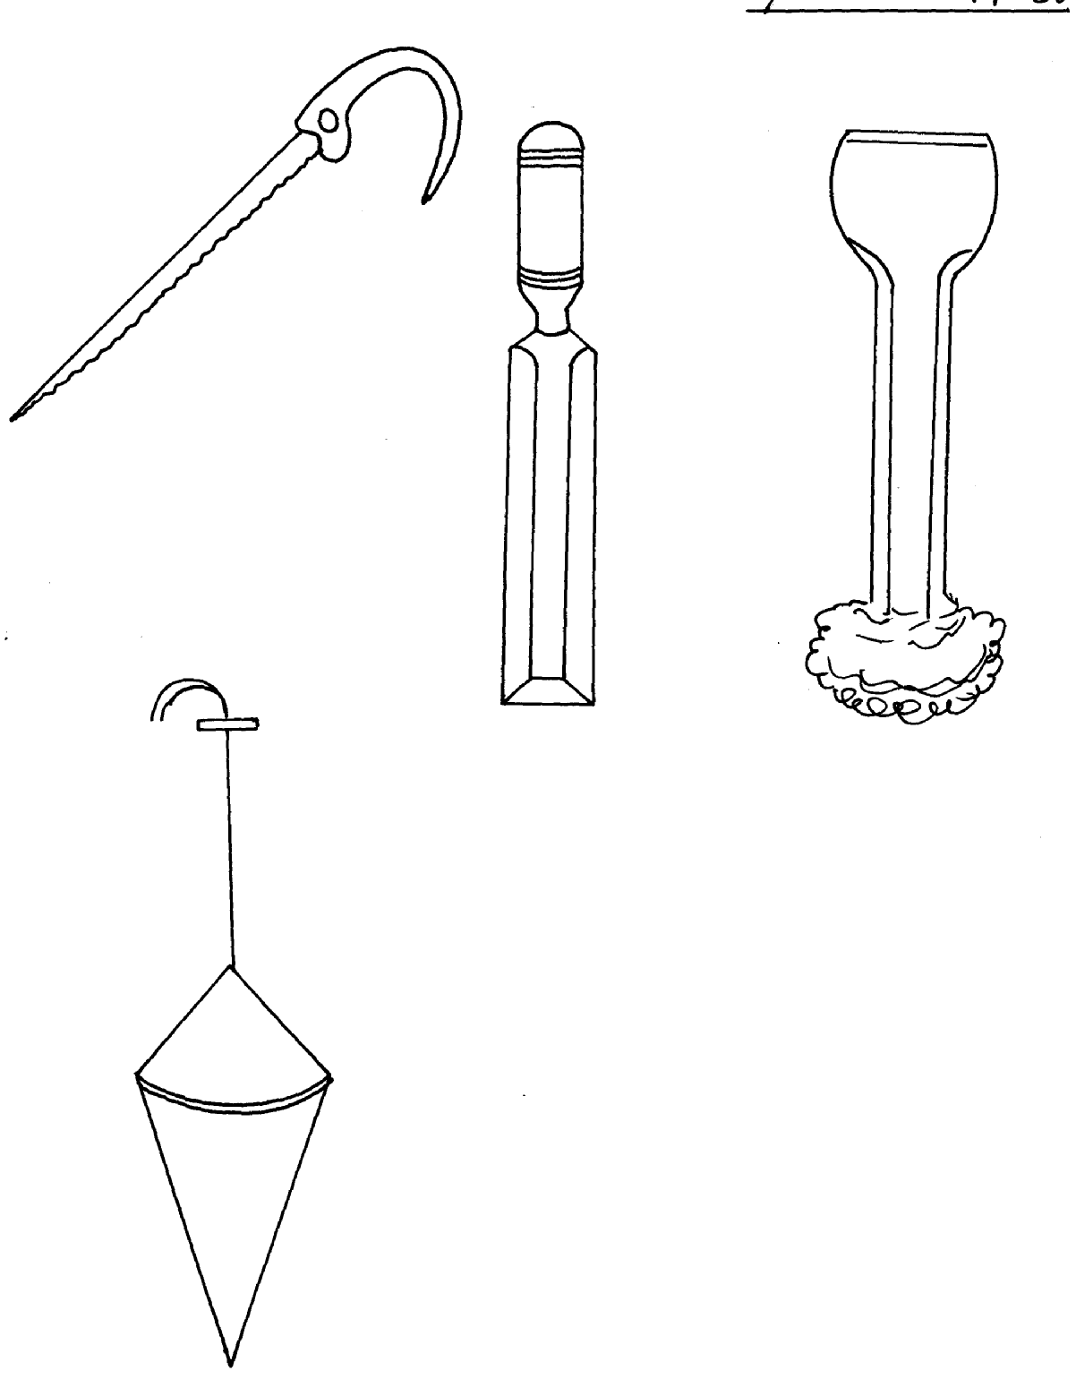

E

F

G

H

ii) State the use of the tools

iii) Name the type of hammer that may be used for driving tool **K** during work b) Given below is an illustration of one of the routine management practices in livestock

production.

Study the diagram and answer the following questions

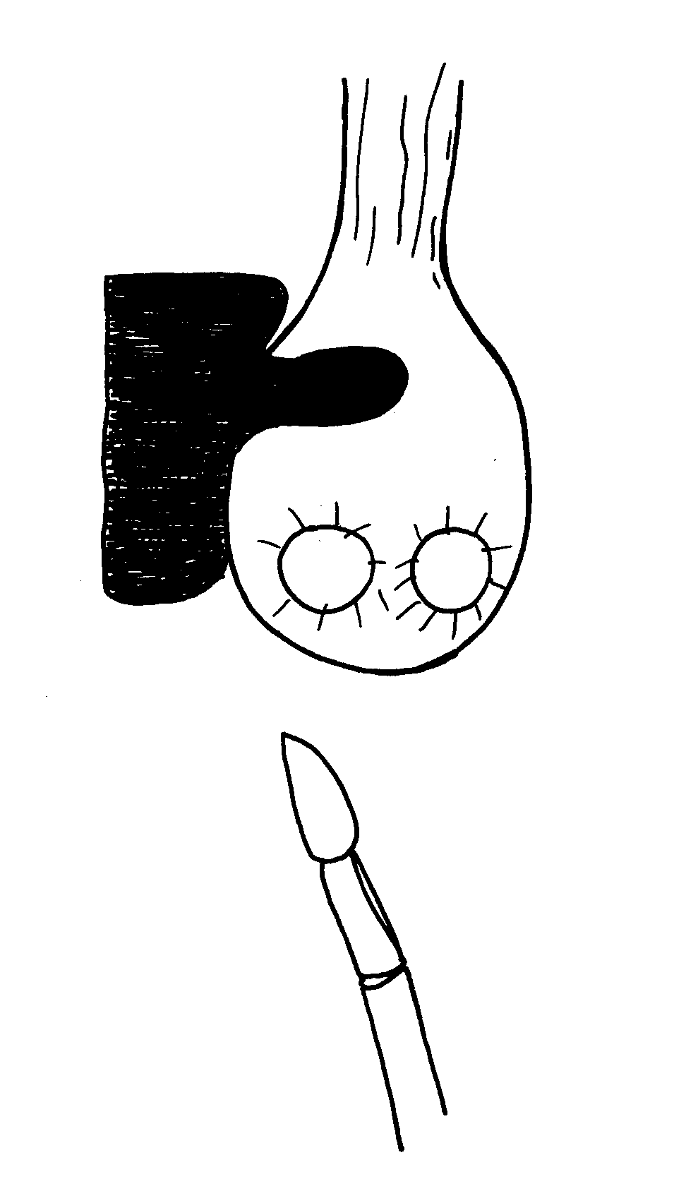

i) Name the practice indicated in the diagram above

ii) Describe the procedure you would follow when carrying out the practice named

in **(i)** above in piglets

21. a) State and explain **four** advantages of age grouping farm animals as a management practice

b) Explain **four** major causes of lamb mortality from birth to weaning

c) Describe brucellosis under the following sub headings

i)Cause

ii) Transmission

iii) Symptoms

iv) Control measures

22. a) Explain the advantage of battery cage system of rearing layers

23. Give **two** reasons why it is important to castrate animals when they are still young

24. (a) Give **two** reasons why dehorning is carried out in farm animals

(b) State **four** methods of dehorning livestock

25. (a) What is **steaming up** in livestock production?

(b) Give **two** reasons why the practice is important in pig rearing

26. State **four** management practices that should be carried on a fish pond in order to obtain

maximum fish production.

27. List four factors considered when formulating livestock ration. (2mk)

28. Study the diagram of a cow below and answer the subsequent questions

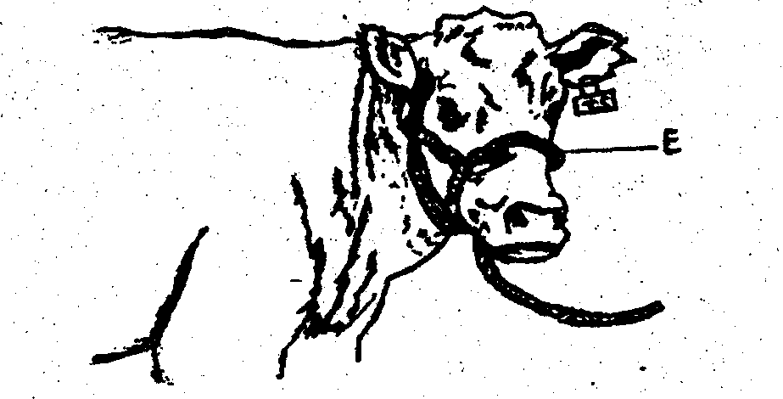

i) Identify the livestock equipment marked **E** above

ii) State **two** uses of the equipment in **17(i)** above

iii) Name the **two** types of identification marks applied on the animal above

iv) Show with an arrow and mark with letter **P** where pye-grease acaricide should be applied

on the anima1

v) Give **one** disadvantage for each of the identification marks made on the animal

|  |  |
| --- | --- |
| **Identification marks** | **Disadvantage** |
| **A** |  |
|  |
| **B** |  |
|  |

29. a) Describe the management practices of a gilt from weaning to the time of farrowing

b) State **five** factors to consider in selecting a gilt for breeding stock.

28. State **four** conditions that necessitate the handling of farm animals .

29. Give any **two** reasons why docking is an important practice in sheep management.

30. Why is crutching a very important management practice in sheep breeding.

**LIVESTOCK PRODUCTION IV**

**(LIVESTOCK MANAGMENT PRACTICES)**

1. Reasons of carrying out crutching in sheep.

- Facilitates easy mating;

- Minimizes blowfly infestation;

- Provides hygienic conditions at lambing time;

- Allows easy access to the teats by the lambs;

- Provides hygienic suckling conditions;

2. Ways of performing closed castration.

- Use of elastrator and rubber ring;

- Use of the burdizzo;

3. (a)

1. B – Should take place – Hooks, cheek, rump
2. V – Is done - Thigh muscles and the shoulders
3. BT – is taken - Anus
4. M – May occur - Udder and teats

b) -- Ears (ear lobes)

- Tail switch..

- Under the tail head.

- Both fore and head flanks.

- Between the hooves.

c) 1 – Muzzle

2 – Poll

3 – Shoulder

4 – Heart girth

4. (a) - The removal of the testicles in male livestock or stoppage of production of spermatozoa or

semen.

- It is the rendering of male reproductive organs non- functional.

(b) – To control breeding and inbreeding.

- To make animals, especially the bulls docile.

- To improve quality of meat by removing unpleasant smell especially in goats.

- To encourage faster growth rates of the castrated male animals.

- To control breeding diseases such as brucellosis, vaginitis trichonomiasis and others that area

transmitted through mating.

5. (a) The management of a gilt from weaning to furrowing

* Feed gilt on at least 3kg of sow and weaner meal daily/balanced diet
* Provide clean drinking water
* Control any external parasites by spraying with pestcides or washing
* Treat the gilt next to the bear at the age 12months ready to be served/serve gilt at the right age.
* Keep the pen clean by maintaining clean
* Flush the gilt 3-4weeks before service by feeding high quality diet
* Take the gilt to the boar’s pen for service and let it stay there for at least 12hours
* Observe the return to heat, f any after three weeks, and repeat the services if necessary
* Steaming up should start 1 ½ months before furrowing by giving 3-4kg of feed
* 7-10days furrowing, the gilt should be washed
* The gilt should be moved to disinfected pen/clean en
* provide guard rails or furrowing crate in a furrowing pen
* Provide a source of heat
* Sow and weaner meal should be reduced three days before furrowing and fed with bran
* Observe the signs furrowing and supervise the process of furrowing
* Deworm the gilt 7-10days before furrowing
* Weigh the gilt regularly
* Keep proper records

(b) The preparation a poultry farmer should make before the arrival of day old chicks

* Ensure the brooder is ready 2-3days before arrival of chicks
* Brooder should be cleaned and disinfected to reduce risk of disease infection
* Spreading litter on the floor to provide warmth
* Provide a functional heat source e.g. electric bulb, lantern e.t.c
* Provide adequate feeding equipment
* Ensure adequate floor space considering the number of chicks
* Ensure the chick mash is ready before chicks arrive
* Provide wire guard
* Make holes on the walls of brooder for ventilation

6.

* To identify mated ewes
* To indicate active rams hence help in culling

Identify the sire of each lamb

7.

* Promote docility
* Improve meat quality
* Control breeding diseases
* Control interbreeding/ control hereditary defects

Improve growth rate

8.

* Use of swarm net
* Use of catcher box

Placing the hire in a strategic position for bees to occupy

9.

* Control deficiency diseases
* Impact resistance to diseases

Good physical appearance/ good coat cover

6. two recommended methods of docking lambs

* Use elastrator and rubber ring
* Sharp knife/scalpel (2x ½ =1mk)

7. three disadvantages of inbreeding

* Loss of hybrid vigour
* May lead to decline fertility leading to species extinction
* May bring about reduction in performance
* Leads to high rate of prenatal mortality (any 3x ½ =1 ½ mks)

8. four routine management practices that should be carried out on a lactating ewe

* Inadequate feeding /balance diet
* Spraying/dipping to control external parasite
* Drenching/deworming to control internal parasite
* Provision of clean water ad-lib
* Tugging
* Avoid extensive movement
* Provide mineral licks (any 4x ½ =2mks)

9. the procedure which should be followed to castrate a three weeks old piglet using

surgical Method

* Assemble equipment and sterilize
* Restrain the animal to be castrated
* Thoroughly wash hands before opening up animals skin
* Artery of forces is used to close up the open blood vessel to stop excess bleeding
* Cut the skin of scrotum
* Remove the two tests completely, leaving on empty scrotal sac
* Disinfect the wound
* Animals heals faster since its castrated when young (7x1@=7mks)

(b) (i) State five factors that should be considered when sitting a bee hive in a farm

* Away from homestead, pastures and road
* Sheltered/quiet place
* Near source of water
* Nearest to flowers producing ants
* Safe from predators (5x1=5mks)

(ii) Describe the management practices that would ensure maximum harvest of fish from a fish

pond

* Control stocking rate
* Control water pollution
* Supply enough food to fish
* Aerate the water/constant in flow and out flow of water
* Maintain appropriate depth of water
* Control predators
* Harvest fish art correct maturity stage
* Fertilize the pond/adequate water plants

10. three types of bees found in a bee colony

* The queen
* The drown
* The workers

11. List three methods of castrating farm

* Closed method-use buidizzer
* Open method-use surgical method
* Caponization-use hormones

12. the routine management practices of piglets from the 1st day to the 8th week

* Placenta disposal
* Umbilical cord cutting with sharp and sterilized scalpel
* Disinfecting the umbilical cord with iodine solution
* Extracting needles teeth/teeth clipping/di-tusking
* Keeping piglets in warm creep area
* Weighing the piglets 24hrs after birth
* Feeding the piglets on colostrums
* Iron supplementation through the intra-muscular injection/paste
* Vaccination against diseases
* Feed the piglets with creep feeds
* Water provision at adlibitum
* Nose ringing
* Putting if identification marks e.g. ear notching
* Deworming /drenching with antihelminthes
* Tail cutting of the piglet
* Castration of the male piglet
* Ensure that they are breathing
* Assist the weak piglets to suckle
* Changing the beddings regularly
* Removing dead piglets from the pen
* Providing furrowing crate to avoid crushing of piglets

13.

* Raised pers with slatted floor
* Permanent calf pen with concrete floor
* Movable calf pen
* Temporary calf pen

14. Poor nutrition – infertility

Poor timing of service

15. three advantages of hoof trimming in sheep production

* Facilitate easy movement
* Control foot rot disease
* Prevents the ram from injuring the ewe during mating ( ½ x3=1 ½ mks)

16. State four factors considered when citing an apiary in the farm

* Availability of water
* Availability of flowers
* A sheltered place
* An area free from noise/disturbance
* Away from lime stead and grazing grounds
* Well drained area (2x2=4mks)

17. three methods of stocking a beehive with honey bee

* Use swarm nets
* Use of a catcher box
* Use of an empty hive ( ½ x3=1 ½ mks)

18. three common methods of extracting honey from the combs

* Use of heat
* Crushing and straining

Centrifugal extractor

19. a) i)

ii) before wearing/3-7 weeks of age/21-56 days/1 month-22months)

iii) -to determine growth rate i.e. weight gain

* -facilitate administration of drugs e.g. drenching
* -for feeding i.e. to know the amount of feed to give
* -to determine the service/breeding time (1x3=3mks)

b) i) B-entrance

C-top bar/bar

D-top cover/lid(1x3=3mks)

ii) by applying bees wax/honey/molasses on the sides or top of the hive/ jaggery/sheep

sorrel/salvial/sugar syrup

(Accept concentrated sugar solution-reject-sugar solution) (1x1=1mk)

iii) Outline the procedure of opening the hive to harvest honey

smoke the hive through the entrance using a smoker then light the hid to remove the top bar(the order must be considered) (1x2=2mks)

20. a) i) E-key hole saw/compass saw

F-wood chisel

G-cold/metal chisel

H-plumb bob (1/2x4=2mks)

ii) E-to cut or make key holes

F-cutting timber

G-cutting metal

H-checking whether a tall wall is vertical (1/2x4=2mks)

iii) wooden hammer/mallet(1mk)

b))i) open castration/surgical castration (1mk)

ii) procedure you would follow when carrying out the practice named in( i) above in piglets

* restrain the piglets
* sterilize the blade
* disinfect the secretal sac
* slit the secretal sac to expose the testicle
* locate and hold the sperm duct
* cut the sperm dust by scrapping with the slide
* sew up the wound
* sterilize/disinfect the wound
* release the animal(piglet) (1/2x6=3mks)

1. four advantages of age grouping farm animals as a management practice
   * Avoids bullying among the animals

* Facilitate feeding /adequate and economic use of feed
* Facilitate the administration of drugs e.g. drenching
* Easy keeping of management records
* Facilitate breeding/cutting of livestock (2x4=8mks)

b) four major cause of lamb mortality from birth to weaning

* chilling
* scours
* internal parasitic infertation
* loss of mother/lack of foster parents
* inadequate mothers milk/malnutrition
* crushing by t he mother (1x4=4mks)

c) i)cause-bacteria/brucella abortus brucells

ii) Transmission-sexually transmitted/it is a breeding diseases

iiI) Symptoms

* abortion/premature birth
* yellowish slimy and odourless discharge through the vulva
* retained afterbirth/placenta
* the cow may become barren (1x4=4mks)

iv) Control measures

* vaccination
* use of healthy semen/bull/Al
* cull/destroy affected cattle
* proper disposal of foetus and carcass (1x2=2mks)

23. Reasons for castrating animals when young

* Less pain
* Quick healing

- Little loss of blood

24. a) Reasons for dehorning farm animals

* Reduce space occupied by animal
* Making handling easier
* To reduce destruction of farm structures
* To make them
* To reduce risk, injury to farmer and other animals 2x ½ = 1 mark

b) Methods of dehorning livestock

* Use of caustic potash stick (Potassium hydroxide)
* Use of dehorning iron
* Use of dehorning saw or wire
* Use of rubber ring and elastrator

- Use of dehorning collation

25. a)Is the giving of high quality seeds to a gestating animal towards end gestation period

b) Reasons for steaming up

* Increase milk yield after farming
* Help build up body reserves for lactation
* Ensure rapid growth and development foetus

- Ensure healthy and string young at birth

26. four management practices that should be carried on a fish pond in order to obtain maximum

Fish production.(2mrk)

* Control predators.
* Control Water pollution.
* Maintain appropriate water level.
* Maintain correct stocking rate.
* Supply adequate food. (4x ½ =2mks

27. four factors considered when formulating livestock ration. (2mk)

* Body weight / size
* Available feeds
* Cost of feeds
* Nutrient composition of feeds available.
* Ingredients required in the ratio.
* Animals level of production.
* Age / stage of growth.

Type of production.

28. four conditions that necessitate the handling of farm animals. (2mk)

* During treatment
* When spraying or hand dressing
* When milking
* When performing some management practices e.g. dehorning

When inspecting animals for any signs of a disease

28. - Large animals e.g. buffaloes

- man activities e.g. farming

- root pressure of plants

- burrowing animals e.g. moles, termites

29. (a) – Random/zigzag soil sampling-Arrow roots

(b) -Old manure heaps

- Ant hills

- Dead furrows

- Rice

- Fence lines

- Cattle bomas