Name: ……………………………………………………… Index Number: …………………..
Candidate’s Signature ……….……………
Date…………………………….
121/1
Mathematics (Alt. A)
Paper 1
Time 2 ½ Hours

SMARTPASS EXAMINATION
Kenya Certificate of Secondary Education (K.C.S.E)
MODEL ONE 2019
121/1
MATHEMATICS
Paper 1

Instructions to candidates
- Write your name and index number in the spaces provided above.
- Sign and write the date of examination in the spaces provided above
- This paper consists of TWO sections: Section I and Section II
- Answer ALL the questions in Section I and only five questions form Section II
- All answers and working must be written on the question paper in the spaces provided below each question.
- Show all the steps in your calculations, giving your answers at each stage in the spaces below each question
- Marks may be given for correct working even if the answer is wrong
- Non-programmable silent electronic calculator and KNEC Mathematical tables may be used except where stated otherwise.
- This paper consists of 15 printed pages
- Candidates should check the question paper to ascertain that all the pages are printed as indicated and that no questions are missing.

SECTION I
1 | 2 | 3 | 4 | 5 | 6 | 7 | 8 | 9 | 10 | 11 | 12 | 13 | 14 | 15 | 16 | TOTAL

SECTION II
GRAND
TOTAL
17 | 18 | 19 | 20 | 21 | 22 | 23 | 24 | TOTAL

SECTION A (50 Marks)
Attempt all questions in the spaces provided

- Show that 8260439 is exactly divisible by 11, using test of divisibility.
(2 marks)
- Use logarithms tables to evaluate

∛(4.562×0.0380)(0.3+0.52)⁻¹
Give your answer to 3 significant figures. (4 marks)

- Without using a calculator, evaluate
36 – 8x – 4 – 15 ÷ -3 (3 marks)
3x – 3 + -8(6 – (-2))

- The figure below (not drawn to scale) shows the cross-section of a metal bar of length 3 metres.
20mm
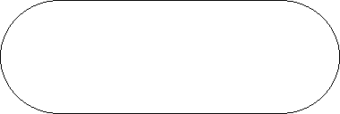

70mm

The ends are equal semicircles. Determine the mass of the metal bar in kilograms if the density of the metal is 8.87 g/cm³ (3 marks)

- A solid metal cone has a diameter of 14cm and a height of 24cm. If the cone is melted and recast into a cylinder of the same diameter, what is the height of the cylinder? (3 marks)

- Find the integral values of x which satisfy the following inequality.
2x+3 > 5x-3 > -8 (3 marks)

- ABCD is a Rhombus with three of its vertices A (2, 5), B (1,-2), C (-5, 1). Determine the equation of line BD in the form of y = mx+c (3 marks)

- If and, find t. (3 marks)

- Factorise completely the expression,
3x²y²-8xy-51 (3 marks)

- On the grid below, draw a histogram to represent the following distribution. (4 marks)

Length (cm) | 1 – 5 | 6 – 9 | 16 – 30 | 31 – 40
Frequency | 2 | 4.5 | 3.33 | 4

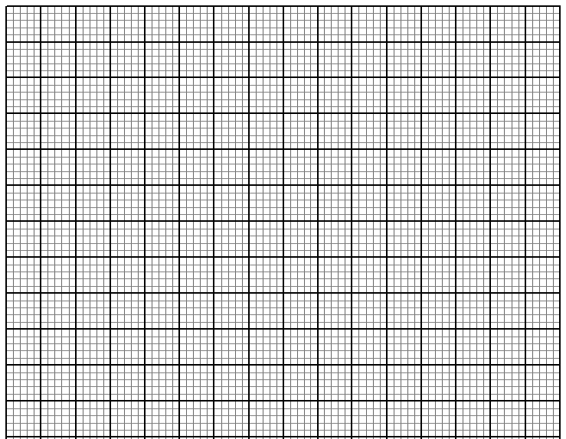

- An observer stationed 20m away from a tall building finds that the angle of elevation of the top of the building is 68° and the angle of depression of its foot is 50°. Calculate the height of the building. (3 marks)

- Solve without using tables.
9^{x+1} + 3^{2x+1} = 108 (3 marks)

- In the figure below ∠ MNO = 54°, and ∠PLM = 50⁰, PN = NM and PO is parallel to LM. Find the value of ∠LPM. (3 marks)
50⁰
54⁰
O
N
P
L
M

- A container of height 90cm has a capacity of 4.5litres. What is the height of a similar container of volume 9m³. (3 marks)

. .
- Express 0.45 as fraction in its simplest form (3 marks)

- a) Find by calculation the sum of all the interior angles in the figure ABCDEFGHI below (2 marks)
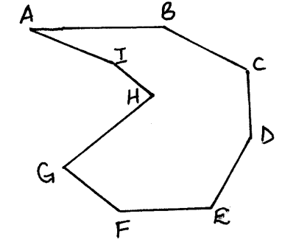

b) Find the number of sides of a regular polygon whose interior angle is 162⁰ (2 marks)

SECTION B (50 Marks)
Attempt five questions only from this section

- The table below shows marks scored by candidates in an examination.
Marks | 1 – 10 | 11-20 | 21-30 | 31-40 | 41-50 | 51- 60 | 61-70 | 71-80 | 81-90 | 91-100
Frequency | 2 | 6 | 10 | a | 24 | 21 | 19 | 12 | 8 | 1
- Determine the value of. (1 mark)
- Taking 1cm to represent 10 marks on the horizontal axis and 1cm to represent 10 pupils on the vertical axis draw an ogive. (3 marks)
From your graph
- Determine the median. (2 marks)

- Determine the range of marks of the middle of the students. (2 marks)

- If 63% is the pass mark for grade B+, how many students will get B+ and above?
(1 mark)

- State the median class (1 mark)

- The position vectors of points A and B with respect to the origin are aand b respectively. P is a point on OA such that OA=3OP. Qdivides OB externally in the ratio 5:2. PQ intersects AB at N.

- Express the vectors AB, AP, OQ and PQ in terms of a and b. (3 marks)
A
B
O
a
b

̰ ̰

- Express AN in two different ways. (5 marks)

- In which ratio doesN divide AB (1 mark)

- Express PN in terms of PQ. (1 mark)

- A commuter train moves from station A to station D via B and C in that order, the distance from A to C via B is 70km and that from B to D via C is 88km. Between the stations A and B, the train travels at an average speed of 48km/h, and takes 15 minutes between C and D. The average speed of the train is 45km/h. Find:-
- The distance from B to C. (2 marks)

- Time taken between C and D. (2 marks)

- If the train halts at B for 3 minutes and at C for 4minutes and the average speed for the whole journey is 50km/h. Find its average speed between B and C. (4 marks)

- If the return journey was at 54km/h, how long did he take for the journey? (2 marks)

20. On the upper part of a line RQ construct locus of points (10 marks)
a) T₁ such that angle RTQ = 45⁰
b) M on RQ which is equidistant from R and Q.
c) S which is equidistant from R and Q and lies on T.
d) Calculate area bounded by loci T₁ and line RQ.

- The marked price of a pick-up is Kshs.1, 087,500/=. A financial company bought this car at a discount of 20%, for a company employee, who was then to give a down payment of Kshs. 180, 000/= and 36 monthly instalments of Ksh.35, 600/= each.
- Calculate the cash price. (2 marks)

- How much will the employee have paid for the pick-up after 3 years? (2 marks)

- What percentage profit did the financial company get from the employee on the pick up? (2 marks)

- If the car was depreciating at the rate of 12% p.a, calculate the value of the car after 3years. (2 marks)

- If the employee is to buy a new car at the same initial cost, at what percentage profit, on the value of the car after the third year, must he sell it? (2 marks)

- Three planes P, Q and R departed Jomo Kenyatta International Airport at 0810 Hrs, 0840 Hrs and 0920 Hrs respectively. Plane P traveled at 300km/h along N70°W, plane Q traveled at 240 km/h along ENE and R traveled at 400 km/h along 210°.
- Using a scale of 1cm to represent100 km, locate the position of the planes at 1050 Hrs. (6 marks)

- Find the distance of plane Q and R at 1050 Hrs. (2 marks)

- Find the bearing of plane Q from plane P (1 mark)

- Find the bearing of plane R from plane Q. (1 mark)

- a) Complete the following table for the function:y = x³ – 2x²+ 5. (2 marks)

x | -3 | -2 | -1 | 0 | 1 | 2 | 3 | 4
x³ |  | -8 | -1 | 0 | 1 |  | 27 | 64
-2x² | -18 |  | -2 | 0 | -2 | -8 | -18
5 | 5 | 5 |  | 5 | 5 | 5 | 5 | 5
y | -40 |  | 2 | 5 | 4 | 5 | 14
- By using the scale of 2cm to represent one unit on the horizontal scale and 1cm to represent 5 unitson the vertical scale, draw the graph of y = x³ – 2x²+ 5. (3 marks)
- Using your graph estimate the roots of x³ – 2x² – 7x – 4 = 0. (2 marks)

- Use integration to find the area bounded by the curvey = x³ – 2x² + 5, the y-axis and line y = 7x + 9. (3 marks)

- Water flows through a pipe of internal radius of 3.5cmat 9 metresper second into a storage tank of rectangular base of 12m by 8m Calculate
- the volume of water delivered into the tank in one minute in litres. (2 marks)

- the capacity of water in litres that is consumed by a village of 435 families that depend on this water, in one week, if each family consumes an average of six jerrycan of 20 litres each per day. (2 marks)

- the minimum height of the water level in the storage tank that will ensure that the village doesn’t suffer from water shortage within the week. (2 marks)

- how long will it take the pipe to fill the tank to that level giving your answer in hours.
(2 marks)

- Calculate the monthly bill of the village if the cost of water is Kshs.1.50 per jerrycan (take a month of 30 days) (2 marks)

