121/1 SMARTPASS MATHEMATICS PAPER 1 MODEL ONE 2019
MARKING SCHEME

1 | Sum of all digits Odd positions :  Even positions  Difference  multiple of hence divisible by | M1  A1 |  |  | Finding the difference alternate digit
2 | 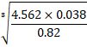 | M1  M1  M1  A1 |  |  | Attempt to form equ(1)  For both eqns
  No | Log
  0.82 | =  3 1
3 | 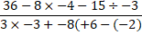  Numerator:  Denominator : | M1  M1  A1 |  |  | ✓Simplification of the num.  ✓Simplification of the den.
4 | Cross sectional area  Volume of solid  Mass in kg 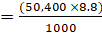 | B1  M1  A1
5 | Voliume of cone = 1/3 x 22/7 x 7² x 24 = 1232cm³  Πr²h = 1232cm³  h = 1232 x 7  7 x 7 x 22  = 8cm | M1  M1  A1
6 | -3x ˃-6  x < 2  5x ˃ -5  X ˃ -1  0, 1 | B1  B1  B1
7 | Gradient of 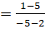 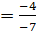  Gradient of 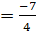  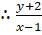 | B1  M1  A1
8 | sin =5t, cos = 6t  = Tan =  = Tan⁻¹(0.8333) = 39.80  Sin 39.80 = 5t or cos 39.8 = 6t  t = 0.128 | M1  M1  A1 |  |  | Combing both sin and cos in term.  expression for ethic cos or sin of equated to
9 |  | M1  M1  A1
10 | 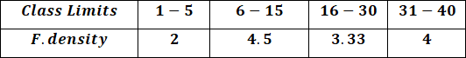  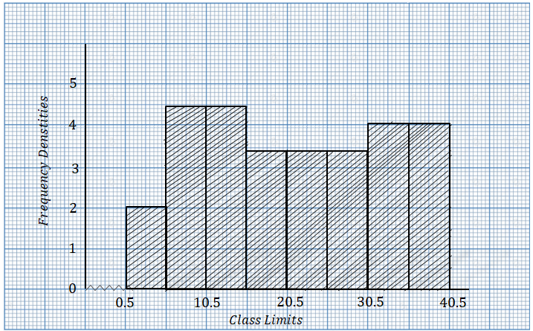 | B1✓ F. density  S1✓ Scale  B1✓Histogram drawn  B1✓ F. density  S1✓ Scale  B1✓Histogram drawn  B1✓ F. density  S1✓ Scale  B1✓Histogram drawn  B1✓ F. density  S1✓ Scale  B1✓Histogram drawn
11 | The height of the building  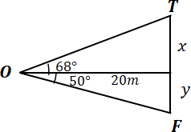  Hence | B1  B1  A1 |  | C.A.O
12 | 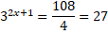 | M1  M1  A1 |  | Simplify
13 |  | B1  B1  B1
14 | 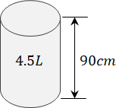  l. s. f :  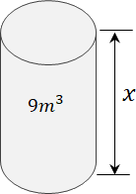 | M1  M1  A1 |  | Accept the length expressed in other units
15 |  | M1  M1  A1 |  | CAO
16 | a)Sum of int ∠’s = ( n - 2)180  n = 9  ( 9 – 2) 180  1260  b) Exterior Angle = 180-162  = 18⁰  n = sides | M1  A1  M1  A1 |  | CAO
17 | 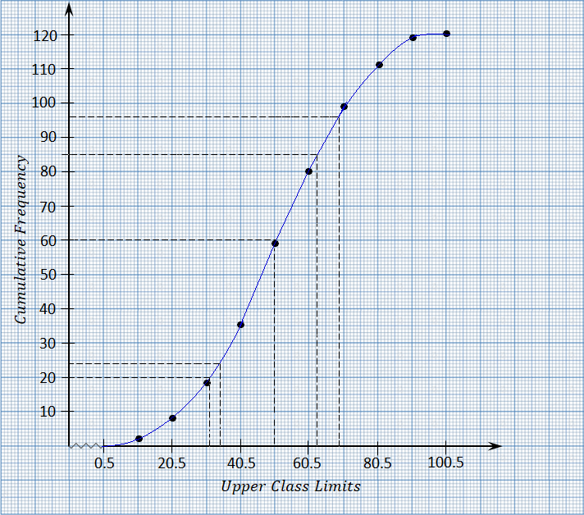 | B1  S1  P1  C1  B1  B1  B1  B1  B1  B1 |  | for the average of a  for using the scale correctly  for plotting  for correct curve  for median class stated  for median  for 20th & 80th mark identified i.e. 68.5 & 34.4  for the range  for 84th identified  for 36th
18 | 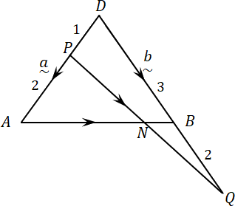  a) AB = b – a ; AP = -²/₃ a, OQ = 5/3 b  ~ ~ ~ ~ ~ ~ ~  PQ = -1/3a + 5/3 b  ~ ~ ~  PQ = 1/3 (5b – a)  ~ ~ ~  b) AN = h AB =h (b- a)  ~ ~ ~ ~  (i) AN = h b – ha  ~ ~ ~  (ii) AN = AP + K (5/3b – 1/3a)  ~ ~ ~ ~  AN = -2/3a + 5/3kb – 1/3Ka  ~ ~ ~ ~  AN = (-2/3 – 1/3k) a + 5/3k b  ~ ~ ~  ∴ -h = -2/3 – 1/3k  h = 2/3 + 1/3k --------(1)  h = 5/3k  ∴5/3k = 2/3 + 1/3k  4/3 = 2/3  4k = 2  k= ½  ∴h = 5/3 x ½= 5/6  c)i) AN = 5/6 AB  ∴ AN : AB = 5: 1  (ii) PN = k PQ  ~ ~  PN = ½ x 1/3 (5b – a) = 1/6(5b –a)  ~ ~ ~ ~ ~  PN = 5/6b – 1/6 a  ~ ~ ~ | B1  B1  B1  B1  B1  B1  B1  B1  B1  B1 |  | For AP  For OQ  For PQ
19 | 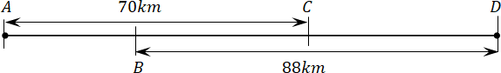  = | M1  A1  M1  A1  M1  A1  M1  M1  A1  B1
20 | line RQ  ∠T, RQ 75⁰  ∠ RQT₁  Locat  T₁   locat M.   loc. S   Measurement of RQ, T₁ and height  b) ½ 11.2 ( 9.3 + 3.5)  5.6 x 12.8  71.68 cm²  45⁰  60⁰  15⁰  60⁰  45⁰  15⁰  S  M  T1  R  R  Q  60⁰  Q | B1  B1  B1  B1  B1  B1  B1  M1  M1  A1
21 | 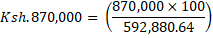  Percentage profit = (146.741 – 100) | M1  A1  M1  A1  M1  A1  M1  A1  M1  A1
22 | )  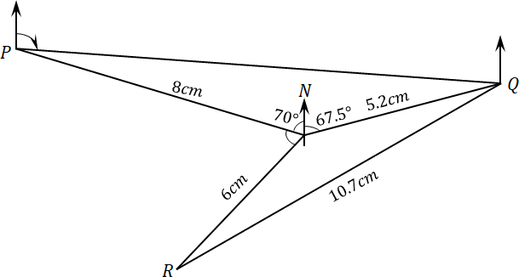  d) | B1  B1  B1  B1  B1  B1  M1  A1  B1  B1 |  | Locating P   locating Q  locating R
23 | 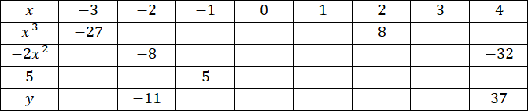  b)  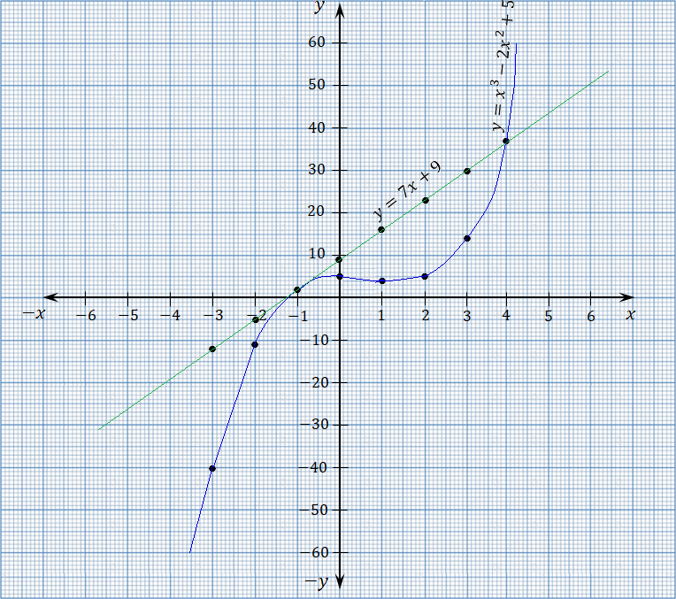  - x = -1 or  x = 4  d)Area of the trapezium = | B2  S1  P1  C1  B1  B1  M1,  M1  A1 |  | For Table  For Scale  For line  For plotting  For the curve
24 | - Volume of water flowing in 1 sec  V = πr² h = 22 x 3.5 x 3.5 x 900  7  = 34650cm³  Volume in litres per min = ( 34650 x 60 )  1000  = 2079 litres  - 1 family = 6 Jericans  435 families = (435 x 6) Jericans  In 1 week = (435 x 6 x 7) Jericans  = (435 x 6 7 x 20) litres  = 365400 litres  - In m³ = (365400)  1000  = 365.4 m³  Volume of tank = 12 x8 x H = 365.4  ∴ H = ( 365.4)  96  = 3.80625 m  - 2079 litres = 1 min  ∴ 365400 litres = ( 365400 x 1)  2079  = 175.75 mins  In hours = 175. 75 = 2.93 hrs  60  - 1 Jerican = 1.50  ∴ (435 x6 30) Jericans =(435 x 6x 30x1.50)  = Ksh. 117,450 |  | B1  A1  M1  A1  M1  A1  M1  A1  M1  A1 |  | ✓ Vol. in 1 sec.  Accept answer in cm

