Name: ………………………………………………………... Index Number: …………………..
Candidate’s Signature ……….……………
Date…………………………….
121/2
Mathematics (Alt. A)
Paper 2
Time 2 ½ Hours
SMARTPASS EXAMINATION
Kenya Certificate of Secondary Education (K.C.S.E)
MODEL ONE 2019
121/2
MATHEMATICS
Paper 2
Instructions to candidates
- Write your Name and Index number in the spaces provided above.
- The paper contains TWO sections: Section I and Section II.
- Answer ALL the questions in section I and strictly any five questions from Section II.
- All answers and working must be written on the question paper in the spaces provided below each question.
- Show all the steps in your calculations, giving your answers at each stage in the spaces below each question.
- Marks may be given for correct working even if the answer is wrong.
- Non-programmable silent electronic calculators and KNEC mathematical tables may be used, except where stated otherwise.
For examiner’s use only
Section I
1 | 2 | 3 | 4 | 5 | 6 | 7 | 8 | 9 | 10 | 11 | 12 | 13 | 14 | 15 | 16 | Total

Section II
17 | 18 | 19 | 20 | 21 | 22 | 23 | 24 | Total

Grand Total

This paper consists of 15 printed pages .Candidates should check the question paper to ascertain that all the pages are printed as indicated and no questions are missing.

SECTION 1 (50 MARKS)
Instructions: Attempt all the questions in the spaces provided
1. Given that log a = -1.3748 and log b = - 1.5934, evaluate log. (3 marks)

2. Make x the subject of the formula. (3 marks)

- Use reciprocal, square and cube root tables to evaluate to 4 significant figures, the expression.
(3 marks)

- A point P undergoes transformation represented by the matrix. Find the coordinate of the image of P. (2 marks)

- Using a ruler and pair of compasses only. Construct an equilateral triangle ABC of sides 4cm construct the locus of a point P such that P is always on the same side of BC as A and BPC=30⁰. Shade the region where Q can be found if Q is outside the triangle and angle BQC > 30⁰. (3 marks)

- A right circular cylinder is to be made so that the sum of its radius and its height is 6cm. Find the maximum possible volume of the cylinder. (3 marks)

- The radius of a circle is measured to the nearest meter as 7m. Calculate the percentage error in the circumference. Leave your answer as a mixed number and take. (3 marks)

- The first, the fifth and eleventh terms of an increasing arithmetic progression are three consecutive terms of a geometrical progression. If the first term of the arithmetic progression is 6. Find the common difference of the arithmetic progression (3 marks)

- Wanjiku pays for a car on hire purchase in 15 monthly instalments. The cash price of the car is Ksh. 300,000 and the interest rate is 15% p.a. A deposit of Ksh 75,000 is made. Calculate her monthly repayments. (4 marks)

- Factorize completely 6(x-4)²-54 (3 marks)

- Without using tables, rationalize the denominator in
2 tan 45⁰-tan 60⁰
4tan45⁰ Sin30⁰-√3 (3 marks)

- (a) Write the expansion of (2- 1/5x) ⁵ (1 mark)

(b) Hence use the expansion to find the value of (1.96) ⁵ correct to 3 decimal places (3 marks)

- Solve the equation 3Sin (2x-50⁰)= -1.5 if 0⁰ < x < 360⁰ (3 marks)

- Two teachers are chosen at random from a staff of three women and 2 men to attend a seminar. Calculate the probability that the two teachers chosen are
(a) Of the same gender (2 marks)

(b) Of opposite gender (2 marks)

- Simplify 2x-2 ÷ x-1
6x²-x-12 2x-3 (3 marks)

- In the figure below AB and CD are chords of a circle that intersect externally at Q. if AB=5cm, BQ=6cm and DQ=4cm, calculate the length of chord CD (3 marks)
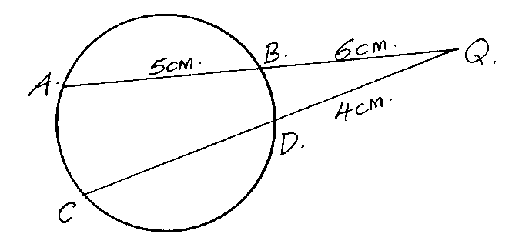

SECTION B (50 MARKS)
ATTEMP ANY FIVE QUESTIONS IN THIS SECTION

- The roof of a ware house is in the shape of a triangular prism as shown below
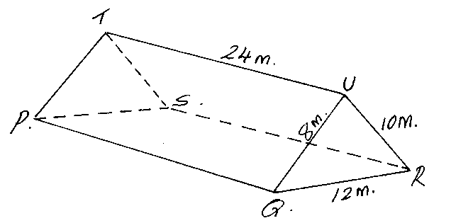
Calculate
(a) The angle between faces RSTU and PQRS (3 marks)

(b) The space occupied by the roof (3 marks)

(c) The angle between the plane QTR and PQRS (4 marks)

- a) Complete the table below for y=sin 2x and y=sin ( 2x + 30) giving values to 2d.p
X | 0 | 15 | 30 | 45 | 60 | 75 | 90 | 105 | 120 | 135 | 150 | 165 | 180
Sin 2x | 0 |  |  |  | 0.87 |  |  |  | -0.87 |  |  |  | 0
Sin ( 2x + 30) | 0.5 |  |  |  | 0.5 |  |  |  | -1 |  |  |  | 0.5
(2 marks)
b) Draw the graphs of y=sin 2x and y = sin (2x + 30) on the axis. (4 marks)

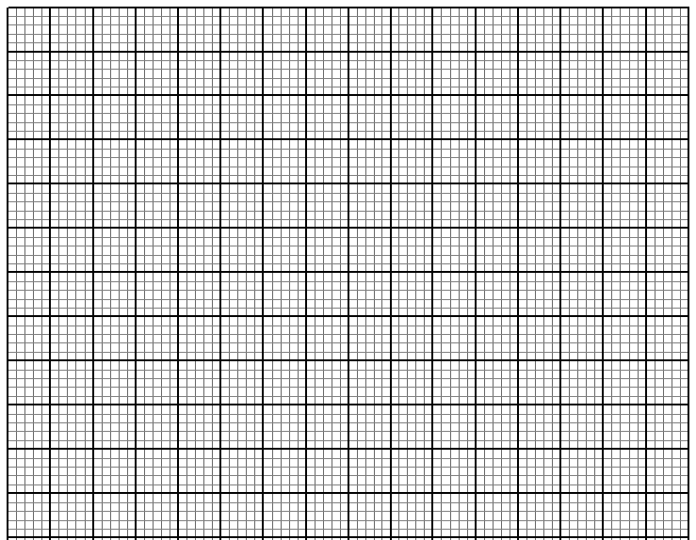

c) Use the graph to solve (1 mark)

d) Determine the transformation which maps (1 mark)

e) State the period amplitude of (2 marks)
- A particle starts from rest at a point A and moves along a straight line coming to rest at another point B. During the motion, its velocity v(m/s) after time t (sec) is given by v=9t² -2t³. Calculate:

a) the time taken for the particle to reach B. (2 marks)

b) the distance traveled during the first two seconds. (3 marks)

c) the time taken for the particle to attain its maximum velocity. (3 marks)

d) the maximum velocity attained (2 marks)

- P and Q are two points on latitude 60⁰S. Their longitudes are 30⁰E and 90⁰W respectively.
Find:
- The distance between P and Q along the parallel of latitude (Take radius of earth = 6370 km and) [to 1 decimal place.] (2 marks)

- The shortest distance along the earth’s surface between P and Q [to 1 decimal place]. (3 marks)

- A weather forecasters reports that the center of a cyclone at (30⁰ S, 120⁰ W) is moving due south at 24 knots. How long will it take to reach a point (45⁰ S, 120⁰ W)? (3 marks)

- If it is 1400 hrs at Q, What will be the time at P? (2 marks)

- A company makes brands A and B of breakfast cereal both of which are enriched with vitamins P and Q. The necessary information about these cereals is given by the table below.
 | Cereal | Minimum Daily Requirement
 | A B | Minimum Daily Requirement
Vitamin P(units/gram) | 1 2 | 100
Vitamin Q(unit /gram) | 5 3 | 300
Cost/gram | Sh 20 Sh 30
- Form all inequalities to represent this information. (3 marks)

- Draw the inequalities on the graphs showing the region which satisfy the inequalities. (3 marks)
- From your graph determine the minimum daily requirements of vitamins P and Q at the lowest cost (2 marks)
- Determine the lowest cost. (2 marks)
- The figure below shows a pulley with wheels center M and N, with a rubber belt ABCDEFA stretched round the wheels. The diameters of the wheel are 24cm and 8cm and the centers are 20 cm apart. Point p divides MN in the ratio 3:1
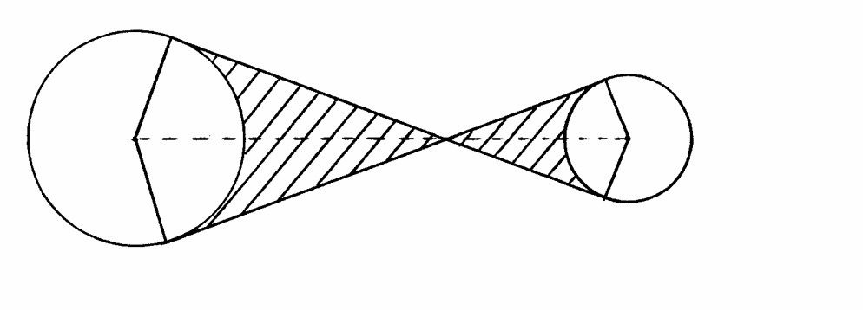

E

B

12cm

F M

N

C

4cm

D

A

p
Find the area of the shaded region (10 marks)

- Given that P varies jointly as Q and R. Given that Q=12, R=27 when P=18 calculate;
(a) The value of P when Q=9 and R=30 (3 marks)

(b) The value of R when P=60 and Q=30 (3 marks)

(c) The percentage by which P is changed when Q is decreased by 12% and R increased by 12% (4 marks)

- The following table shows the distribution of marks obtained by 50 students.
Marks | 45 – 49 | 50 – 54 | 55 – 59 | 60 – 64 | 65 – 69 | 70 – 74 | 75 – 79
No. of students | 3 | 9 | 13 | 15 | 5 | 4 | 1
By using an assumed mean of 62, calculate
- the mean (5 marks)

- the variance (3 marks)

- the standard deviation (2 marks) `

