121/2 SMARTPASS MATHEMATICS PAPER 2 MODEL ONE 2019
MARKING SCHEME
1. |  | M1  M1  A1 | Log a – log b  substitution  C.A.O
2 | . | M1  M1  B1 | equating the det  attempt to solve
3. |  | B1  B1  B1 | reciprocal of square  sum of square & recip.  C.A.O
4. |  | M1  A1
5 | Diagram  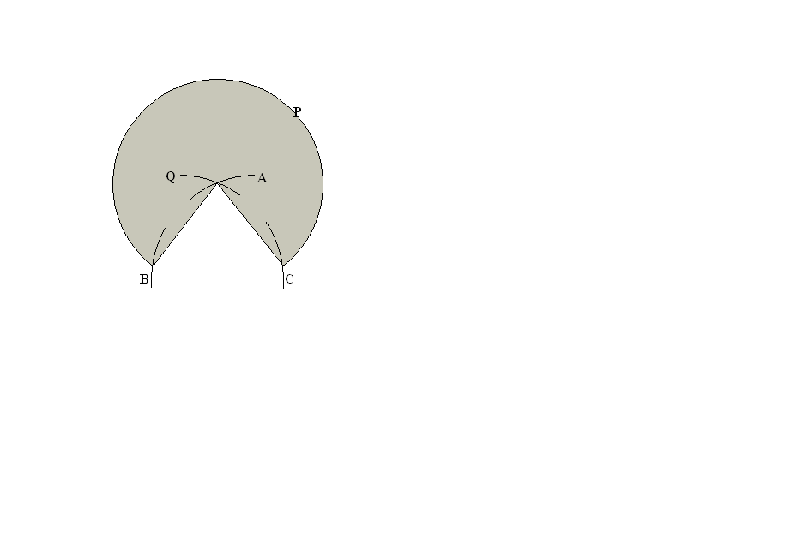 | B1  B1  B1  B1 | loc A,B& C third vertex  Complete triangle ABC  loc P  loc of Q
6 | = | M1  M1  A1 | exp. With one unknown  equating to 0  accept 100.54, 100.6 if tables are used
7 |  | M1  M1  A1 | Max  exp. For % error  C.A.O  ()
8. | a, a+4d and a+10d  6 + 4d = 6+10d  6 6 + 4d  (6 + 4d)² = 6(6 + 10d)  36 + 48d + 16d² = 36 +60d  16d2 – 12d = 0  d = 0 or d = ¾  d = 3/4 | M1  M1  A1
9 | P = 300,000 – 75,00✓  = 225,000✓  A=225,000x1.15¹⁵  MI = 225000 x 1.15¹⁵ ✓  15  Ksh = 122,056 ✓ | M1  B1  M1  A1 | for expression  for monthly installment
10 | 6(x-4) (x-4) -54  6(x²-8x+16)-54  6x²-48x+96-54  6x²-48x+42  (x-1) (6x-42) | ✓M1  ✓ M1  ✓ A1 | For correct expansion  For correct equation  For correct factorization
11 | (2-√3) (2+√3)  (2-√3) (2+√3)  4+ 2√3-2√3-3  4+2√3-2√3-3  =1/1=1 | ✓M1  ✓M1  ✓ | For correct surd notation  For identification the conjugate  For correct answer
12 | (2-1/5x)⁵  32-16x+8x²-8x³+ 2x⁴- 1x⁵  25 125 3125  - 1/5 x=-0.04  X=0.2  32-16 (0.2)+ 8(0.2)²- 8 (0.2)³  25  = 32-3.2+0.32-o0.00256  = 29.11744  = 29.117 | ✓ M1  ✓ M1  ✓ A1 | For correct expansion  For correct substitution of x  For correct answers
13 | Sin (2x-50°) = -0.5  (2x-50°)=210, 330  2x-50° =210, 330  2x=260, 380  Hence x = 130°, 190°  Thus x= 130°, 190° | ✓B1  ✓B1  ✓B1 | For both
14 | 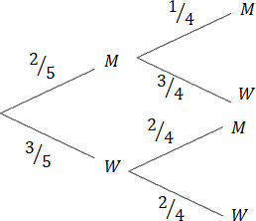  - P (same gender)  = (3/5x2/4)+ (2/5x1/4)  = 6/20+2/20=8/20 = 2/5  - P (opposite gender)  = (2/5x3/4) +(3/5x2/4)  = 6/20+6/20=12/20  = 3/5 | ✓M1  ✓A1  ✓M1  ✓A1
15 | 2(x-1) X (2x-3)  (3x+4) (2x-3) (x-1)  = 2  3x+4 | ✓M1  ✓M1  ✓A1 | Factorization  of both  Change ÷^{n} X^{n}
16 | 3  AQ x BQ = CQx DQ  11x6 = (CQ+ 4) 4  - = 4CQ+ 16  - = 4CQ  CQ= 12.5 | ✓M1  ✓M1  ✓A1
17 | a)  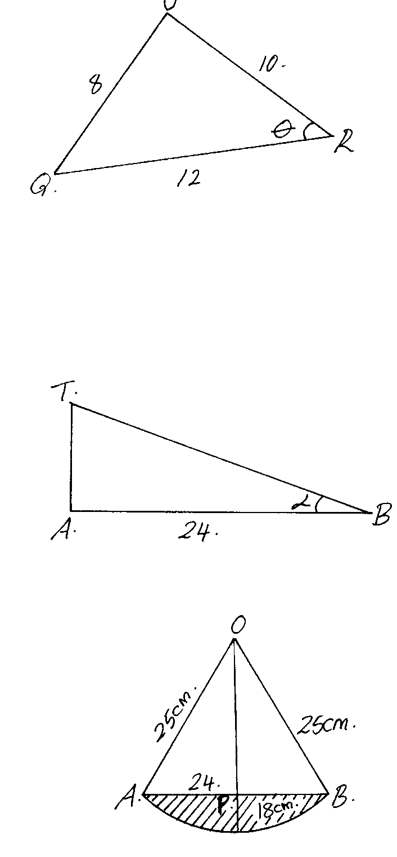  Required angle is θ  82=102+12²-2x10x12cosθ  64=244-240 cosθ  -180= -240 cosθ  cosθ =180  240  θ= cos ⁻¹180 = 41.41°  240  b) Space =volume  = ½ x 6 x10sin 41.41°x24  = 60sin41.41°x24  =952.5m³  C)  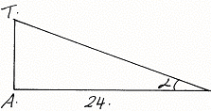B  TA= 10 sinθ= 10xsin41.41°  Tan∝=10xsin41.41  24  tan∝=0.2756  = 15.41° | M1  M1  A1  M1  M1  A1  M1  M1  M1  A1
18 | (a)  b)  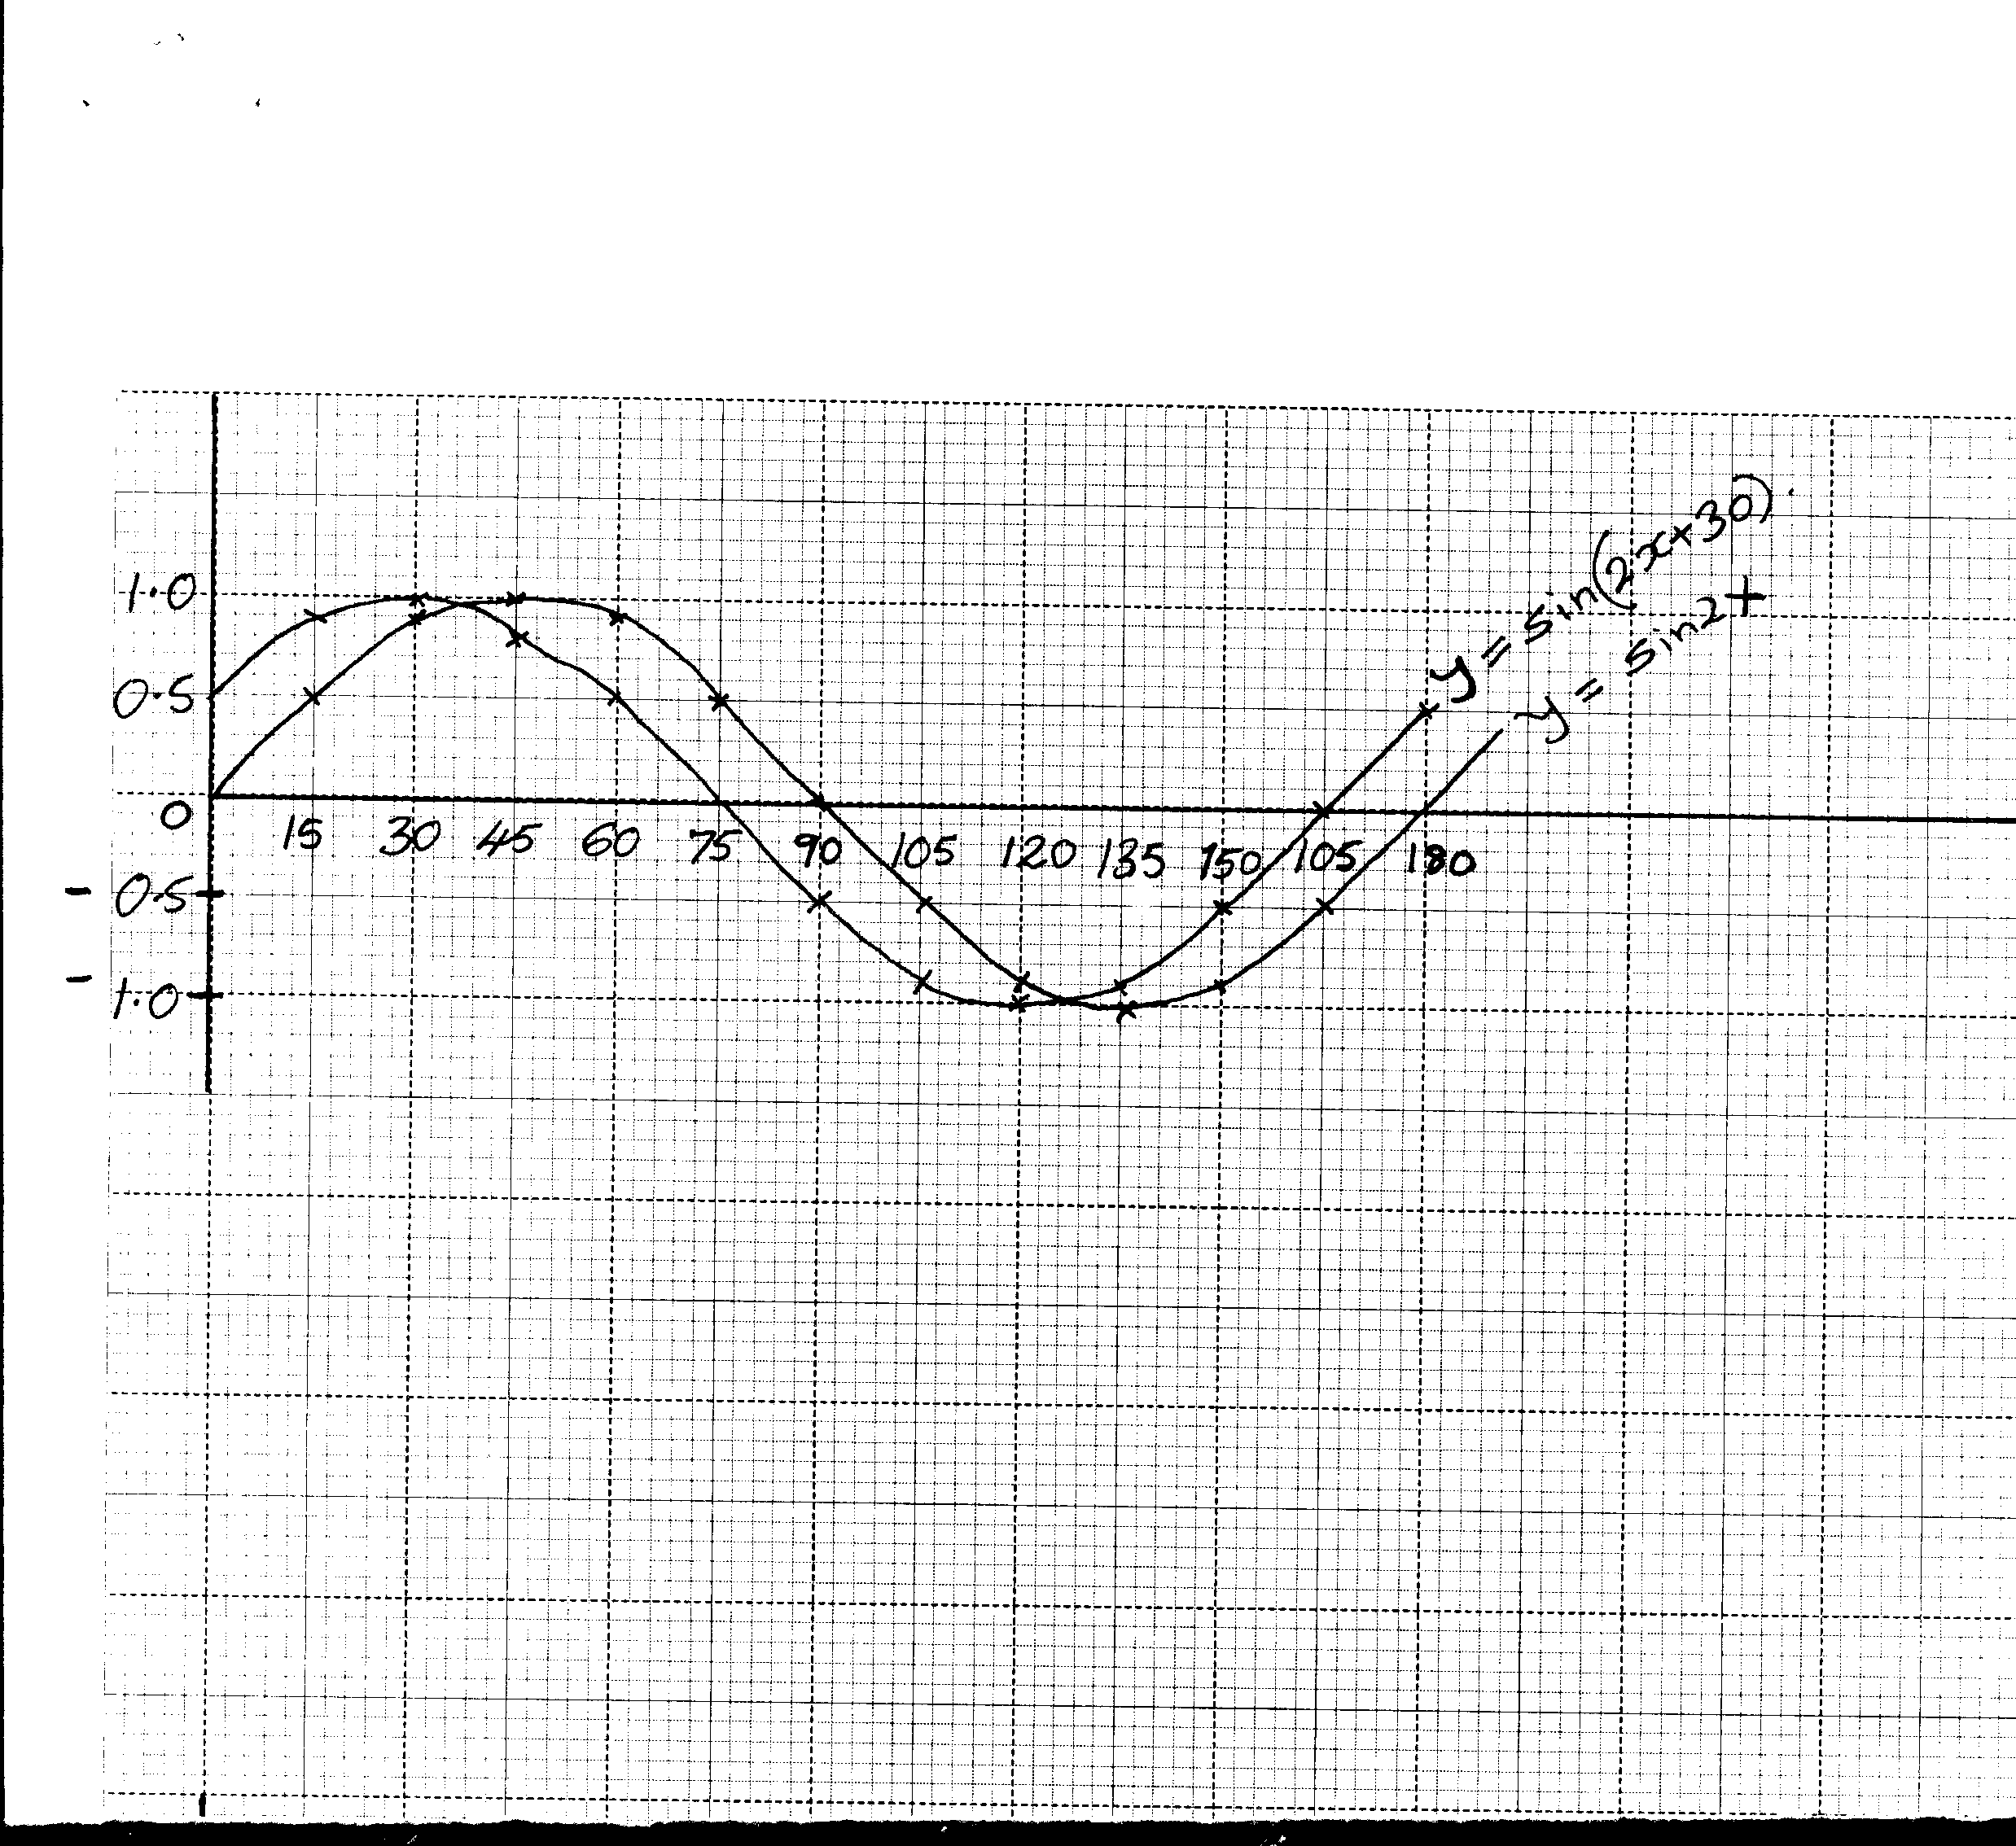  - x = 30.6 º 120.9º  - Translation -30º  0  (e)Period 180º amplitude 1
  x | 0 | 15 | 30 | 45 | 60 | 75 | 90 | 105 | 120 | 135 | 150 | 165 | 180
  Sin 2x | 0 | 0.5 | 0.87 | 1 | 0.87 | 0.5 | 0 | -0.5 | -0.87 | -1 | -0.87 | -0.5 | 0
  Sin (2x+30) | 0.5 | 0.87 | 1 | 0.87 | 0.5 | 0 | -0.5 | -0.87 | -1 | -0.87 | -0.5 | 0 | 0.5
19 | (a) V= 9t² – 2 t³ = 0  t²(9 – 2t) = 0 ✓  t = 0 or t = 4.5 ✓  (b) Distance 2  (9t² - 2t³) dt  0  ²  = 3t - ½ t⁴  ₀  = 3.8 – ½ x 16  = 24 – 8  = 16m  (c) a = ^{dv}/_{dt} = 18t – 6t² ✓  6t (3 – t) = 0  t = 0 or t = 3 ✓  Time in 3 seconds  (d) Max velocity = 9 x 9 – 2 x 27✓  =81 – 54  = 27m/s | M1  A1  M1  M1  A1  M1  B1  A1  M1  A1
20 |  | M1  A1  B1  M1  A1  M1  M1  A1  M1  A1
21 | (a) Let the mass of A be x grams  B be y grams  (b) x 0 100  y 50 0  x 0 60  y 100 0 |  | B1  B1  B1  B1  B1  B1  B1  B1  B1  B1
22 | Area of shaded region BPD = 20 – 10.3 = 9.7 cm  Area of MEP = 2 x ½ x 12 x 15 = 180cm²  Area of shaded part APE = 180 – 92.68  = 87.32  Area of shaded region = 87.32 + 10.30  = 97.62cm² | B1  M1  B1  M1  M1  B1  M1  B1  M1  A1
23 | - 18= Kx12x27  3 1  K= 18 = 1  12x27 8  2 9  P= 1 QR  18 1  = 1 x 9x30 15  18 2  - P = 1 QR  18  18 P = QR  R= 18 p = 18x60  Q 30  = 36  c) P = KQR  P₁= K 88 Q x112 R  - 100  = 0.88x1.12 KQR  % change= 0.88x1.12KQR-KQR X100  KQR  = (0.9856-1)KQR X100  KQR  = -1.44%  P decreases by 1.44% | M1  M1  A1  M1  M1  A1  M1  M1  M1  A1
24 | a) A =62  _  Mean , x = A + ∑fd  ∑f  = 62 + -120  50  = 62 - 2.4  = 59.6  - v = ∑fd² - ∑fd ²  ∑f ∑f  = 2650 120)²  50 50  = 53 – 5.76  = 47 .24  - s.d = √ ∑fd² - ∑fd ²  ∑f ∑f  = √ 47.24  = 6.873 | B1  B1  B1  M1  A1  M1  M1  A1  M1  A1 |  | ✓ value of x  ✓ d and fd  ✓ ∑fd & ∑fd²
  Marks | f | x | d=  x -A | Fd | d² | Fd²
  45 – 49  50 -54  55- 59  60 – 64  65 – 69  70 – 74  75- 79 | 3  9  13  15  5  4  1 | 47  52  57  62  67  72  77 | -15  -10  -5  0  5  10  15 | -45  -90  -65  0  25  40  15 | 225  100  25  0  25  100  225 | 675  900  325  0  125  400  225
   | f = 50 |  |  | ∑fd = ⁻120 | ∑fd² = 2650

