MATHEMATICS F3
PAPER 1

MARKING SCHEME

1. | $$\begin{aligned}3\sqrt{\frac{\text{119}×\text{256}}{\text{68}×7×\text{1000}}} \\ 3\sqrt{\frac{\text{64}}{\text{1000}}}=\frac{4}{\text{10}} \\ =\frac{2}{5}\end{aligned}$$ | M1  M1  A1 | ✓ removal of decimal and simplification  ✓cube root  C.A.O.
 |  | 3
2. | Share of elder boy =$\frac{4}{9}x$  Share of younger boy=$\frac{2}{5}\left(\frac{5}{9}x\right)$  =$\frac{2}{9}x$  Girls share =  $\begin{aligned}x−\left(\frac{4}{9}x+\frac{2}{9}x\right) \\ =\frac{3}{9}x \\ =\frac{1}{3}x\end{aligned}$  % share of younger boy to girls share  $\begin{aligned}=\left(\frac{2}{9}x÷\frac{1}{3}x\right)×\text{100} \\ =\frac{2}{9}×\frac{3}{1}×\text{100} \\ =\text{66}\text{.}\text{67}\text{\%} \text{or} \text{66}\frac{2}{3}\text{\%}\end{aligned}$ | B1  B1  M1  A1
 |  | 4

3. | 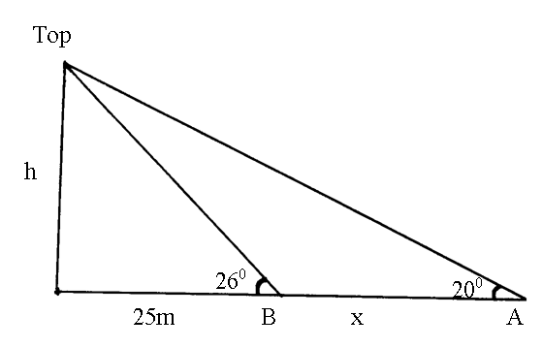  h = 25 tan 26⁰  = 12.1933  $$\begin{aligned}\frac{h}{\text{25}+x}=\text{tan} {\text{20}}^{0} \\ h=\left(\text{25}+x\right)\text{tan} {\text{20}}^{0} \\ \text{12}\text{.}\text{19}=\text{25} \text{tan}{\text{20}}^{0}+x \text{tan}{\text{20}}^{0} \\ x=\frac{\text{12}\text{.}\text{1933}+\text{25} \text{tan}{\text{20}}^{0}}{\text{tan} {\text{20}}^{0}} \\ =\frac{\text{12}\text{.}\text{1933}−9\text{.}\text{0993}}{\text{tan} {\text{20}}^{0}} \\ =\frac{3\text{.}\text{094}}{\text{tan}{\text{20}}^{0}} \\ =8\text{.}\text{501}m\end{aligned}$$ | B1  M1  A1 | ✓ height  for equation in x  ✓ solution
 |  | 3
4. | 5<2x²<35  2.5<x²<17.5  1.581<x<4.183  2,3,4 | B1  B1  B1 | Removal of fraction or equivalent  ✓Square roots  ✓ integral values
5. | Overtaking speed (Relative speed)  =80km/h-40km/h=40km/h  Distance= 60m+20m  =80m  $\frac{\text{80}}{\text{1000}}=0\text{.}\text{08}\text{km}$  Time take = $0\text{.}\text{08}×\frac{1}{\text{40}}$  =0.002hrs  =7.2seconds | M1  M1  A1 | ✓ distance  Expression for time
 |  | 3

6. | Let no. be XY  $∴$product XY =20---------------(i)  Reversed no YX  $⇒$(10y+x)-(10x+y)=9-----------(ii)  $⇒$9y-9x=9  y-x=1  $⇒$y=1+x  Substitution in (i) we’ve  x(1+x)=20  x+x²=20  x²+x-20=0  x²+5x-4x-20=0  x(x+5)-4(x+5)=0  (x+5)(x-4)=0  $∴$x=-5 or x=4 | M1  M1 | ✓ Formation of the two equation  ✓solving of any unknown
7. | (a) (x-5)²+(y-5)²=5²  x²-10x+25+y²-10y+25=25  x²-10x+y²-10y+25=0  (b) Grad PQ=$\frac{8−5}{7−5}=\frac{3}{2}$  (c) grad of the tangent at Q =$\frac{−2}{3}$  Let (x,y) be any other point on it  $\begin{aligned}⇒\frac{y−8}{x−7}=\frac{−3}{2} \\ 3y−\text{24}=−2x+\text{14} \\ 2x+3y=\text{38}\end{aligned}$ | B1  B1  M1  A1
 |  | 4
8. | Area of A = ½ ×4×15=30cm²  Area of B = ½ QR×15  ½ QR×15=30  QR=4cm  Area of C= ½ ST×PR  = ½ ST×8=30  ST=7.5cm  PT²+PR²=TR²  22.5²+8²=X²  $\begin{aligned}X=\sqrt{\text{570}\text{.}\text{25}} \\ =\text{23}\text{.}\text{88}\text{cm}\end{aligned}$ | B1  B1  M1  A1
 |  | 4
9. | (2500×5)+270(480-30×5)  =SH. 101,600 | M1  A1
 |  | 2

10. | I=$\frac{\text{PRT}}{\text{100}}$  $\begin{aligned}=\frac{\text{90},\text{000}×\text{13}×5}{\text{100}×2} \\ =\text{Sh}\text{.} \text{29},\text{250}\end{aligned}$  A =(90,000+29,250)  =SH. 119,250 | M1  A1  B1
 |  | 3
11. | 3^{2(t+1)}+3^{2t}=30  3^{2t} . 3²+3^{2t} =30  3^{2t}(3²+1)=30  3^{2t}×10=30  3^{2t}=3¹  2t=1  t= ½ | M1  M1  A1
 |  | 3
12. | $\frac{\text{dy}}{\text{dx}}$=2x-2  2x-2=4  x=3  y=3²-2(3)+6  = 9-6+6  =9  $∴$point is (3,9) | M1  A1
 |  | 2
13. | Let 50 shilling notes = x  And 20 shilling coins = y  $⇒$ x=3y--------------------------------(i)  50x+20y=3400--------------------(ii)  Substitute (i) in (ii)  50(3y)+20y=3400  150y+20y=3400  170y=3400  y=20  x=3(20)  x=60 | M1  M1  A1 | Formation of both equations  ✓elimination of one unknown  Both ✓
 |  | 3
14. | 45×10=450  45×4=180  Remaining day =270  No. of days =$\frac{\text{270}}{\text{30}}$=9 days | M1  M1  A1
 |  | 3

15. | 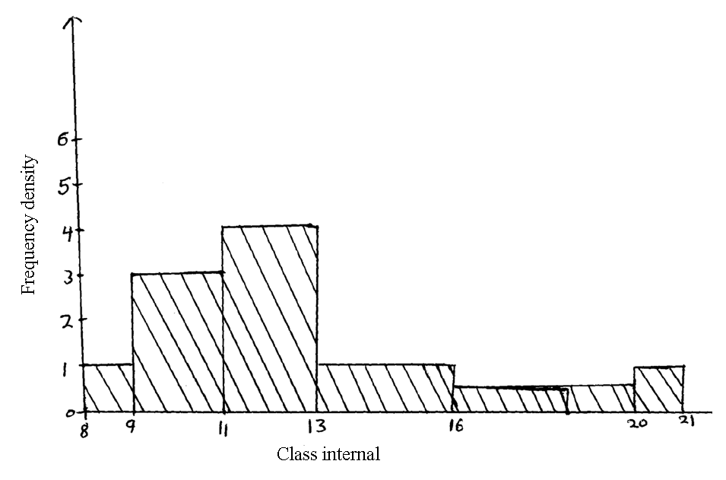 | B1  B1  B1 | ✓Frequency density  ✓bars
 |  | 3
16. | $$\begin{aligned}\left(\begin{matrix}2 & −1 \\ −3 & 2\end{matrix}\right) \\ \left(\begin{matrix}2 & 1 \\ 3 & 2\end{matrix}\right)\left(\begin{matrix}x \\ y\end{matrix}\right)=\left(\begin{matrix}\text{21} \\ \text{34}\end{matrix}\right) \\ \left(\begin{matrix}x \\ y\end{matrix}\right)=\left(\begin{matrix}2 & −1 \\ −3 & 2\end{matrix}\right)\left(\begin{matrix}\text{21} \\ \text{34}\end{matrix}\right) \\ =\left(\begin{matrix}8 \\ 5\end{matrix}\right)\end{aligned}$$ | B1  M1  M1  A1
 |  | 4

17. | 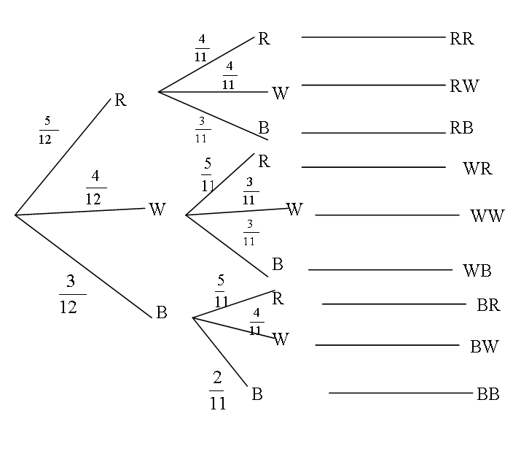  (b) (i) P(RR) or P(WR) or P(BR)  $\begin{aligned}=\frac{5}{\text{12}}×\frac{4}{\text{11}}+\frac{4}{\text{12}}×\frac{5}{\text{11}}+\frac{3}{\text{12}}×\frac{5}{\text{11}} \\ =\frac{5}{\text{33}}+\frac{5}{\text{33}}+\frac{5}{\text{44}} \\ =\frac{5}{\text{12}} \text{or} 0\text{.}\text{4167}\end{aligned}$  (ii) P(RR) or P(WW) or P(BB)  $\begin{aligned}=\frac{5}{\text{12}}×\frac{4}{\text{11}}+\frac{4}{\text{12}}×\frac{3}{\text{11}}+\frac{3}{\text{12}}×\frac{2}{\text{11}} \\ =\frac{5}{\text{33}}+\frac{1}{\text{11}}+\frac{1}{\text{22}} \\ =\frac{\text{19}}{\text{66}} \text{or} 0\text{.}\text{2879}\end{aligned}$  (iii) P(RB) or P(WB) or P(BR) or B(BW) or P(BB)  $\begin{aligned}=\frac{5}{\text{12}}×\frac{3}{\text{11}}+\frac{4}{\text{12}}×\frac{3}{\text{11}}+\frac{3}{\text{12}}×\frac{5}{\text{11}}+\frac{3}{\text{12}}×\frac{4}{\text{11}}+\frac{3}{\text{12}}×\frac{2}{\text{11}} \\ =\frac{5}{\text{44}}+\frac{1}{\text{11}}+\frac{5}{\text{44}}+\frac{1}{\text{11}}+\frac{1}{\text{22}} \\ =\frac{5}{\text{11}} \text{or} 0\text{.}\text{4545}\end{aligned}$ | B2  B1  M1  A1  M1  A1  M1  M1  A1
 |  | 10

18. | (a) < STQ= < PQS = 28⁰(angle in alternate segment)  (b) < TQU = $\frac{{\text{180}}^{0}−{\text{54}}^{0}}{2}={\text{63}}^{0}$(base angles of isosceles triangles)  (c) < TQS =63⁰-28⁰=35⁰(< TUQ is alternate to <PQT=63⁰)  (d) < UOQ =54⁰×2=108⁰(angle subtended at centre is twice that at  circumference by same chord UQ)  $∴$Reflect < UOQ=360⁰-108⁰=252⁰  (e) < TQR=< TSQ  = 180⁰-(28⁰+35⁰)  = 117⁰  (angle in alternate segment are equal) | B1  B1  B1  B1  B1  B1  B1  B1  B1  B1 | Angle  Reason  Angle  Reason  Reason  Angle  Angle  Reason  NB:Accept  Alternative reasons which are correct.
 |  | 10
19. | $$\begin{aligned}a)\frac{x−3}{5}+2\left(\frac{2x}{5}\right)=\frac{9x−\text{15}}{5} \\ \frac{x+3}{5}+2\left(\frac{2x}{5}\right)=\frac{9x+\text{15}}{5} \\ \left(\frac{9x−\text{15}}{5}\right)\left(\frac{9x+\text{15}}{5}\right)=\text{315} \\ x^{2}=\frac{\text{8100}}{\text{81}} \\ 9x^{2}−{\text{15}}^{2}=\text{7875} \\ x^{2}=\text{100} \\ x=\sqrt{\text{100}} \\ =\text{10}\end{aligned}$$  b) Dancing floor area  = (10-3)(10+3)  = 91  Total floor area =15×21=315  Carpeted margin Area =315-91=224m²  c) 750×224=sh 168,000 | M1  M1  M1  M1  A1  M1  M1  A1 M1A1 | For the two expressions  For equality the two expressions  Removal of fractions and forming quadratic equation
 |  | 10

20. | $$\begin{aligned}(a) \frac{5×\text{25}+2×\text{30}+\text{45}×1}{8}=\text{28}\text{.}\text{75} \\ \text{Pr}\text{ofit} \text{28}\text{.}\text{75}\frac{\text{20}}{\text{100}}=\text{sh}\text{.} 5\text{.}\text{75} \\ (b) (i) \text{New} \text{Pr}\text{ice} =\frac{\text{28}\text{.}\text{75}}{\text{100}} ×\text{110}×\frac{\text{115}}{\text{100}}=\text{36}\text{.}\text{40} \\ (\text{ii}) \frac{\text{28}\text{.}\text{75}×\text{110}}{\text{100}} = \text{31}\text{.}\text{60} \\ \text{New} \text{Pr}\text{ofit} \frac{\text{45}−\text{31}\text{.}\text{60}}{\text{31}\text{.}\text{60}}×\text{100} \\ = \frac{\text{13}\text{.}4}{\text{31}\text{.}\text{60}}×\text{100} \\ = \text{42}\text{.}\text{41}\text{\%}\end{aligned}$$ | Ml  A1  Ml  Al  M1  M1  A1  M1  M1  A1
21. | $$\begin{aligned}\left(a\right) (i) a=\frac{\text{12}−0}{\text{10}}m/{s^{2}} \\ =\frac{\text{12}}{\text{10}} \\ =1\text{.}2m/{s^{2}}\end{aligned}$$  $\begin{aligned}\left(\text{ii}\right)\frac{0−\text{12}}{−1\text{.}5}=\frac{−\text{12}}{−1\text{.}5} \\ =8\text{sec}\end{aligned}$ | M1  A1  M1  A1

 | (b)  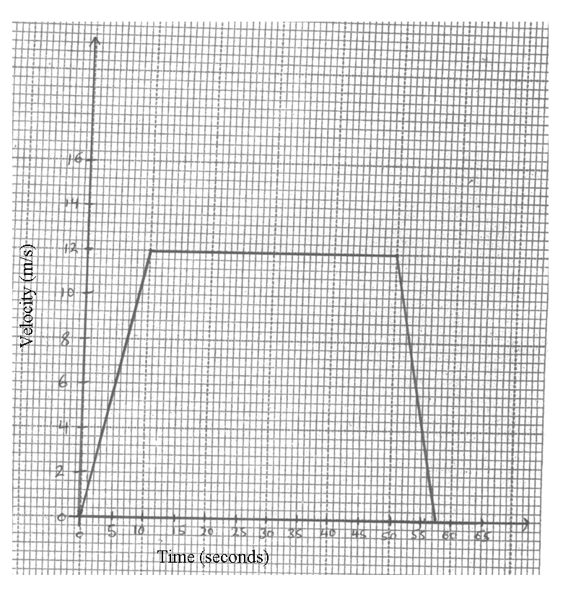  $$\begin{aligned}(i) \text{dis}\text{tan}\text{ce} =\frac{1}{2}×\text{12}×\left(\text{58}×\text{40}\right) \\ =\text{588}m\end{aligned}$$  (ii) 1st 15 seconds  $\begin{aligned}\text{dist} =\frac{1}{2}×\text{10}×\text{12}+5×\text{12} \\ =\text{120}m \\ \text{\%}=\frac{\text{120}}{\text{588}}×\text{100} \\ =\text{20}\text{.}\text{41}\text{\%}\end{aligned}$ | B2  M1  A1  M1  A1
 |  | 10

22. | (a)  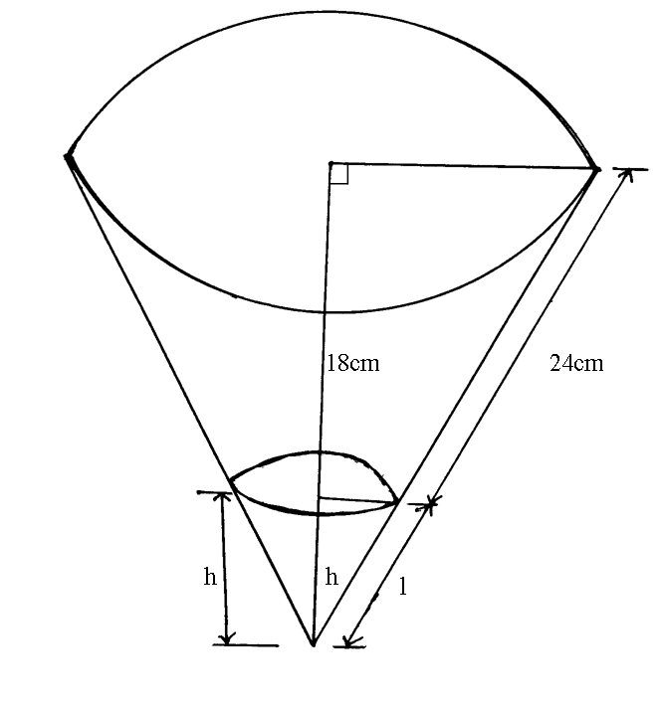  $$\begin{aligned}\frac{h}{h+\text{18}}=\frac{2}{5} \\ L=\text{12}\text{cm} \\ \frac{l}{l+\text{24}}=\frac{2}{5} \\ l=\text{16}\text{cm}\end{aligned}$$  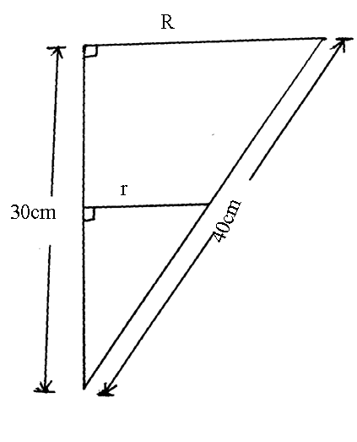$\begin{aligned}R^{2}={\text{40}}^{2}−{\text{30}}^{2} \\ R=\sqrt{\text{700}} \\ =\text{26}\text{.}\text{46}\text{cm} \\ r=\frac{2}{5}×\text{26}\text{.}\text{46}\text{cm} \\ =\text{10}\text{.}\text{584}\text{cm}\end{aligned}$  $$\begin{aligned}\text{Volume}=\frac{1}{3}×3\text{.}\text{142}×\text{26}\text{.}{\text{46}}^{2}×\text{30}−\frac{1}{3}×3\text{.}\text{142}×\text{10}\text{.}\text{584}×\text{12} \\ =\left(\text{21998}\text{.}1−\text{1407}\text{.}9\right){\text{cm}}^{3} \\ =\text{20},\text{590}\text{.}2{\text{cm}}^{3}\end{aligned}$$ | B1  B1  B1  M1  A1  M1  A1

 | (b) Curved surface area  = 3.142×26.46×40-3.142×10.584×16  =(3325.5-532.08)cm²  = 2793.42cm² | M1M1  A1
 |  | 10
23. | (a) -(x²-2xy+y²)  -(x²-xy-xy+y²)  -x(x-y)-y(x-y)  -(x-y)(x-y)  -(x-y)²  = -(3)²  = -9  (b) 9x²+3xy+3xy+y²  3x(3x+y)+y(3x+y)  (3x+y)(3x+y)  = (3x+y)²  = 17²  = 289  (c) 3x²-3xy+xy-y²  3x(x-y)+y(x-y)  (x-y)(3x+y)  = 3(17)  =51  (d) numerator  3x²-3xy-xy+y²  3x(x-y)-y(x-y)  (x-y)(3x-y)  Denominator :  (3x+y)(3x-y)  $\begin{aligned}\frac{\left(x−y\right)\left(3x−y\right)}{\left(3x+y\right)\left(3x−y\right)} \\ =\frac{x−y}{3x+y} \\ =\frac{3}{\text{17}}\end{aligned}$ | M1  A1  M1  A1  M1  M1  A1  M1  M1  A1
 |  | 10

24. | (a)  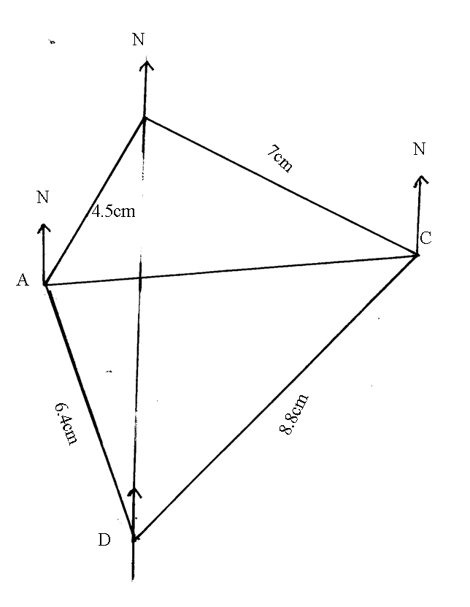  B  (b) (i) N20⁰W  (ii) 542⁰W  (c) (i) 6.4×100km=640km  (ii) 8.8×100km=880km  (d) (i) 300⁰  (ii) 268⁰ | B1  B1  B1  B1  B1  B1  B1  B1  B1  B1
 |  | 10

