NAME:…………………………………………………………………………………...…………
SCHOOL:…………………………………………………………………………………………..
A.D.M NO:……………………………………….. DATE:………………………………………
SIGNATURE:……………………………………

121/1
MATHEMATICS
PAPER 1

FORM THREE
MATHEMATICS P1

INSTRUCTIONS TO CANDIDATES:
- Write your name and admission number in the spaces provided above
- This paper contains two sections; Section I and section II.
- Answer all the questions in section I and only five questions from section II.
- All workings and answers must be written on the question paper in the spaces provided below each question.
- Marks may be given for correct working even if the answer is wrong.
- Calculators and KNEC mathematical tables may be used EXCEPT where stated otherwise
- Show all the steps in your calculations, giving your answers at each stage in the spaces below each question

For Examiner’s Use Only;

Section I

Questions | 1 | 2 | 3 | 4 | 5 | 6 | 7 | 8 | 9 | 10 | 11 | 12 | 13 | 14 | 15 | 16 | TOTAL
Marks

Section II

GRAND
TOTAL
Questions | 17 | 18 | 19 | 20 | 21 | 22 | 23 | 24 | TOTAL
Marks

1. Without using mathematical tables or calculators, evaluate the following leaving your answer as a
fraction in its simplest form. (3mks)
$$3\sqrt{\frac{0\text{.}\text{119}×0\text{.}\text{256}}{0\text{.}\text{068}×7}}$$

2. Two boys and a girl shared some money .The elder boy got $49$of it, the younger boy got $25$of the
reminder and the girl got the rest. Find the percentage share of the younger boy to the girl’s share.
(4mks)

3. From a point A, the angle of elevation of top of a watch tower is 20⁰.From another point which is
25m from the base of the tower, the angle of elevation of the top of the tower is 26⁰.Giving your answer to three decimal places, determine the height of the tower and hence calculate the distance between the points A and B if they are both on the same side of the tower and lie on a straight line with the base of the tower. (3mks)

4. If X is a positive integer, find all possible values of x given that 1<$\frac{2}{5}x^{2}$<7. (3mks)

5. A train whose length is 60 metres is travelling at 40km/h in the same direction as a bus whose length is 20m.If the speed of bus is 80km/h and moving parallel to the train, calculate the time it takes the truck to overtake the train completely in seconds. (3mks)

6. A positive two digit number is such that the product of the digits is 20.When the digits are reversed , the number so formed is greater than the original number by 9.Find the number.

7. The diagram below shows a circle with centre P(5,5) and radius 5 units
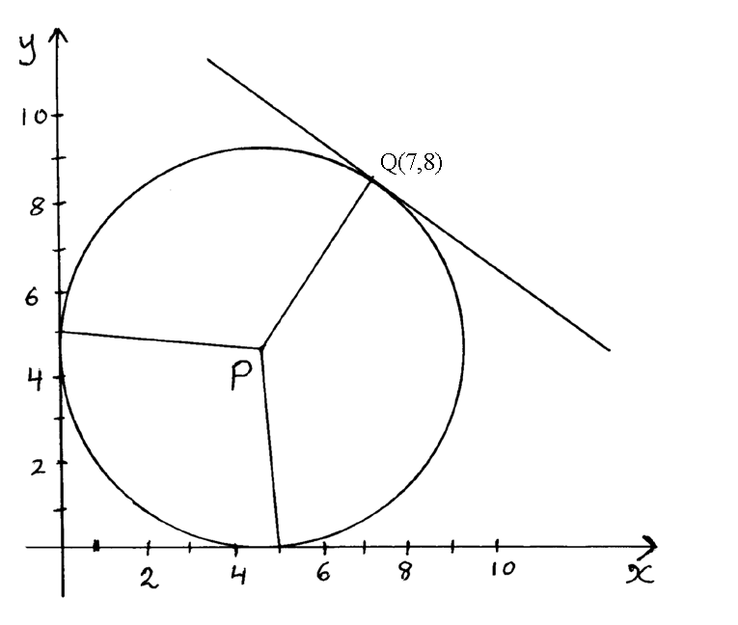
- Write down in terms of x and y the equation of the circle in the form ax²+by²+cx+dy+e=0
where a,b,c,d and e are constants. (1mk)

- Determine the gradient of PQ (1mk)

- Find the equation of the tangent at Q in the form ax+by=c. (2mks)

8. Find the value of x in the following figure given that area A =Area B=Area C(Give your answer
to 2 decimal places) (4mks)
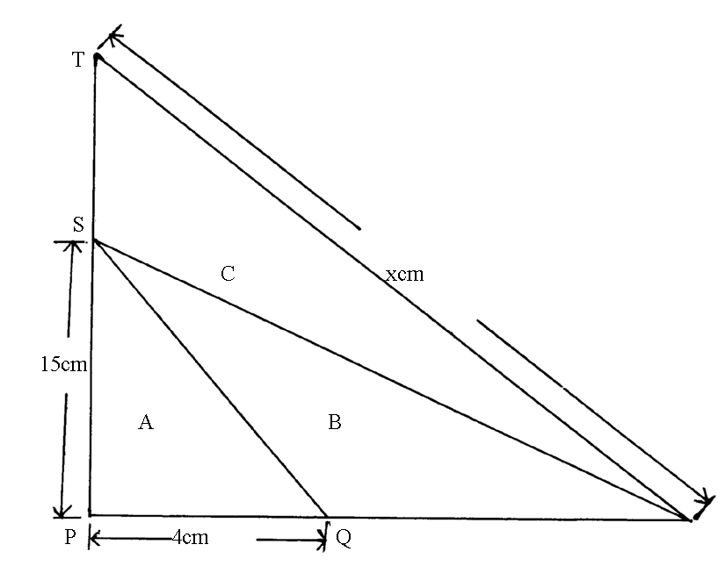

9.Odhis car Hire company hires out as follows; sh. 2500 per day and sh. 270 per kilometer covered. They offer a discount of 30km free each day of hire.Makori hires a car for 5 days and drives for 480km.Calculate the total cost. (2mks)

10.Omwando borrows sh. 90,000 for 5 years at 6 ½ % simple interest p.a.What amount does he have to pay at the end of that time? (3mks)

11.Solve for t in the equation
9^{t+1} +3^{2t}=30. (3mks)

12.Given the curve y= x²-2x+6, find the coordinates of the point on the curve at which the gradient is 4. (2mks)

13.Mary has some money in two denominations only. Fifty shilling notes and twenty shilling coins. She has three times as many fifty shilling notes as twenty shilling coins. If altogether she has sh. 3400, find the number of fifty shilling notes and 20 shilling coins.

14.In Ngamongo village, a piece of work can be completed by 45 workers in 10 days .They worked for 4 days after which 15 workers were laid off. How many days would it take the remaining workers to complete the work? (3mks)

15. The table below shows marks obtained by a form three class in a certain school.

Marks (x) | $$8≤X<9$$ | $$9≤X<\text{11}$$ | $$\text{11}≤X<\text{13}$$ | $$\text{13}≤X<\text{16}$$ | $$\text{16}≤X<\text{20}$$ | $$\text{20}≤X<\text{21}$$
No. of students (y) | 2 | 6 | 8 | 3 | 2 | 1
Use the table to represent the information on a histogram. (3mks)

16. Find the inverse of the matrix$\left(\begin{matrix}2 & 1 \\ 3 & 2\end{matrix}\right)$ and hence solve the simultaneous equations below. (4mks)
2x+y=21
3x+2y=34

SECTION II (50 MARKS)
ANSWER ANY FIVE QUESTIONS.
17. A bag contains 5 red , 4 white and 3 blue beads. Two beads are selected at random.
(a) Draw a tree diagram and list the probability space. (3mks)

(b) Find the probability that
(i) The last bead selected is red. (2mks)

(ii) The beads selected were of the same colour (2mks)

(iii) At least one of the selected beads is blue. (3mks)

18. In the figure below,O is the centre of the circle.PQR is a tangent to the circle at Q. Angle PQS=28⁰,angle UTQ=54⁰ and UT =TQ.
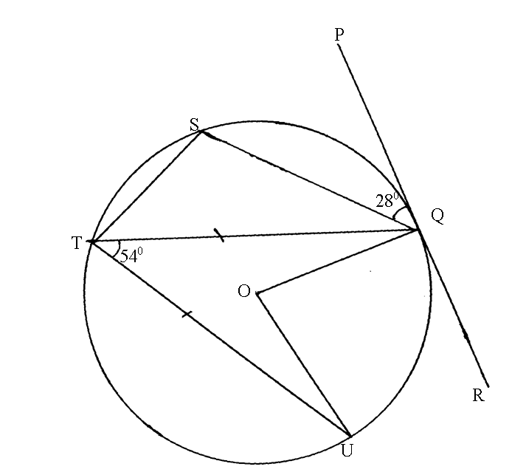

Giving reasons , determine the size of
(a) Angle STQ. (2mks)

(b) Angle TQU. (2mks)

(c) Angle TQS (2mks)

- Reflex angle UOQ . (2mks)

- Angle TQR. (2mks)
19.The following figure represent a dancing floor with a carpeted margin all around of $\frac{2}{5}x$ wide leaving a dancing space of (x-3)m by (x+3)m
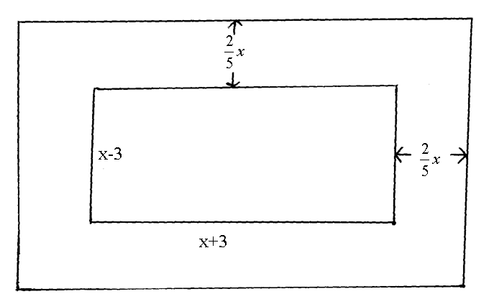
If the total area of the entire room is 315m²
(a) Calculate the value of x. (5mks)

(b) Calculate the area of the carpeted margin. (3mks)

(c) If the carpet cost sh. 750 per m²,calculate the total cost of the sealed margin. (2mks)

20. John bought 3 brands of tea, A B and C. The cost price of the three brands were sh 25, sh 30, sh 45 per kg respectively. He mixed the three brands in the ratio 5:2:1 respectively: After selling the mixture he made a profit of 20%.
(a) How much profit did he make per kilogram of the mixture? (4 mks)

(b) After one year the cost price of each brand was increased by 10%
(i) For how much did he sell one kilogram of the mixture to make a profit of 15%? (Give your answer to the nearest 5 cents) (3 mks)

(ii) What would have been his percentage profit if he sold one kilogram of the mixture at sh. 45. (3 mks)

21. A car accelerates from rest for 10 seconds until it reaches a velocity of 12 metres per second.It then continues at this velocity for the next 40 seconds after which it brakes and comes to rest until a constant retardation of 1.5 meres per second
(a) Determine
(i) The acceleration over the first 10 seconds (2mks)

(ii) The time taken during the retardation (2mks)

(b) Draw the velocity time graph for the journey and use it to determine.
(i) The total distance covered by the car (4mks)

(ii) The percentage of the total distance which was covered during the first 15 seconds.
(2mks)

22. The diagram below shows a flower vase of depth 18cm.The ratio of the top and bottom diameters is 5:2 (Take =3.142)
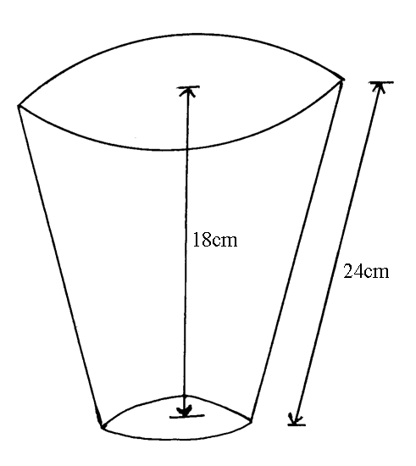

Calculate
(a) The volume of the flower vase (7mks)

(b) The curved surface area of the flower vase (3mks)

23. Given that x-y=3 and 3x+y=17, find without solving for X and Y the value of
(a) 2xy-x²-y² (2mks)

(b) 6xy+y²+9x² (2mks)

(c) 3x²-2xy+y² (3mks)

(d) $\frac{3x^{2}−4\text{xy}+y^{2}}{9x^{2}−y^{2}}$ (3mks)

24. Three Kenyan warships A,B and C are at sea such that ship B is 450km on a bearing of 030⁰ from ship A. ship C is 700km from ship B on a bearing of 120⁰.An enemy ship D is sighted 1000km due south of ship B.
(a) Taking a scale of 1cm to represent 100km locate the position of the ships A,B,C and D
(4mks)

(b) Find the compass bearing of :
(i) Ship A from ship D (1mk)

(ii) Ship D from ship C (1mk)

(c) Use the scale drawing to determine
(i) The distance of D from A (1mk)

(ii) The distance of C from D (1mk)

(d) Find the bearing of :
(i) B from C (1mk)

(ii) A from C (1mk)

END

