NAME: …………………………………………. INDEX NO: ……………………………….

SCHOOL: …………………………………….. DATE : …………………………………….

CANDIDATE’S SIGNATURE: …………………

121/2
MATHEMATICS
PAPER 2
TIME: 2½ HOURS
GOLDEN ELITE EXAMINATIONS

Kenya Certificate of Secondary Education (KCSE)
MATHEMATICS
PAPER 2
TIME: 2½ HOURS

INSTRUCTIONS TO CANDIDATES
- Write your Name and Index Number in the spaces provided at the top of this page.
- Sign and write the date of examination in the spaces provided above.
- This paper contains TWO sections: section I and section II
- Answer all the questions in section I and any FIVE questions from section II.
- All answers and working must be written on the question paper in the spaces provided below each question.
- Show all the steps in your calculations, giving your answers at each stage in the spaces provided below each question.
- Marks may be given for correct working even if the answer is wrong.
- Non-programmable silent electronic calculators and KNEC mathematical tables may be used except where stated otherwise.
FOR EXAMINER’S USE ONLY:
Section I
1 | 2 | 3 | 4 | 5 | 6 | 7 | 8 | 9 | 10 | 11 | 12 | 13 | 14 | 15 | 16 | TOTAL

Section II GRAND TOTAL
17 | 18 | 19 | 20 | 21 | 22 | 23 | 24 | TOTAL

SECTION I: (50 MARKS)
Answer ALL Questions in this section
- Use logarithm table to evaluate: (4mks)

0.7493cos²16.335⁰
Log 559.3 + 10tan3⁰

- What must be added to ¼x² + ¹/₉ in order to make it a perfect square? (2mks)

- Expand (x – ª/_{x}²)⁶ in ascending powers of x, up to the term independent of x. If this independent term is 1215, find the value of a. (3mks)

- An angle of 1.75 radians at the centre of a circle subtends an arc of length 24.8cm. Find the diameter of the circle. (2mks)

- ABCDEFG is a rectangular box in which AB, AD, AE are 3cm, 4cm and 5cm long respectively. M is the midpoint of FG.
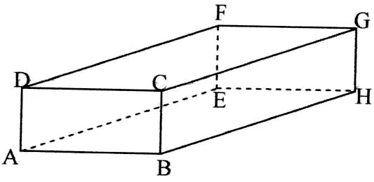
Find the length AM and determine the inclination of AM to EFGH. (3mks)

- Use square roots, reciprocals and square tables to evaluate the expression: (3mks)
(0.00546667)^{½} + 3 ²
0.043279

- A member of a county assembly sold his car for shs. 1,250,000 and deposited this money in a savings account in one of the banks in Kaiboi town. The banks paid 18%p.a compounded quarterly. After two years, the member of the county assembly withdrew a half of the amount from the account. He left the rest for a further two and a half years. Calculate the total interest he earned in the 4½ year period. (4mks)

- Given that x⁰ is an angle in the third quadrant such that 16sin²x⁰ + 4cos x⁰ = 10. Find tan x. (3mks)

- Two variables P and L are such that P varies partly as L and partly varies inversely as the square root of L.
  - Determine the relationship between P and L given that L = 16 when P = 500 and L = 25 when P = 800. (3mks)

  - Hence find P when L = 81. (1mk)

- The angle of elevation from the base of a wall to the top of the flag post 70 metres away is 62. The angle of depression from the top of the flag post to the wall is 25⁰.
Calculate:-
  - The height of the flag post. (1mk)

  - The height of the wall. (2mks)

- Given that log 3 = 1.583 and log 5 = 2.322, evaluate without using table or calculator:
Log 135 (2mks)

- Two values of a and b are such that 7.1 < 7.3 and 12.5 < b < 12.7. Calculate the percentage error in b, giving your answer correct to 2 decimal places. (3mks)

- The following figure is a solid and its incomplete net.
  - Complete and label the net.
H
G

8cm

E F C A D
8cm
2cm B C
A 2cm B

F

G
  - Hence or otherwise, find the surface area of the solid. (2mks)

- Solve for x in the equation: (3mks)
9^{x+1} – 54 = 3^{2x+1}

- The points P (-6, 5) and Q (2, -1) are the ends of a diameter of a circle centre M.
Determine:-
  - The coordinates of M. (1mk)

  - The equation of the circle in the form x² + y² + ax + by + c = 0. (2mks)

- Solve the simultaneous equations: (3mks)
y + 2x + 1 = 0
x² + xy = -6

SECTION II (50 MARKS)
Answer ONLY FIVE questions in this section in the spaces provided

- Mr. Maiyo, who works in a sugarcane plantation, owns a bicycle which he sometimes rides to work. Out of the 21 working days in a month, he rides to work for 18 days. If he rides to work, the probability that he is bitten by a rabid dog is ⁴/₁₅ otherwise it is only ¹/₁₃. When he is bitten by the dog, the probability that he will get treated is ⁴/₅ and if he does not get treated, the probability that he will get rabies is ⁵/₇.
  - Draw a tree diagram using the given information. (3mks)

  - Using the tree diagram in (a) above, determine the probability that;
    - Maiyo will not be bitten by a rabid dog. (2mks)

    - He will get rabies. (3mks)

    - He will not get rabies. (2mks)

- Tax rates in operation in a certain year in Kenya are as given in the table below.
Income | Tax Rates
(kf p.a.) | (sh. Per £)
1 – 4,512  4,513 – 9,024  9,025 – 13,536  13,537 – 18,048  18,049 – 22,560  Over 22,560 | 2  3  4  5  6  6.5

  - Mr. Koech pays Ksh. 2,172 P.A.Y.E. monthly. He was entitled to a house allowance of Ksh. 5,000 and a medical allowance of Ksh. 2,000 and gets a monthly tax relief of Ksh. 1,093. Calculate his monthly basic salary. (8mks)

  - Mr. Koech’s other deduction per month were as follows:-
NHIF – Kshs. 320
Co-op Loan – Kshs. 4,000
Calculate Koech’s net pay per month. (2mks)

- Using a ruler and a pair of compasses only:
  - Three points A, B and C are vertices of a triangle ABC such that AB = 8cm, BC = 5cm and AC = 6.4cm. Draw triangle ABC with AB as the base. (2mks)
  - Construct the locus of P such that it is equidistance from the sides AB, BC and AC. (3mks)
  - On the opposite side of point C on AB, construct the locus L such <ALB = 60⁰. (3mks)
  - Hence determine the area of the major sector bounded by the locus L. (2mks)

- (a) Complete the table below for the functions y = 4 Cos 2x and y = 3 Sin (2x + 30⁰) giving the values to 1 decimal place. (2mks)
 | -30⁰ | 0⁰ | 30⁰ | 60⁰ | 90⁰ | 120⁰ | 150⁰ | 180⁰ | 210⁰ | 240⁰ | 270⁰
4 Cos 2x | 2.0 | 4.0 | 2.0 |  | -4.0 | -2.0 |  | 4.0 | 2.0 |  | -4.0
3 Sin (x+30⁰) | 0.0 | 1.5 | 2.6 | 3.6 |  | 1.5 | 0 |  | -2.6 |  | -2.6

(b) Draw the graphs of y = 4 Cos 2x⁰ and y = 3 Sin (x + 30⁰) for -30 < x < 270⁰ on the same axes. Use a scale of 1cm for 30⁰ on x-axis and 1cm for 1 unit on the y-axis. (4mks)

- Use your graphs in (b) above to solve the equation:
  - 3 Sin (x + 30⁰) – 4 Cos 2x = 0. (2mks)

  - 3 Sin (2x + 30⁰) + 1 = 0 (1mk)

- Determine the period of the function y = 4 Cos 2x. (1mk)

- An aircraft takes off from the airport X(65⁰N, 36⁰E) and flies by the most direct route to another airport Y (R⁰N, 144⁰W) covering a distance of 4800nm.
  - Find R⁰ (1mk)

  - If instead, the aircraft had flown along the meridian144⁰W to point Y, find how much further it would have flown. (5mks)

  - Two aircrafts takes off from X to Y at the same time. Given that both fly at the same speed and one flies on the direct route and the other takes the route described in (b) above, state the position of the second aircraft when the first is landing at Y. (2mks)

- The diagram shown below represents the area between the curves y = x² + 2 and y = 10 – x² and y-axis.
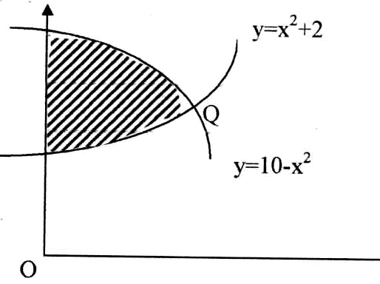
Find:-
  - The coordinates of Q (a point of intersection) (1mk)

- The area of the shaded region, by use of mid-ordinate rule with 8 ordinates(6mks)

- Use integration method to calculate the same area as in (b) above. (3mks)

- Two quantities of p and r are given below.
P | 1.2 | 1.5 | 2.0 | 2.5 | 3.5 | 4.5
r | 1.58 | 2.25 | 3.39 | 4.74 | 7.86 | 11.5

- State the linear equation connecting p and r. (1mk)

- Using the scale 2cm to represent 0.1 units on both axes, draw a suitable straight line graph on the grid provided;

Hence estimate the value of k and n. (8mks)

- Write an equation connecting p and n. (1mk)

- An aircraft leaves point A and flies on a bearing of 020⁰ to a second point B, which is 600km from A. From B, the aircraft then flies on a bearing of 320⁰ to a third point C which is 1000km from B. The aircraft then flies directly back to A from C at a speed of 200km/hr. By scale drawing, find:-
- Time taken to fly directly from C to A. (6mks)

- The bearing in which it would fly from C to A. (1mk)

- Locate point D on a bearing 170⁰ from C and 280⁰ from A. Calculate BD in kilometers. (2mks)

- What is the bearing of D from B? (1mk)

