2020 FORM 4 TERM 1 ENTRY EXAMS
PP2 Marking Scheme
SECTION 1
- No log Log
4.4497 $\underline{1}$.5650÷2 0.6529+ m1
0.3673 $\underline{1}$. 7825
0.4354
1-cos 81.53 $1-8527 ⇐$ $\underline{1}$ .9308 m1
3.196 0.5046

$\underline{1}$.5650 - 2 + 1.5650 m1
2 2 A1

- a+ 4d + a +5d=30⁰ B1 simultaneous equation formed
2a+9d=30⁰ (i)
a+2d=5 (ii)
2a+9d=30
2a+4d=10 M1 attempt to solve
5d=20
d=4
a+2x4=5
a=5-8=-3 A1

- t²= (2y x 1)²
2yk+k
t²(2ky +k)= (2y + 1)² m1
2ky + k= (2y + 1)² m1
t²
k(2y + 1)=(2y+1)²
t ²
k=2y+1
t² A1

- let log x be a
2+a² =3a m1
a² -3a+2=0
a²-2a –a +2=0
a(a-2)-1(1-2)=0 m1
a=1 a=2.
Log x=1 log x=2
X=10 x=100 A1

- A.E =(4.5 + 6.25 + 9.505)-(3.5 + 6.15 + 9.495) m1
2
=20.255-19.145=1.11
2 2 m1
=0.555
% error=0.555 x100
19.7
=2.32% A1
- QR = 8
Sin 100 sin 35⁰
QR=8 sin 100⁰= 13.74cm B1
Sin 35º
Area = ½x13.74 x 8 sin 45⁰ m1
=38.86cm² A1

- (a) 1+ 6(2x)¹ + 15 (2x)² + 20(2x)³ m1
1+12x + 60x² +160 x³ A1

b) 1+2x = 0.98
x=0.01 m1
1+12(0.01 ) + 60(0.01)²+160 (0.01)
1+ 0.12+0.006 + 0.00016
=1.1262(4 d.p) A1

- AP x BP = CP x DP
9 x 3 = ( 8 + X)X
X2 +8X -27 =0
$$X= \frac{-8 ± \sqrt{64+108}}{2}$$
$$=\frac{-8 ±\sqrt{172}}{2}$$
$$=\frac{-8±13.11}{2}$$
=2.557

- (5-x)4 -6x=0 m1
20-4x – 6x =0
20-10x=10
20=10x
X=2 A1

- $6\sqrt{7}+6\sqrt{2}=3\sqrt{7}+3\sqrt{2}$ 6&7+6&2=3&7+3&2 m1
$4\sqrt{2}$ +$2\sqrt{7}$ $2\sqrt{2}+\sqrt{7}$
=$3\sqrt{7}+3\sqrt{2}$ ($\sqrt{2}$ – $\sqrt{7 )}$ m1
$2\sqrt{2+ \sqrt{7}}$ ($\sqrt{2}$ - $\sqrt{7}$)

=$6\sqrt{14}$ - 2+12-3$\sqrt{14}$
8 - 7
=3$\sqrt{14}$ - 9 A1

- X² + y² – 4x+6y-3=0
X²-4x+4 + y²+6y +9=3+4+9 m1
(x-2)² +(y+3)²=16 m1
Centre (2,-3) radius=4 A1

- 0.92x x 0.88x = 121,440 m1
X90.92 x 0.88)= 121,440
0.92x0.88 m1
X=sh.150,000 A1
- C=hA+KA²
20=2h+4k m1
21=3h+9k
K=-3 h=16
C=16a-3a²
64-48
=16 A1

- X+6 ½ X=180^{O} m1
X + $\frac{13}{2}X$ =180^{O}
2X + 13X =360^{O} m1
X =24^{O}
$\frac{360}{24}=15 Sides$ A1
- X:y=2:3
(5x-2y) :(x-y) m
(5(2) – 2(3): (2+3) m1
(10-6):(5) m1
4:5 A1

SECTION II
- Without profit
Cost = 150= sh 120 m1
1.25
112x +132 y=120
X+y
112x + 132 y = 120
X+y
112x + 132 y=120 x+120 y m1
12y = 8x
12 = x
8 y
x:y=3:2 A1

- a)38300 + 1200 + 3600 m1
53900 x 12 = k£ 32,340 pa A1
20
b) 32,340
8800 x2=17600 m1
8000 x 3= 24,000
8000 x 5= 40,000
6540 x 7= 45,780 m1
127,380 m1
Monthly = 127,380 = 10,615 m1
12
Less ……. 1172
9443 m1
c) ³/₁₀₀ x 4600 = 198 m1
= 9,245
Total deduction (9245 + 776 + 4600 + 4200) m1
Sh.28,821
Net pay = 53900-28821 m1
=sh.25079 A1
- (a)
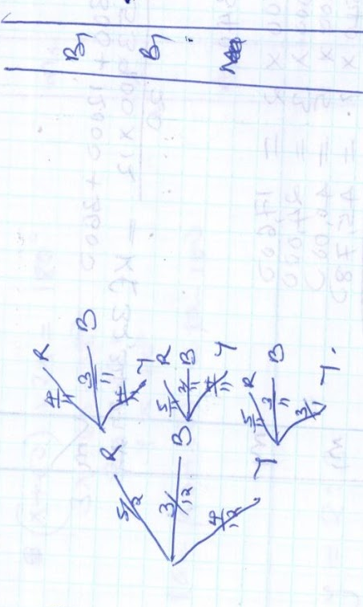
(b)(i) P(both red) ⁵/₁₂x ⁴/₁₁=⁵/₃₃ M1 A1

(ii)P(same colour) m1
⁵/₁₂ x ⁴/₁₁ or ⁴/₁₂ x ²/₁₁ or ⁴_{/12} x ³/₁₁ m1
=19 /66 A1

(iii) P(no red)
³/₁₂ x ^{2/}₁₁ or ³/₁₂ x ⁴/₁₁ or ⁴/₁₂ ³/₁₁ or ⁴/₁₂ ³/₁₁ m1
=⁷/₂₂ A1
- (a)(i) OS =²/₅ q
(ii) PQ=q-p B1
(iii) OR = ³/4p + ¼ q B1

(b) OT=h (³/₄p + 1/₄q) B1
OT=p +k (2/₅ q – p) B1
3/₄hp + 1/₄hq = 1/₄hq=p+2/₅kq –kp B1
3/₄h = 1-k h/₄=2/₅k B1
3/₄h (8k/₅) (1-k)
6k/₅ = 5-5k B1
11k=5
K=5_{/11} B1
11=8/₁₁
PT:T=5/₁₁:6/₁₁
5:6 A1

- (a)(i)$<$ORS = 40⁰
(ii) $<$USP=80⁰(50+30)⁰
(iii)$<$<QR= 180-50=130⁰

(b)(ST)²=PT:RT
(9)²=PT=7cm
PT=81/7=11.6(3s.f)
11.6-7=4.6 A1

c)4.6=2R m1
Sin 50⁰ m1
=3.00 A1

- (a) n^{th}= ar^{n-1}
a x ar x ar²=64 m1
a³r³=64

r³ =⁶⁴/a₃ m1
r=⁴/_{a} A1

(b)a + ar + ar²=14 B1
a+a(⁴/_{a}) + a(⁴/_{a})²=14 m1
a+ 4+¹⁶/_{a}=14

a² + 4a + 16 =149 a=2 r=2 B1
a²-10a + 16 =0 a=8 r=½ B1
a² -8a -2a + 16=0
a(a-8) -2(a-8)=0
a=2 or 8
r=4/8 or 4/2 ½or2

r=½=8,4,2,1,or A1
r=2=2,4,8,18

(c)S₅₀= a(1-r^{n}) r$<1$1
1-r m1
a(r^{n}-1) r$>$ 1
1-r
2(s^{s}-1) = 62 A1
2-1

- a) 150,000 m1
120,000
270,000cm³/min 270 c/min m1
= 18,900 70min A1
270

b) (i) 270 l/min x 25
=6,750 litres by one m1
He opened to his custom m1
18,900- 6750 = 12,150 litres m1
Rate of filling = 270-20=250 m1
48³/₅min A1
ii) 542 x 25= 13,550 m1
+ 6300
19,850 A1

- $P=\frac{kQ}{r^{2}}$ m1
$9= \frac{12k}{2^{2}}$= 12k/2^2
$k=\frac{9}{3} =3$ A1

$P= \frac{3(15)}{25}$ M1
$P=1.8$ A1

$P=\frac{KQ}{r^{2}}$

$$\frac{pr^{2}}{3}=q$$

New P = 1.2 p
- 