
FORM FOUR TRIAL 2, 2019
Kenya Certificate of Secondary Education
121/1 MATHEMATICS
PAPER ONE
TIME: 2½HRS
Instruction: Attempt ALL Questions in Section I and any FIVE in section II
SECTION 1
1 | 2 | 3 | 4 | 5 | 6 | 7 | 8 | 9 | 10 | 11 | 12 | 13 | 14 | 15 | 16 | Total

SECTION 2
17 | 18 | 19 | 20 | 21 | 22 | 23 | 24 |  | GRAND TOTAL

SECTION I (50Mrks)
Answer ALL the Questions in the section
- Evaluate: 3mks
$$\frac{2\frac{1}{2} of 1\frac{3}{4}-5\frac{1}{4}}{1\frac{2}{5} + 2(1\frac{1}{4}-2\frac{3}{4})}$$

- An electrician made a loss of 30% by selling a multi plug at Sh. 1400. What profit would he have made if he sold the multi plug at sh 2300. 3mks

- Simplify $\sqrt{\frac{{12x}^{4}y^{-1}z^{5}}{{3x}^{-2}y^{-3}z^{3}}}$ 2mks

- Solve the following inequalities and represent the solutions on a number line
X + 1≤ 4x – 5< 3x + 2

- The figure below shows a net of a solid.
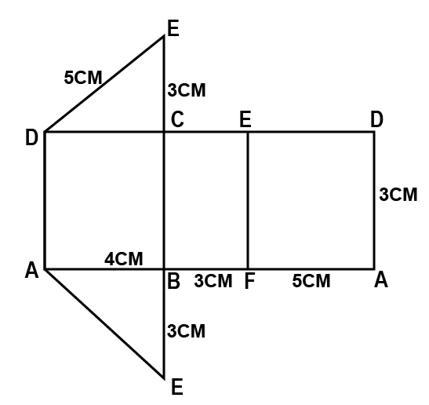
- Sketch the solid of the net showing the hidden edges with broken lines. 2mks

- Find the surface area of the solid. 2mks

- Determine the quartile deviation for the following distribution. 3mks
3,4,9,5,4,7,6,2,1,6,7,8,9

- Given that 2^{3/2x} = 4096, find the value of x 2mks

- It would take 15men 8days to dig a trench of 240m long. Find how many days it would take 18men to dig a trench 360meters long working at the same rate.
3mks

- Use logarithms to evaluate. 4mks
$$\sqrt[3]{\frac{0.921 x 0.00739}{0.023}}$$

- A regular polygon is such that its exterior angle is one eighth the size of interior angle. Find the number of sides of the polygon. 3mks

- A translation vector $\left(\begin{aligned}x-1 \\ 2-y\end{aligned}\right)$ maps a point A(4,6) onto A^{I}(9,12). Find the value of x and y. 3mks

- A Canadian tourist arrived in Nairobi with Canadian dollars 6200. She converted all his money into Kenya Shillings and then spent a total of Kshs. 100,000. She paid her Kenyan tour guide a commission equivalent to 20% of the remainder. Given that 1 canadian dollar = Ksh. 48.12. calculate
- How much she got in kenya shillings after converting all her money. 1mk

- The amount of kenya shillings she was left with at the end. 2mks

- In the figure below <A=62°, <B = 42°, BC = 8.4cm and CN is a bisector of angle ACB. Calculate to 1dp the length of CN. 3mks
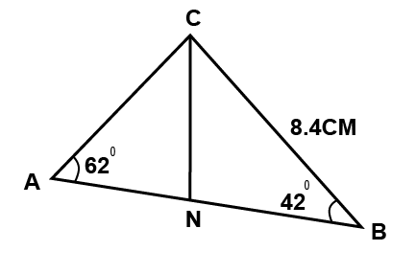

- A father is now four times as old as his son. Five years ago, he was exactly one year and half times as old as his son will be in ten years from now. Determine the sum of their present ages. 4mks

- An arc length of 11cm subtends an angle of 140° at the circle. Find the area of the enclosed sector. 4mks

- Factorize and simplify the expression. 3mks
$$\frac{x^{2}+6x+9}{x^{2}-9}$$

SECTION II (50 marks)
Answer any FIVE questions from this section
- The triangle ABC with coordinates A(2,3), B(4,2) and C(1,1) is mapped onto triangle A¹B¹C¹ by a reflection in the line y + x = 0.
- (i) Draw triangle ABC and its image A¹B¹C¹on the same plane. 3mks

(ii) Triangle A¹B¹C¹ is mapped onto A¹¹B¹¹C¹¹ by a transformation represented by the matrix. $\left(\begin{matrix}0 & 1 \\ -1 & 0\end{matrix}\right)$
Draw triangle A¹¹B¹¹C¹¹ and describe fully a single transformation that maps triangle ABC onto triangle A¹¹B¹¹C¹¹ 4mks

- Triangle ABC is mapped onto xyz with A being mapped onto x, B onto Y and C onto Z. given that the coordinates of x is (-4,3), Y is (0,2) and Z is (-1,1), find the matrix representing the transformation. 3mks

- A lorry left town A for B at 6.50pm at an average speed of 60km/h. at 8.35pm, a car left tow A for B at an average speed of 90km/h. if A is 317km from B. determine:
- The distance of the lorry from town A when the car took off. 3mks

- The distance the car travelled to catch up with the lorry. 4mks

- What time of the day did the car catch up with the lorry? Give your answer in 24hrs system. 3mks

- Three ships X, Y and Z are approaching a habour H. X is 150km from the habour on a bearing of O90°. Y is 130km from the habour on a bearing of 130°E and Z is 180km to the west of Y.
- Taking a scale of 1cm to represent 20km, make a scale drawing of the routes of the three ships to the habour. 2mks

- What is the distance between ships X and Z? 2mks

- Find the bearing of H from Z. 2mks

- If ship Y is travelling at a speed of 50km/h how long will it take to reach the harbor. 2mks

- The figure below shows a triangle OAB with O as the origin. OA=a OB = b, OM 2/5a and ON = 2/3b.
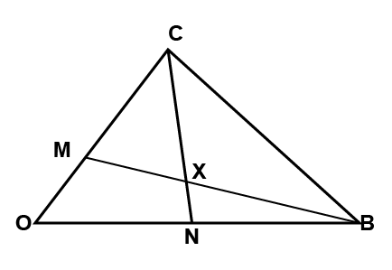

- Express in terms of a and b the vectors
- BM 1mk

- AN 1mk

- Vector OX can be expressed in two ways: OB + KBM or OA + hAN, where K and h are constants.
Express OX in terms of:
- a, b and k. 2mks

- a, b and h. 2mks

- find the valuesof k and h. 4mks

- in a certain meeting, there were 95men in attendance. There were 50 more women than men and twice as many children as men.
- Determine the number of people in attendance. 2mks

- Find the percentage of children in attendance, correct to 3 significant figures. 2mks

- A hall for the meeting was fitted with benches that could accommodate eighher 10 children or 7 adults per bench.
Find the number of benches
- Used by the children 2mks

- Completely filled by the adults. 2mks

- Adults who would fill the unoccupied space. 2mks

- a) The point A(-2, 4) and B(3,-6) lies on a straight line AB, find
- the equation of the line perpendicular to AB and passing through A 3mks

- The equation of the line parallel to AB and passing through the point.
(3,-1). 3mks

b) The points A and B are translated by a vector
M = $\left(\begin{aligned}2 \\ -1\end{aligned})\right.$. Find
- the images of A and B. 2mks

- the equation of the line passing through A¹ and B¹ the images of A and B respectively. 2mks

- the figure below represents a solid made up of a conical frustum and a hemispherical top. The slant height of the frustum is 8cm and its base radius is 4.2cm.
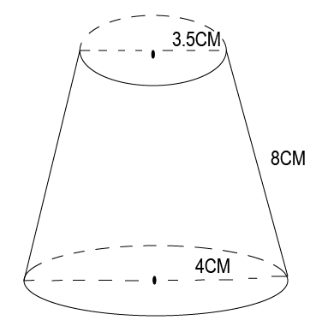4.2cm
If the radius of the hemispherical top is 3.5cm
- Find the area of:
- The circular base 2mks

- The curved surface area of frustum. 4mks

- The hemispherical surface 2mks

- A similar solid has a total surface area of 81.5cm2. determine the radius of the base. 2mks

- Using a ruler and a pair of compasses, construct parallelogram ABCD such that AB = 8cm, diagonal AC = 12cm and angle BAC = 22.5° 4mks

- Measure (i) The diagonal BD 1mk

(ii) The angle ABC 1mk

- Draw the circumference of triangle ABC 2mks

- Calculate the area of the circle drawn 2mks

