
MATHEMATICS PAPER 1 (121/1)
TRIAL 2, 2019
MARKING SCHEME

1 | 5/2 x 7/4 = 35/8 – 21/4 = -7/8  5/4 – 11/4 = -6/4 x 2= -3  7/5 x ¯ 5/-8  -7/8 x 5/-8 = 35/64 | M1  M1  A1
2 | 100/70 x 1400 = 2000  2300 – 2000  300 | M1  M1  A1
3 | $$\sqrt{4x^{6}y^{2}z^{2}}$$  = 2x³yz | M1  A1
4 | X + 1 ≤ 4x – 5  x≥ 2  4x – 5< 3 x 2  X < 7  -1 0 1 2 3 4 5 6 7 8 | B1  B1  B1
5 | 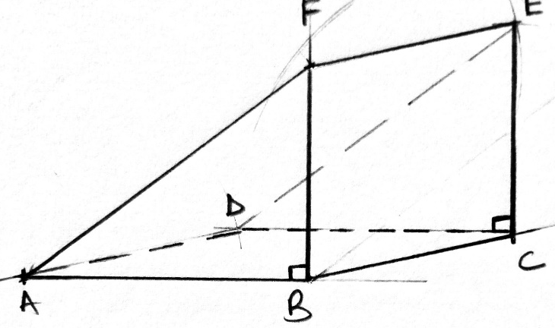  SA = 2 x ½ x 4 x3 + 4 x 3 + 3 x 3 + 5 x 3  = 48cm² | B1 and equal  Sides  B1 √ Solid show broken lines  M1  A1
6 | 1,2,3,4,4,5,6,6,7,7,8,9,9,  Q1 = 3 + 4 = 3.5  2  Q3 = 7 + 8 = 7.5  2  Q.D = ½(7.5 – 3.5)  = 2 | B1 (Bolt Q, & Q3  M1  A1
7 | 2 ^{3/2x} = 2¹²  ³/₂x = 12  X = 8 | M1  A1
8 | Men Days Trench Length  15 8 240  18 ? 360  No. of Days = 8x 15/18 x 360/240  = 10days | M1  M1  A1
9 | No. sf log  0.921 T.9643  0.00739 $3.8686$  3.8329_  0.023 2.3617  T. 4712  1.4712  3  6.663 x 10⁻¹ = 1.8237  = 0.6663 | M1 all logs  M1 (+ & -)  M1 (÷3)  A1
10 | Exterior = x  Interior = 1/8x  X + 1/8x = 180  X = 160⁰  No. of sides = 360/20 = 18sides | M1  A1  B1
11 | T + A = A¹  X – 1 + 4 = 9  2 – y 6 12  X – 4 + 4 = 9  X = 6  2 – y + 6 = 12  Y = +4 | M1  A1  B1
12 (i) | 6200 x 48.12  = 298,344  298,344 – 100,000  = 198,344  80/100 x 198,344  = 158,675.20 | B1  M1  A1
13 | 8.4 = CN  Sin100⁰ Sin 42⁰  CN = 8.4sin 42⁰  Sin 100  = 5.7cm | M1  M1  A1
14 |  | B1
   | 5yrs Ago | Now | 10yrs time
  Fatter | 4x – 5 | 4x | 4x + 10
  Son | X - 5 | x | X + 10
 | 4x + 5 = 3/2 (x + 10)  5/2x = 20  Son –x = 8yrs  Father = 4(8) = 32yrs  Sum = 8 + 32  = 40yrs | M1  M1  A1
15 | 140/360 x 22/7 x D = 11  Dian = 11 x 360 x 7  140 x 22  D = 9cm.  Radius = 4.5  Area of sector  = 140/360 x 22/7 x 4.5²  = 24.75cm² | M1  A1  M1  A1
16 | Nume = x² + 3x + 3x + 9  (x + 3) (x +3)  Deno = (x + 3)(x – 3)  Therefore (x + 3) (x +3)  (x + 3) (x – 3)  = x + 3  x - 3
SECTION B
17 | 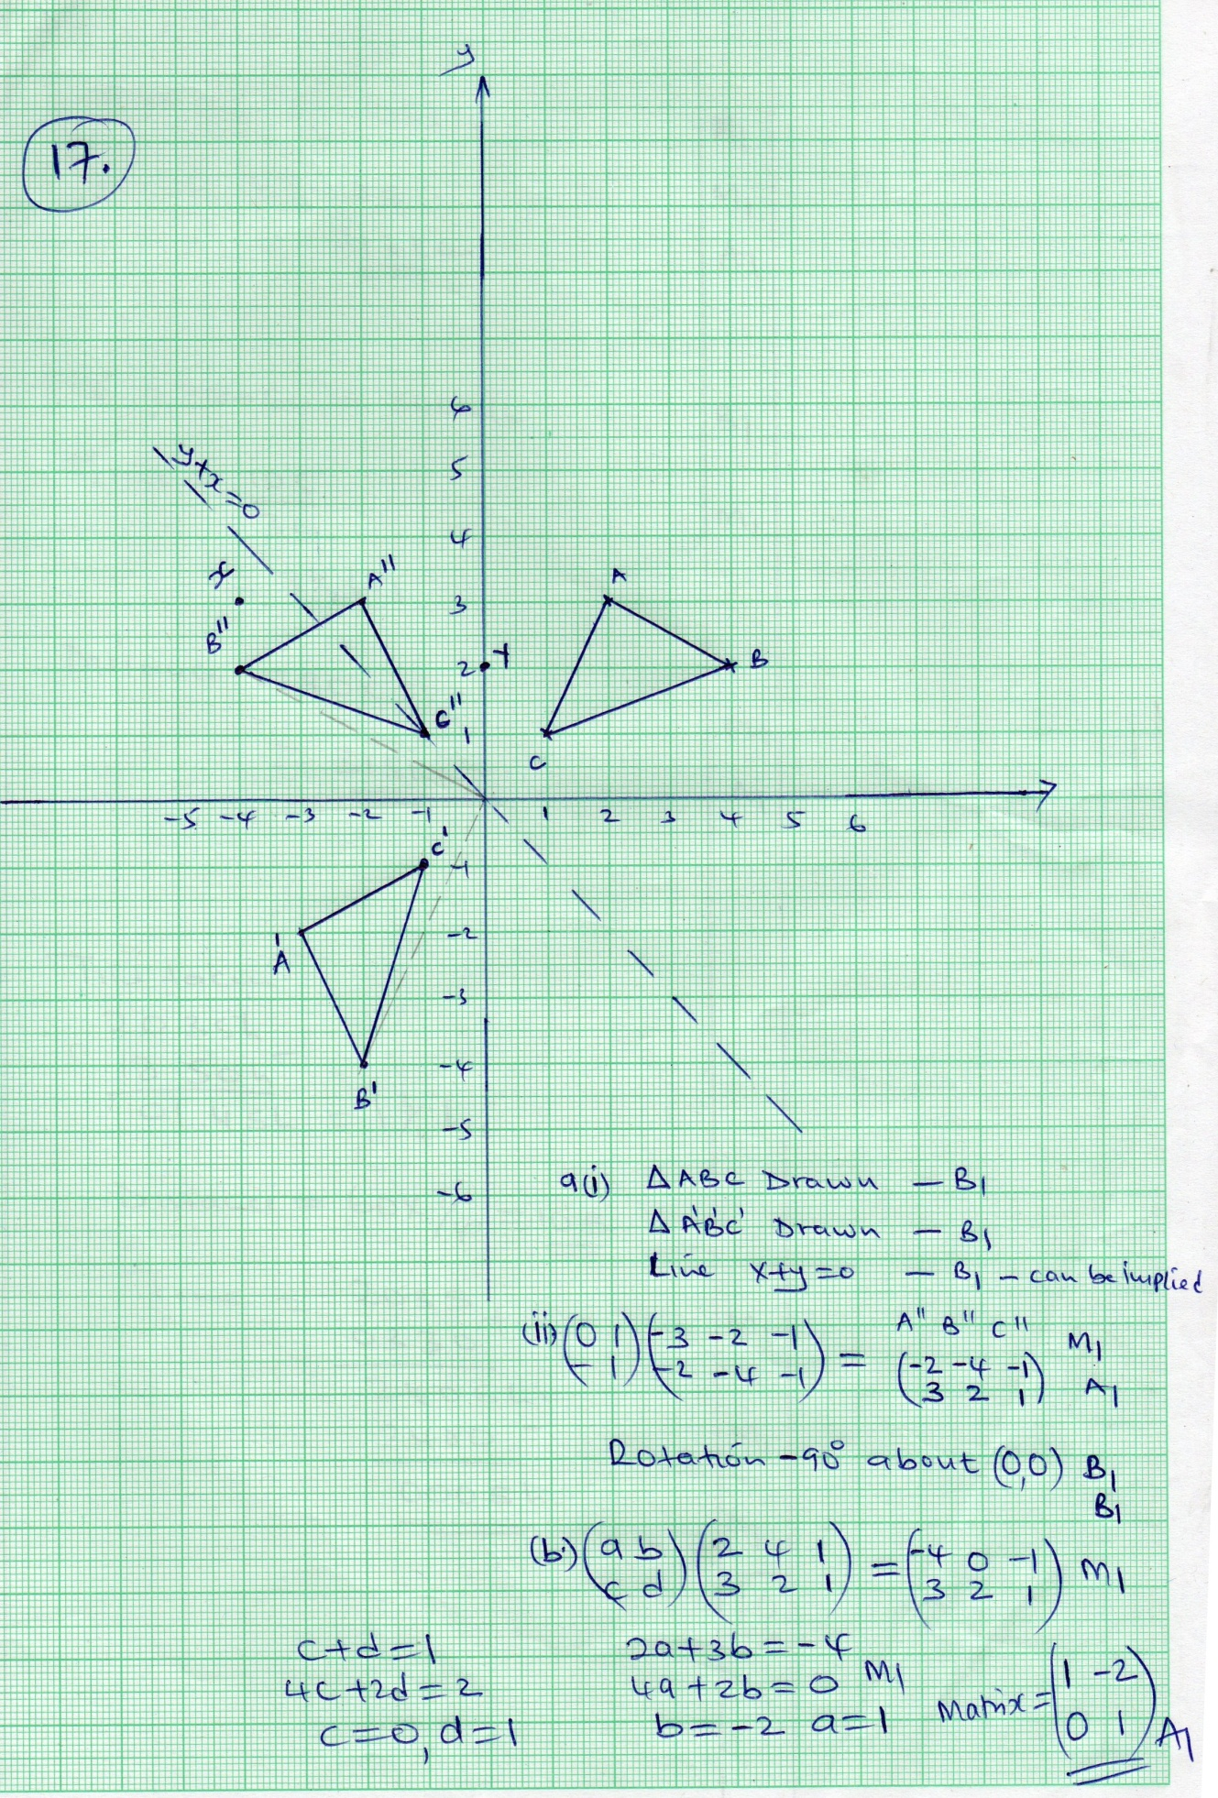
18(a) | Distance of a lorry  60 x 1¾ = 105km  Dist = 317 – 105  = 212km | M1  M1  A1
(b)  (C) | R.S = 90 – 60 = 30KM/H  Time = 105  30  = 3½hrs  Distance = 90 x 3½  = 315km  Time taken  2035h  1850h  0145sh - 1¾hrs  Distance = 60 x 7/4 – 105  Time = 2035  0330  2405sh  2400  0005h | B1  M1  M1  A1  M1  M1  A1
19 | 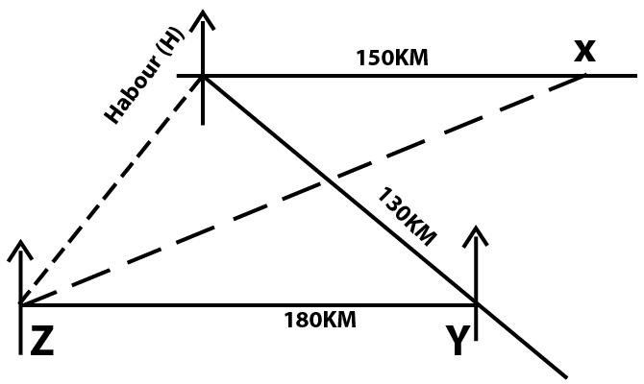  - Location x  Location y  Location z  Relative position correct  - 12.3 X 20 = 246KM ± z  - 43⁰ ± 1⁰  - D = 130km  S = 50km/hr  T = 130 = 2.6hrs  50  Or 2hrs 36mins | B1  B1  B1  B1  B1B1  B1B1  M1  A1
20 a)  b) i)  (ii) | 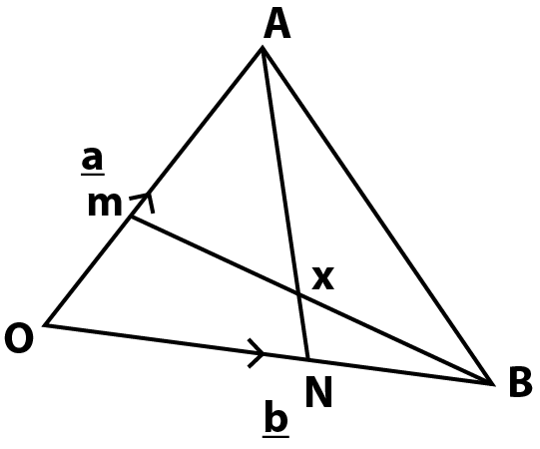  - BM = b + 2/5a  - AN = -a + 2/3b  OX = OB + KB  = b + 2/5ka – kb  = 2/5ka + (1-k)b  OX = OA + hAN  = a + (2/3b –a)h  = a + 2/3hb – ha  = 2/3hb + (1 – h) a  2/5ka + (1-k)b = 2/3hb + (1 – h)a  2k + 5h = 5  3k + 2h = 3  11h = 9  H = 9  11  K – 5/11 | B1  B1  M1  A1  M1  A1  M1  M1  M1  A1
21 a)  b)  c) i)  ii)  iii) | Men = 95  Women = 95 + 50 = 145  Children = 2 x 95 = 1900  95 + 145 + 190  = 430  % children = 190 x 100  430  = 44.2%  No. of benches = 190 = 19benches  10  No, of benches = 240/7 = 34.2857  = 34 benches  240 – 34 x 7  240 – 238  = 2  Unoccupied = 7-2  = 5 adults | M1  A1  M1  A1  M1  A1  M1  A1  B1  B1
22 i)  ii)  b) | Grad(m₁) = -6-4 = -2  3 + 2  M2 = ½  Y – 4 = ½  X + 2  Y = ½x + 5  M₁ = -2  Y + 1 = -2  X – 3 1  Y = 2x + 5  A¹= -2 + 2 = 0  4 -1 3  A¹(0,3)  B1 = 3 + 2 = 5  -6 -1 -7  B1 (5, -7)  Grad (m) = 3- -7 = -2  0 – 5  Y – 3 = -2  X – 0  Y = -2x + 3 | B1  M1  A1  B1  M1  A1  B1  B1  M1  A1
23 a(i)  ii)  iii)  b) | 22/7 x 4.2²  = 55.44cm²  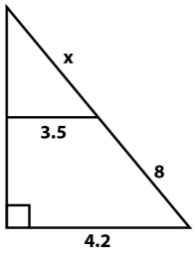  X + 3 = 4.2  X 3.5  X = 40cm  22/7 x 4.2 x 48  = 633.6cm²  Area of frustum  = 22/7 x 4.2 x 48 – 22/7 x 3.5 x 40  633.6 – 440  = 193.6cm²  2 x 22/7 x 3.5²  = 77cm²  Total SA – 55.44 + 193.6 + 77  = 326.04cm²  Asf = 326.04 = 4  81.51  Radius = 4.2  2  = 2.1cm | M1  A1  B1  M1  M1  A1  M1  A1  M1  A1

24. 