
FORM FOUR TRIAL 2, 2019
Kenya Certificate of Secondary Education
121/2 MATHEMATICS
PAPER TWO
TIME: 2½HRS
Instruction: Attempt ALL Questions in Section I and any FIVE in section II
INSTRUCTIONS
1 | 2 | 3 | 4 | 5 | 6 | 7 | 8 | 9 | 10 | 11 | 12 | 13 | 14 | 15 | 16 | Total

17 | 18 | 19 | 20 | 21 | 22 | 23 | 24 | Total  GRAND TOTAL

SECTION I (50Mks)
Attempt ALL Questions from this section
- Make x the subject of the formula 3mks
P = x + 2w
4x + 3R

- P varies partly as the square of v and partly as the cube of v. when V=2, P = -20 and when v = -3, P=135. Find the relationship between P and v. 3mks

- Expand (1 + 2x)⁷ up to x³, hence use the expansion to estimate the value of (1.02)⁷ correct to four decimal places. 3mks

- Simplify the following by rationalizing the denominator. 3mks
2 – 1
4 2– 3

- The diagram below represents a field ABC.
A

B C
(a) Draw the locus of points equidistant from sides AB and AC 2mks

(b) Draw the locus of points equidistant from points A and C. 2mks

C) A coin is lost within a region which is nearer to point A than to point C and closer to side AC than to side AB. Shade the region where the coin can be located. 2mks

- Given x = 13.4cm and y=4.3cm. calculate the percentage error in^{x}/_{y} correct to 4 d.p
3mks

- If matrix A = $(\begin{matrix}1 & 2 \\ 4 & 3\end{matrix}$) Find B given that A² = (A +B). 3mks

- In the figure below QT is a tangent to a circle at Q. PXRT and QXS are straight lines. PX = 6cm, RT = 8cm, QX= 4.8CM
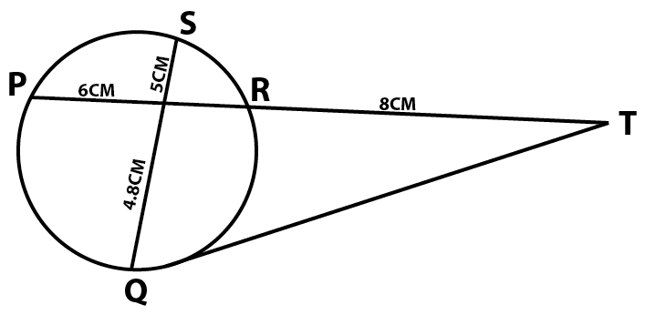
X
Find the length of
- XR 2mks

- QT 2mks

- A circle whose equation is (x -1)² + (y – k)² = 10 passed through point (2,5). Find the coordinates of the two possible centresof the circle. 3mks

- A blender mixes two brands of juice A and B to obtain 70mls of the mixture worth Ksh. 165 per litre. If brand A is valued at Kshs. 168 per litre and brand B at Ksh. 153 per litre bottle, calculate the ration in which the brands A and B are mixed. (2mks)

- Without using logarithm tables solve the equation log
(5x – 4) = log(x + 2) + ¹/₃ log 27. 3mks

- a) Use reciprocal tables to find the value of = ¹ / _{0.325} 1mk

b) Hence, evaluate $\frac{\sqrt[3]{0.000125}}{0.325}$ 1mk

- The G.C.D of three numbers is 45 and the LCM is 18900. Two of the numbers are 675 and 540. Find the other possible numbers. 3mks

- solve for $θ$ given that $θ$ is acute and sin (3$θ$ - 50⁰) – Cos (20 + 10⁰) = 0 3mks

- A container of height 90cm has a capacity of 4.5L. What is the height of a similar container of volume 9cm³. 3mks

- A point R divides a line PQ internally in the ration 3:4. Another point S, divides the line PR externally in the ratio 5:2. Given that PQ = 8cm, calculate the length of RS, correct to 2 decimal places. 3mks

SECTION II (50mrks)
Attempt any FIVE questions from this section
- Complete the table below for the function
- y=x² + ¹²/_{x} – 15 for 0.5≤ x ≤4
X | 0.5 | 1 | 1.5 | 2 | 2.5 | 3 | 3.5 | 4
y | 9.25 |  |  | -5 | -4

- Draw the graph of y=x² + ¹²/_{x} – 15 for 0.5≤x≤4. using a scale of 2cm rep 1 unit on the x – axis and 2cm for 5 units on the y – axis. 3mks

- (i) from your graph, state the range of values of x for which y=x² + ¹²/_{x} ≤ 18 3mks

(ii) By adding a suitable straight line to your graph, solve the equation y = x² + ¹²/_{x} – 5x + 20 3mks

- The product of the first three terms of a geometric progression is 64. If the first term is a and the common ratio is r.
- Express r in terms of a 3mks

- Given that the sum of the three terms is 14,
- Calculate the values of a and r and hence write down two possible sequences each up to the 4th term. 5mks

- Find the product of the 50th terms of the two sequences 2mks

- The table below shows income tax rates for certain year.
Monthly income in Kenya Shillings (Kshs) | Tax rate in each shillings
0 – 10164 | 10%
10165 – 19740 | 15%
19740 – 29316 | 20%
29317 – 38892 | 25%
Over 38892 | 30%

A tax relief of Kshs. 1162 per month was allowed. In a certain month of the year, an employee’s taxable income in the fifth band was Ksh. 2108.
- Calculate
- Employees total income in that month 2mks

- The tax payable by the employee in that month. 5mks

- The employee’s income includes a house allowance of Ksh. 15,000 per month. The employees contributed 5% basic salary to a cooperative. Calculate the employee net pay for that month. 3mks

- The following table shows the distribution of marks obtained by 50 students in a test.
Marks | 45-49 | 50-54 | 55-59 | 60-64 | 65-69 | 70-74 | 75-79
No. of Students | 3 | 9 | 13 | 15 | 5 | 4 | 1

By using an assumed mean of 62, calculate
- The mean 5mks

- The variance 3mks

- The standard deviation 2mks

- A red and black dice are rolled and the events x, y and z are defined as follows.
X = the red die shows a 4
Y = the sum of the scores of the two dice is 6
Z = the black dice shows a 3
- Find the probability of event x 2mks

- The probability of events x and y 3mks

- Which event is mutually exclusive to x 1mk

- Which event is independent of x 2mks

- The probability of event Y 2mks

- a) Complete the table below 2mks
X | 0 | 30⁰ | 60⁰ | 90⁰ | 120⁰ | 150⁰ | 180⁰ | 210⁰ | 240⁰ | 270⁰ | 300⁰ | 330⁰ | 360⁰
- Cos x | -1 |  | -0.5 |  | 0.5 | 0.87 |  | 0.87 |  |  | -0.5 | 0.87
Sin(x-30⁰) |  | 0.0 | 0.5 |  |  | 0.87 | 0.5 |  | -0.5 |  |  | -0.87 | -0.5

b) Draw the graphs of y=sin(x-30) and y=-Cos x on the same axes, for 0⁰≤x≤360⁰
(5mks

Grid square
c) Use your graph to solve the equation sin(x - 30⁰) + Cos x = 0 (3mks)

- in the figure below, O is the centre of the circle, PQR is the tangent to the circle at Q, Angle PQS=28⁰, angle UTV = 54⁰ and UT = TQ
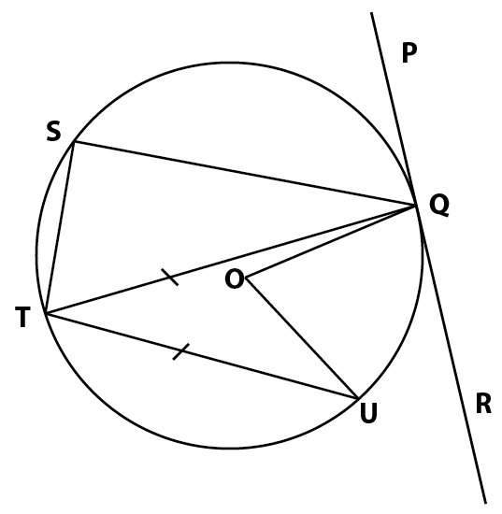

Giving reasons, determine the size of
- Angle STR 2mks

- Angle TQU 2mks

- Reflex angle TQS 2mks

- Reflex angle UOQ 2mks

- Angle TQR 2mks
- The cost c of producing n items varies directly as n and partly as the inverse of n to produce two items it costs Ksh. 135 and to produce three items it costs Ksh. 140. Calculate
- The constant of proportionality and hence write the equation connecting c and n. 5mks

- The cost of producing 10 items 2mks

- The number of items produced at a cost of Ksh. 756. 3mks

