
MATHEMATICS PAPER 2 (121/2)
TRIAL 2, 2019
FORM FOUR
PAPER 2
TIME: 2½
MARKING SCHEME

- p² = x + 2w
4x + 3R M1
4p²x + 3p²R = x + 2w
4p²x – x = 2w – 3p²R
X(4p² - 1) = 2W – 3p²R M1
X = 2w – 3p²R
4p² - 1 A1

- p = av² + bv³ : 4a + 8b = -20 M1
9a – 27b = 135
36a + 72b = -180
36a – 108b = 540
180b = -720 M1
B= -4

-20 = 4a +32
4a = -52
a = -13
p= -13V² + 4V³ A1

- (1+2x)⁷ = 1 + 7 (I)⁶(2x)¹ + 21(1)⁵ + 35(1)⁴(2x)³ B1
= 1 + 14x + 84x² + 280x³ + _ _ _ _
(1.02)⁷ = (1 + 0.02)⁷ = (1 + 2x) ⁷
2 x = 0.02 —› x = 0.01
Subst x = 0.01
(1.02)7= 1 + 14(0.01) + 84(0.01)² + 280(0.01)³ M1
= 1 + 0.14 + 0.0084 + 0.00028
= 1.14868
= 1.1487 (to 4d.p) A1

- √2 – 1 x 4√2 + 3 = √2(4√2 + 3) – 1(4√2 + 3) M1
4√2 – 3 4√2 + 3 4√2(4√2 + 3) -3(4√2 + 3)

= 8 + 3√2 - 4√2 – 3
32 + 12√2 - 12√2 – 9 A1

= 5 - √2
23 A1

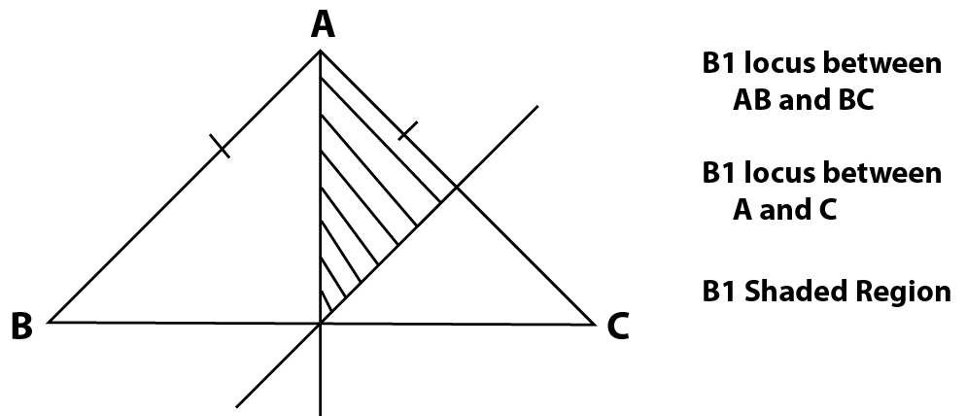

- Max val of x 13.45min 13.35 B1
Max val of Y 4.35 min 4.25

Max vals of x 13.45 = 3.164y
4.25

Min value of x13.35 = 3.069
Y 4.35

Actual value of x13.4 = 3.1163 B1
y 4.3

Absolute error = 3.1642 – 3.069 = 0.04785
2

Percentage error = 0.04785 x 100 = 1.5355% A1
3.1163
- A² = $\left(\begin{matrix}1 & 2 \\ 4 & 3\end{matrix}\right)\left(\begin{matrix}1 & 2 \\ 4 & 3\end{matrix}\right)$ = $\left(\begin{matrix}9 & 8 \\ 16 & 17\end{matrix}\right)$ M1
Let B be = a b
c d
9 8 = 1 2 + a b
16 14 4 3 c d

a + 1 = 9 a = 8
b + 2 = 8 b = 6 M1
c + 4 = 16 c = 12
d + 3 = 17 d = 14
B 8 6
12 14 A1

- a) 6 x R = 4.8 x 5 M1
XR = 4.8 x 5
6
= 4 A1

b) QT² = 18 x 8 = 144 M1
Qt = 12cm A1

- (2-1)² + (5 – K)² = 10
1 – 25 – 10K + 1K² = 10
K² - 10K + 16 = 0
(K-2)(K – 8) = 0
K = 2 or 8
Centre (1,2) and (1,8)

- A B
168 153 M1
165
12 3
4:1 A1

Alt: Method
168A + 153B = 165 M1
A + B
3A = 12B
A = 12 = 4
B 3 1
A:B 4:1 A1

- Log 5x – 4 = Log 3 M1
x + 2

5x – 4 = 3 M1
x + 2

5x – 4 = 3x + 6
2x = 10
x = 5 A1

- (a) 1 x 10
3.25 = 0.3077 x 10 = 3.077 B1

(b) 0.05 x 3.077 M1
= 0.1539 A1

- Sin(30 - 50⁰) = Cos (20 + 10⁰)
30 – 50 + 20 + 10⁰ - 90⁰
50 - 40⁰ = 90⁰
50 = 130⁰
0 = 26⁰

- 4.5L = 4.5 x 10³cm³
9m³ = 9 x 10cm³
v.s.f 4.5 x 10³ : 90 x 10⁶
1 : 2000
l.s.f 3√1 : 3√2000
1 : 12.6
90cm = x
h= 90 x 12.6
1134cm

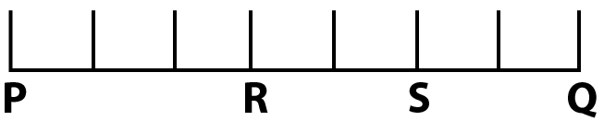

PR: RQ = 3:4
PS : SR = 5: -2
PQ = 8CM
RS = ²/₇ PQ

= ²/₇ x 8

= 2.29cm

- a)

X | 1 | 1.5 | 3 | 3.5 | 4
Y | -2 | -4.75 | -2 | 0.6 | 4

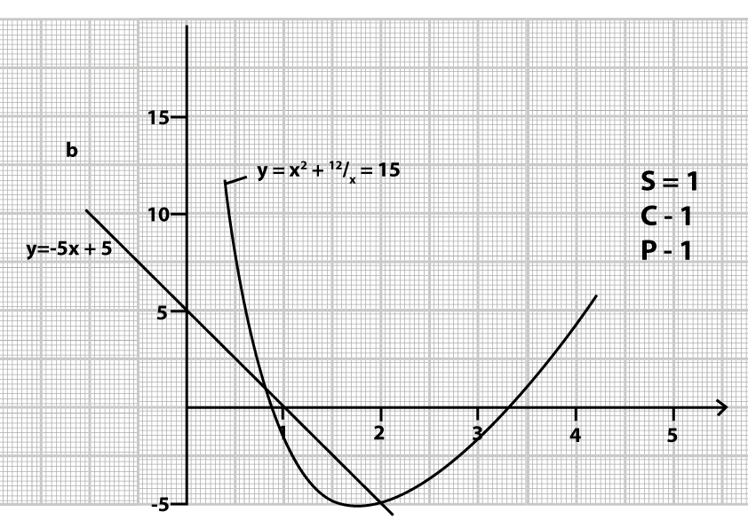

- 1.15 ≤ x ≤ 2.75 B2

- y = 2² + ¹²/_{x} – 15
y = x² + ¹²/_{x} - 5x + 20 M1
y = -5x + 5

X | 0 | 1
y | 5 | 0
M1
x = 2 or 0.8$±$ A1

- (a) 1st three terms are a, ar, ar² M1
Product a x ar x ar² = 64
a³r³ = 64 A1
r³ = ⁶⁴/_{a³}
r = ⁴/_{a}

sum a + ar + ar² = 14
but R = ⁴/_{a}
(a +a) 4/a) + a (4/a)2 = 14 M1
A + 4 + 16/q – 14
a² - 10a + 16 = 0
a² - 2a – 8a + 16 = 0 M2
a(a-2) – 8(a – 2) = 0 A1
a = 8 or a = 2
when a = 2, r = 2 when a = 8, r =½ B1
for a = 2 : Sequence 2, 4, 8, 16
For a = 8 : Sequence 8,4,2,1 A1

50thterm are ar⁴⁹ and ar⁴⁹ ^{M1}
2(2) ⁴⁹ and 8(½) ⁴⁹
Product 2(2)⁴⁹ x 8(½)⁴⁹ A1
= 16

- a) (i) Taxable income 38892 + 2108 – Shs. 41,000 M1A1
(ii) 10164 x ¹⁰/₁₀₀ = 1016.40

9576 x ¹⁵/₁₀₀ = 1436.40 M1

9576 x ²⁰/₂₀₀ = 1915.21

9576 x ²⁵/₁₀₀ = 2394.00 M1

Rem 2108 x 30/100 = 632.40 M1
7394.40 M1

Less relief 1162.00
Kshs. 6232.40 A1

(b) Total deductions 41,000
15,000
Basic solar 26,000 M1

⁵/₁₀₀ x 26000 = 1300 + payee

1300 + 6232.40 = 7532.40 M1

Net pay 41000 = 7532.40
Kshs 33,476.60 A1
10

- Let A = 62
Marks | f | x | D=x-A | fd | d² | fd²  B1 d value  B1 fd²ratio  B1 -
45-49 | 3 | 47 | -15 | -45 | 225 | 675
50-54 | 9 | 52 | -10 | -90 | 100 | 900
55-59 | 13 | 57 | -5 | -65 | 25 | 325
60-64 | 15 | 62 | 0 | 0 | 0 | 0
65-69 | 5 | 67 | 25 | 25 | 25 | 125
70-74 | 4 | 72 | 40 | 40 | 100 | 400
75-79 | 1 | 77 | 15 | 15 | 225 | 225
 | F = 50 |  |  | Efd - 120 |  | =2650
- Mean x = A + Efd
Ef
62 + -¹²⁰ / ₅₀ M1

= 62 – 2.4 = 59.6 A1

b) v = Efd² - Efd ² M1
Ef Ef

= 2560 - 120 ² = 53 – 5.76 M1A1
50 50

c) s.d= Efd² - Efd
Ef Ef M1

47.24

= 6.873 A1

10
B3
B
1 | 1 2 3 4 5  2 3 4 5 6
2  3  4  5  6 | 3 4 5 6 7  4 5 6 7 8  5 6 7 8 9  6 7 8 9 10  7 8 9 10 11

- P = (x) = ¹/₆ M1
- P(x and z) = p(x) x p(2) M1A1
¹/₆ x¹/₆ = ¹/₃₆
- Event Y B1
- Event Z B1
- P(Y) = ⁵/₃₆ M1A

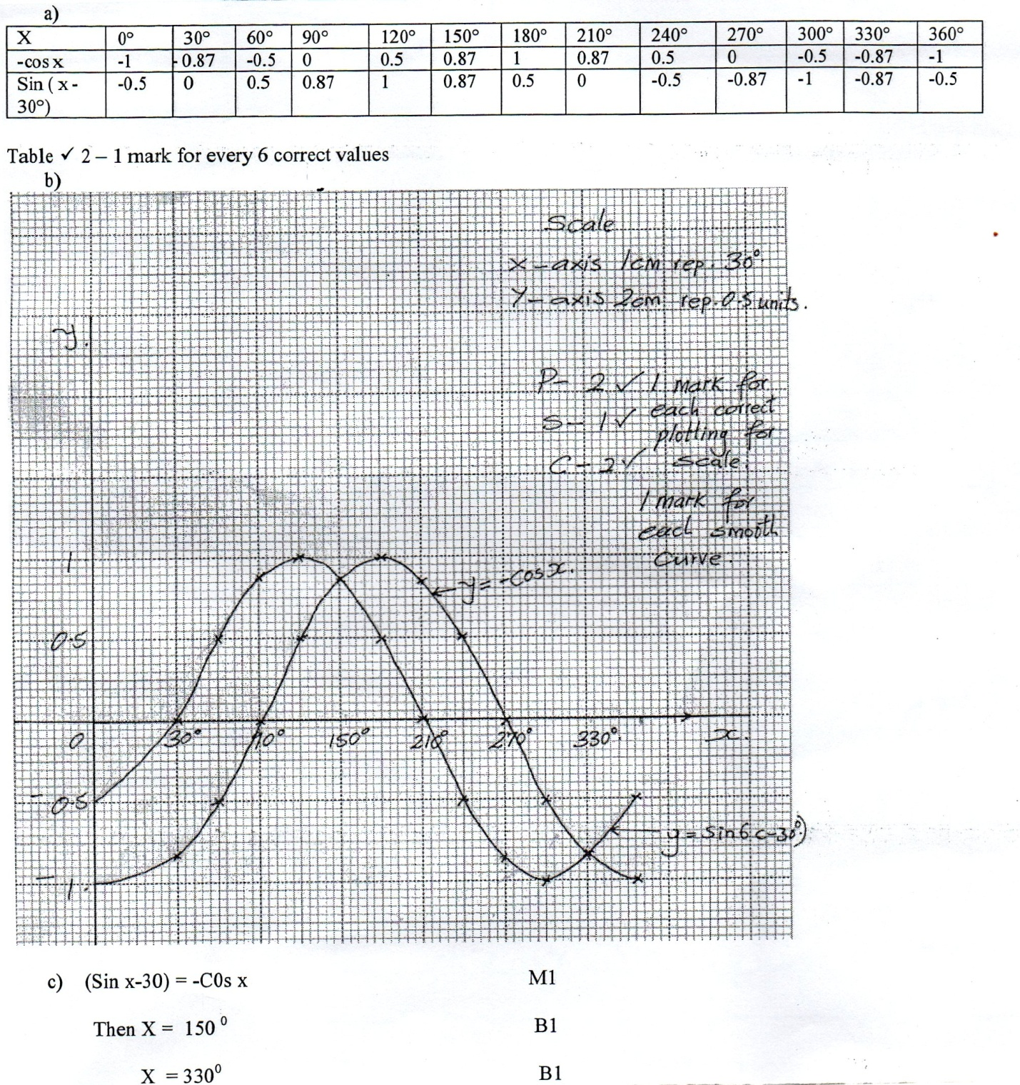

- <STQ = <PQS = 28⁰ B1
Angles in alternative segment. A1

- <TQU = 180 – 54 = 63⁰ A1
2
Base angles of an isosleles triangle B1

- <TQS = 63 – 28 = 35⁰ M1
<TUQ is alternative to <PQT = 63 B1

- <UOQ = 54 x 2 = 108⁰
Angle subtended at the centre is twice that at the circumference by the same chord UQ B1
.·.Reflex<UOQ = 360 - 108⁰ A1

- <TQR = <TSQ
= 180 – (28 + 35) = 117 B1
Angles in alternative segment are equal A1

- C = n + ¹/_{n}
C = kn + ^{c}/_{n} M1

135 = 2k + ^{c}/₂- (i)
140 = 3k + ^{c}/₃- (ii) M1

270 = 4k + c - - (i)
420 = 9k + c + (ii)

-150 = -5k
K = 30
270 = (4x30) + C M1
270 = 120 + C

C = 150 A1 correct value K & C

.·.C = 30n + ¹⁵⁰/₁₁ A1
b. C = (30 x 10) + ¹⁵⁰/₁₀ M1
= Shs. 315

c. 756 = 30n + ¹⁵⁰/_{n}
756n = 30n² + 150 M1
30n²= 756n + 150 = 0
15n² - 378n + 75 = 0 ac = 1125 -375 and -3 M1
15n² - 375n – 3n + 75 = 0 b = 378
15n(n – 25) -3 (n – 25)
(15n – 3) (n – 25) = 0
N = 25 A1

10

