MERU CENTRAL CLUSTER EXAMINATION

121/1
MATHEMATICS PAPER 1
TERM 2, 2020
DECEMBER 2020
MARKING SCHEME
Q
 | Num Den  $\frac{7}{4}x\frac{7}{3}=\frac{49}{12}$ $\frac{5}{8 } x\frac{2}{3}=\frac{5}{12}$  $\frac{7}{5 } x\frac{12}{49}=\frac{12}{35}$ $\frac{10}{7}-\frac{5}{12}=\frac{120-35}{84}$  $\frac{3}{5 } x\frac{12}{5}= \frac{21-12}{35}$ =$\frac{85}{84}$  = $\frac{9}{35}$  $\frac{Num}{Den }=\frac{9}{35} x\frac{7}{5}$ = $\frac{9}{25}$ $\frac{12}{7} x\frac{85}{84}=\frac{5}{7}$ | M1  M1  A1 | Numerator  Denominator  Accuracy
 | 118 yens = ksh. 76  $∴$2,950,000 yens = $\frac{2,950,000}{118}$ x 76  =ksh. 1,900,000  The duty paid $\frac{20}{100}$ x 1,900,000  =Ksh. 380,000 | M1  M1  A1
 | 2 + $\frac{40}{60}$ = 2 $\frac{2}{3}$ hours  2$\frac{2 }{3}$ x 120 = 320 km  $\frac{320}{4}$ = 80 litres  80x59 = 4720 sh. | B1  M1A1
 | 2$πrl=1980$  2 x $\frac{22}{7}$ x 21 x h = 1980  h=$\frac{1980}{132}$ = 15cm  v = $π$r²h = $\frac{22}{7}$x 21²x 15  = $\frac{20790}{1000}$  =20.8l | M1  M1  A1
 | Adjacent = $√{13}^{2}$ -5² = 12 B1 for 12  Tan (90 – $θ$) = 12/5 B1 - answer | B1  A1

 | - 2x – 5y – 10 = 0  5y = 2x – 10  Y = $\frac{2}{5}$x - 2  M₁= $\frac{2}{5}$  M₂ = $\frac{-5}{2}$ B1 gradient of L₂  $\frac{-5}{2}$ = $\frac{y+2}{x-5}$ M₁ Equation  2y + 4 = -5x +2s  2y= -5x + 21 A₁ answer  Y = $\frac{5}{2}$x + $\frac{21}{2}$ | B1  M1  A1
 | 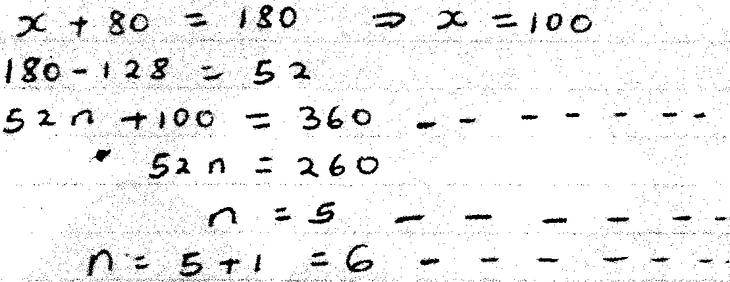 | M1  M1  A1 | Alternative  (n-2)180=80+  (n-1)128
 | 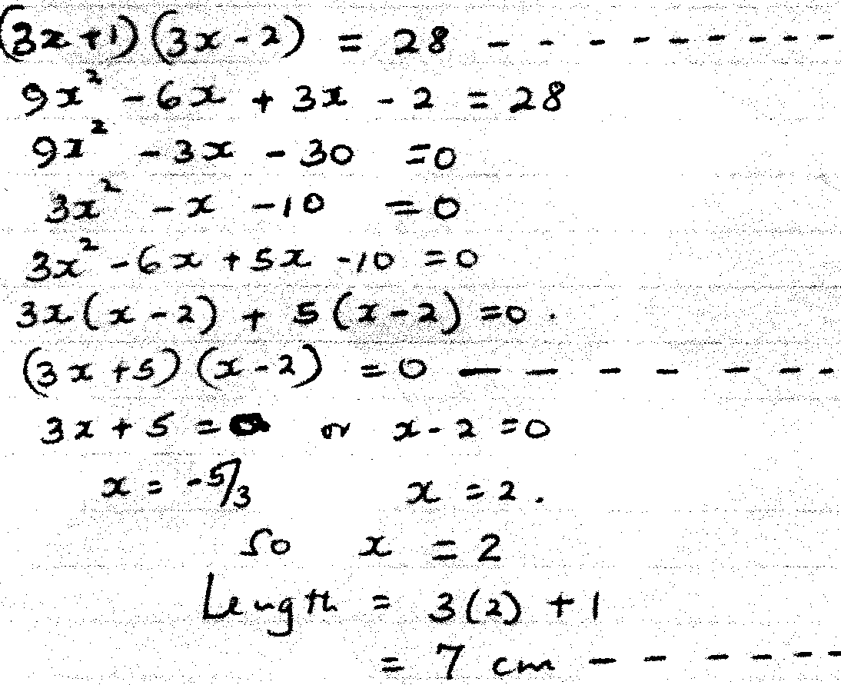 | M1  M1  A1
 | 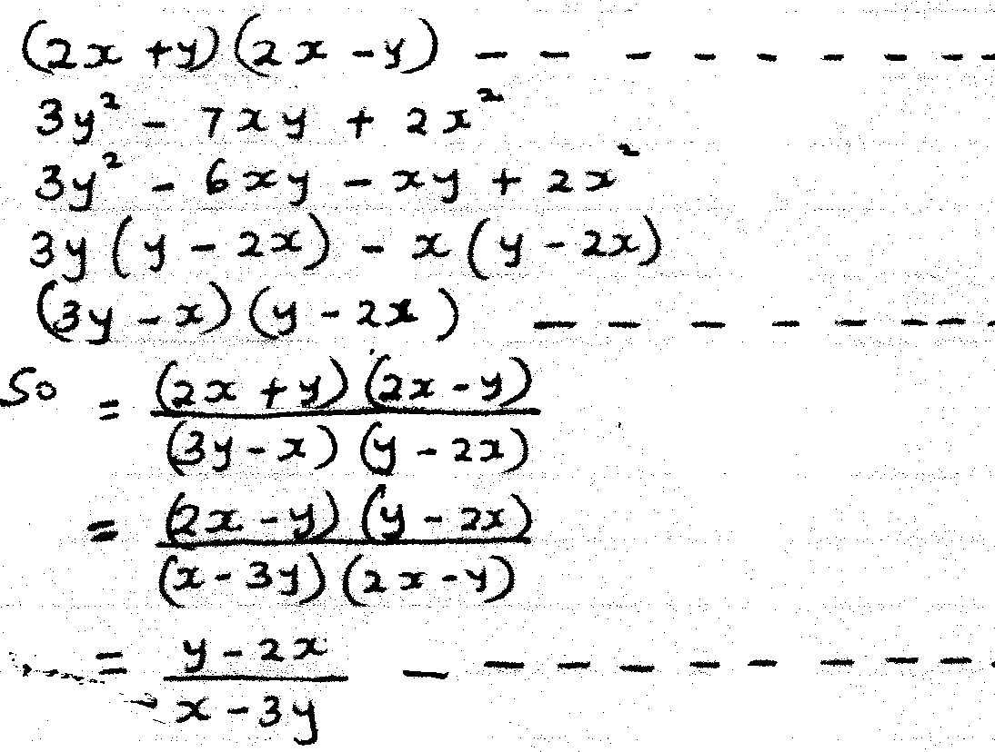 | M1  M1  A1
 | 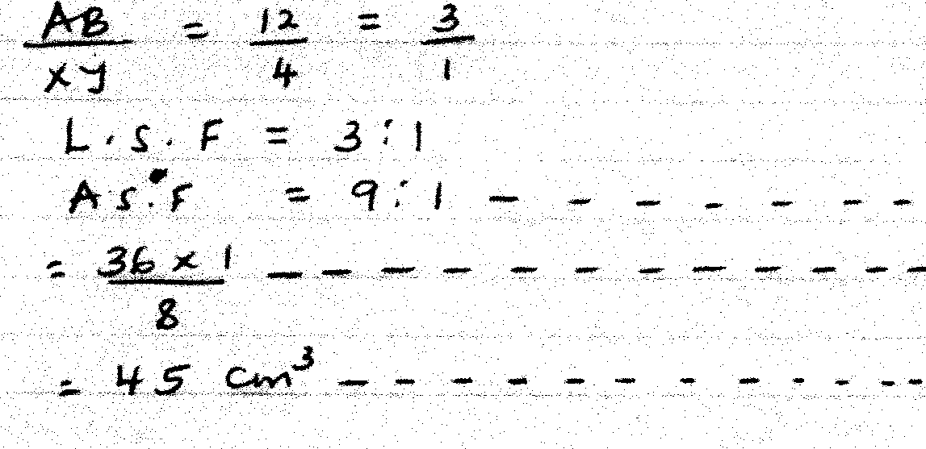 | B1  M2  A1

 | a)  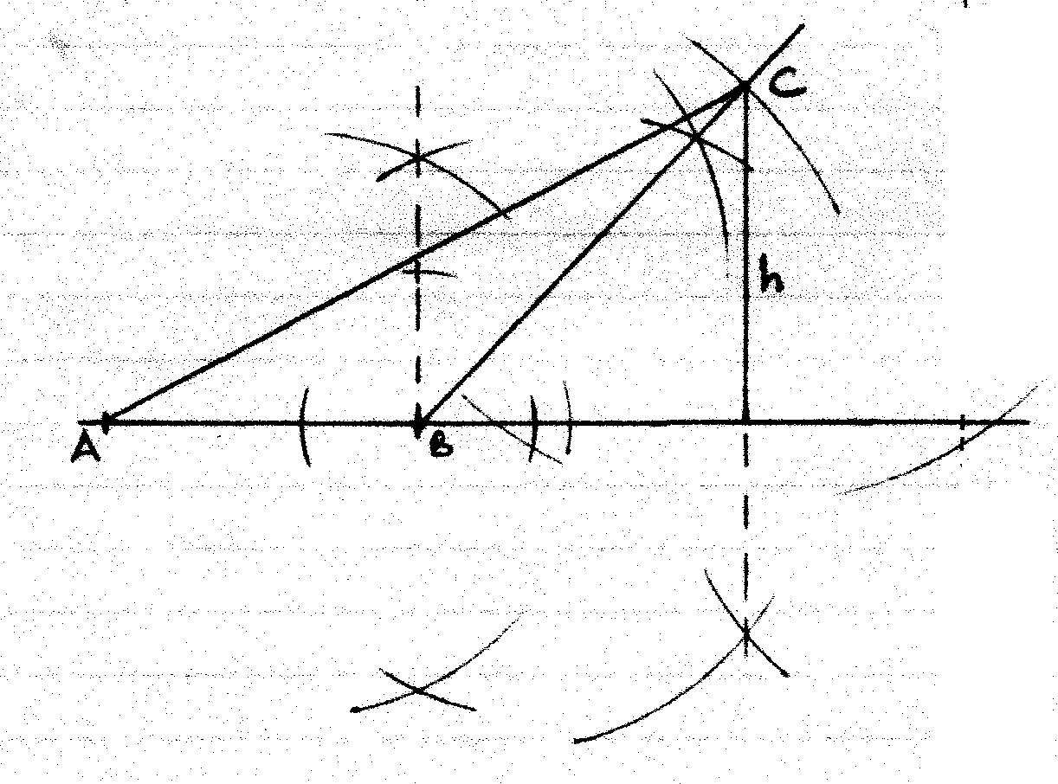  b)  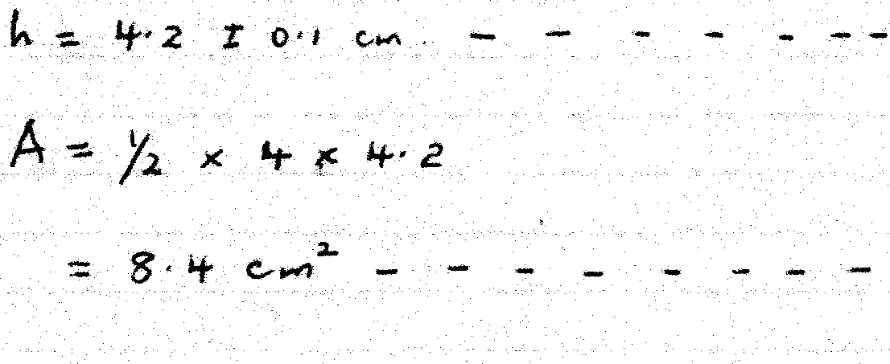 | B1  B1  B1  B1  04 | For $<A\hat{B}$C  For complete  ABC  For the height
 | Internal dimensions  Length = 40cm  Width = 20cm  Height = 15cm  Volume of container= 40 x 20 x 15 = 12000cm³  8 liters = 8000cm³  Unoccupied volume = 4000  h $\frac{4000}{8000}$ = 5cm  ALT2  40 x 20h = 8000  H=10  changle = 15 – 10  = 5cm  Alt 3  40 X 20 (H – 0.5) = 8000  H= 10.5  15.5 – 10.5 = 5cm | B1  M1  A1  B2 M1  A1  B2M1 M1A1 | dimensions seen  Equation and solving
a. | 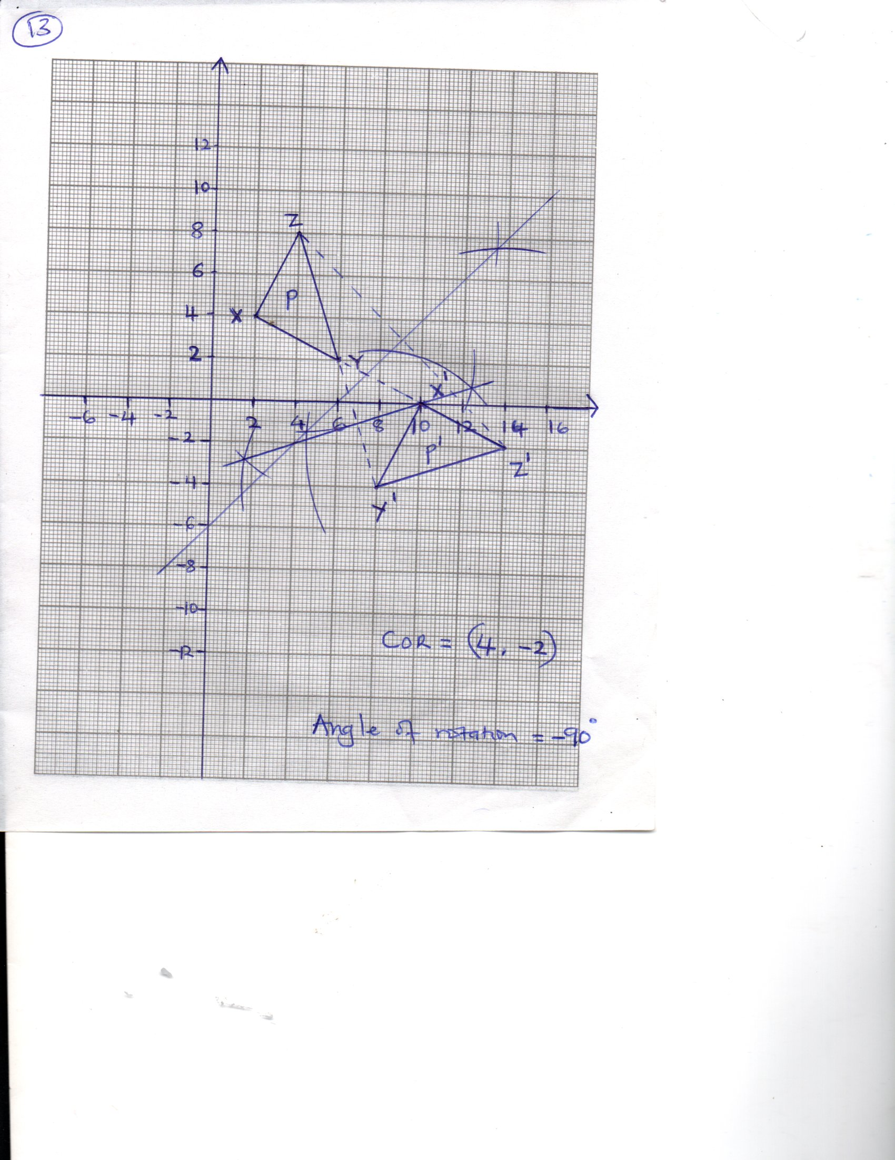  (b) centre of rotation = (4,-2)  Angle of rotation = +90⁰ | D2  B1  B1
 | 2x – 2 $≤3x+1$  -2 – 1 $≤3x-2x$  -3 $≤x$ B1 for -3$≤x$  3x + 1 < x + 11  2x < 10  X<5 B1 for x < 5  -3 $≤x<5$  Integral values -3,-2, -1, 0, 1,2,3,4 B1 – All correct integral values | B1  B1  B1
 | $\frac{12}{{\sin{30}}^{0}}$ =$\frac{QR}{{{\sin{70}}}^{0}}$ M1 Equating  QR =$\frac{{12\sin{70}}^{0}}{{\sin{30}}^{0}}$ =22.55cm A1 answer for QR  Area = ½ x 12 x 22.55 x sin 80⁰ M1 - Equation  = 133.2 (to 4 s.f -A1 – Answer for 4 s.f  NB- FOLLOW THRO | M1  A1  M1  A1

 | Let the number = xy  X+y = 13 y = 13 – x  (10x + y) – (10y + x) = 9  9x – 9y = 9  x-y = 1  x-1 = y  x-1 = 13- x  2x = 14  X=7  Y=13-7  =6cm A1 – both values correct  Original number = 76 B1 –for the digit | M1  B1  A1 | Equation
 | 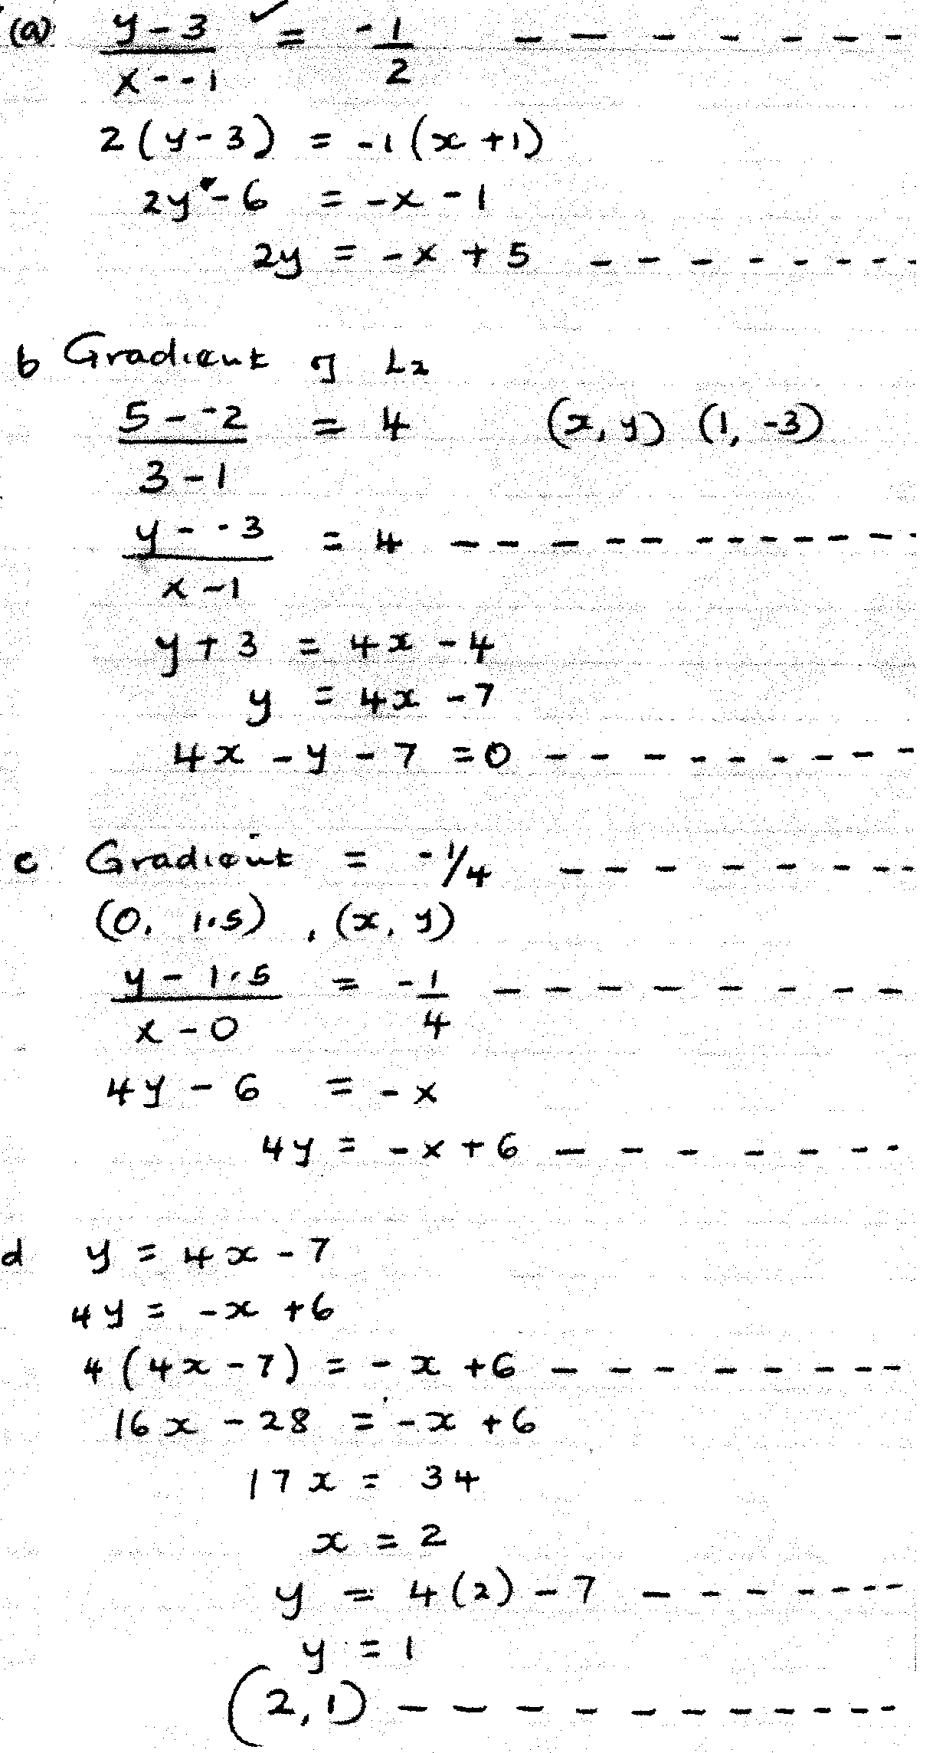 | M1  A1  M1  A1  B1  M1  A1  M1  M1  A1  10 | or equivalent  C.A.O  or equivalent
 | (a) a = $\frac{v-u}{t}$  2.75 =$\frac{22-0}{t}$  t=$\frac{22}{2.75}$  = 8 sec  (b) Distance = ½ x 8 x 22  = 88m  (c) 847 = ½ ( 40+t) + 32) x 22  847 = ½ (72 +t) x 22  1694 = (72+t) 22  $\frac{1694}{22}$ = 72 + t  $$77=72+t$$  T = 5 sec  T = 40 +t = 40+5 = 45 sec.  (d) a = $\frac{v-u}{t}$ = $\frac{0-22}{5}$  = -4.4m/s² | M1  M1  A1  M1  A1  M1  M1 A1  M1  A1 | Equation  Simplifying  Equation  Expression  for 5sec Adding 40 +5  Expression
 | 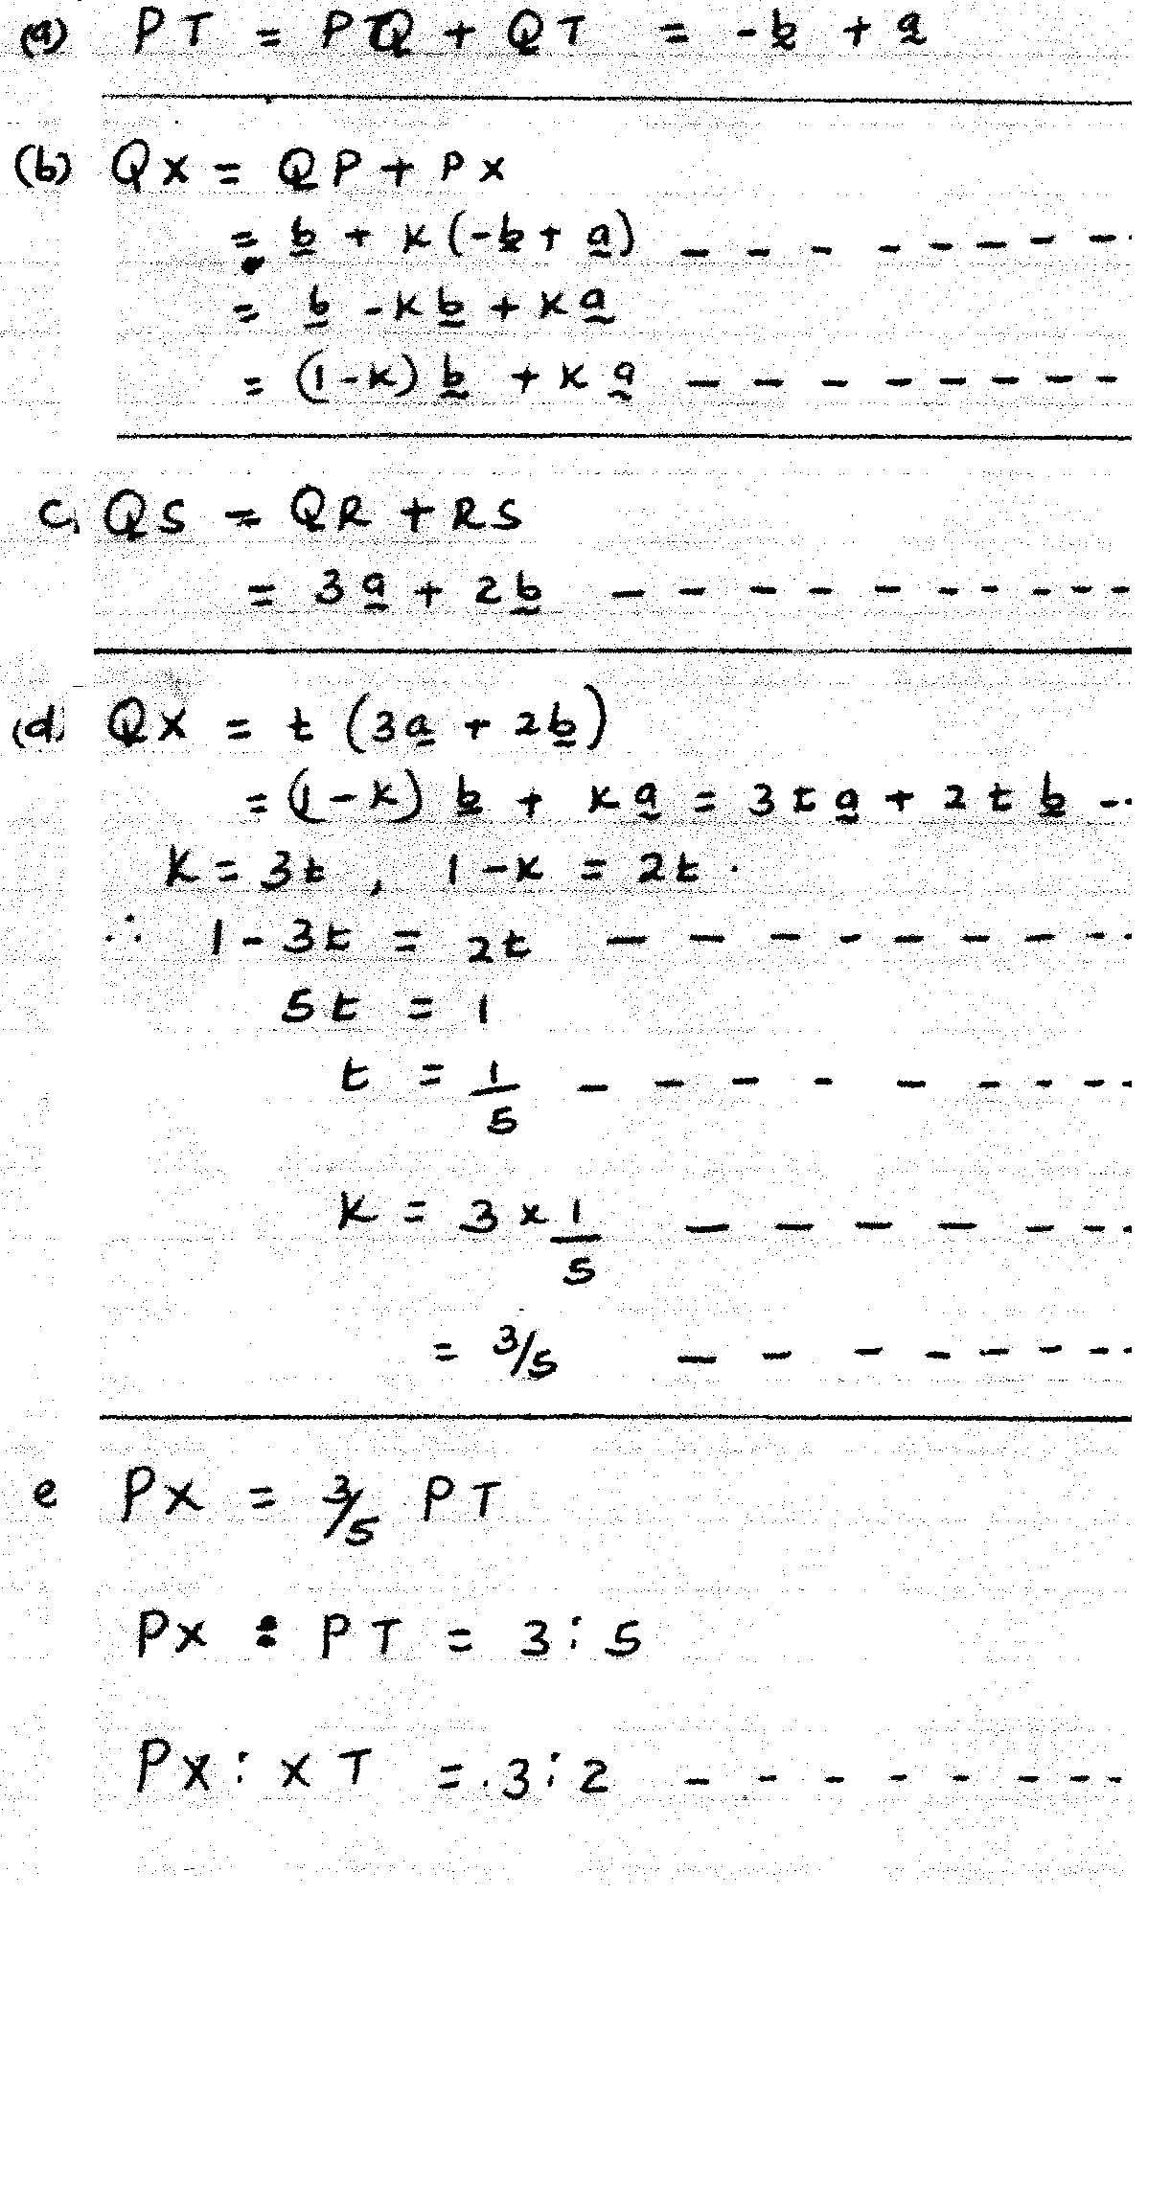 | B1  M1  A1  B1  M1  M1  B1  M1  B1  B1  10

 | 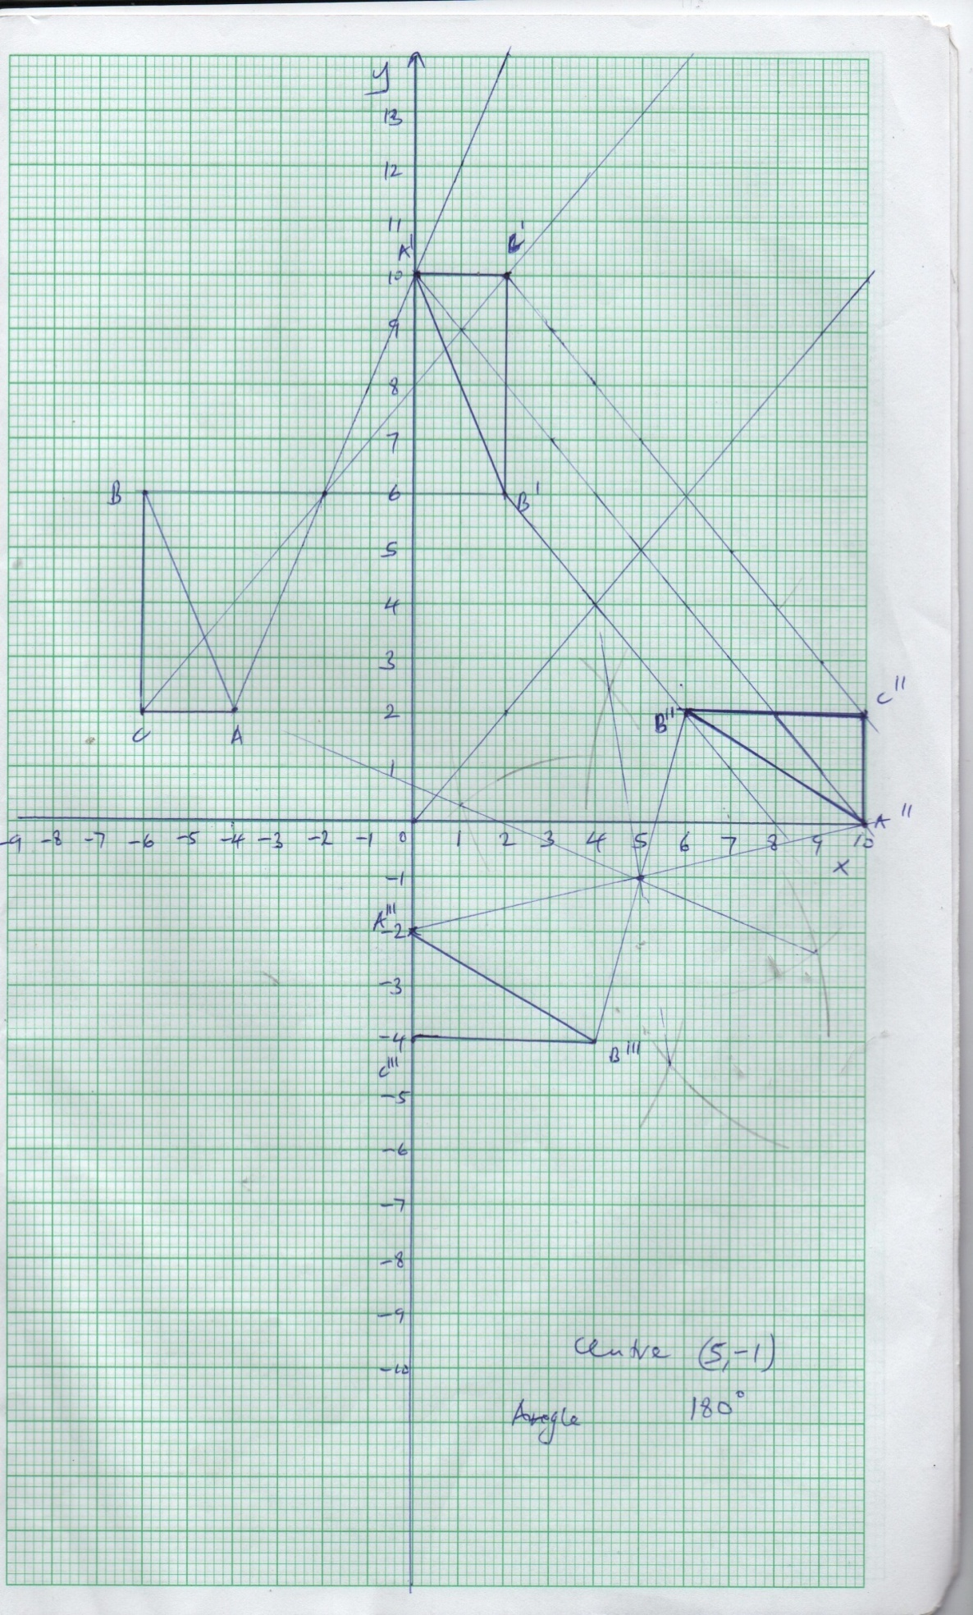 | A1  A1 | A’(0,10)  B’(2,6) 3  C’(2,10)  A”(10,2)  B”(6,2) 3  C”(10,2)  ABC =2

 | 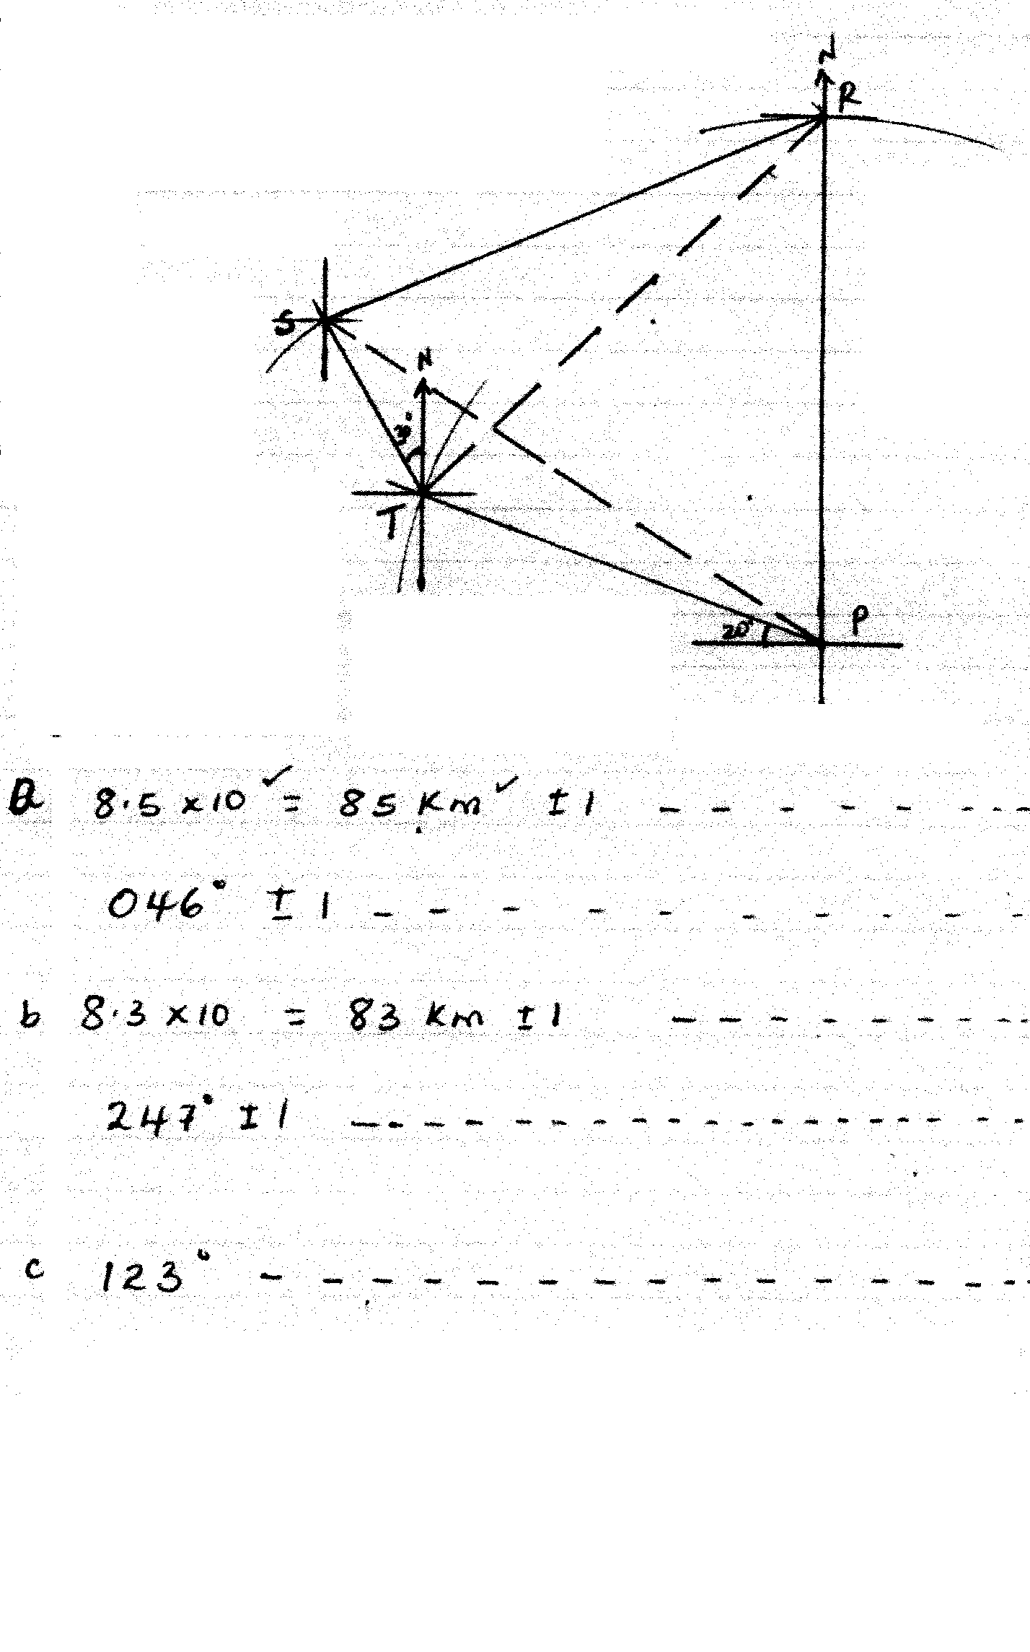 | B1  B1  B1  B1  M1  B1  B1  B1  B1  B1  10

 | 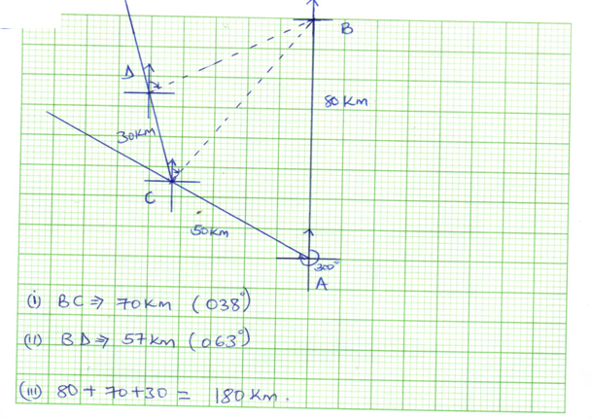  b (i) distance BC = 6.9cm = 6.9 x 10 = 69km  Bearing of B from C = 0.35 $-^{+}$ 1  (ii) Distance BD = 5.7 x 10 = 57km  Bearing of B and D = 063  (iii) distance = 80km + 30km + 50km + 57km  = 217km | M4  M1A1  M1A1  M1A1
 | - (a) (i) $\frac{16200}{x}$ B1 Expression  (ii) $\frac{16200}{x+3}$ B1 Expression  (b) $\frac{16200}{x}$ - 60 = $\frac{16200}{x+3}$ M1 equation  16200 (x +3) – 60x (x+3) = 16200x  16200x + 48600 – 60x² – 180x = 16200x M2 (removing L.C.M)  60x² +180x – 48600 = 0  X²+3x – 810 = 0  (x+30) (x – 27) = 0 M1 simplified equation  X = -30 or 27  No. of calculators = 27 A1 - Answer  (c) initial cost = $\frac{16200}{27}$  = 600  After discount = $\frac{16200}{30}$  = 540 B1 – Both 600 and 540 seen  % discount =$\frac{600-540}{600}$ x 100% M1 - Expression  = 10% A1 – Answer | B1  B1  M1  M2  M1  A1  B1  M1  A1
 | 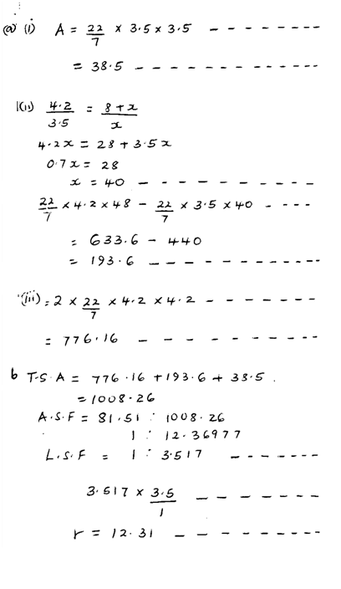 | M1  A1  B1  M1  A1  M1  A1  M1  M1  A1  10

