MERU CENTRAL CLUSTER EXAMINATION
121/2
MATHEMATICS
PAPER 2
TERM 2, 2020
DECEMBER 2020
MARKING SCHEME
Q
 | Log $\left(\frac{5^{2}x {40}^{2}}{{16}^{1/2}}\right)$  Log $\left(\frac{25x1600}{4}\right)$  Log 10,000  4 log 10  =4 | M1  M1  A1
 | n=? $δn$=$\frac{n}{2}\left(2a+(n-1\right)d)$  a=3  d=6  $δn$=7500  7500=$\frac{n}{2}\left[2\left(3\right)+\left(n-1\right)6\right]$  7500=$\frac{n}{2}\left[6+6n-6\right]$  7500=$\frac{n}{2}$(6n)  7500=3n²  n²=2500  n=50 | M1  M1  A1
 | $\left(\begin{matrix}5 & 3 \\ 3 & -4\end{matrix}\right)$ $\left({X \atop Y}\right)$ = $\left({35 \atop -8}\right)$  det = -20 - 9  = 29......................................................................................................  Inverse = $\frac{1}{29}$ $\left(\begin{matrix}-4 & -3 \\ -3 & 5\end{matrix}\right)$  $\frac{1}{-29 }$ $\left(\begin{matrix}-4 & -3 \\ -3 & 5\end{matrix}\right)$ $\left(\begin{matrix}5 & 3 \\ 3 & -4\end{matrix}\right)$ $\left({x \atop y}\right)$ = $\frac{1}{-29}$ $\left(\begin{matrix}-4 & -3 \\ -3 & 5\end{matrix}\right)$ $\left({35 \atop -8}\right)$  $\left(\begin{matrix}1 & 0 \\ 0 & 1\end{matrix}\right)$ $\left({x \atop y}\right)$ = $\frac{-1}{29}$ ( $\left(\begin{aligned}-140+24 \\ -105-40\end{aligned}\right)$  $\frac{x}{y}$ = $\frac{-1}{29}$ ($\left({-116 \atop -145}\right)$  $\left({x \atop y}\right)$ = $\left({4 \atop 5}\right)$  X = 4, y=5 | M1  M1  A1
 | 8.95 $–$ 9.05  14.5 $–$ 15.5  Max=$\frac{1}{3}x\frac{22}{7} x {9.05}^{2 }x 15.5=132.94$  Min = $\frac{1 }{3 } x\frac{22}{7}x {8.95}^{2} x 14.5=1216.80$  Actual = $\frac{1}{3}x\frac{22}{7}x 9^{2}x 15=1272.86$  A.E = $\frac{1}{2}(1329.94-1216.80$  =56.57  %error = $\frac{56.57}{1272.86}x 100$  =4.445% | M1  M1  A1 | For any 2 correct
 | $\frac{p}{w}$ = $\frac{my-2}{\begin{aligned}ny+4 \\ \\ \end{aligned}}$  Pny + 4p = mwy – 2w  4p+2w = mwy – pny  4p +2w = (mw – pn) y  ,y= $\frac{4p+2w}{mw-pn}$ | B1  M1  A1
 | tan²x – 2 tan x -3=0  Let tan x be P  P²-2p -3=0  P(p-3) + 1(p-3)=0  (p-3)(p+1)=0  P=3 or p=-1  tan x =3  x=71.57º or x = 135º | M1  M1  M1  A1
 | 1st tax band = 9680 x 10/100 = 968  2nd tax band = 9120 x 15/100 = 1368  3rd tax band = 9120 x 20/100 = 1824  4th tax band = 9120 x 25/100 = 2280  5th tax band = 5460 x 30/100 = 1638  Gross tax = 8078..............................................  Relief = 1056  Net tax = 7022  Monthly income tax = 7022 | M1  B1  A1
 | $$\frac{\sqrt[2]{ 2 } (1-\sqrt{2)}- \sqrt{2 } (1+\sqrt{2}}{(1+\sqrt{2 } (1- \sqrt{2)}}$$  $$\frac{\sqrt[2]{2}- 4- \sqrt{2 } -2}{-1}$$  $$\frac{\sqrt{2}- 6}{-1}$$  = 6- $\sqrt{2}$ | M1  M1  A1
 | (1-n)⁵=1-5n+10n²-10n²+5n⁴-n⁵  - (0.98)⁵ = (1-0.02)⁵ = (1-n)⁵  = 0.02=n  1-5(0.02) + 10(0.02)² -10(0.02)³  1-0.01+0.004-0.00008 = 0.99392 | B1  B1  M1  A1
  X5 | 1⁵ | 1⁴ | 1³ | 1² | 1¹ | 1⁰
  Y | 0 | (-n)¹ | (-n)² | (-x)³ | (-n)⁴ | (-n)⁵
  coeff | 1 | 5 | 10 | 10 | 5 | 1
   | 1 | -5n | 10n² | -10n³ | 5n⁴ | -n⁵
 | P(fail) = $\frac{1 }{2 } x\frac{1}{3}x\frac{1}{5}$ =$\frac{1}{60}$ | M1  A1
 | x²+y²-4x+6y+4=0  x²-4x+y²+6y=-4  (x²-4x + (-2)²+(y²+6y+(3)²=-4+(-2)²+(3⁾²  (x-y)²+(y+3)²=9  Centre =(2,-3)  Radius =3 | A1  B1  A1
 | A(50ºS, 25ºE)  B(50ºS, 140ºE) $θ$= 140-25  long  $θ,$ $∝$ $θ=115$º  ^{km =}$\frac{θ}{360}2π2$  $\frac{{115}^{o} }{360}$x $2x\frac{22}{7}$ x 6370  = 12,790.56km | B1  M1  A1
 | A (-1,1,0)  AM = $\left(\begin{matrix}1 \\ -1.5 \\ 2\end{matrix}\right)$-$\left(\begin{matrix}-1 \\ 1 \\ 0\end{matrix}\right)$=$\left(\begin{matrix}2 \\ -2.5 \\ 2\end{matrix}\right)$  $$\left(\overset{→}{AM}\right)=\sqrt{2^{2}+ {-(2.5)}^{2}+ 2^{2}}$$  = $\sqrt{4+6.25+4}$  = $\sqrt{14.25}$  = 3.775 x 2  = 7.550  =7.6 | M1  M1  A1 | For subtraction
 | 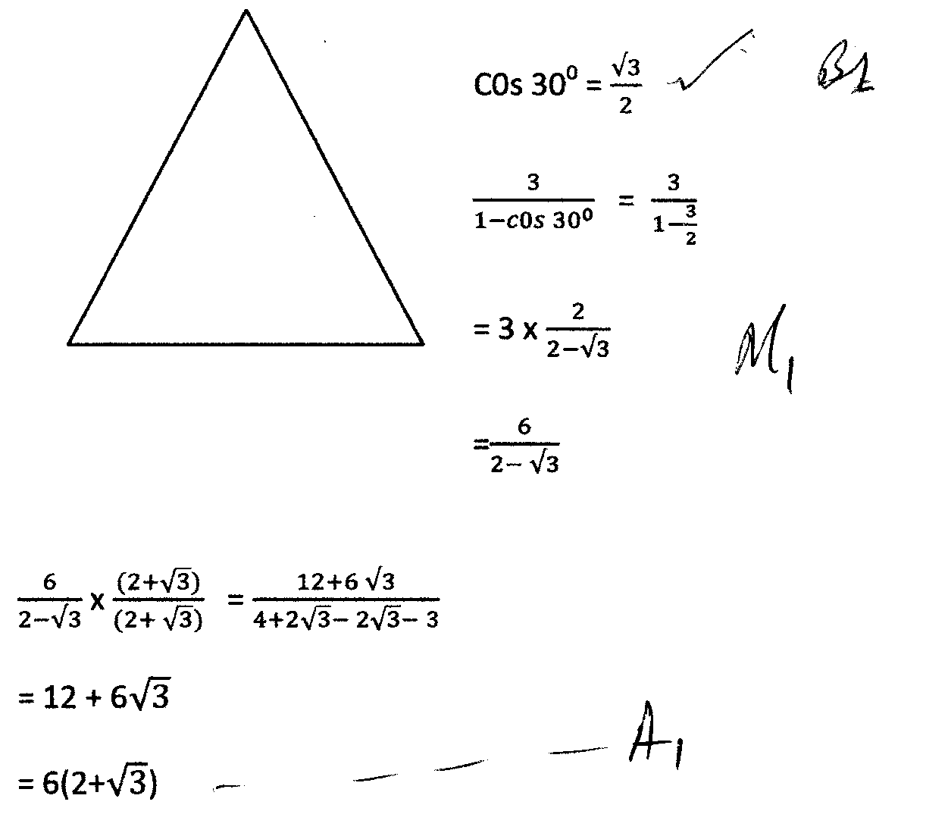
 | y(y+9) = 4x9  y²+9y-36=0  y² + 12y-3y-36=0  y(y+12)-3(y+12)=0  (y-3) (y-12) = 0...................................................  Y=3 or y=-12(ignore)  $∴$ = BC = 3cm | M1  M1  A1
 | Log (3x+8) – lof 8 = 10g (x – 4)  Log ($\frac{3x+8 }{8}$) = log (x-4)drop logs  $\frac{3x+8}{8}$ x – 4  $$3x+8=8x-32$$  3x – 8x = -32 -8  -5x = -40  X=8 | M2  A1
 | A= ½ h$[($y_{o} + y_{n}) + 2(y₁ +y₂+y₃+y₄+y₅)]  = ½ (0.5) [(1+28) + 2(3+6+10+25+21)]  = ¼ x 139  = 34.75  - $\int_{0}^{3}{(}$2x² + 3x+)dx  =[$\frac{{2x}^{3}}{3}$ + $\frac{{3x}^{2}}{2}$ + x$│_{0}^{3}$]  =(2($\frac{2 ({3)}^{3}}{3}$ + $\frac{3}{2}$(3)² + (3) – ($\frac{{2(0)}^{3}}{3}$ + $\frac{3}{2}$(0)² + (0) ]  =$\frac{2}{3}$ X 27 + $\frac{3}{2}$ X 9+ 3  $=\frac{18}{1}$ + $\frac{27}{2}$ + $\frac{3}{1}$  $$=\frac{36+27+6}{2}$$  = $\frac{69}{2}$  = 34.5  - Error = actual estimate  34.5 – 34.75  =-0.25  %error = $\frac{- 0.25 }{34.5 }$x 100  = 0.725 decrease | B2  M1  M1  A1  M1  M1  A1  M1  A1
  X | 0 | 0.5 | 1 | 1.5 | 2 | 2.5 | 3
  Y | 1 | 3 | 6 | 10 | 15 | 21 | 28

 | 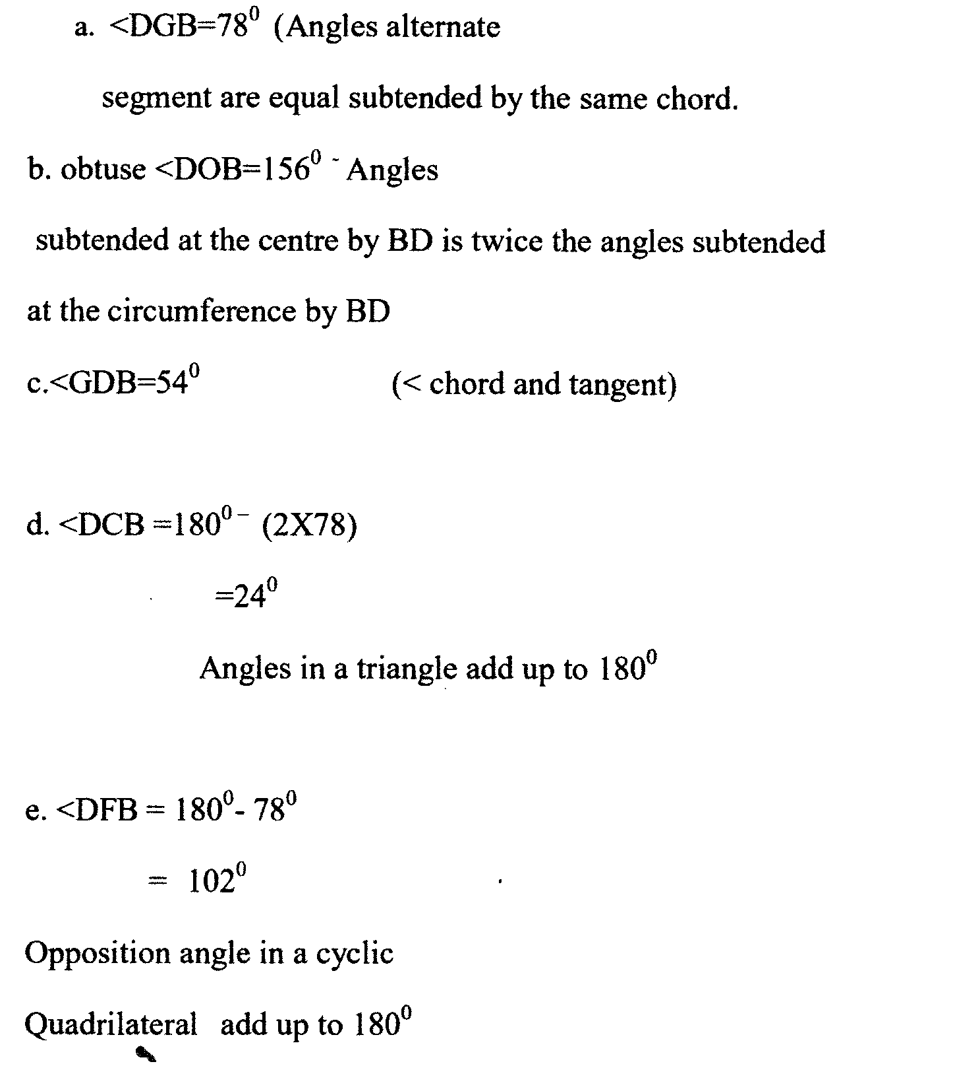 | B1  B1  B1  B1  B1  B2  B1  B1  B1  B1  B1
 | - T.T = $\frac{18000+6000}{20}$  = $£$ 1200 p.m  - 1st 236 x $\frac{10}{100}$ = 23.6  2nd 236 x $\frac{15}{100}$ = 35.4  3rd 236 x $\frac{20}{100}$ = 47.2  4th 236 x $\frac{25}{100}$ = 59 | M1  A1  M1  M1
 | 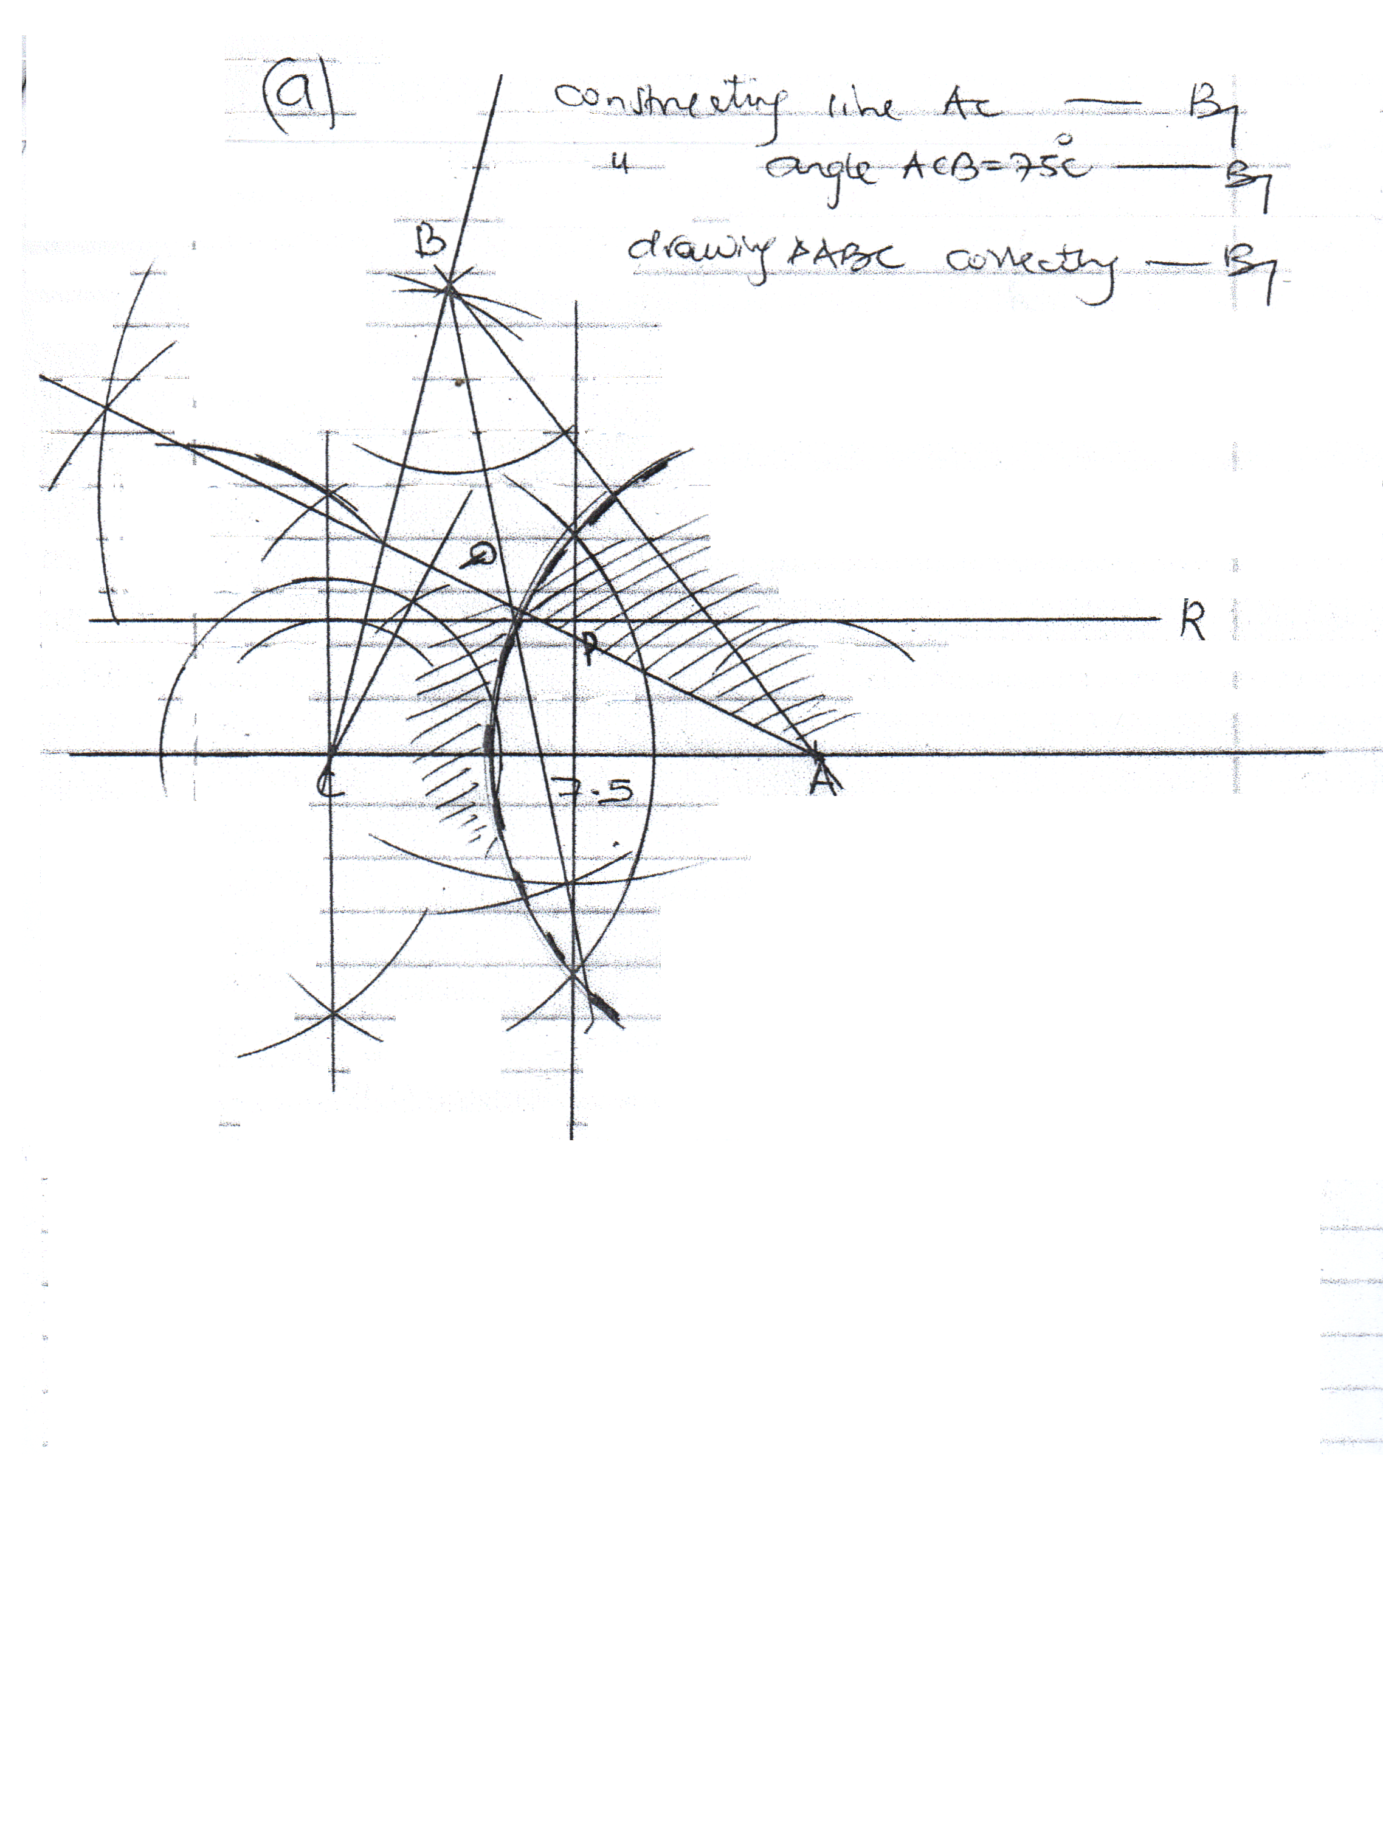  b)Constructing bisector of line AC  locating locus P  c)Bisecting angle ABC (locus Q)  constructing a line 2cm away from AC locating locus R  d)Bisecting $<$ BAC  drawing an arc (dotted) 5cm away from A.  Shading unwanted side | B1  B1  B1  B1  B1  B1  B1  B1  B1  B1

 | 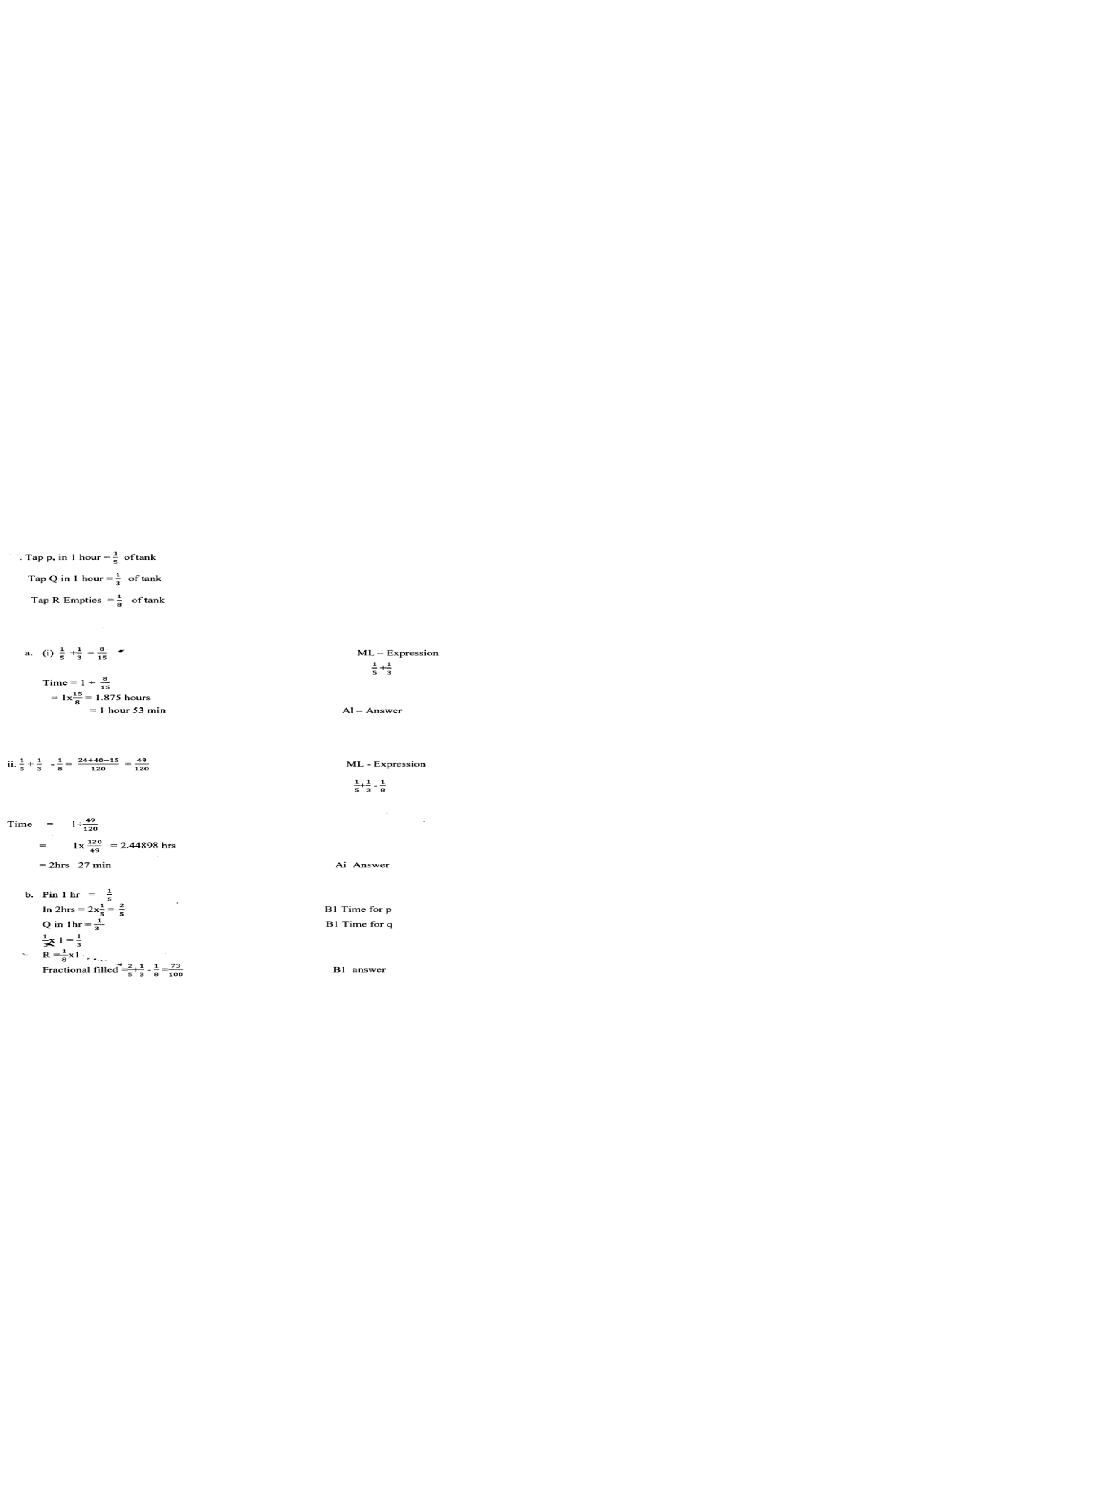  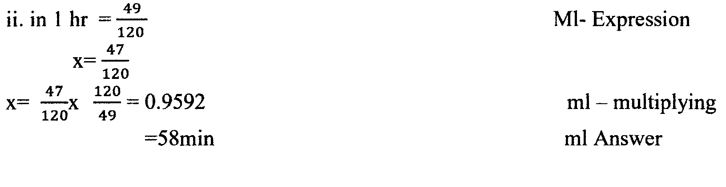 | M1  A1  M1  A1  B1  B1  B1  M1  M1  A1 | Expression  $$\frac{1}{5}+\frac{1}{3}$$  Expression  $$\frac{1}{5}+\frac{1}{3}-\frac{1}{8}$$  Time for P  Time for q  Expression  Multiplying
 | 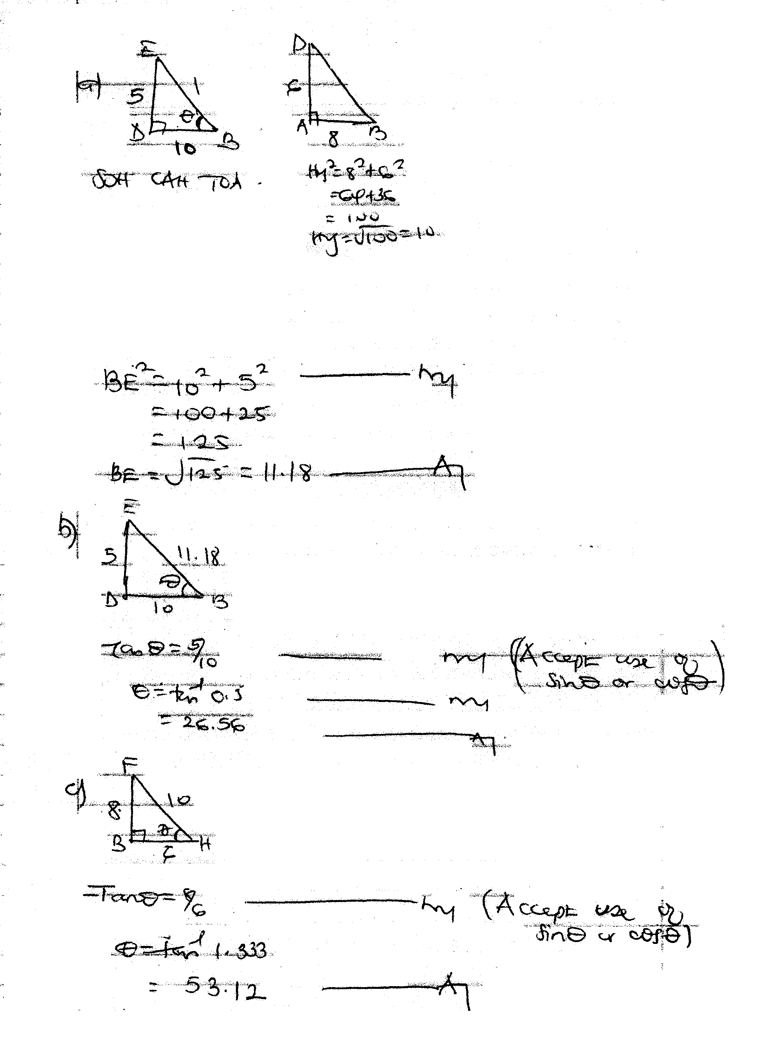  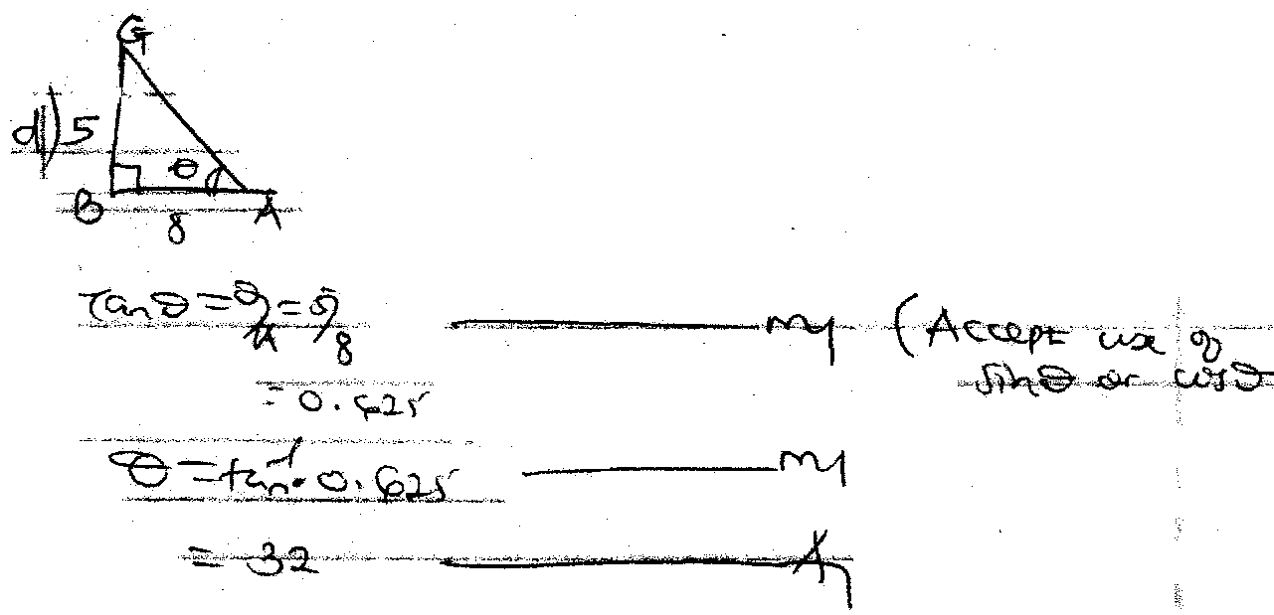 | M1  A1  M1  M1  A1  M1  A1  M1  M1  A1

 | 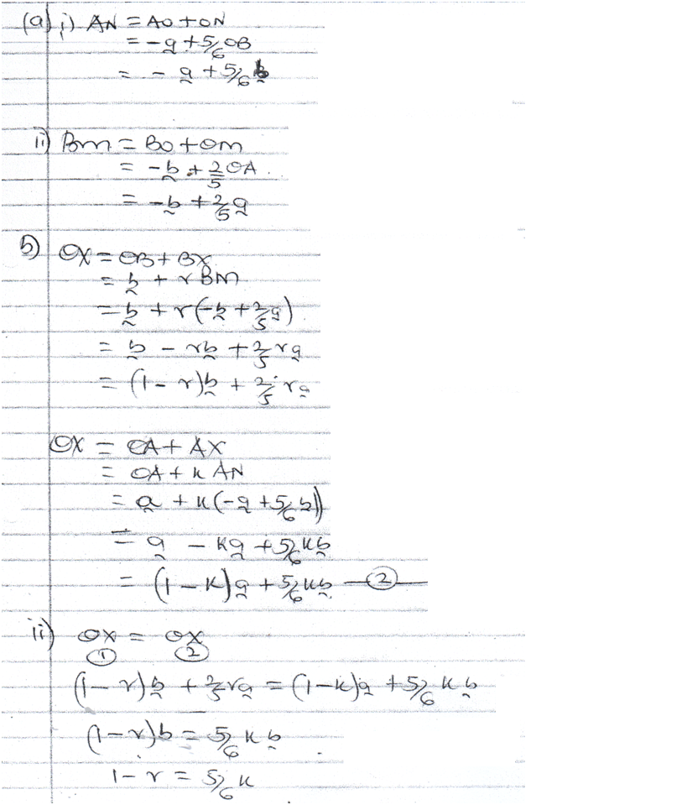  B1  B1  B1  A1  B1  A2  M1  M1  A1  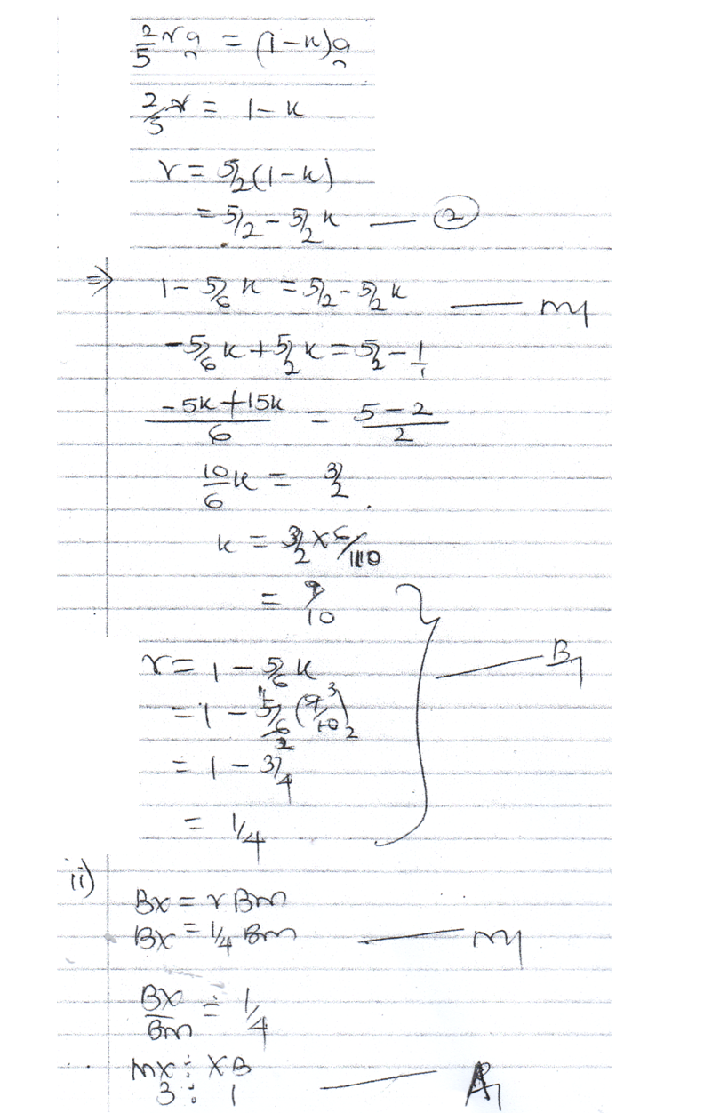  For both ans correct | A2  M1  A1  M1  M1  A1
 | 