**Name _________________________________________ Index No______________________**

**School ____________________________ Candidate’s Signature ___________________**

**Date __________________________**

**121/2**

**Mathematics alt A**

**Paper 2**

**March/April 2020**

2 ½ hours

**ARISE AND SHINE TRIAL 1 EXAM**

**MARCH/APRIL, 2020**

**INSTRUCTIONS TO CANDIDATES**

1. *Write your name and index number in the space provided above.*
2. *Sign and write the date of examination in the space provided above.*
3. *This paper consists of* ***TWO*** *sections:* ***section I*** *and* ***section II***
4. *Answer* ***all*** *the questions in* ***section I*** *and on only* ***five*** *questions from* ***section II***
5. ***Show all the steps in your calculations, giving your answers at each stage in the spaces provided below each question****.*
6. *Marks may be given for correct marking even if the answer is wrong*
7. ***Non-programmable*** *silent calculator* ***and*** *KNEC Mathematical tables may be used, except where stated otherwise.*
8. ***The paper consists of 16 printed pages.***
9. ***Candidates should check the question paper to ascertain that all the pages are printed as indicated and that no questions are missing.***
10. ***Candidates should answer the questions in English***

**FOR EXAMINER’S USE ONLY**

**SECTION I**

|  |  |  |  |  |  |  |  |  |  |  |  |  |  |  |  |  |
| --- | --- | --- | --- | --- | --- | --- | --- | --- | --- | --- | --- | --- | --- | --- | --- | --- |
| **1** | **2** | **3** | **4** | **5** | **6** | **7** | **8** | **9** | **10** | **11** | **12** | **13** | **14** | **15** | **16** | **TOTAL** |
|  |  |  |  |  |  |  |  |  |  |  |  |  |  |  |  |  |

**Grand Total**

|  |
| --- |
|  |

**SECTION II**

|  |  |  |  |  |  |  |  |  |
| --- | --- | --- | --- | --- | --- | --- | --- | --- |
| 17 | 18 | 19 | 20 | 21 | 22 | 23 | 24 |  |
|  |  |  |  |  |  |  |  |  |

**SECTION A (50 MARKS)**

*Answer* ***all*** *the questions in this section in the spaces provided.*

1. Evaluate without using tables or calculators.

$\sqrt{5}$_____ - $\sqrt{5}____$

$\sqrt{6}- \sqrt{4}$ $\sqrt{6}+ \sqrt{4}$ (3 marks)

1. A businessman withdrew sh 39,062.50 from financial institution which included both the principal and the compound interest for a period of 3 years. If the compound inters rate was 25% p.a, calculate the principal amount. (3 marks)
2. Given that the expression 36x2 – 84x + (k-6) is a perfect square
3. Find the value of k. (2 marks)
4. Hence solve the equation ( 2 marks)

36x2 – 84x + (k-6) = 0

1. Make x the subject of the formula (3 marks)

Y = $\sqrt{\left(\frac{X^{2}-5}{V}\right)}$ W

1. Given that **a** = 3**i** + 4**j** and **b** = 6 **i** + k**j**

Find the value of k if vectors **a** and **b** are parallel. (2 marks)

1. Construct triangle ABC such that AB=3.5cm, AC = 4cm and angle CAB=30o. Construct the locus of a point P on line BC such that it is equidistant to the lines AC and AB. Measure AP (4 marks)
2. Solve for $θ$ in the domain 0o≤≤360o 2 cos 2 = -0.7071 (3 marks)
3. A shopkeepers mixes coffee costing sh 160 per kg with another type which cost sh 240 per kg. Find the ratio in which the two types should be mixed so that when the mixture is sold at shs 220, a profit of 10% is realized. (3 marks)
4. A student took the measurement of his classroom and gave the width as 7m and length as 9m. If there is an error of 2% in each measurement, determine the greatest value of $\frac{x+y}{y}$, if x and y are the width and length of classroom respectively. Give your answer to 4 decimal places. (3 marks)
5. (a). Expand (1+x)4 (1 mark)

(b). Hence use the first 4 terms of the expansion to estimate (1.02)4, correct to 2 decimal places. (3 marks)

1. Determine the possible values of x for which the matrix below is a singular matrix. $\left({2x \atop 6} {12 \atop x}\right)$ (3 marks)
2. In the figure below, chords, AB and CD are produced to meet at T. AB=16cm, BT=5cm and CD=8cm. Find the length of DT. (4 marks)

**A 16cm B 5 cm T**

**C**

**8cm**

**D**

1. Find the centre and radius of a circle given the equation (3 marks)

x2+y2-16x+24y+127=0

1. Pipe A can fill a tank in 2 hours, pipe B and C can empty the tank in5 hours and 6 hours respectively. How long would it take;
2. To fill the tank if A and B are left open and C closed. (2 marks)
3. To fill the tank with all pipes open. (2 marks)
4. Find the value of x if;

Log5 + logx – log20 = 1 (3 marks)

1. Solve for x and y in the equations. (3 marks)

*X + y =* 13

*X2 +* 8*y =* 87

**SECTION II (50 MARKS)**

*Answer any* ***five*** *questions from this section in the spaces provided.*

1. (a). Find the sum of the first 21 terms in the series 11 + 15 + 19 + 23 + ----------------------

(3 marks)

(b). In a geometric progression, the sum of the second and the third is 4 and the sum of the third and the fourth term is 2. Find the first term and the common ratio. (4 marks)

(c). The sum of the first 8 terms of an AP is 220. If the third term is 17, find the first term and the common difference. (3 marks)

1. The vertices of a rectangle ABCD are A (-1,-1), B (-4,-1), C (-4,-3) and D (-1,-3)

(a). On the grid provided, draw the rectangle and its image AIBICIDI under a transformation whose matrix in $\left(\begin{matrix}-2 & 0 \\ 0 & -2\end{matrix}\right)$

(2 marks)

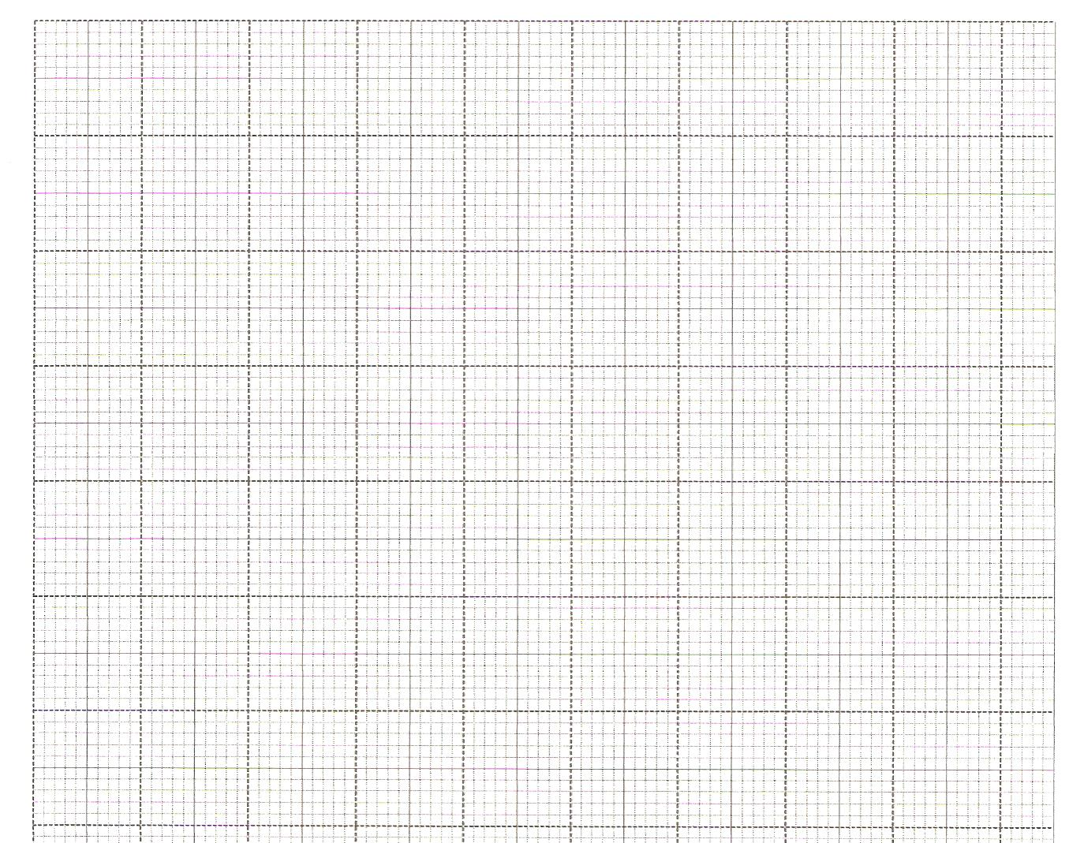

(b). A2B2C2D2 is the image of AIBICIDI under a transformation matrix P $\left(\begin{matrix}\frac{1}{2} & 1 \\ 1 & \frac{1}{2}\end{matrix}\right)$

1. Determine the coordinates of A2B2C2D2 (2 marks)
2. On the same grid, draw the quadrilateral A2B2C2D2 (1 mark)

(c) Find the area of A2B2C2D2  (3 marks)

1. Two fair dice one a regular tetrahedron (4 faces) and the other a cube are thrown. The scores are added together. Complete the table below to show all possible outcomes. (2 marks)

1 2 3 4 5 6

1

2

3

4

1. Find the probability that
2. The sum is 6 (1mark)
3. The sum is an odd number (1mark)
4. The sum is 6 or 9 (2 marks)
5. If a player wins a game by throwing a sum of 6 or 9, draw a tree diagram and use it to find probability that he wins at least once when the dice are thrown twice. (4 marks)
6. The table below shows the marks scored by students in a Maths exam.

|  |  |  |  |  |  |  |
| --- | --- | --- | --- | --- | --- | --- |
| Marks | 30-39 | 40-49 | 50-59 | 60-69 | 70-79 | 80-89 |
| No. of Students | 3 | 17 | 27 | 23 | 8 | 2 |

1. Draw a cumulative frequency curve (4 marks) 
2. Use your graph to find:
3. The median (1mark)
4. The quartile deviation (3 marks)
5. The number of students who score above 67 (2 marks)

1. A number of people working at a factory decided to raise sh.72000 to buy a plot of land. Each person was to contribute the same amount. Before contributions five people retired from working in the factory and thus did not contribute. The same target of sh.72000 was still to be met by the remaining.
2. If n stands for the number of people working in the factory originally, show that the increase in the contribution per person was shs. $\frac{360000}{n(n-5)}$ (3 marks)
3. If the increase in contribution per person was sh.1200, find he number of people originally working at the factory. (4 marks)
4. Calculate the percentage increase in the contributions per person caused by retirement giving your answer to one decimal place. (3 marks)
5. *x, y* and *z* are three quantities such that *x* varies directly as the square of *y* and inversely as the square root of *z*.
6. (i). Given that *x* = 12, and y= 24, and *z* = 36, find *x* when *y* = 27 and *z* = 121 (3 marks)

(ii). If *y* increases by 5% and *z* decreases by 19%, find the percentage increase in *x* (5 marks)

1. If *y* is inversely proportional to the square root of *x* and that *x* = 4 when *y* = 3, calculate the value of *x* when *y*=8. (2 marks)
2. In the figure below P, Q, R and S are points on the circle centre O. PRT and USTV are straight lines. UV is a tangent to the circle at S angle RST = 5o and angle RTV = 150o.

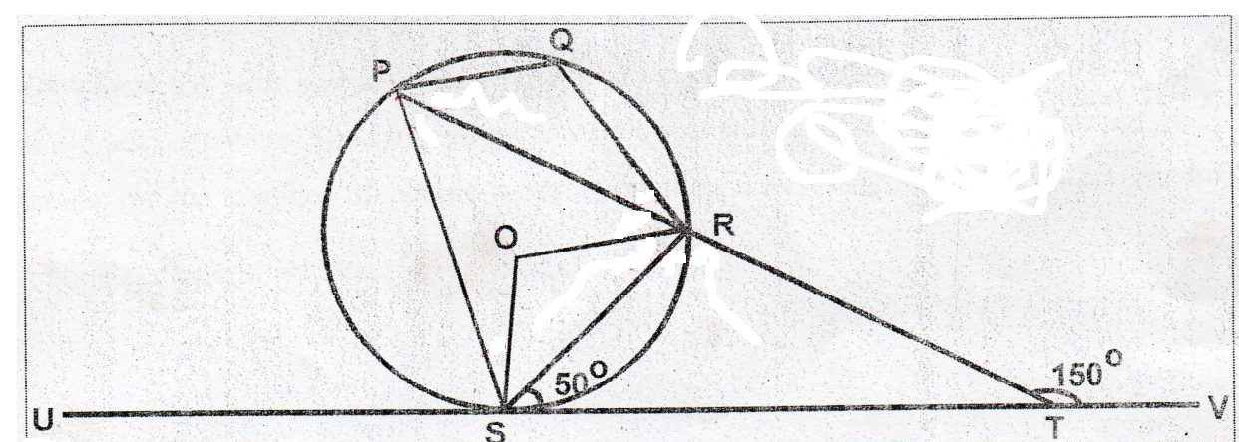

Giving reasons, calculate the size of;

1. Angle ORS (2 marks)
2. Angle USP (2 marks)
3. Angle PQR (2 marks)
4. Angle PSO (2 marks)
5. Reflex or angle SOR (2 marks)

1. The table below shows the income tax rate in Kenya during a certain year.

Monthly taxable income Tax rate percentage

(Ksh)

1-9720 10%

9721-19180 15%

19181-28640 20%

28641-38100 25%

38101-47560 30%

47561 and above 35%

During the year, Otieno earned a basic salary of ksh.30, 600 per month. He also paid a house allowance of ksh.15, 200 and medical allowance of ksh.6, 400 per month. He is entitled to a personal relief of ksh.1, 260 per month

1. Calculate:
2. Otieno’s taxable income per month (2 marks)
3. Net income tax paid per month (5 marks)
4. Apart from income tax, the following deductions are made from Otieno’s monthly tax.
5. Loan Ksh1875
6. NHIF Ksh1320
7. 2% basic salary towards windows and children fund. Calculate Otieno’s net monthly salary (3 marks)