121/2 MATHEMATICS PAPER 2 – MARKING SCHEME

NO | WORKING | MARKS | COMMENTS

1 | Log 559.3 = 2.7476  10 tan 3⁰ = 10 x 0.0524  = 0.524  - 2.7476  + 0.5240  3.2716  0.7493 cos² 16.3350  3.2716  No. Std. form Log  0.7493 7.493 x 10⁻¹ 1.8747  Cos²16.335 2(1.982) 1.9642 +  1.8389  3.2716 3.2716 x 10⁰ 0.5148 -  1.3241  -1 + 0.3241  2  = 1.6621  = 10⁻¹ x 4.593  = 0.4593 | M1  M1  M1  A1 | ✓Working out the denominators to get 3.2716  ✓For attempt to add and subtract correctly.  ✓Division by 2  CAO
 |  | 04
2 | ¼x² + ¹/₉  ¼ x² + k + ¹/₉  a + 2ab + b²  a² = ¼ x b² = ¹/₉  2ab = k  2 x ½ x ¹/₃ = k  k = ¹/₃ x | M1  A1
 |  | 02
3 | x⁶, x⁵ -9 , x⁴ a ², x³ -a ³, x² -a ⁴ , x -a ⁵, -a ⁶  x² x² x² x² x² x²  1.x⁶ – 6.x⁵ a +15x⁴ a ² – 2x³ a 6 +15x² a ⁴- 6x a ⁵ + 1. a ⁶  x² x² x² x² x² x²  x⁶ – 6ax⁵ + 15x⁴ a² – 20x³ a³ + 15x² a⁴ – 6xa⁵ + a⁶  x² x⁴ x⁶ x⁸ x¹⁰ x¹²  x⁶ – 6ax³ + 15a² 20a³ + 15a⁴ - 6a⁵ x a⁶  x³ x⁶ xª x¹²  15a² = 1215  a² = 81  a = +9 | B1  M1  A1 | For items and coefficients combined correctly  Equating to 1215  C.A.O (+9)
 |  | 03
4 | 1.75^{r} 24.8cm  θ = 2πr = c  360  1^{r} = 57.296⁰  1.75 – (1.75 x 57.296⁰)  = 100.268⁰  100.26 x D x 22 = 24.8  560 7  0.8754D = 24.8  D = 24.8  0.874  D = 28.33cm | M1  A1 | ✓For substitution  For diameter
 |  | 03
5 | 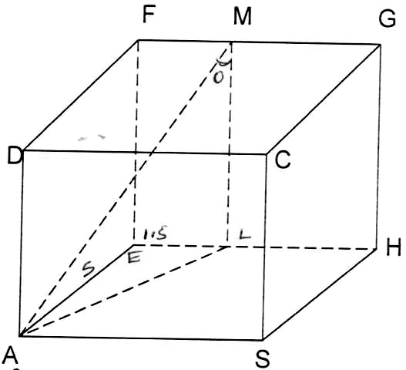  AL² = AE² + EL²  = 5² + (1.5)²  = 27.5  = 5.240  AM = 5.244² + 4²  = 27.5 + 16  = 43.5  = 6.5955  Cos θ = 4  6.596  = 0.6064  θ = cos⁻¹ 0.6064 = 52.67⁰ | M1  M1  A1
 |  | 04
6. | (0.0054667)^{½} = (54.667 x 10-4)^{½}  = 7.3939 x 10⁻²  = 0.073939  = 3  0.043279  = 3 x 0.2305 x 100  = (69.15)²  = (6.915 x 10¹)²  = 47.82 x 10²  = 4782  - 0.073939 + 4782  = 4782.073989  = 4782.1 | M1  M1  A1 | Use of table, to get square root.  Getting reciprocals and squaring it using log tables.  Giving answer to 5 significant figure.
 |  | 03
7 | A = P(1 + r)^{n} Period = 4  100 Rate = 4  A = 1250000 ( 1 + 4.5)⁸  100  = 1250000 (1.045)⁸  = 1777625.766  Half withdrawn  Remaining 888812.883  A = 888812.883 (1 + 45)¹⁰  100  = 888812.883 (1.045)¹⁰  = 1380299.229  Interest in phase one  = (1777625.766  Interest in phase two  1380299.229 – 888812.883  = 491486.346  Total interest  (527625.776 + 4914863.436)  =1019112.112  ≈ 1019112 | M1  M1  M1  A1
 |  | 03
8 | 16sm² x + 4 cos x = 10  8sm² x + 2 cos x = 5  8(1 – cos²x) + 2 cosx = 5  8 – 8 cos²x = 2 cos x = 5  -8 cos ²x + 2 cos x + 3 = 0  8 cos²x – 2 cosx – 3 = 0  Let cos x = y  8y² – 4y – 3 = 0  y = 2 ± (-2)² – 4 x 8x – 3  16  = 2 ± 4 + 96  16  = 2 ± 10  16  Cos x = 12 => cos x = 0.75  16  and cos x = -8 => cos x = -1  16 2  Cos x = -0.5 – found in the 2nd and 3rd quadrant.  For 3rd quadrant  Acute angle = 60⁰  Then x – 180⁰ = 60⁰  x = 240⁰  Tan 240⁰= 1.7321 | M1  M1  A1  B1 | Accept use of sin
 |  | 04
9 | (a) P = KL + B K & B where K and B are constants  √C  500 = 16K + B ……….. (i)  4  800 = 25K + B ……… (ii)  5  K = 2000 = 32.79  61  B = -98.56  P = 32.79L - 98.56  √C  (b) P = 2000 (81) – 98.56  61 √81  = 1327.87 – 10.95  = 1,316.92 | M1  A1  M1  A1 | Attempt to find  the constants.
 |  | 04
10 | 1250  Wall F. Post  (H)  62⁰  70m  - Tan 62⁰ = H => H = 131.65m  70  - Tan 25⁰ = x  70  - x = 70 Tan 25⁰  = 32.64  Therefore (wall) = 131.05 – 32.64  = 99.03m | B1  M1  A1
 |  | 03
11 | Log 135 = log 3³x5  = 3 log 3 + log 5  = (1.583) + 2.322  = 7.071 | M1  A1
 |  | 02
12 | Max. Q = 12.7 = 1.7887  7.1  Min. Q = 12.5 = 1.7123  7.3  Actual = 12.6 = 1.75  7.2  A.E = ½ (1.7887 – 1.7123)  = 0.0383  % Error = 0.0382 x 100  1.75  = 2.1829 | M1  M1  A1 | Both values
 |  | 03
13 | H  10  F  8  A E B 8 8 H  2 2 2  B 8 C  G 10 F 2 G  8  F  10  G  Area of part A = 2 x 10 = 20  Area of part B = 2 x 2 = 4  Area of part C = ½ (2 + 8) 8 x 2 = 80  Area of part D = 8 X 2 = 16  Area of part E = 2 x 8 = 16  Total area = 136cm³ | B1  B1  M1  A1 | ✓Sketch  ✓ Labelling
 |  | 04
14 | 9^{x+1} – 54 = 3^{2x+1}  (3^{2x}) (3²) – 54 = (3^{2x}) (3¹)  Let 3^{2x} = y  9y – 54 = 3y  6y = 54 = y = 9  3^{2x} = 3² => 2x = 2  Therefore x = 1 | M1  M1  A1
 |  | 04
15 | B(2, -1)  A(-6,5)  M -6+2, 5 -1  2 2  = M (-2, 2)  MB = 2 – -2 = 4  -1 2 -3  MB = Radius = 4² + (-3)²  = 5  (x + 2)² + (y – 2)² = 5  x² + y² + 4x – 4y – 17 = 0 | B1  M1  A1
 |  | 03
16 | y + 2x + 1 = 0  x² + xy = -6  y = (-2 – 1)  x² + x (-2x – 1) = -6  -x² – x + 6 = 0  (x – 2) (x + 3) = 0  x = 2 when y = -5  x = -3 when y = 5 | M1  M1  A1
 |  | 04
17 | - Tree diagram  ⁴/₅ T ………….RBT  B ¹/₅ N ………...RBN  ⁴/₁₅  ⁵/₇ R ……….. RNR  ¹⁸/₂₁ R N  ¹/₁₅ ²/₇  N ……… RNN  ³/₂₁ B ⁴/₅ T ……….. NBT  ¹/₁₃  N ¹/₅ N ……….. RBN  ¹²/₁₃ N ⁵/₇ R ………. NNR  ²/₇ N ………. NNN  - (i) P (RNR) or P (RNN) or (RNN) or P (NNR) or (NNN)  6 x 11 x 5 + 6 x 1 x 2 + 3 x 12 x 5 + 3 x 12 x 2  7 15 15 7 15 7 21 13 7 21 13 7  = 2 + 60 + 60 + 23 = 170  49 637 637 637 637  (ii) P (RNR) or P(NNR)  = 6 x 11 x 5 + 3 x 12 x 5  7 15 7 21 13 7  = 86  637  (iii) P (R’) = 1 – P (RNR + P (NNR)  = 1 – 86  637  = 557  637 | B1  B2  M1  M1 A1  M1  A1  M1  A1 | Labelling  Indicating all probs
 |  | 10
18 | Total tax = PAYE – Relief  = Ksh. 2172 + 1093  = Ksh. 3265p.m  = Ksh. 39,180 p.a.  Tax (K£ p.a.) Taxable income (K£p.a.)  4512 x 2 (9024) 4,512  4512 x 3 (13,536) 4,512  4x = 16,620 (16,2620) 4,155  13,179  Therefore taxable income = Ksh. 13,179 p.a  = Kshs. 21,965p.m.  Basic salary = Ksh. 21965 – (5000 + 2000)  = Ksh. 14,965p.m.  Total deductions = Ksh. 2172 + 320 + 4000  = Ksh. 6,492p.m.  Gross income = Ksh. 21965p.m.  Therefore Koech’s net pay = Ksh. 21965 – 6492  = Kshs. 15,473p.m. | M1  A1  M1  M1  M1  M1  M1  A1  M1  A1
 |  | 10
19 | (d) radius = 4.6 + o.1  Area = 120 x 22 x 4.6 x 4.6  360 7  = 22.17cm² | B1  B1  B1  B1  B1  B1  B1  B1  M1  A1 | Construction of pt C  Construction of ΔABC  Locating the centre  Bisecting <s  Radius of circle construction.  Construction of angles 30⁰.  Centre of circle  Locus L
 |  | 10
20 | 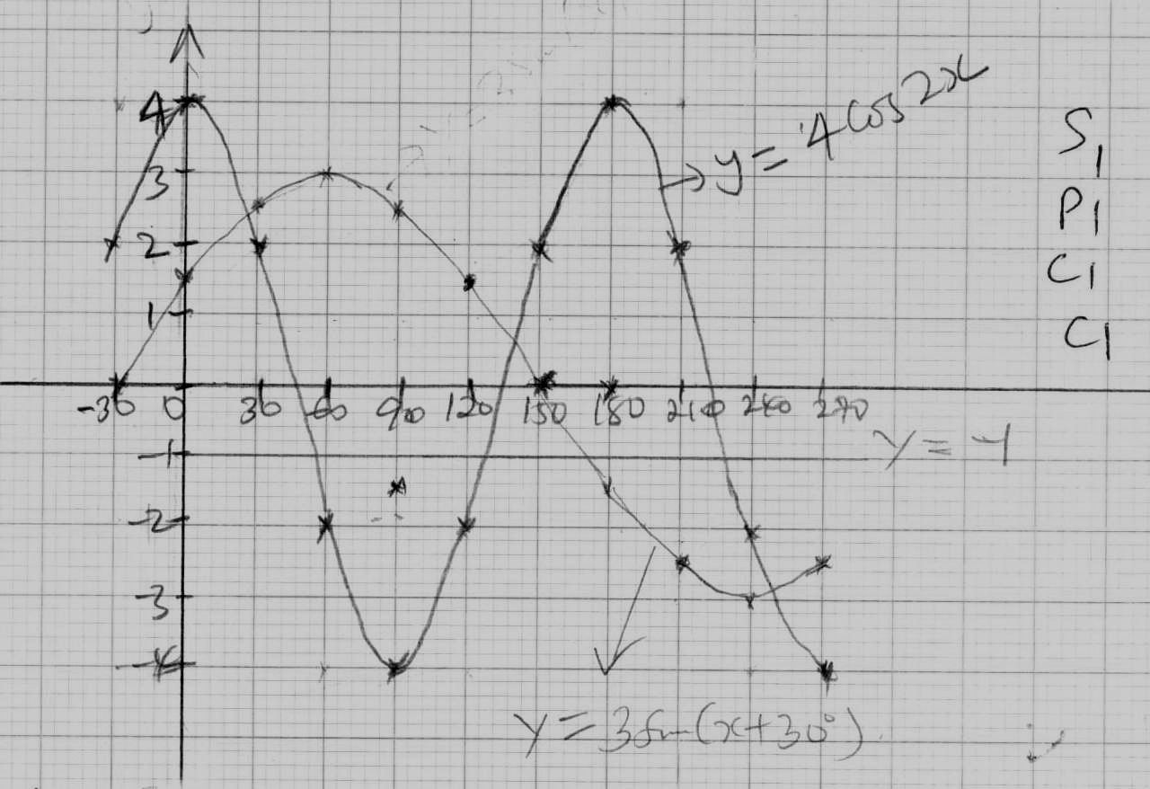  - (i) x = 24⁰, 138⁰, 352⁰ + 0.5  (ii) 3 sin (x + 30⁰) = y  3 sin (x + 30) = y -y = y x = 168 + 0.5  (iii) 4 cos 2x = y 2x = 360  x = 180⁰  Therefore period = 180⁰✓ | B2  B1  B2  B1  B1  B1 | All 6  At least 4  ✓all  ✓2
  x | -30 | 0 | 30 | 60 | 90
  + cos 2x | 2.0 | 4.0 | 2 | -2.0 | -4.0
  3 sin (x+30) | 0 | 1.5 | 2.6 | 3.0 | 2.6
  120 | 150 | 150 | 210 | 240 | 270
  -2.0 | 2.0 | -4.0 | 2.0 | -2.0 | -4
  1.5 | 0 | -1.5 | -2.6 | -3.0 | -2.6
 |  | 10
21 | - 4800 = 80⁰  60  90 – 65 = 25⁰  80 – 25 = 55⁰  90 – 55 = 35⁰  R = 35⁰ …………  - X (65⁰N, 36⁰E)  Y (65⁰N, 144⁰W)  Angle difference  144 + 36 = 180⁰  Small circle  Therefore 180⁰ x 60⁰ cos 65⁰  = 4564.28nm  Then: (65⁰N, 144⁰W)  (35⁰N, 144⁰W)  Angle difference  65 – 35 = 30⁰  Current circle  30 x 60 = 1800nm  Total distance  4564.28 + 1800  = 6364.28nm  Direct route  Angle difference = 80⁰  Along a great circle (Longitude)  Therefore 80 x 60 = 4800nm  Route difference in distance  6364.28 – 4800 = 1564.28nm  - Route difference in distance = 1564.28nm  Angle difference = 1564.28 = 26.07⁰  60  - 35⁰ + 26.07⁰ = 61.07⁰  (61.07⁰N, 144⁰W) | M1  M1  A1  M1  M1  A1  A1  A1  M1  A1
 |  | 10
22 | - y = x² + 2  y = 10 – x²  x² + 2 = 10 – x²  x² + x² = 10 -2  2x² = 8  x² = 4  x = +2  x = 2  y² = x + 2 y = 10 – 2  y= 4 + 2 or y = 10 – 4  y = 6 y = 6  Q(2, 6) ……………………………..  - h = 2 – 0 = 2 = ¼ or 0.25  8 8  For y = 10 – x²  9.96875 9.4375 9.59375 9.21875 8.71875 8.09375 7.34375 6.46875  = 0.25(9.96875+09.84375+9.59375+9.21875+8.71875+8.09375+7.34375+6.46875)  = 0.25 (69.25)  = 17.3125………………….  For y = x² + 2  3.03125 2.15625 2.40625 2.78125 3.28125 3.90625 4.65625 5.53125  =0.25(3.08125+2.15625+2.40625+2.78125+3.28125 + 3.90625 + 4.65625+5.53125)  = 0.25 (27.75)  = 6.9375…………………..  Shaded region:  17.3125 – 6.9375  = 10.375  - y = 10 – x²  2  (10x – x²)dx  0 ₂  10x – x³  3 ₀  10(2) – (2)³ – (10(0) – (0)³  3 3  (20 – 2.6667) – 0  17.3333 |  | A1  T2  A1  T1  A1  A1  M1  M1  A1
  x | 0.00 | 0.25 | 0.50 | 0.75 | 1.00 | 1.25 | 1.50 | 1.75 | 2.00
  10 | 10 | 10 | 10 | 10 | 10 | 10 | 10 | 10 | 10
  -x² | 0.00 | -0.0625 | -0.25 | -0.5625 | -1.00 | -1.5625 | -2.25 | -3.0625 | -4.00
  y | 10.00 | 9.9375 | 9.75 | 9.4375 | 9 | 8.4375 | 7.75 | 6.9375 | 6
  X | 0.00 | 0.25 | 0.50 | 0.75 | 1.00 | 1.25 | 1.50 | 1.75 | 2.00
  x² | 0.00 | 0.0625 | 0.25 | 0.5625 | 1.00 | 1.5625 | 2.25 | 3.0625 | 4.00
  2 | 2 | 2 | 2 | 2 | 2 | 2 | 2 | 2 | 2
  y | 2.00 | 2.0625 | 2.25 | 2.5625 | 3.00 | 3.5625 | 4.25 | 5.0625 | 6.00
 |  | 10
23 | (a) p = kr^{n}  Log p = Log r^{n} + log k  Log p = n logg r + log k  (b)  n = the gradient  n = 0.3522 – 0.1987 = 0.1535 = 1.58  0.1761 – 0.0792 0.0969  Log k = 0.9  No Log  k 0.9  7.943  k = 7.943 ……………….  (b)  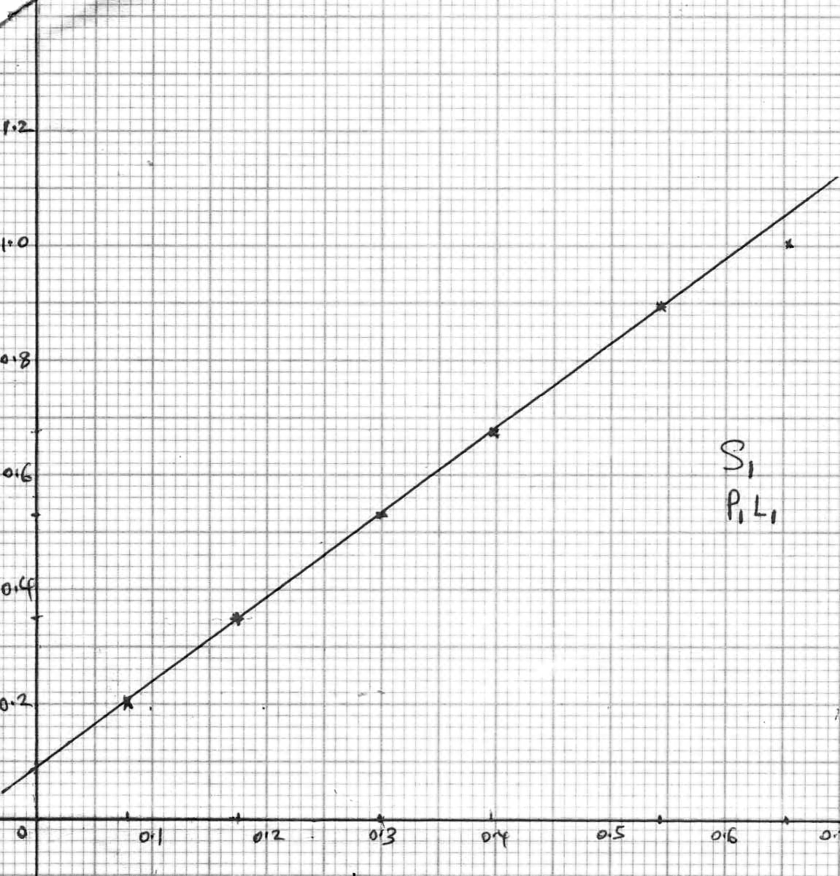  Log p  (c) P = 7.943r^{1.58} | B1  T2  M1 A1  A1  A1
  p | 1.2 | 1.5 | 2.0 | 2.5 | 3.5 | 4.5
  r | 1.58 | 2.25 | 3.39 | 4.74 | 7.86 | 11.5
  Log p | 0.792 | 0.1761 | 0.3010 | 0.3979 | 0.5441 | 0.6532
  Log r | 0.1987 | 0.3522 | 0.5302 | 0.6758 | 0.8954 | 1.0607
 |  | 10
24 | Scale 1cm rep 100km  B  D  A  - AC => 12.5cm  12.5 x 100  = 1250km  S = D  T  200 = 1250  T  T = 1250 = 6.25  200  = 6 hours 15 minutes  - 149⁰  - 8.3cm  8.3 x 100 = 830km | B3  B1  A1  M1  A1  B1  A1 | For locating ABC  For locating D  For 1250km  For correct substitution
 |  | 10

