NAME ………………………………………………….. INDEX NO ………………
SCHOOL ……………………………………………… DATE …….………………
ADM No ………………………………………………. CLASS ………………….
CANDIDATE’S SIGNATURE …………………….………………………..
121/1
MATHEMATICS
PAPER 1
JUNE 2022
TIME: 2¹/₂ HOURS

EVALUATION EXAMINATION 2022
Kenya Certificate of Secondary Education (K.C.S.E)

INSTRUCTIONS TO THE CANDIDATES
Write your name and school and index number in the spaces provided above
- This paper contains two sections; Section 1 and Section 11.
- Answer all the questions in section 1 and only five questions from Section 11
- Show all the steps in your calculations, giving your answers at each stage in the spaces below each question.
- Marks may be given for correct working even if the answer is wrong.
- Non-Programmable silent calculators and KNEC Mathematical tables may be used EXCEPT where stated otherwise.
FOR EXAMINERS’S USE ONLY
Section 1
Question | 1 | 2 | 3 | 4 | 5 | 6 | 7 | 8 | 9 | 10 | 11 | 12 | 13 | 14 | 15 | 16 | Total
Marks
Section 1I GRAND TOTAL
Question | 17 | 18 | 19 | 20 | 21 | 22 | 13 | 24 | Total
Marks

This paper consists of 16 printed pages. Candidates should check carefully to ascertain that all the pages are printed as indicated and no questions are missing.
SECTION I (50 Marks)
Answers all the questions in this section in the space provided.
- Evaluate without using tables or calculators (3marks)
$$\frac{\sqrt{\text{45}}×(2\text{.}\text{04})^{2}}{2\text{.}\text{89}×\sqrt{0\text{.}\text{05}}}$$

- Momanyi spent one eight of his February Salary on farming, half on school fees and two thirds of the remainder on food. Calculate his February salary and the amount he spend on school fees if he spent sh. 3200 on food. (3marks)

- Makau, Wanjiru and Kemboi start a race at 9.03 a.m in the same direction to run round a circular course. Makau makes the circuit in 252 seconds, Wanjiru in 308 seconds and Kemboi in 198 seconds. If they start from the same point, at what time will they next be all at the starting point together? (3marks)

4. Use squares square roots and reciprocal tables to evaluate (3marks)
$$3\text{.}{\text{045}}^{2}+\frac{1}{\sqrt{\text{49}\text{.}\text{24}}}$$

5. Simplify the expression
$\frac{9t^{2}−\text{25}a^{2}}{6t^{2}+\text{19}\text{at}+\text{15}a^{2}}$ (3marks)

6. A square based brass plate is 2mm high and has a mass of 1.05kg. The density of the brass is 8.4g/cm³. Calculate the length of the plate in centimeters. (3 marks)

7. The currency exchange rates of a given bank in Kenya are as follows;
Currency | Buying | Selling
1 sterling pound | 135.50 | 135.97
1 US dollar | 72.23 | 72.65
A tourist arrived in Kenya with 5,000 US dollars which he converted to Kenya shillings upon arrival. He spent ksh.214, 500 and converted the remaining to sterling pounds. How many pounds did he receive? (3marks)

8. The figure below shows a simple tent.AF=FB=10cm, AB=12cm and BC=FE=AD=20cm. On the tent, a tight rope is tied as shown on the diagram from BD, DE and EA. Draw the net of the tent and show the path of the rope on the net using the scale $1\text{cm}$rep.$5\text{cm}$ (3marks)

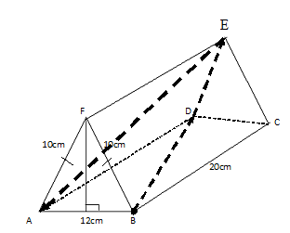
9. Mrs Wekesa paid shs 12500 for a wrist watch after the shopkeeper gave her a discount of 2%. If the shopkeeper made a profit of 20%.calculate the price the shopkeeper bought from the manufacturer. (3marks)

10. Solve for x in ${\left(\frac{4}{9}\right)}^{x}×{\left(8\right)}^{1−x}=\text{486}$ (4marks)

11. Find the equation of a perpendicular bisector of line PQ if the coordinates of P and Q are (-2,6) and (4,-2) respectively, in the form $y=\text{mx}+c$ (3marks)

12. Complete the figure below by adding the correct missing features if it has a rotational symmetry of order 4 about O. (3marks)
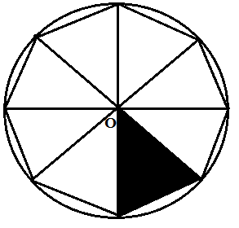
13. The volumes of two similar cylindrical containers are 27cm³ and 125 cm³ respectively. Given that the height of the smaller container is 12cm, find the height of the larger container.
(3marks)

14. Without using calculator or mathematical tables, simplify (4marks)
$\frac{\text{cos}\text{30}−\text{sin}\text{45}}{{\text{sin}}^{2}\text{30}+{\text{tan}}^{2}\text{45}}$

15. Form three inequalities that satisfy the unshaded region R. (3marks)
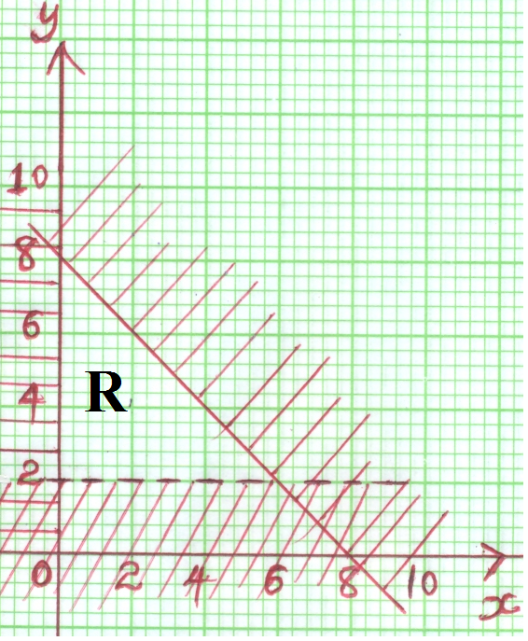

16. A railway line and a road are parallel to each other on a flat and level section of land. A 5 metre long car moving at a speed of 110kmh⁻¹ starts overtaking a train which is 495 metres and moving at 80kmh⁻¹ .How long will it take the car to completely overtake the train?
(3marks)

SECTION II (50 Marks)
Answers only five questions from this section in the spaces provided.
17. The vertices of a parallelogram are O (0,0), A(5,0),B(8,3) and C(3,3)
Plot on the same axes
i) Parallelogram O’A’B’C’, the image of OABC under reflection in the line x=4 (4marks)
ii) Parallelogram O’’A’’B’’C’’ the image of O’A’B’C’ under a transformation described by the matrix$\left(\begin{matrix}0 & −1 \\ 1 & 0\end{matrix}\right)$. Describe the transformation. (4marks)
iii) Parallelogram O’’’A’’’B’’’C’’’, the image of O’’A’’B’’C’’ under the enlargement, centre (0,0) and scale factor $\frac{1}{2}$ (2marks)


18. Two circles with centres O and Q and radii 8cm intersect at points A and B as shown below.
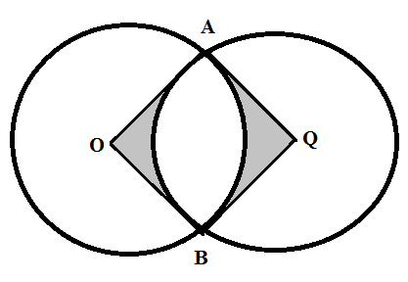
Given that the distance between O and Q is 12cm and that the line AB meets OQ at X, find:
(a) the length of the chord AB. (3marks)

(b) the reflex angle AOB. (3marks)

(c) the area of the shaded region. $π=3\text{.}\text{142}$ (4marks)

19. In the figure below, EG is the diameter of the circle centre O. Points B, G, D, E and F are on the circumference of the circle. $∠\text{BFD}={\text{50}}^{0}$, $∠\text{BEO}={\text{25}}^{0}$and line ABC is a tangent to the circle at B

E

D
F
O

A
C
G
B

Giving reasons, calculate the size of
- $∠\text{CBD}$ (2marks)

- $∠\text{BED}$ (2marks)

- The reflex angle$\text{BOD}$ (2marks)

- $∠\text{EBA}$ (2marks)

- $∠\text{BGD}$ (2marks)

20. OAB is a triangle in which OA= a, OB= b, M is a point on OA such that OM:MA=2:3 and N is another point on AB such that AN:NB = 1:2. Lines ON and MB intersect at X.
a) Express the following vectors in terms of a and b
i) AB (1mark)
ii) ON (1mark)

iii) BM (1mark)

b) If OX=k ON and BX=h BM, express ON in two different ways. Hence or otherwise find the value of h and k (6marks)

c) Determine the ratio OX: XN (1mark)
21. Every Sunday Alex drives a distance of 80km on a bearing of 074⁰ to pick up his brother John to go to church. The church is 75km from John’s house on a bearing of S50⁰E. After church they drive a distance of 100km on a bearing of 260⁰ to check on their father before Alex drives to John’s home to drop him off then proceeds to his house.
(a) Using a scale of 1cm to represent 10km, show the relative positions of these places. (4 marks)

(b) Use your diagram to determine:
(i) the true bearing of Alex’s home from their father’s house. (1 mark)

(ii) the compass bearing of the father’s home from John’s home. (1 mark)

(iii) the distance between John’s home and the father’s home. (2 marks)

(iv) the total distance Alex travels every Sunday. (2 marks)

22. The data below shows the sample of age distribution of some of the people who reside in a Yoruba village in years.
Age group |  | Number of persons in age group
1 - 5 |  | 4
6 - 10 |  | 12
11 - 20 |  | 9
21 - 30 |  | 6
31 - 50 |  | 18
51 - 55 |  | 4
56 - 65 |  | 2

- Complete the frequency distribution table above and hence
- Calculate the mean. (3marks)

- Calculate the median. (2marks)

- Draw a frequency polygon from the given data on the grid below (5marks)



23. Two variables x and V are known to satisfy the relation $V={\text{Kx}}^{n}$ where k and n are constants. The table below shows data collected from an experiment.
x | 3.01 | 3.98 | 5.01 | 6.02 | 7.08 | 8.94
V | 10.5 | 101 | 989 | 9600 | 95000 | 854000

- Write down the function $V={\text{Kx}}^{n}$ in linear form and make a suitable table of values correct to one decimal place. (3marks)


- Draw a suitable graph to represent the relation $V={\text{Kx}}^{n}$ (3marks)

- Use your graph to determine the values of k and n (4marks)

24. A particle moves in a straight line. It passes through point O at $t=0$ with velocity$V=−4m/s$. The acceleration a $m/{s^{2}}$ of the particle at time t seconds after passing through O is given by $a=\text{10}t+1$
(a) Express the velocity V of the particle at time t seconds in terms of t. (3marks)

b) Find V when $t=3$ (1mark)

c) Determine the value of t when the particle is momentarily at rest (3marks)

d) Calculate the distance covered by the particle between $t=2$and $t=4$ (3marks)

