**8. MINING**

**This topic entails**

1. ***Defining mining***
2. ***Explaining the factors influencing:-***

***-The occurrence of minerals***

***-Mining activities***

1. ***Describing methods of mining***
2. ***Locating major minerals on the map of East Africa***
3. ***Explaining the significance of minerals in Kenya***
4. ***Accounting for the problems facing the mining industry in Kenya.***
5. ***Explaining the effects of mining on the environment in Kenya.***
6. ***Describing the occurrence of specific minerals and their exploitation in selected countries.***

1. (a) (i) What problem has been brought about by uncontrolled mining of minerals in Kenya?

(ii) Where is fluorspar mined in Kenya?

(iii) Describe how trona is mined and processed in Magadi

(b) (i) List **two** ways in which mining leads to loss of biodiversity

(ii) List **two** ways in which mining leads to pollution

2. (a) (i) Name **three** methods of mining.

(ii) State **five** factors that influence the exploration of minerals.

(iii) State **three** ways in which mining derelicts can be reclaimed.

3. (a) State **two** ways in which gold in South Africa occurs. (2mks)

(b) Give **three** ways in which abandoned mined sites could be rehabilitated.

4. (a) Name **two** countries in Africa where oil is mined

(b) State t**wo** by-products of crude oil

5. (a) (i) Define the term ‘**mining method’**

(ii) Explain how the following factors influence mining:-

- Technology

- Quality of the ore

(b) Use the map of East Africa below to answer question (i)

**MAP OF EAST AFRICA**

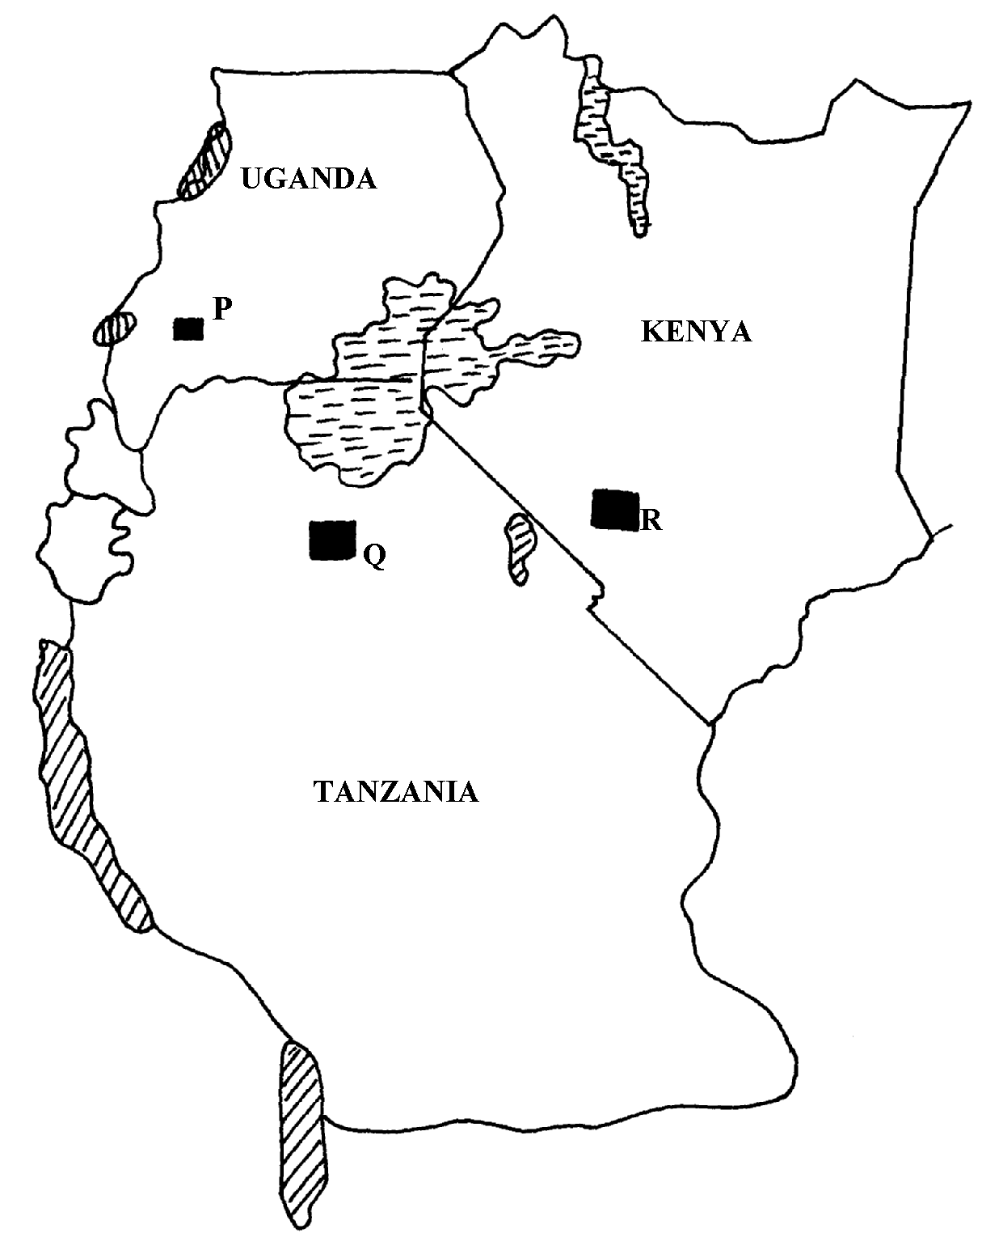

(i) Name the minerals found in the areas marked **P, Q, R**

(ii) Name **two** areas in South Africa where diamonds are mined

c) Open-cast method of mining.

d) Benefits of trona to Kenya.

e) Problems facing the mining industry in Kenya.

6. Use the map of East Africa below to answer question (a) (i)

(a) (i) Name the minerals mined in the areas marked **W, X, Y** and **Z**

(ii) Give **four** ways in which minerals occur

(b)Identify any **five** factors that influence the exploitation of minerals

(c) Explain any **four** problems associated with mining

(d) List any **four** main minerals mined in Kenya

7. (a) Give **three** main methods of mining

(b) The following data shows the value of minerals exported from Tanzania between the

years 2000-20003. Use it to answer the following questions:

|  |  |  |  |  |
| --- | --- | --- | --- | --- |
| **Value of mineral exports in millions of Tshs.** | | | | |
|  | **2000** | **2001** | **20002** | **2003** |
| Gold | 680 | 700 | 500 | 400 |
| Diamonds | 1000 | 800 | 700 | 900 |
| Mica | 400 | 100 | 400 | 100 |

(i) Calculate the percentage decline in the value of diamond exports between 2000 and 20001.

(c)Explain any **four** ways in which trona mining contributes to the growth of the economy

in Kenya

8. (a) (i) State **three** methods used in mining

(ii) Name the mineral found in the following areas;-

***-*** Magadi

***-*** Mwandui

***-*** Kasese

(b) Describe the following factors influence mining of minerals

(i) Technology

(ii) Quality of ore

(iii) Accessibility

(c) Explain **four** problems facing the mining of Gold in South Africa

(d) (i) List **two** leading to oil producing countries in the middle East

(ii) State **three** uses of petroleum

(e). State **three** problems of land dereliction

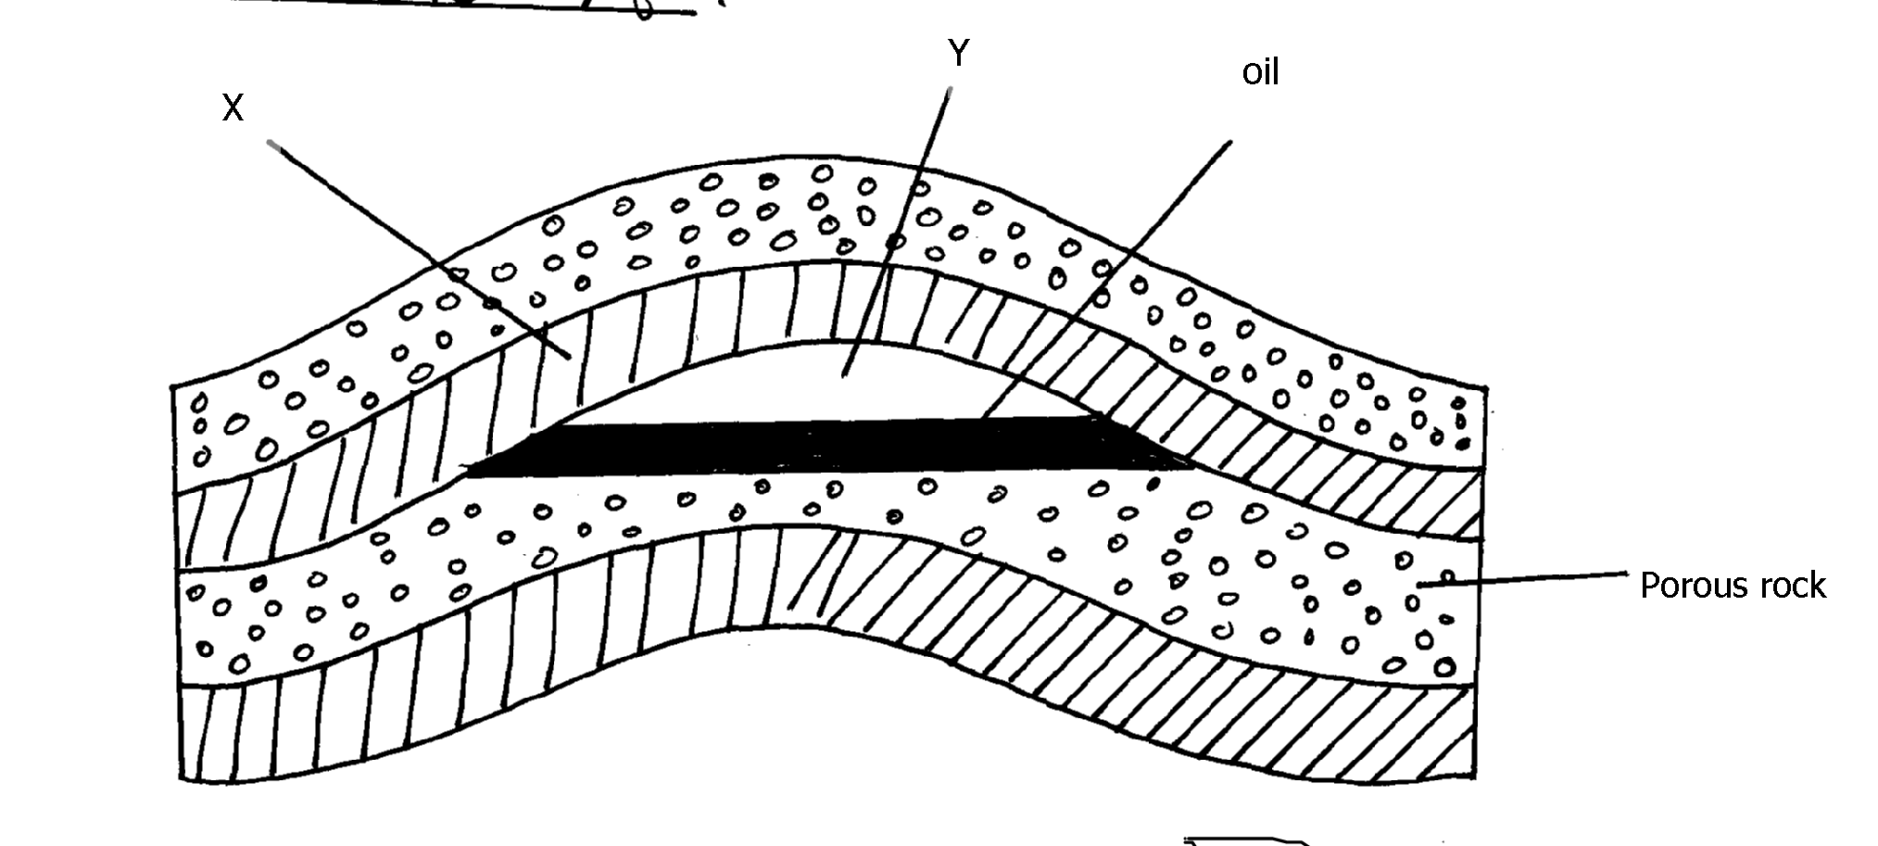9. The diagram below shows

(a) Identify the parts marked **X** and **Y**

(b) Give **three** reasons why Kenya imports petroleum in crude form and not as refined

by-products

10. (a) Differentiate between veins and lodes

(b) State **three** effects of land dereliction

11. (a) (i) Give **three** methods of mining.

(ii) Name **two** places where gold is mined in Tanzania.

(b) Explain **four** factors which influence the exploitation of minerals.

(c) State f**our** negative effects of mining on the environment.

(d) (i) Describe how solution mining is carried out.

(ii) State **three** ways n which mining contributes to the economy of Kenya.

12. (a) (i) Name **three** methods of mining

(ii) Explain **three** ways in which soda ash contributes to the economy of Kenya

(iii) Identify **four** problems facing gold mining in South Africa

(b) (i) State **three** conditions necessary for the formation of petroleum

(ii) Give **two** by-products obtained when crude oil is refined

(c) What **three** benefits would Kenya get if the current prospecting for oil yields good results

(d) (i) Name **two** minerals mined in the Southern Highlands of Tanzania

(ii) Name **two** ports through which minerals from East Africa are exported through