Name ………………………..………………………… Index No: ………………..…….….
Candidate’s Signature …………....……. Date: ……………………………….

232/1
PHYSICS
(THEORY)
Paper 1

Time: 2 Hours
SMARTPASS EXAMINATION
Kenya Certificate of Secondary Education (KCSE)
MODEL ONE 2019

INSTRUCTION TO CANDIDATES
- Write your name, index number and school in the spaces provided.
- This paper consists of TWO sections: A and B
- Answer ALL questions in section I and II in the spaces provided.
- ALL workings MUST be clearly shown.
- Mathematical tables and electronic calculators may be used.

For examiner’s use only:

Section | Question | Maximum score | Candidate’s score
A | 1 – 10 | 25
B | 11  12  13  14  15 | 11  12  11  10  11
 | Total | 80

This paper consists of 11 printed pages. Candidates should check the question paper to ensure that all the pages are printed as indicated and no questions are missing.
SECTION A (25 Marks)
- Figure below shows part of a scale of a vernier calipers. What is the reading indicted by the scale? (2 marks)
2 3

- A horse pipe of internal diameter 4 cm is connected to a sprinkler with 25 holes each of diameter 0.04 cm, the water in the pipe flows at a speed of 5 cm/s. Determine the velocity with which the water leaves the sprinkler. (3 marks)
……………………………………………………………………………………………………………………………………………………………………………………………………………………………………………………………………………………………………………………………………………………………………………………………………………………………………………………………………………………………………….
- The figure below shows a uniform bar of weight 8N. It is acted on by two forces as shown.
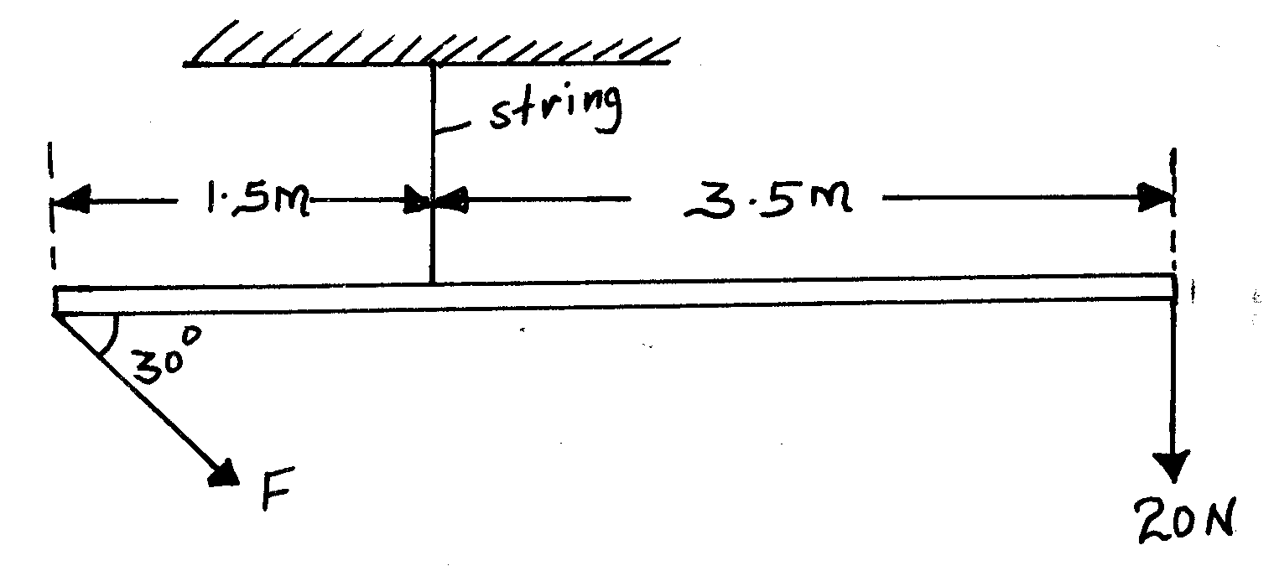

Determine the value of F. (3 marks)
……………………………………………………………………………………………………………………………………………………………………………………………………………………………………………………………………………………………………………………………………………………………………………………………………………………………………………………………………………………………………….
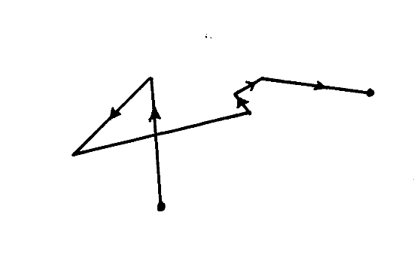
- The figure below shows a path taken by a gas molecule moving from point x to z
X
Z

(a) Explain how this movement can be observed (1 mark)
……………………………………………………………………………………………………………………………………………………………………………………………………………………………………………………………………………………………………………………………………
(b) State in full, the law of motion that governs movement from x to z (1 mark)
……………………………………………………………………………………………………………………………………………………………………………………………………………………………………………………………………………………………………………………………………
- a) State one factor that a bimetallic strip relies on for its working (1 mark)
…………………………………………………………………………………………………………………………………………………………………
b) Two objects made of the same material and having the same mass are heated to a temperature of 35ºC above that of the atmosphere and then allowed to cool in still air for 30 minutes. State one factor that will determine their final temperature (1 mark)
…………………………………………………………………………………………………………………………………………………………………
- (a) What is surface tension? (1 mark)
……………………………………………………………………………………………………………………………………………………………………………………………………………………………………………………………………………………………………………………………………
(b) The figure below shows a funnel dipped into a liquid soap solution.
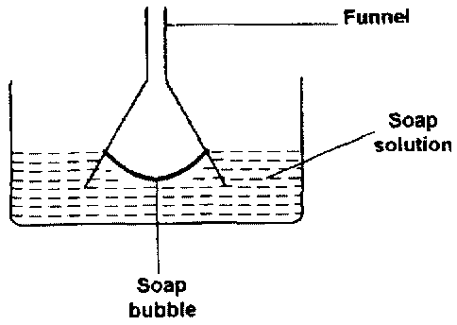

Explain what happens to the soap bubble when the funnel is removed. (2 marks)
…………………………………………………………………………………………………………………………………………………………………………………………………………………………………………………………………………………………………………………………………………………………………………………………………………………………………………………………………………………………………………………………………………………………………………………………………………………………………………………………………………
- A solid displaces 8.5cm³ of liquid when floating on a certain liquid and 11.5cm³ when fully submerged in the liquid. The density of the solid is 0.8g/cm³, determine upthrust on the solid when it is floating (3 marks)
…………………………………………………………………………………………………………………………………………………………………………………………………………………………………………………………………………………………………………………………………………………………………………………………………………………………………………………………………………………………………………………………………………………………………………………………………………………………………………………………………………
- Fifty drops of oil have a volume of 1.0cm³. If a drop of oil forms an oil patch of diameter 20cm, determine the size of the oil molecule. (2 marks)
………………………………………………………………………………………………………………………………………………………………………………………………………………………………………………………………………………………………………………………………………………………………………………………………………………………………………………………………………………………………………
- In a faulty mercury-in-glass thermometer was found that the mercury level stands at 3 cm mark in the tube at 0⁰ C and 18 cm when in steam above boiling water at normal atmospheric pressure. Calculate the temperature when the mercury stands at 12 cm mark. (3 marks)
…………………………………………………………………………………………………………………………………………………………………………………………………………………………………………………………………………………………………………………………………………………………………………………………………………………………………………………………………………………………………………………………………………………………………………………………………………………………………………………………………………
- Give two reasons why mercury is preferred to water in the manufacturing of barometers
(2 marks)
………………………………………………………………………………………………………………………………………………………………………………………………………………………………………………………………………………………………………………………………………………………………………………………………………………………………………………………………………………………………………………………………………………………………………………………………………………………………………………………………………………………………………………………………………………………………………………………………………………………………………………………………………………………………………………………………………………………………………………………………………………

SECTION B (55 Marks)
- (a) The figure below shows two containers filled with two different liquids to the same height.
A
B

It was found that the pressure at the bottom of A is greater than that at B. Explain (1 mark)
……………………………………………………………………………………………………………………………………………………………………………………………………………………………………………………………………………………………………………………………………
(b) The figure below shows a car braking system. The brake fluid is an oily liquid.

Brake drum
Brake shoe
Return spring
Brake pedal
Pivot
Master piston
Master cylinder
Brake fluid
Slave piston

The brake drum rotates with the wheel of the car.
- Explain how pushing the brake pedal makes the brake rub against the drum. (4 marks)
………………………………………………………………………………………………………………………………………………………………………………………………………………………………………………………………………………………………………………………………………………………………………………………………………………………………………………………………………………………………………………………………………………………………………………………………………………………………………………………………………………………………………………………………………………………………………………………………………………………………………………………………………………………………………………………………………………………………………………

(ii) The cross-sectional area of the master piston is 2.0cm². A force of 140N is applied to the master piston.
(I) Calculate the pressure created in the brake fluid by the master piston. (2 marks)
………………………………………………………………………………………………………………………………………………………………………………………………………………………………………………………………………………………………………………………………………………………………………………………………………………………………………………………………………………………
(II) The cross-sectional area of each slave piston is 2.8cm². Calculate the force exerted on each slave piston by the brake fluid. (2 marks)
………………………………………………………………………………………………………………………………………………………………………………………………………………………………………………………………………………………………………………………………………………………………………………………………………………………………………………………………………………………
(III) The force exerted on the master piston is greater than the force applied by the foot on the brake pedal. Using the principle of moments, explain this. (2 marks)
………………………………………………………………………………………………………………………………………………………………………………………………………………………………………………………………………………………………………………………………………………………………………………………………………………………………………………………………………………………
- (a) State two factors that affect the magnitude of centripetal force of an object moving along a curved path. (2 marks)
…………………………………………………………………………………………………………………………………………………………………………………………………………………………………………………………………………………………………………………………
- A stone is tied to a light string of length 0.5m. If the stone has a mass of 20g and is swung in a vertical circle with a uniform angular velocity of 6 revolutions per second, determine.
(i) The period T. (2 marks)
…………………………………………………………………………………………………………………………………………………………………………………………………………………………………………………………………………………………………………………………………………………………………………………………………………………………………………………………………………………………………………………………………………………………………………………………………………………………………………………………………………………………………………………………………………………………………………………………………………………………………………………………………………………………………………………………………………………………………………………………………………………………………………………………………………………………………………………………………………………………………………………………………………………………………………

- The tension of the string when the stone is at
I. The bottom of the swing. (3 marks)
………………………………………………………………………………………………………………………………………………………………………………………………………………………………………………………………………………………………………………………………………………………………………………………………………………………………………………………………
II. The top of the swing. (2 marks)
………………………………………………………………………………………………………………………………………………………………………………………………………………………………………………………………………………………………………………………………………………………………………………………………………………………………………………………………
III. The linear velocity. (3 marks)
………………………………………………………………………………………………………………………………………………………………………………………………………………………………………………………………………………………………………………………………………………………………………………………………………………………………………………………………
- a) Define the term uniform acceleration. (1 mark)
…………………………………………………………………………………………………………………………………………………………………………………………………………………………………………………………………………………………………………
b) A rocket was launched vertically upwards with uniform acceleration of 100ms⁻² for 20 seconds. After this the rocket was acted upon only by a constant gravitational force.
(i) Calculate the maximum height reached by the rocket (3 marks)
…………………………………………………………………………………………………………………………………………………………………………………………………………………………………………………………………………………………………………………………………………………………………………………………………………………………………………………………………………………………………………………………………………………………………………………………………………………………………………………………………………………………………………………………………………………………………………………………………………………………………………………………………………………………………………………………………………………………………………………………………………………………………………………………………………………………………………………………………………………………………………………………………………………………………………

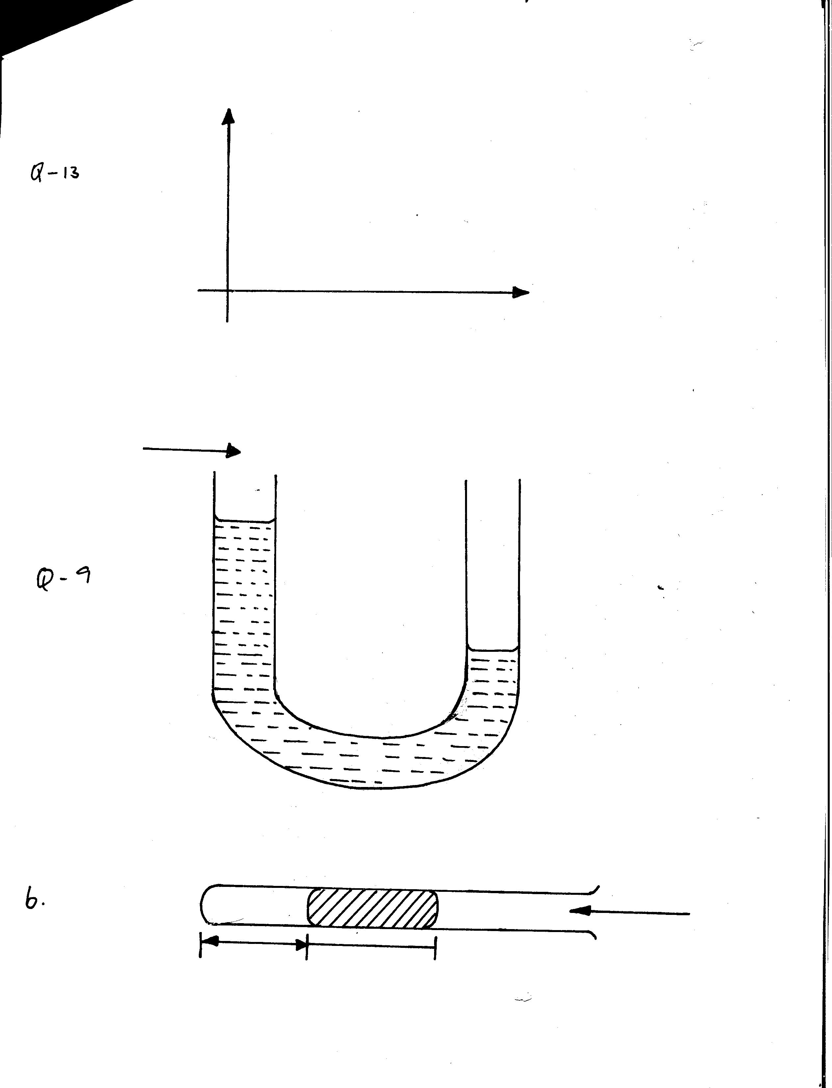
(ii) Draw to scale, on the axes provided below, the displacement – time graph for the motion of the rocket. (2 marks)
Displacement (km)
Time (s)

(iii) State Newton’s second law of motion. (1 mark)
…………………………………………………………………………………………………………………………………………………………………………………………………………………………………………………………………………………………………………
(iv) A car of mass 800Kg is initially moving at a speed of 25m/s. Calculate the constant force required to bring the car to rest over a distance of 20m. (4 marks)
………………………………………………………………………………………………………………………………………………………………………………………………………………………………………………………………………………………………………………………………………………………………………………………………………………………………………………………………………………………………………………………………………………………………………………………………………………………………………………………………………………………………………………………………………………………………………………………………………………………………………………………………………………………………………………………………………………………………………………………………………………………………………………………………………………………………………………………………………………………………………………………………………………………………………………………………………………………………………………………………………………………………………………………………………………………………………………………………………………………………………………………………………………………………………………………………………………………………………………………………………………………………………………………………………………………………………………………………………………………………………………………………

- A worker on a building site raises a bucket full of cement at a slow steady speed using the pulley as shown below.
Force
Pulley
Bucket full of cement
The weight of the bucket and cement is 200N. The force F exerted by the worker is 210N
- State why F is bigger than the weight of the bucket and cement. (1 mark)
……………………………………………………………………………………………………………………………………………………………………………………………………………………………………………………………………………………………………………………
- The bucket is raised through a height by 4m. Determine the distance through which the worker pulls the rope. (1 mark)
………………………………………………………………………………………………………………………………………………………………………………………………………………………………………………………………………………………………………………………………………………………………………………………………………………………………………………………………………………
- How much work is done on the bucket and cement? (2 marks)
………………………………………………………………………………………………………………………………………………………………………………………………………………………………………………………………………………………………………………………………………………………………………………………………………………………………………………………………………………
- State the kind of energy gained by the bucket. (1 mark)
…………………………………………………………………………………………………………………………………………………………
- Determine the total work done be the worker. (3 marks)
…………………………………………………………………………………………………………………………………………………………………………………………………………………………………………………………………………………………………………………………………………………………………………………………………………………………………………………………………………………………………………………………………………………………………………………………………………………………………………
- Calculate the efficiency of the machine used by the water. (2 marks)
……………………………………………………………………………………………………………………………………………………………………………………………………………………………………………………………………………………………………………………
- (a) The figure below shows a set-up that may be used to verify Charles’ law.

Dry air

Drop of sulphuric acid
Millimeter scale
Water bath
Thermometer
Heat
(i) State the measurements that should be taken in the experiment. (2 marks)
........................................................................................................................................................................................................................................................................................................................................................................................................................................................................................................................................................................................................................................................................................................................................................................................................................................................................
- Explain how the measurements taken in (i) above may be used to verify Charles’ law.
(2 marks)
.................................................................................................................................................................................................................................................................................................................................................................................................................................................................................................................................................................................................................………………………………………………………………………………………………………………………………………………………………………………………………………………………………………………
- A certain mass of hydrogen gas occupies a volume of 1.6cm³ at a pressure of 1.5 x 10⁵ pa and temperature of 12º C. Determine its volume when the temperature is 0ºC at a pressure of 1.0 x 10⁵ pa. (2 marks)
................................................................................................................................................................................................................................................................................................................................................................................................................................................................................................................................................................................................................................................................................................
(b) (i) An electric kettle connected to a 250V mains supply draws a current of 4.0A. It contains 1 litre of water with 1 kg of ice, all at 0⁰C. Neglecting all heat losses, including heat absorbed by the kettle, find the time taken for all the ice to be just melted. (Take specific latent heat of fusion to be 3.34 x 10⁵ J/kg and latent heat of vaporization is 2.26 x 10⁶ J/kg Specific heat capacity of water is 4.2J/g). (2 marks)
........................................................................................................................................................................................................................................................................................................................................................................................................................................................................................................................ ........................................................................................................................................................................
(ii) Determine the time taken until half the contents of the kettle boils away. (3 marks)
........................................................................................................................................................................................................................................................................................................................................................................................................................................................................................................................ ................................................................................................................................................................................................................................................................................................................................................

