232/1 SMARTPASS PHYSICS PAPER 1 MARKING SCHEME MODEL ONE 2019
SECTION A
- Main scale reading = 2.10 cm
Vernier scale reading = 0.05 cm
Reading on the scale = 2.15 cm.
- A₁U₁ = A₂U₂ ✓¹
π x 2 cm x 2 xm x 5cm/s = π x 0.02cm x 0.02cm x 25 x U₂cm/s ✓¹
Make U₂ to get that U₂ = 2,000 cm/s ✓¹
- Clockwise moments = Anti clockwise moments;
(20x3.5) + (8x2.5) = F sin 30 x 1.5;
70 + 20 = 0.5 F x 1.5
⁹⁰/_{1.5} = 0.5 F
60 = 0.5 F
F = 60/0.5 = 120N
- a) By strongly illuminating a suspension of pollen grains in water/dust particles in air or smoke cell ✓¹
b) A body continues in its state of rest or motion with uniform velocity unless acted upon by an external force ✓¹
- a) Difference in expansion rates of materials
b) Surface Area to Volume ratio
- a) Surface tension is the force per unit length acting on the surface of a liquid and perpendicular to one side of an imaginary line drawn in the surface. ✓¹
b) Bubble flattens to form a film ✓¹ and moves up the funnel in order to make its surface area be as small as possible due to surface tension ✓¹

- Up thrust = weight of solid ✓¹
= ℓvg
= 800kg/m³ x (115 x 10⁻⁶) m³ x 10N/Kg✓¹
= 0.092 N ✓¹

- 50 drops = 1.0 cm³
Hence, 1 drop = 0.02 cm³
Volume = Area x Thickness ✓¹
Thickness = 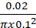 = 6.37x10⁻¹ m ✓¹

100⁰C 18cm ✓¹

X 12cm
✓¹ ⁰C ✓¹
0⁰C 3cm

- a) Mercury is denser, hence rises to reasonable heights
b) Due to great cohesion forces between mercury molecules, it does not stick on the glass surface.

SECTION B
- (a) Liquid A is denser than liquid B. ✓¹
(b) (i) When the pedal is pushed, pressure is generated in the master cylinder; ✓¹ This pressure is
transmitted to the slave cylinder; ✓¹ This causes the pistons of the slave cylinder to open the brake shoe ✓¹ and hence the brake lining presses the drum. ✓¹
(ii) (I) P = , ✓¹
= 700,000N/m² ✓¹
(II) F = P x A ✓¹
= 700,000 x 2.8 x 10⁻⁴
= 1,960N ✓¹
(III) Distance from the foot to pivot ✓¹ is larger than piston to pivot;
Force x distance = Constant ✓¹
- (a) -Radius of path
-Mass of the object
-Linear speed.
(b)(i) The period T.
T = 1/f
= 1/6
= 0.1675
- The tension of the string when the stone is
I at the bottom of the swing.
T = mw²r + mg
= 0.02 (6² x 0.5 + 10)
= 0.02 (28)
= 0.56 N
II the top of the swing.
T = mw2r – mg
= 0.02 (62 x 0.5 – 10)
= 0.02 (8)
= 0.16 N
III the linear velocity.
V = wr
= 6 x 0.5
= 3m/s
- a) Uniform acceleration is the constant change of velocity of a body per unit time.
b) (i) Maximum Height reached
distance covered in first 20seconds
s = ut + ½ at² v=0
= ½ x 100 x (20) ²
= 20,000m ✓¹
Distance covered after the first 20 seconds
v² = u² – 2as.
= v²-u² = s
-2a
= 0-(2000)²
-2x10
= 200,000m ✓¹
H_{max} = 200,000+20,000
= 220,000m ✓¹
=220 km
(ii). Total time taken = 20s + 200s = 220s. ✓¹
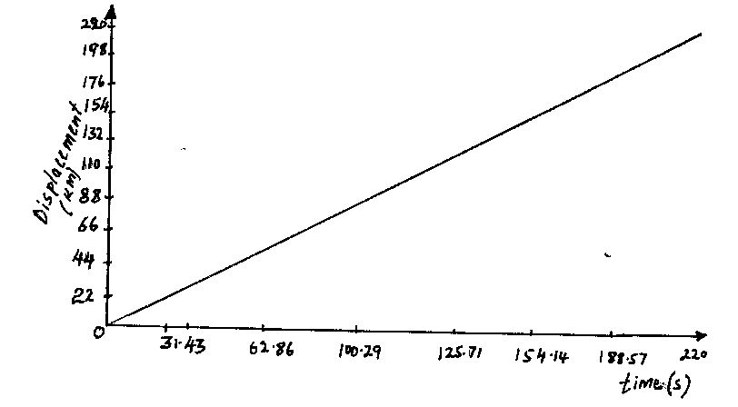
✓¹
(iii). Newton’s second law of motion states that the rate of change of linear momentum is directly proportional to force and takes place in the direction of the force.
(iv).
M = 800kg
u = 25 m/s
f =?
V = 0
F = mv - mu
t
v² = μ² – 2as
0 = (25)² – 2 x a x 20
625 = - 40a
a = 15.625 m/s²
v = u – at
0= 25 – (-15.625)t
15.625t = 25 + 15.625
t = 25/15.625
= 1.6s
F = mv – mu
t
= (800x0) – (800 x 25)
1.6
= -12,500N.
- a) Extra force was to overcome the weight of the body and friction
b) Since V.R is 1, the worker pulls the ropes through 4 m ✓¹
c) Work = Force x distance ✓¹ work = 200 x 4 = 800J ✓¹
Deny ½ marks for missing units in F.A
d) Potential Energy ✓¹
e) Total Work = Effort x distance ✓¹
= 210 x 4 ✓¹ = 840 J ✓¹
f) η = Work output x 100 ✓¹
Work input
= 800 x 100 = 95% ✓¹
840
- (a)
(i) Measurements that should be taken in the experiment
-Length of column of dry air (½ mark) -Temperature (½ mark)
-Length/ height of the mercury thread (½ mark) -Volume of air (½ mark)
(ii) How the measurements taken are used to verify Charles’ Law
Temperature is varied and values of Length and Temperature are measured and recorded (½ mark); a graph of Length versus Temperature. is plotted (½ mark). This is a straight line cutting T axis at O (A) (½ mark) (or – 273⁰C) since tube is uniform Length α Temperature. (½ mark)
- Determine the Volume
P₁V₁ = P₂ V₂ (½ mark) = 1.5.x 10⁵ x 1.6 = 1.0 x 10⁵ x V₂ (½ mark)
T₁ T₂ 285 273
= V₂ = 23m³ (1 mark)
(b)
(i) Time taken for all the ice to be just melted
Vit = ml_{f}, 250 x 4 x t = 1 x 3.34 x 10⁵, ✓¹
t = t = 334 seconds or 5 minutes 34 seconds✓¹

(ii) Time taken until half the contents of the kettle get boiled away
Vit = ml_{f} + m_{w}c_{w}∆θ + ½ ml_{v}, (½ mark)
250 x 4 x t(½ mark) = 3.34 x 10⁵ + 2 x 4200 x 100 + 1 x 2.26 x 10⁶ ✓¹
t = t = 3434 seconds or 57 minutes and 14 second ✓¹

