Name ………………………..……………………………... Index No: ………………..…….…...
Candidate’s Signature …………....……. Date: ……………………………….
232/2
PHYSICS
(THEORY)
Paper 2

Time: 2 Hours
SMARTPASS EXAMINATION
Kenya Certificate of Secondary Education (KCSE)
MODEL ONE 2019

INSTRUCTION TO CANDIDATES
- Write your name, index number and school in the spaces provided.
- This paper consists of TWO sections: A and B
- Answer ALL questions in section I and II in the spaces provided.
- ALL workings MUST be clearly shown.
- Mathematical tables and electronic calculators may be used.

For examiner’s use only.
Section | Question | Maximum score | Candidate’s score
A | 1 – 10 | 25
B | 11  12  13  14  15  16 | 8  10  10  13  7  7
 | Total | 80

This paper consists of 11 printed pages. Candidates should check the question paper to ensure that all the Pages are printed as indicated and no questions are missing.

SECTION A (25 MARKS)
- a) Distinguish between a real and virtual image (1 mark)
………………………………………………………………………………………………………………………………………………………………………………………………………………………………………………………………………………………………
b) Complete the diagram below to show how the object is viewed (2 marks)

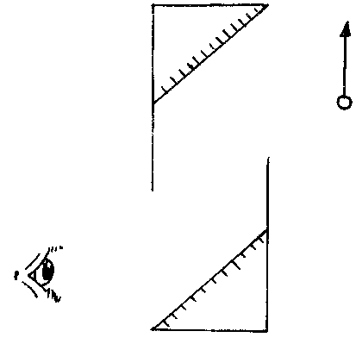
- A concave mirror has a focal length of 8cm. A real object of length 2cm is placed 12cm from the mirror. Calculate the distance of the image from the mirror. If the length of the image formed is 4cm. (3 marks)
………………………………………………………………………………………………………………………………………………………………………………………………………………………………………………………………………………………………………………………………………………………………………………………………………………………………………………
………………………………………………………………………………………………………………………………………………

- a) Explain what is meant by soft iron being a soft magnetic material. (1 mark)
………………………………………………………………………………………………………………………………………………
………………………………………………………………………………………………………………………………………………
- How do you can make the bell ring only once and not continuously (1 mark)
………………………………………………………………………………………………………………………………………………………………………………………………………………………………………………………………………………………………
- Explain (2 marks)
………………………………………………………………………………………………………………………………………………
………………………………………………………………………………………………………………………………………………………………………………………………………………………………………………………………………………………………
- Find the effective capacitance of the following circuit (2 marks)

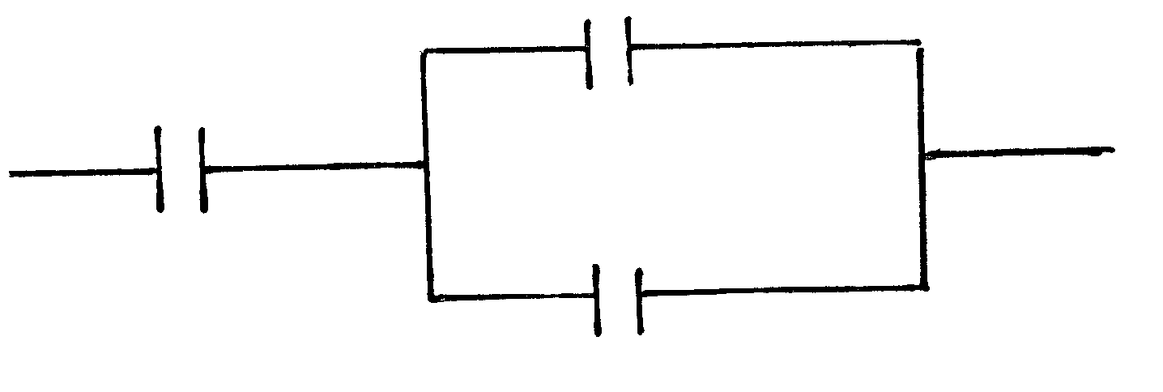
25 µf
2 µf
3 µf
………………………………………………………………………………………………………………………………………………
………………………………………………………………………………………………………………………………………………………………………………………………………………………………………………………………………………………………

- State one factor that affects the speed of sound through a solid (1 mark)
………………………………………………………………………………………………………………………………………………
- The following is a part of a radio – active series.

r
Identify the radiation r, find the values of c and d. (3 marks)
r ………………………………………………………….
c …………………………………………………………
d …………………………………………………………
- A hair drier is rated 2000W, 240V. Determine its resistance. (2 marks)
…………………………………………………………………………………………………………………………………………………….
……………………………………………………………………………………………………………………………………………………………….………………………………………………………………………………………………………………………………………………………………………………………………………………………………………………………………………………………………
- The refractive index of glass is and that of water is . Calculate the refractive index of glass with respect to water. (2 marks)
…………………………………………………………………………………………………………………………………………………….
……………………………………………………………………………………………………………………………………………………………….……………………………………………………………………………………………………………………………………………………………………………………………………………………………………………………………………………………………….
- State two advantages of an Alkaline battery over a Lead Acid accumulator (2 marks)
…………………………………………………………………………………………………………………………………………………….
………………………………………………………………………………………………………………………………………………………………………………………………………………………………………………………………………………………………………….…………………………………………………………………………………………………………………………………………………….
- In an X-Ray machine, give the reasoning behind the following
- Using a concave shaped cathode (1 mark)
…………………………………………………………………………………………………………………………………………………….
……………………………………………………………………………………………………………………………………………………
- Evacuating the X-Ray Machine (1 mark)
…………………………………………………………………………………………………………………………………………………….
……………………………………………………………………………………………………………………………………………………

SECTION B (55 MARKS)
- a) Fig 5 shows plane waves in a ripple tank. The water is deeper in section A & C than
in section B.
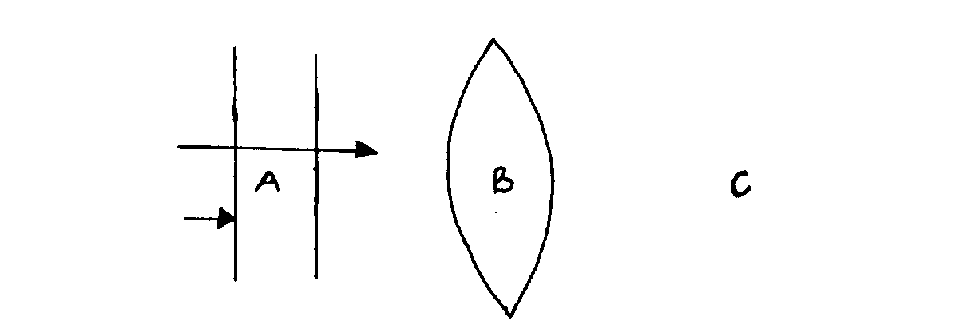
Deep
Shallow
Deep
Fig. 5

Draw the waves after passing section B. (2 marks)
b) State two conditions necessary for production of interference. (2 marks)
…………………………………………………………………………………………………………………………………………………………………………………………………………………………………………………………………………………………………………………………………………………………………………………………………………………………………………………………………………………………………………………………………………………………………………
c) A tube of length 36cm is closed at one end. It is resonance with a tuning fork of frequency 256Hz sounded above the open end. Given that the velocity of sound in air is 334m/s determine.
i) The wavelength of the wave generated by the tuning fork (2 marks)
………………………………………………………………………………………………………………………………………………………………………………………………………………………………………………………………………………………………………………………………………………………………………………………………………………………………
ii) The end correction of the tube (2 marks)
…………………………………………………………………………………………………………………………………………………………………………………………………………………………………………………………………………………………………………………………………………………………………………………………………………………………………………………………………………………………………………………………………………………………………………
- Figure 10 below shows the main features of cathode ray oscilloscope (C.R.O)

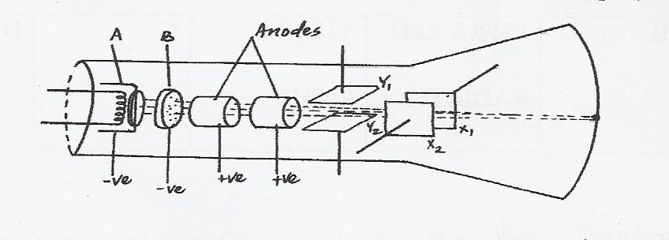
  - (i) Name the parts labeled A and B. (2 marks)

……………………………………………………………………………………………………………………………………………………………………………………………………………………………………………………………………………………
(ii)State the function of B and briefly outline how it works. (2 marks)

………………………………………………………………………………………………………………………………………………………………………………………………………………………………………………………………………………………………………………………………………………………………………………………………………………………………
(iii) State two function of the anodes. (2 marks)
………………………………………………………………………………………………………………………………………………………………………………………………………………………………………………………………………………………………………………………………………………………………………………………………………………………………
  - The output of an a.c generator was connected to the input of the cathode ray oscilloscope whose time base settling was 5 milliseconds per centimetre and the y-gain at 10 volts per centimetre, the figure below shows the waveform displayed on the screen of the C.R.O.
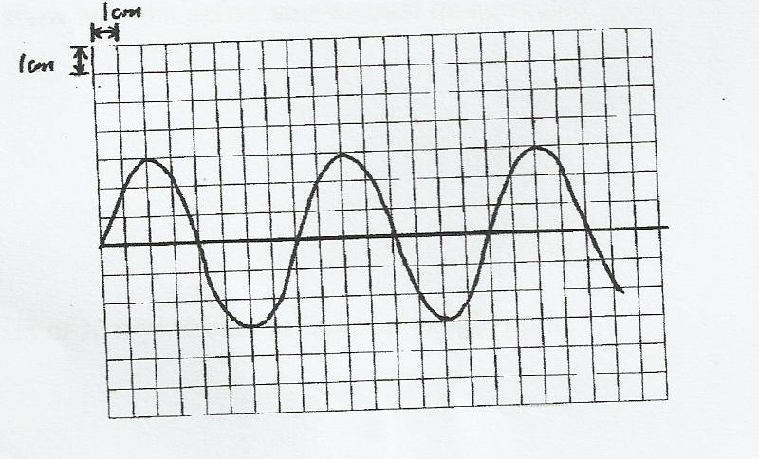

Determine
- The park voltage of the generator. (2 marks)
………………………………………………………………………………………………………………………………………………………………………………………………………………………………………………………………………………………………………………………………………………………………………………………………………………………………
- The frequency of the voltage. (2 marks)
………………………………………………………………………………………………………………………………………………………………………………………………………………………………………………………………………………………………………………………………………………………………………………………………………………………………

- (a) Define doping (1 mark)
………………………………………………………………………………………………………………………………………………………………………………………………………………………………………………………………………………………………

(b) Distinguish between a p-type and n-type semi-conductors (2 marks)
………………………………………………………………………………………………………………………………………………………………………………………………………………………………………………………………………………………………………………………………………………………………………………………………………………………………………………
(c) Give one example of a semi-conductor and one example for a conductor.
(2 marks)
………………………………………………………………………………………………………………………………………………………………………………………………………………………………………………………………………………………………
(d) What is meant by donor impurity in a semiconductor? (1 mark)
………………………………………………………………………………………………………………………………………………………………………………………………………………………………………………………………………………………………
(e) Why is a capacitor included in a bridge circuit? (1 mark)
………………………………………………………………………………………………………………………………………………………………………………………………………………………………………………………………………………………………
(f) Sketch the graph for when a load is connected to a CRO, in a bridge circuit where a
capacitor has been used. (3 marks)

- a) i) What is meant by photoelectric effect? (1 mark)
…………………………………………………………………………………………………………………………………………………………………………………………………………………………………………………………………………………………………………
ii) (I) You are provided with highly polished Zinc Plate, electroscope, source of ultra-violet
rays, and materials for charging the electroscope. Draw a setup of the apparatus and
show how electric effect may be demonstrated in a laboratory. (2 marks)

(II) Explain how the set up can be used to determine the nature of photoemission
taking place. (3 marks)
………………………………………………………………………………………………………………………………………………………………………………………………………………………………………………………………………………………………………………………………………………………………………………………………………………………………
…………………………………………………………………………………………………………………………………………

(b) (i) State two factors that affect photo- electric emission. (2 marks)
………………………………………………………………………………………………………………………………………………………………………………………………………………………………………………………………………………………………………………………………………………………………………………………………………………………………
(ii) When a certain photoelectric surface is illuminated with light of different frequencies,
the corresponding stopping potential was measured.
The graph below shows how frequency (f) varies with stopping potentially, Vs.
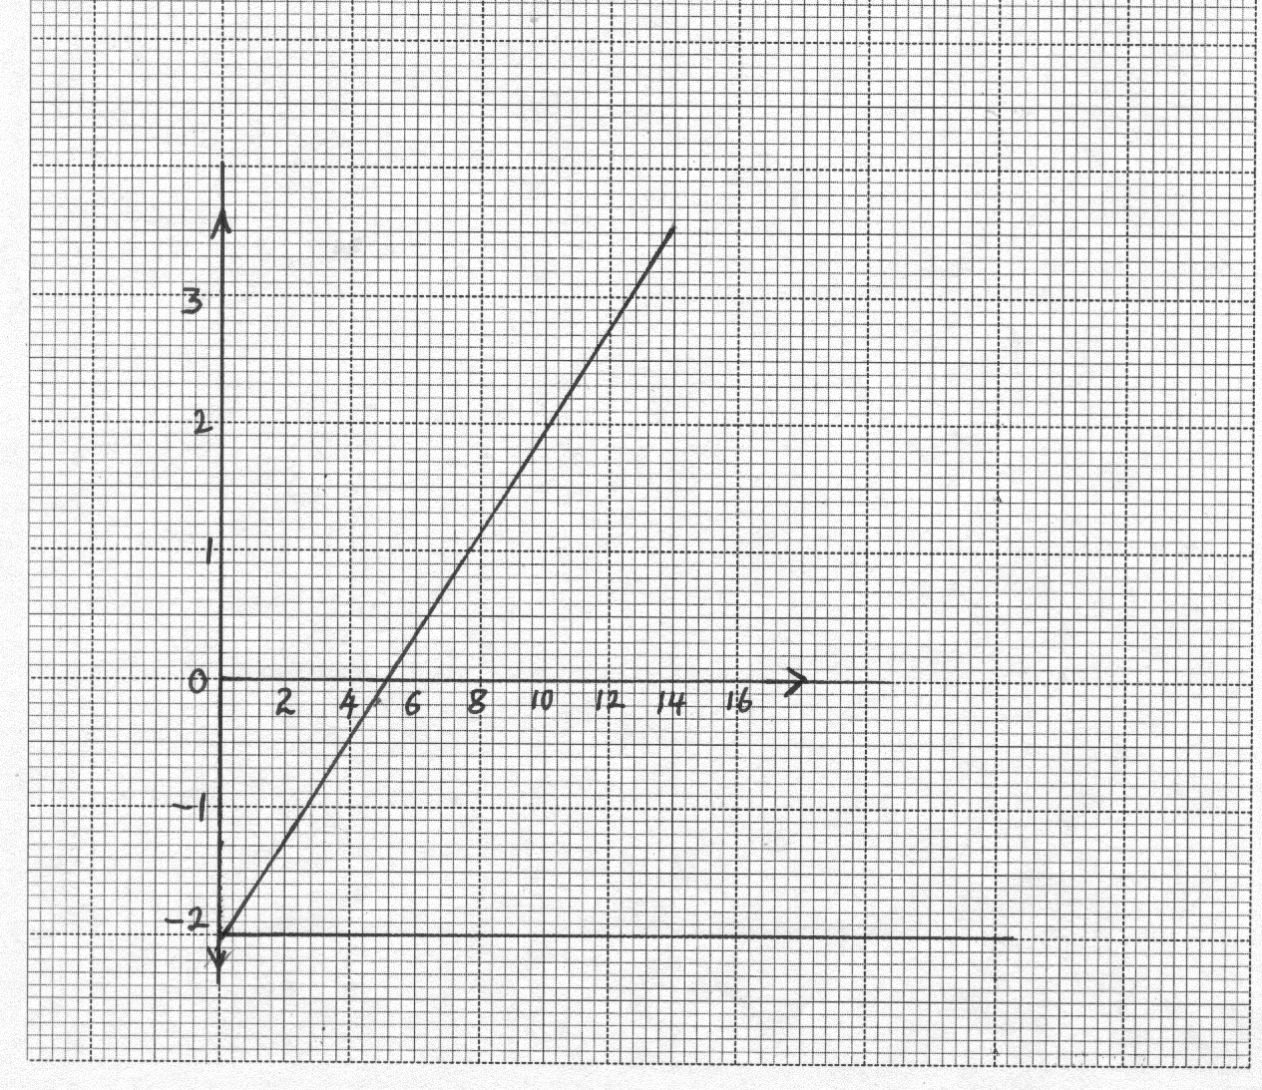
-

-
Given that eVs = hf-φ, determine the values of h and φ from the graph. (5 marks)
(electronic charge = 1.6 x 10⁻¹⁹C)

………………………………………………………………………………………………………………………………………………………………………………………………………………………………………………………………………………………………………………………………………………………………………………………………………………………………………………………………
……………………………………………………………………………………………………………………………………………………………………………………………………………………………………………………………………………………………………………………………………………………………………………………………………………………………………………………………….…………………………………………………………………………………………………………………………………………………….

- a) i) State two properties of a wire that make it suitable as a fuse. (2 marks)

…………………………………………………………………………………………………………………………………………………….…………………………………………………………………………………………………………………………………………………….…………………………………………………………………………………………………………………………………………………….…………………………………………………………………………………………………………………………………………………….
ii) Two fuses of the same length and material may be rated differently. What physical property determines the rating of such fuses? (1 mark)

………………………………………………………………………………………………………………………………………………………………………………………………………………………………………………………………………………………………………….
b) Long distance power transmission is done at very high voltages. Explain how this is achieved and why it is necessary to transmit at high voltage (3 marks)

……………………………………………………………………………………………………………………………………………………
……………………………………………………………………………………………………………………………………………………………………………………………………………………………………………………………………………………………………………………………………………………………………………………………………………………………………………………………….…………………………………………………………………………………………………………………………………………………….…………………………………………………………………………………………………………………………………………………….
c) In most 3 – pin plugs the earth pin is normally longer/ explain why. (1 mark)
……………………………………………………………………………………………………………………………………………………
………………………………………………………………………………………………………………………………………………………………………………………………………………………………………………………………………………………………………….
- a) State Lenz’s law of electromagnetic induction. (1 mark)

……………………………………………………………………………………………………………………………………………………
………………………………………………………………………………………………………………………………………………………………………………………………………………………………………………………………………………………………………….
b) A transformer with 2000 turns in the primary circuit and 150 turns in the secondary
circuit has its primary circuit connected to an 800V a.c source. It is found that when a
heater is connected to the secondary circuit, it produced heat at the rate of 1000W.
Assuming 100% efficiency, determine the;

- Voltage in the secondary circuit. (2 marks)

……………………………………………………………………………………………………………………………………………………
……………………………………………………………………………………………………………………………………………………
……………………………………………………………………………………………………………………………………………………
- Current in the primary circuit. (2 marks)

……………………………………………………………………………………………………………………………………………………
……………………………………………………………………………………………………………………………………………………
……………………………………………………………………………………………………………………………………………………

- Current in the secondary circuit. (1 mark)

……………………………………………………………………………………………………………………………………………………
……………………………………………………………………………………………………………………………………………………
……………………………………………………………………………………………………………………………………………………
- State the type of transformer represented above. (1 mark)

……………………………………………………………………………………………………………………………………………………

