232/2 SMARTPASS PHYSICS PAPER 2 MARKING SCHEME MODEL ONE 2019
SECTION A
- a) Real images can be formed on a screen while virtual image cannot ✓
Or Real images are formed by real rays while virtual images are formed by imaginary rays ✓
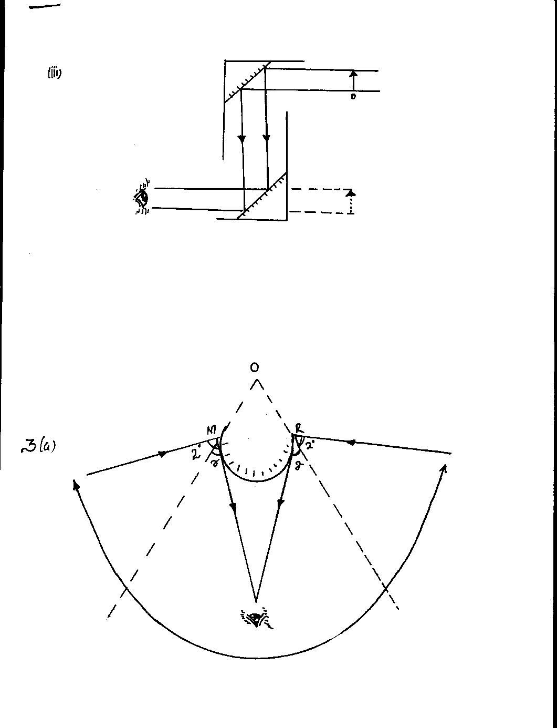
b)
Direction of Arrows ✓
Position of image ✓

- Magnification(m) = length of image
Length of object
But m= hence 2 = ✓
Image distance v = 24cm✓
- a) Soft iron easy to magnetize and has very low magnetic retention ✓
b) By use of a steel core. ✓
c) Steel becomes permanently magnetized✓ so the core attracts the armature permanently ✓

- 1/25 + 1(2 +3) 1 = 1/25 + 1/51
1/C = 6/25
C = 4.16µf; 1
- - Temperature of the solid
- Density of the solid
- r =beta particle ✓, c=206 ✓ d= 82 ✓
- ¹¹
= 1.13

- An Alkaline Battery:
-Produces higher current
-Lasts longer
-Is Portable
-Requires less maintenance
- a) The cathode is concave shaped so as to focus the electron beam onto the target
b) Prevent the electron beam from colliding with air particles before reaching the target

SECTION B

a) Shape; 1
Same wavelength; 1
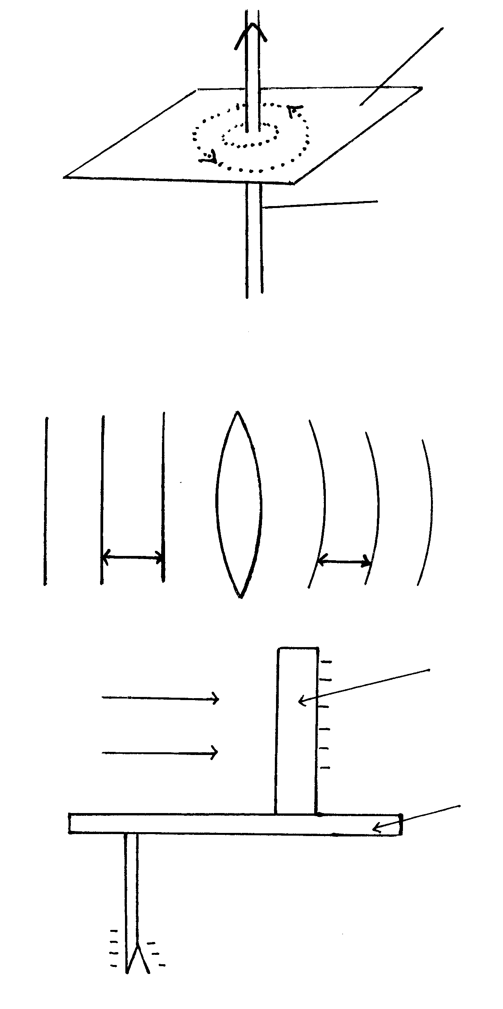
λ
λ
b) - Constant phase difference / same C frequency ; 1
- Approximately same amplitude1
c) i) V = fλ 1
λ = v/f
= 334/256
= 1.305 1
ii) ¼ λ = e = ³⁶/₁₀₀; 

¼ ( 1.305) + e = 0.36
0.326 + e = 0.36
e = 0.034m
or =3.4cm
- a) (i) A: Cathode√
B: Grid√

(ii) B(Grid) – controls the brightness of the spot on the screen. √
When the grid is more negative it repels electrons allowing only a few to reach √the screen hence the spot becomes less bright. (2 marks)

(iii) To ACCELERATE and FOCUS √ the electron beam to the screen.

b) (i) Peak voltage Vo = 3cm x 10V/cm√
=30V
(ii) Period T = 8cm x 5ms/cm

= 40ms
T = 0.040S

Therefore frequency f = 1
T

= 1 Hz√ = 25Hz
0.040

- a) The process of introducing foreign element (impurity) into a pure semi-conductor
(1mk)
b)
n-type | p-type
1. doped with group five elements  2.Electrons are majority current carriers | 1. doped with group three elements  2. Holes are majority current carriers.
c) Semi-conductors – silicone/ Germanium
Conductors - copper, tin etc.
d) Is an impurity which when introduced into a semi-conductor (during doping) provides extra electrons for conduction.
e) A capacitor is included in the circuit to act as a rectifier by reducing ripple voltage.
f)
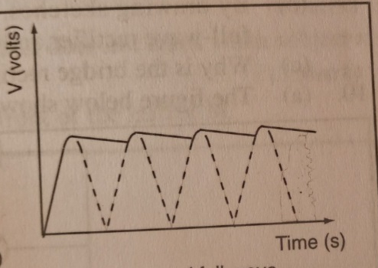
- a) i) Emission of electrons from a surface when irradiated with radiation of sufficient frequency; 1
ii) (I) Workability of set up 1
Labelling 1
U.V light
Zinc Plate
Electroscope

- Irradiate the Zinc plate with uv light ;  Electrons are ejected and hence leaf diverge reduces.
Nature of emission is thus electrons
b) i) - Work function of metal ; 
- Freq. of irradiation ; 1
h = grad x e; 1
h = Grad; xe
Extract;
Subst ;
Ans;

Ø = extract;
h = ( 3.6 – 0); x -1.6 x 10⁻¹⁹; 1
(14 – 5.2) x 10¹⁴
h = 6.545 x 1⁻³⁴; 1

ø = y – intercepts ;
ø = -2.1 x -1.6 x 10⁻¹⁹

h= 3.36 x 10⁻¹⁹ J 1
- a) i) -A good conductor of electricity
-A material of low melting point

ii) The thickness

b) High voltage is achieved by stepping up the voltage using step-up transformers,  stepping up the voltage brings down the current , which minimizes the heating effect on the cables to minimize power loss 

c) It opens up the flaps on the live and neutral

- a) The direction of the induced current is such that it opposes the change producing it √

  - (i) V_{p} = N_{p}√ ; 800 = 2000
V_{s} N_{s} V_{s} 150

Vs = 800 x 150 = 60V√
2000

(ii)Power input = power output

I_{p} = 1000 = 1.25A√
800

(iii) I_{s} = power output = 1000 = 16.67A√
Output voltage 60

(iv) Step-down transformer

