Name ………………………..……………………………... Index No: ………………..…….…...
Candidate’s Signature …………....……. Date: ……………………………….
PHYSICS
(PRACTICAL)
Paper 3
232/3

2 ½ Hours

SMARTPASS EXAMINATION
Kenya Certificate of Secondary Education (KCSE)
MODEL ONE 2019

INSTRUCTIONS TO CANDIDATES
a) Answer all questions in the spaces provided in the question paper.
b) You are supposed to spend the first 15 minutes reading the whole paper carefully before
commencing your work.
c) Candidates are advised to record their observations as soon as they are made.
d) Marks are given for observation actually made, their suitability, accuracy and the use made of
them.

FOR EXAMINER’S USE ONLY

QUESTION | MAXIMUM SCORE | CANDIDATE’S SCORE
1 | 20
2 | 20
TOTAL | 40

This paper consists of 8 printed pages. Candidates should check the question paper to ensure that all the pages are printed as indicated and no questions are missing.

QUESTION 1
You are provided with the following apparatus
- A Metre rule
- A wire of length at least 100cm
- A retort stand, boss and clamp.
- A stop watch or stop clock
- A micrometer screw gauge
- An overflow can
- A beaker at least 50ml or more.
- A 50ml measuring cylinder
- A piece of thread about 30cm
- Water in a 250ml beaker
- Two pieces of wood.
- Mass labelled m.
You are required to follow the following procedure
(a) (i) Fill the overflow can with water to overflowing and then allow it to drain.
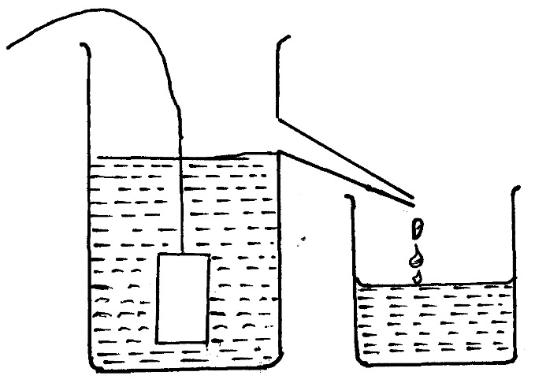
(ii) Immerse the mass m into the can. Collect the overflow in a beaker as shown below in
Overflow can
Thread
Mass (m)
Beaker
the figure below.

Fig. 1
(iii) Using the measuring cylinder provided determine the volume V of the water
collected in the beaker.
V = cm³ (1 mark)
(iv) Calculate I given that I = (Where m=0.30 kg) (2 marks)
…………………………………………………………………………………………………………………………………………………………………………………………………………………………………………………………………………………………………………
……………………………………………………………………………………………………………………………………………………
(b) Set up the apparatus as shown in figure 2 below. Ensure that the wire is free of kinks and the end tied to the hook is firm and the hook does not move.
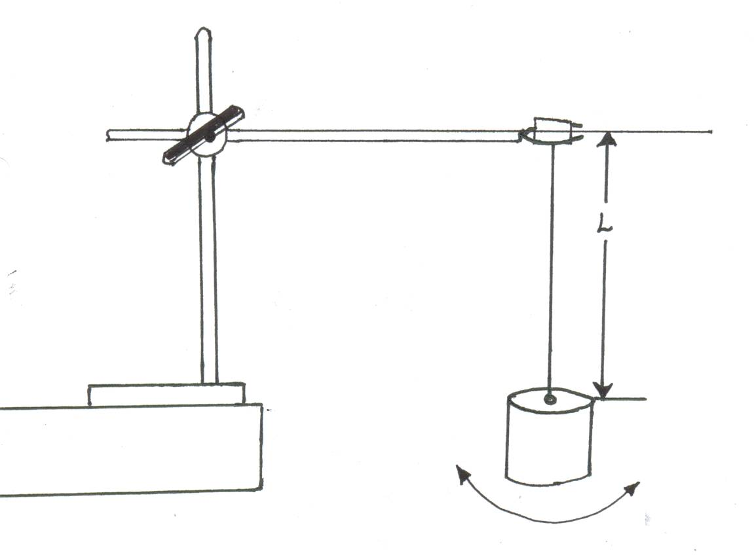
Boss
Pieces of wood
Mass (m)
Bench

Fig 2.
(c) Adjust the length L, of the wire so that L = 70cm, Give the mass m, a slight twist such that when released it oscillates about the vertical axis as shown by the arrows in figure 2. Measure the time for twenty oscillations and record in Table 1.

(d) Repeat the procedure in (c) above for other values of L, as shown in Table 1.
Complete the table. (6 marks)
Length L (cm) | 70 | 60 | 50 | 40 | 30 | 20
Length L (m)
Time for 20 oscillations(s)
Period T(s)
T² (S²)
Table 1
(e) On the grid provided, plot the graph of T² (S²) (y – axis) against L (m) (5 marks)
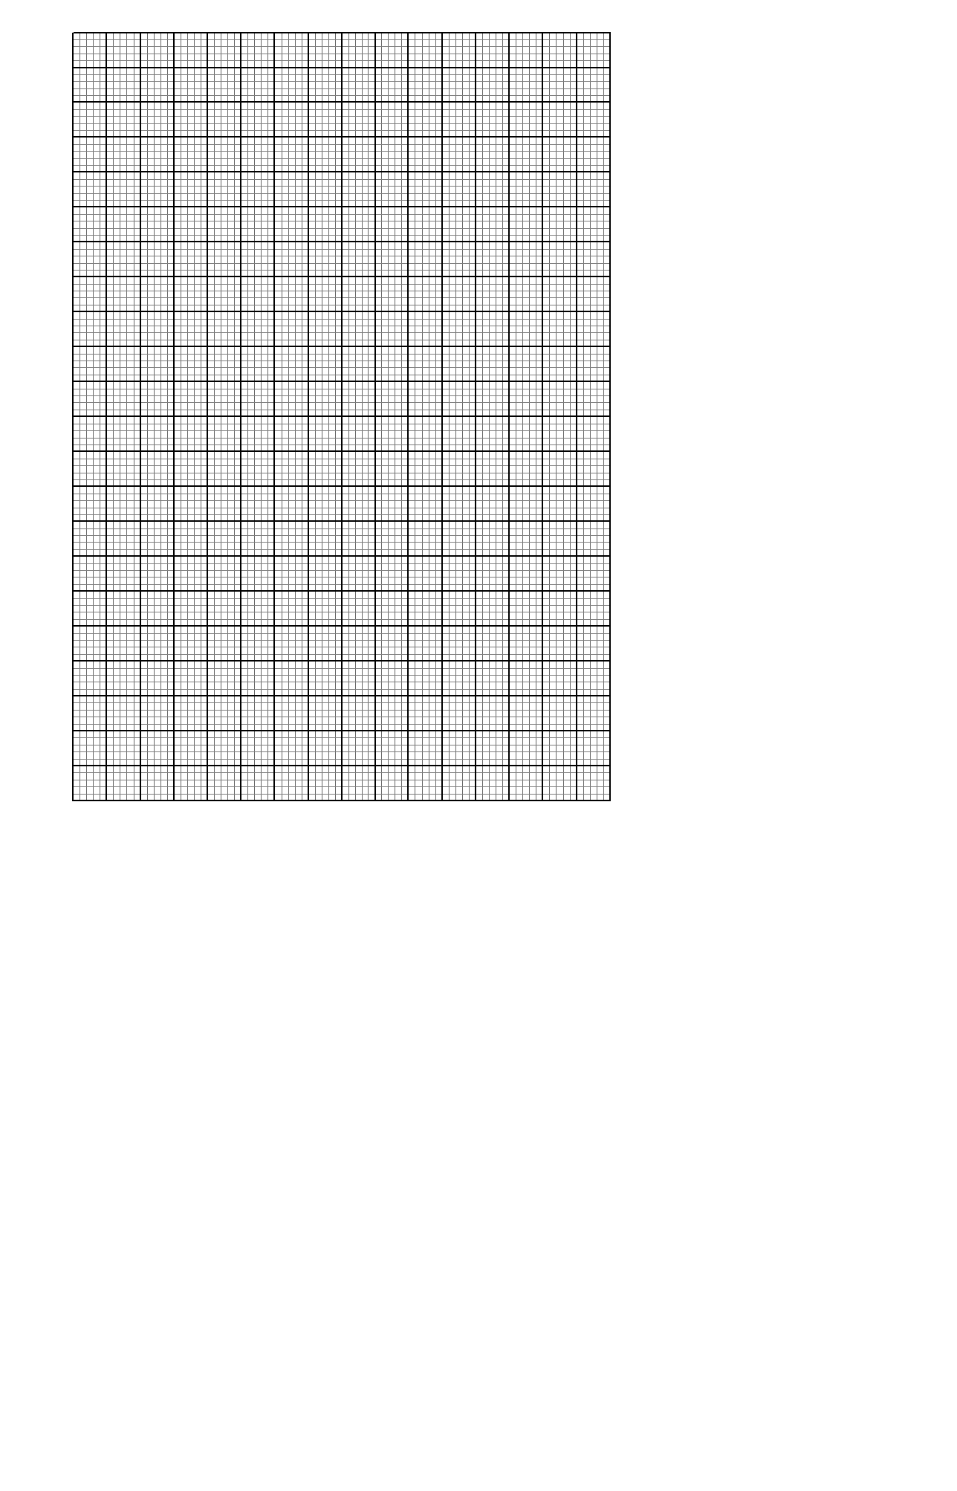
(f) Measure the diameter d of the wire. (1 mark)
d = ………………………. metres
(g) (i) Determine the slope of the graph. (2 marks)
…………………………………………………………………………………………………………………………………………………………………………………………………………………………………………………………………………………………………………
………………………………………………………………………………………………………………………………………………………………………………………………………………………………………………………………………………………………………………………………………………………………………………………………………………………………………………………………
……………………………………………………………………………………………………………………………………………………
(ii) Given that T² = where G is a constant, use the graph to determine the value of G. (3 marks)
…………………………………………………………………………………………………………………………………………………………………………………………………………………………………………………………………………………………………………
……………………………………………………………………………………………………………………………………………………
…………………………………………………………………………………………………………………………………………………………………………………………………………………………………………………………………………………………………………
……………………………………………………………………………………………………………………………………………………

QUESTION 2
You are provided with the following apparatus
- A metre rule
- A screen fitted with cross-wires labelled O
- A mounted white screen labelled S
- A lump of plasticine
- A candle
- A plane mirror
- Two lenses mounted on holder labelled L1 and L2 - pieces of cello tape.
Proceed as follows:
- Arrange the apparatus as shown in the figure below so that the candle flame, the cross-wires and the centre of the lens lie on a straight line.
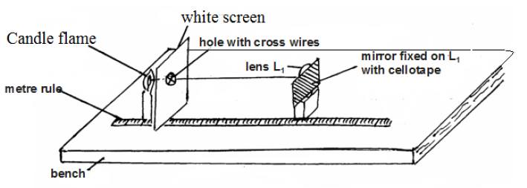
- Adjust the position of the lens arrangement (lens, mirror and holder) until a sharp image of the cross-wires is observed on the screen O.
Note: It might be necessary to adjust the position of the candle to make the image clearer. Measure the distance L1 between the screen and the centre of the lens L1
L1 =......................................................... (1 mark)

- Remove L1 and replace it with L2. Repeat procedure in (b) above to obtain distance, L2 between the screen and the centre of lens L2
L2 =........................................................... (1 mark)
- Now remove the mirror and arrange the apparatus as shown in figure below so that the two lenses, the cross-wires and candle flame lie on the straight line.
- Adjust the position of lens L1 so that the distance, d, is 5cm. (See figure below). Adjust the position of the screen S until a sharp image of the cross-wires is observed on the screen
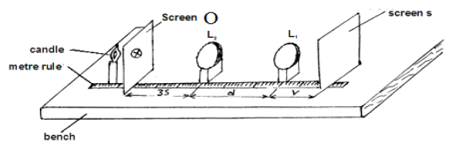
- Repeat the procedure in (f) above for values of, d, equal to 8cm, 12cm, 16cm and 20cm.
Distance d (cm) | 5 | 8 | 12 | 16 | 20
Distance v (cm)

- On the grid provided below, plot a graph of V(y-axis) against d. (5 marks)
- Determine the intercept Vo on the V-axis.
VO =.......................................................................................... (1 mark)
- Calculate constant F of the lenses using two methods.
i)
F₁ = 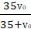 (2 marks)
……………………………………………………………………………………………………………………………………………………
…………………………………………………………………………………………………………………………………………………………………………………………………………………………………………………………………………………………………………
……………………………………………………………………………………………………………………………………………………

ii)
F₂ = 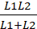 (2 marks)
……………………………………………………………………………………………………………………………………………………
…………………………………………………………………………………………………………………………………………………………………………………………………………………………………………………………………………………………………………
…………………………………………………………………………………………………………………………………………………………………………………………………………………………………………………………………………………………………………
……………………………………………………………………………………………………………………………………………………

- Calculate the power of lens L2 and state its SI unit. (3 marks)
……………………………………………………………………………………………………………………………………………………
……………………………………………………………………………………………………………………………………………………
…………………………………………………………………………………………………………………………………………………………………………………………………………………………………………………………………………………………………………
…………………………………………………………………………………………………………………………………………………………………………………………………………………………………………………………………………………………………………
…………………………………………………………………………………………………………………………………………………………………………………………………………………………………………………………………………………………………………
……………………………………………………………………………………………………………………………………………………

