232/3 SMARTPASS PHYSICS PAPER 3 MARKING SCHEME MODEL ONE 2019
QUESTION 1
1. a) iii) V = 45cm³ ✓ (1mk)
iv) ✓ (1mk)
✓ (1mk)
d)
Length L (cm) | 70 | 60 | 50 | 40 | 30 | 20
Length L (m) | 0.70 | 0.60 | 0.50 | 0.40 | 0.30 | 0.20
Time for 20 oscillations (s) | 61.01 | 56.08 | 51.36 | 46.06 | 39.81 | 32.80
Period T (s) | 3.051 | 2.804 | 2.568 | 2.303 | 1.991 | 1.640
T² (s²) | 9.309 | 7.862 | 6.595 | 5.304 | 3.960 | 2.690

- Correct conversion of length L in M ✓ (1mk)
- Time for 20 oscillation ✓ (¹/₂mk for each value within range (maximum of 3mks)
- Correct evaluation of period ✓ (1mk)
- Correct evaluation of T² ✓ (1mk)
e) Axes: Labelled with units ✓ (1mk)
Scale: Simple and uniform ✓ (1mk)
Plotting: Each correctly plotted point ✓( ½ mk) to a max
To a max of 2mks (4points within 1 small square)
Line: Passing through at least 3 points correctly plotted ✓(1mk)
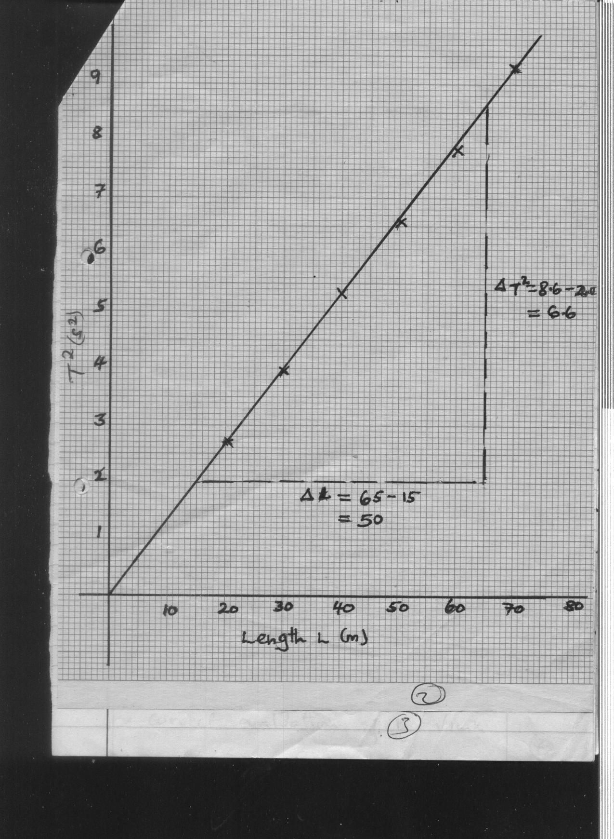
f) d = 0.34 x 10⁻³
= 3.4 x 10⁻⁴m ✓(1mk)
g) i)
✓ (2mk)
ii)
✓ (1mk)
✓ (1mk)

= 7.03898 x 10⁻⁷ m ✓ (1mk)

QUESTION 2
b) L1 = 20.0 cm, L2 = 20.0 cm ✓ (2mk)
f)
Distance d (cm) | 5 | 8 | 12 | 16 | 20
Distance v (cm) | 11.5 | 10.5 | 9.5 | 8.5 | 7.5
One mark given for each, a total of 5 marks
g)
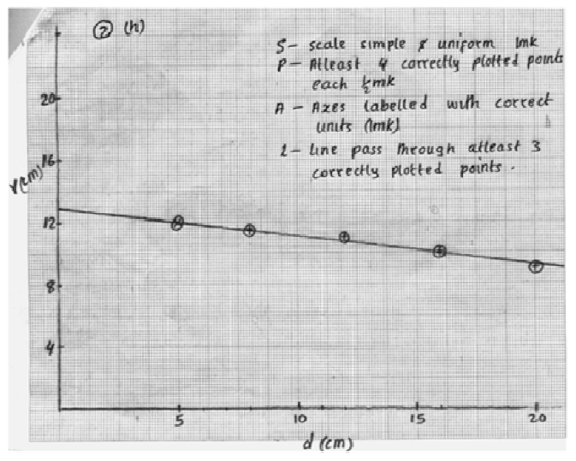
h) Vo = 13.0

i) i) Substitution ✓ (1mk)
Evaluation ✓ (1mk)
ii) Substitution ✓ (1mk)
Evaluation ✓ (1mk)

j) f = 20.0cm or 0.2 m
Substitution with f being in metres ✓ (1mk)
Accuracy ✓ (1mk)
Units ✓ (1mk)

