232/3 – PHYSICS PAPER 3 - MARKING SCHEME

- PART A
- h = 15cm + 1cm ✓½
- d = 2cm + 1cm ✓½
- t = h – d = (15.0 – 2.0)cm
= 13.0cm✓½
- m = 61.2g + 10g✓½
- D = 2.53cm + 0.1cm✓½
- R = D = 2.53 = 1.265cm✓½
2 2
- m = 12pπR²

=> p = m
13πR²
= 61.2 ✓²
12 x 3.142 x (1.265)²
= 61.2
60.335
= 1.014gcm⁻³✓¹

PART B

(e)
u (cm) | 20 | 25 | 30 | 35 | 40 | 45
v (cm) | 20 | 17 | 15 | 14 | 13 | 13 | ✓3mks
u + v | 40 | 42 | 45 | 49 | 53 | 58 | ✓1½ mks
uv (cm²) | 400 | 425 | 450 | 490 | 520 | 585 | ✓1½ mks

Values of V within +4cm of the given value – ½mk each.
Values of u + v – Each ½ mk each to a max. of 3 values – use the candidate’s value correctly added.
Values of uv – ½ mk each to a max of 3 values – use the candidate’s value correctly worked.

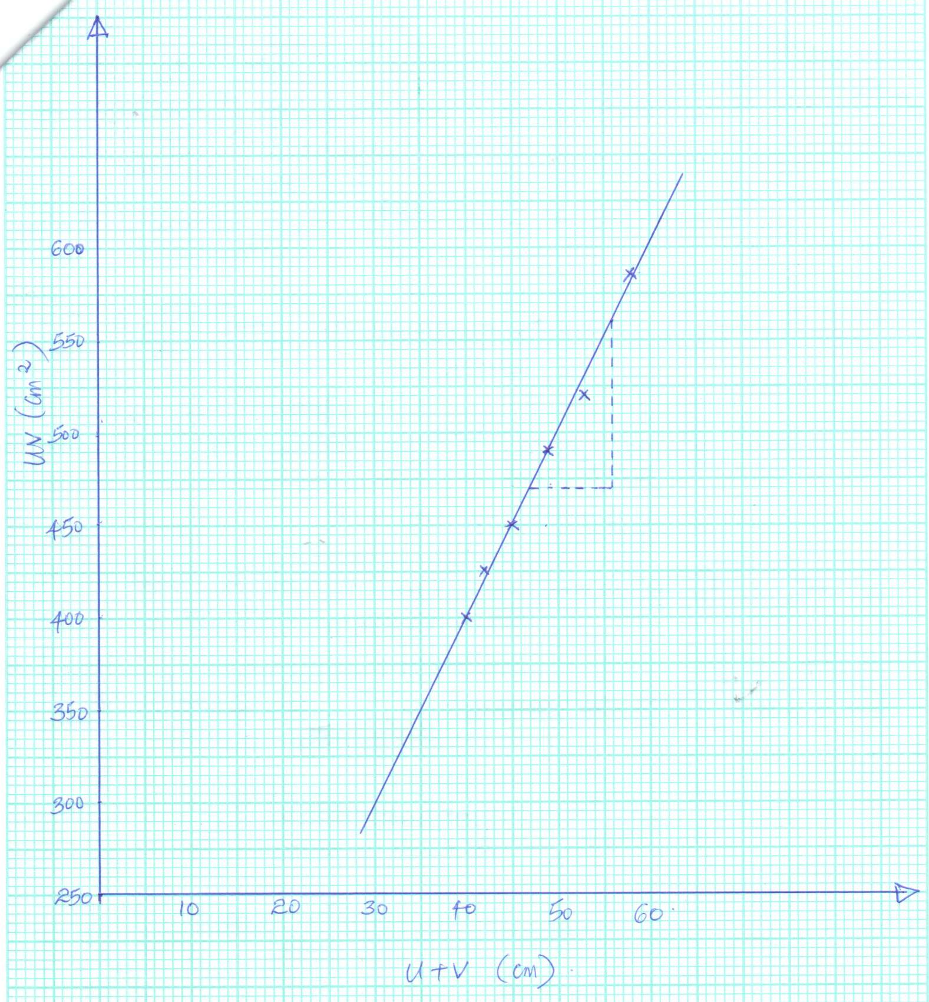
        - Axes correctly labelled with correct units – 1mk
        - Appropriate scale, simple, covering all values and at least half of the grid – 1mk
        - Each point correctly plotted to within one small square – ½ mk to a max of 4 points.
        - Line passing through at least 3 correctly plotted points – 1mk.

- Slope = Δuv✓½ (Evidence on the graph)
Δu
= (560 – 470)cm²✓1
(56 – 47)cm
= 90 = 10cm✓½
9
Significance – Focal length of the lens. ✓1

- (c)
Length (xy) cm | 80 | 70 | 60 | 50 | 40 | 30 | 20
Voltmeter reading (V) | 2.65 | 2.60 | 2.55 | 2.50 | 2.45 | 2.35 | 2.25 | ✓3½ mks
Ammeter reading (A) | 0.22 | 0.28 | 0.30 | 0.35 | 0.40 | 0.45 | 0.56 | ✓3½ mks
- Award ½ mk for each correct value of V and I.

- (i)
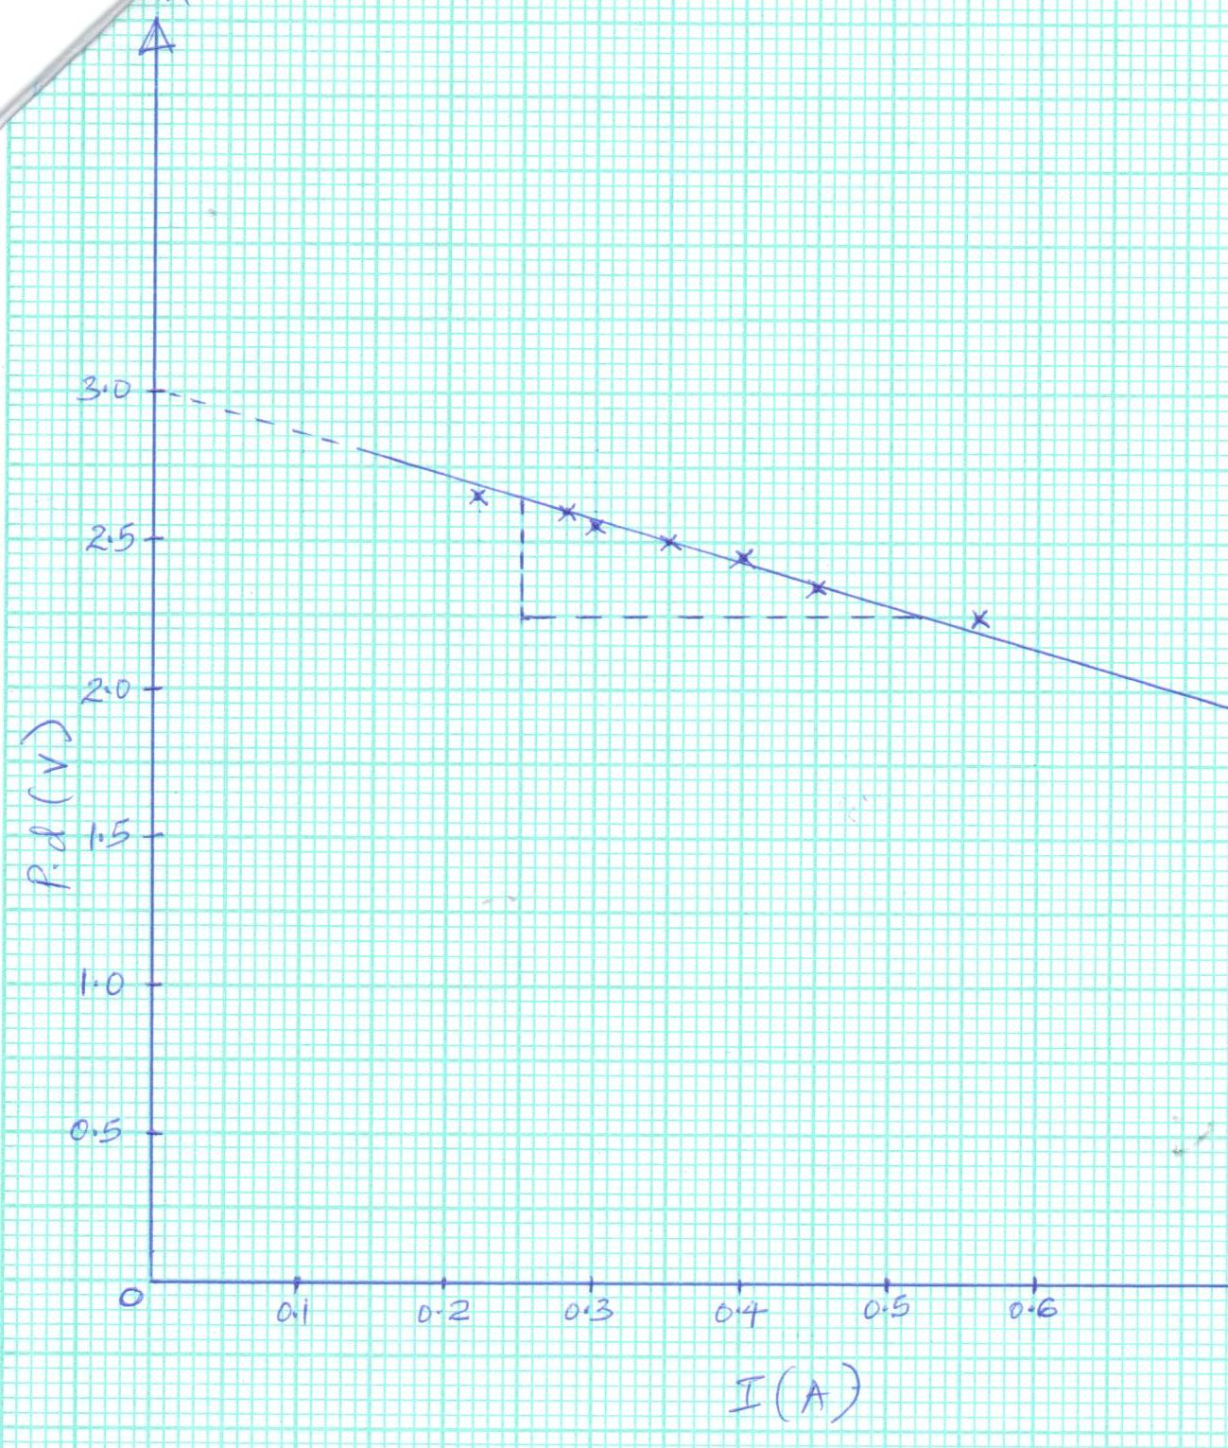
Labelling – 1mk (Axes correctly labelled with correct units).

Scale – 1mk – Appropriate scale, simple, covering all values.

Plotting – 2mks – Each point correctly plotted to within one small square – ½ mk each to a max of 4 points.

Line – 1mk – should pass through atleast 3 correctly plotted points.

(ii) Slope = Δv✓1 (Evidence on the graph)
ΔI

= (2.25 – 2.65)v
(0.52 – 0.25)A ✓1

= -0.4
0.27

= -1.481Ω

- (i) V = K₁I + K₂
K₁ = Gradient
= -1.481Ω✓1

(ii) K₂ = Y – intercept
= 3.0V✓1

- K1 – Internal resistance.✓1

K2 – E.M.F. of the cells. ✓1

- To minimize errors due to heating✓1 effect of electric current.

