FORM 2 PHYSICS END OF TERM 2
232/1 –MARKING SCHEME

1. + 5.5
0.38 –
5.88 1 (5.88)
+ 0.02
5.90mm 1 (5.90)

= 9.112m

2. Ad = V 1  form
2000d = 0.4 1  substitution
d = 0.4
2000
= 2 x 10⁻⁴mm
= 2 x 10⁻⁷m 1  answer

3.
0 4 20 temp.
Density

1 label axis
1 curve
(4° seen)

4. - Mass on dull tin plates falls off before mass on polished tin. 1
- Dull tin absorbs heat faster than polished tin (it heats up faster
and wax on it melts before 1

5. - Charge the glass rod by rubbing it with silk.
- Place the rod near the cap of the electroscope.
- If the divergence of the leaf increases, the electroscope is positive.
- If the divergence of the leaf decreases, the electroscope is negative.

6. - It can give a bigger current.
- It can be left in the discharge condition for a long time without damage. 1, 1 any 2 correct
- It requires less attention.
- It is lighter.
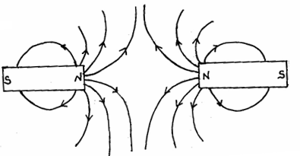
7. 1 pattern
1 arrows

8. Clockwise moment = anticlockwise moment
0.3χ + 1.8 x 0.1 = 1.8 x 0.4 1  expression
χ = 1.8N 1  ans.

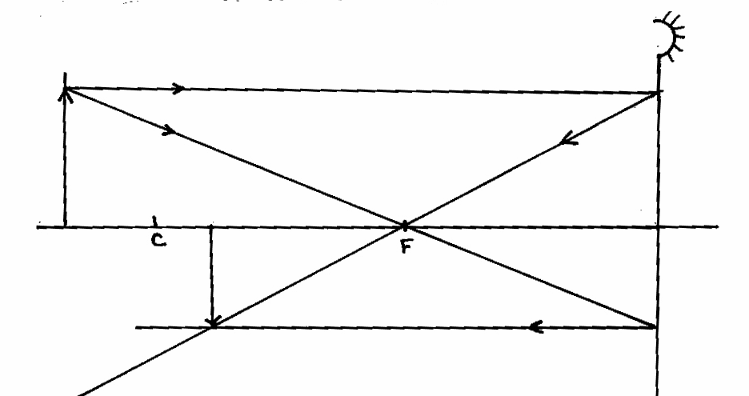
9. 1, 1 each  ray
with arrows

1,  image

10. - Magnet will be repelled 1
- Coil is magnetized with end near magnet acquiring North Pole 1

11. For A and B
4N – 1cm
8N - $\frac{1}{4} x 8$ 1
= 2cm each 1
For C 4N – 1cm
15.5N - $\frac{1}{4N} x \text{15}\text{.}5N$
= 3.875cm 1

12. - Mechanical waves require a material medium. 1
- Electromagnetic waves do not require a material medium. 1

13. (a) Velocity of sound = 50,000 x 0.05 1 formular
= 2500m/s 1  velocity
Depth = 2500 x 10 1  expression
2
= 12,500m 1  ans

2
(b) (i) Level of fluid in C is higher than level in B. 2
(ii) In B the fluid flow with relatively high velocity hence 1
low pressure. While in be the velocity is low hence
high pressure. 1

SECTION B
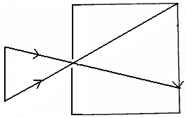
14. (a) 1 both rays
Object
image
1 arrows
1 image
(Check that rays
get to screen)

(b) Real 1mk
Inverted 1mk

(c) Becomes - Brighter Any two (2mks)
- Blurred
- Bigger

(d) $\frac{\text{hi}}{\text{ho}} = \frac{V}{U}$ 1mk formular
$\frac{4}{\text{ho}} = \frac{\text{12}}{\text{30}}$ 1 substitution
h₀ = 10cm 1 (answer)

10mks

15. (a) (i) 2cm 1mk
(ii) 4cm = 0.04m 1mk
- 3 oscli → 1.55
1 0scli →
Period = $\frac{1\text{.}\text{55}}{3}$ 2mks
= 0.55 1mk

(b) (i) $f = \frac{1}{T}$ 1mk
= $\frac{1}{0\text{.}5}$
= 2Hz 1mk

(ii) V = λƒ 1mk
= 2 x 0.04 1mk
= 0.08m/s 1mk

10mks

16. (a) It is the spreading of particles from regions of high concentration to those
of low concentration. 1mk

(b) - Bright specks are seen in continuous random motion. 1mk
- This is because of uneven bombardment by the invisible
particles or molecules of air. 1mk

(c) (i) To avoid splashing the water. 1mk
(ii) Because the salt particles fitted well in the spaces
between the water molecules. 1mk

(d) (i) Ammonia gas diffuses at faster rate than hydrochloric acid gas. 1mk
(ii) A denser gas diffuses at a slower rate than the lighter one. 1mk
- Diffusion takes longer time, ¹ because the particles are at low
kinetic energy/moves slowly. 1mk

9mks

17. (a) Mass Weight

Quantity of matter in a body. - Pull of gravity on a body.
- Measured in kilogram. - Measured in Newton’s.
- Same everywhere. - Changes from place to place.
- Measured using a bean balance. - Measured using a spring balance.
- Has magnitude only. - Has both magnitude and direction Any four correct
(4mks)

- Pressure applied at one part of a liquid is transmitted equally to all other
parts of the enclosed liquid. 1mk

(c) (i) Hydraulic lift 1mk
(ii) Hydraulic brake system 1mk

(d) $ℓ,\text{gh} = ℓ\text{gh}$ 1mk
1600 x 10 x h₁ = 800 x 10 x 0.18
h₁ = $\frac{800^{1} × 10 × 0\text{.}\text{09}}{216000}$ 1mk
h₁ = 0.09m 1mk
= 9cm ___
10mks

